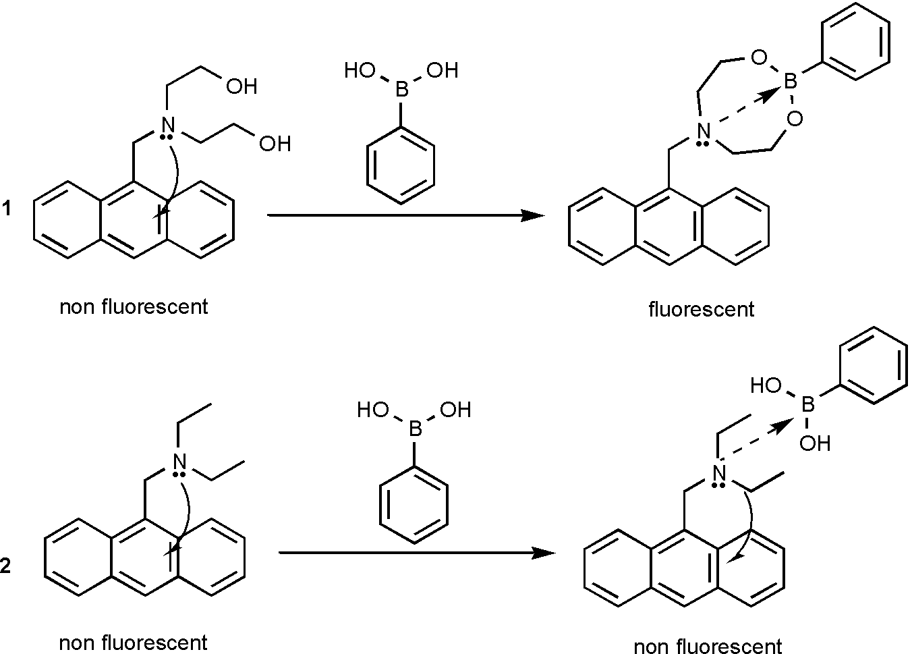
PET sensors 1 and 2

¹H and ¹³C NMR spectra of 1 (shift on addition of PBA).
Solvent | Assignment | ¹H (ppm) (300.2MHz) |  | ¹³C (ppm) (75.5MHz)
 | Assignment | 1 | 1 + PBA | 1 | 1 + PBA
CDCl₃ | 1 | 4.69 | –ª | 51.55 | 51.52 (-0.03)
 | 2 | 2.80 | –ª | 55.85 | 55.99 (+0.14)
 | 3 | 3.52 | –ª | 59.65 | 62.68 (+3.03)
CD₃OD | 1 | 4.60 | 4.65 (+0.05) | 52.92 | 52.90 (-0.02)
 | 2 | 2.70 | 2.75 (+0.05) | 57.60 | 57.59 (-0.01)
 | 3 | 3.46 | 3.46 (0.00) | 61.25 | 61.05 (-0.20)
ª Proton spectra too broad to assign.

¹¹B NMR spectra of phenylboronic acid (shift on addition of 1).
Solvent | PBA  ¹¹B (ppm) (96.3MHz) | PBA + 1  ¹¹B (ppm) (96.3MHz)
CDCl₃ | 32.27 | 15.90 (-16.37)
CD₃OD | 29.97 | 30.70 (+0.73)

