Macrocyclic multi-telluranes with hypervalent Te-O apical linkages

Kenji Kobayashi,*ª Hiroyuki Izawa,ª Kentaro Yamaguchi,^{b} Ernst Horn^{c} and Naomichi Furukawaª

ªDepartment of Chemistry, University of Tsukuba, Tsukuba, Ibaraki 305-8571, Japan

E-mail: kenjinor@staff.chem.tsukuba.ac.jp
^{b}Chemical Analysis Center, Chiba University, Inage-ku, Chiba 263-8522, Japan
^{c}Department of Chemistry, Rikkyo University, Nishi-Ikebukuro, Toshima-ku, Tokyo 171-8501, Japan

Supplementary Information

Macrocyclic multi-tellurane (4): Triflic anhydride (22.0 μL, 0.13 mmol) was added to a suspension of bis(4-methylphenyl) telluroxide (42.0 mg, 0.13 mmol) in dry CH₃CN (2 mL) at –40 °C under an argon atmosphere. The mixture immediately changed to a homogeneous pale yellow solution. After stirring at –40 °C for 30 min, the solution containing 1 was added to a suspension of 3 (27.0 mg, 0.13 mmol) in dry CH₃CN (2 mL) at room temperature. The resulting mixture immediately changed to a homogeneous pale yellow solution and was stirred at room temperature for 12 h. After evaporation of solvent, the residue was triturated with benzene (10 mL) and then filtered. The filtrate was evaporated, recrystallized from CH₃CN, and dried in vacuo to give 4 (46.9 mg, 76% yield) as a white powder. Single crystals were prepared by slow diffusion of p-xylene into a solution of 4 in CH₃CN.
M.p. 199-200 °C (decomp); ¹H NMR (270 MHz, CD₂Cl₂, 23 °C) δ 2.35 (s, 18H), 7.31 (d, J = 8.3 Hz, 12H), 7.38 (dd, J = 3.2 and 5.9 Hz, 6H), 7.48 (dd, J = 3.2 and 5.9 Hz, 6H), 7.78 (d, J = 8.3 Hz, 12H); ¹²⁵Te NMR (85.2 MHz, CD₂Cl₂, 23 °C) δ 997.0; IR (KBr) ν 1647 (s), 1307 (s), 1134 (m), 1076 (m), 800 (m), 485 (m) cm^{–1}; FAB-MS (2-nitrophenyl octyl ether matrix) m/z (%) 1423 (4, [M + H]⁺), 801 (7, [M – Ar₂Te – 2C₆H₄(CO₂)₂ + OH]⁺), 477 (43, [1/3M + H]⁺), 329 (79, [Ar₂TeO + H]⁺), 312 (100, [Ar₂Te]⁺); Anal. Calcd for C₆₆H₅₄O₁₂Te₃·2H₂O (%): C, 54.37; H, 4.01. Found: C, 54.05; H, 3.76.

¹H NMR spectrum of 4 (CD₂Cl₂ at 23 °C).
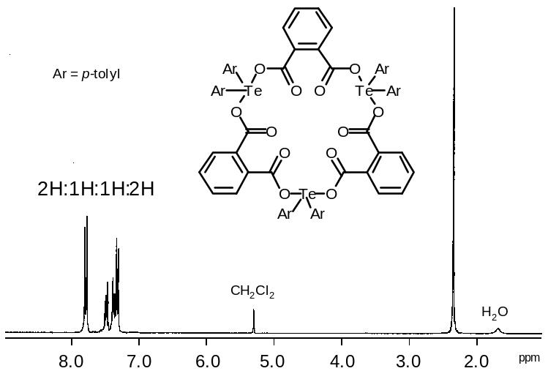

¹²⁵Te NMR spectrum of 4 (CD₂Cl₂ at 23 °C).
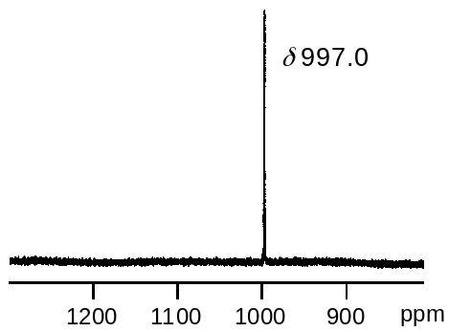

FAB-MS spectrum of 4 (2-nitrophenyl octyl ether as a matrix).
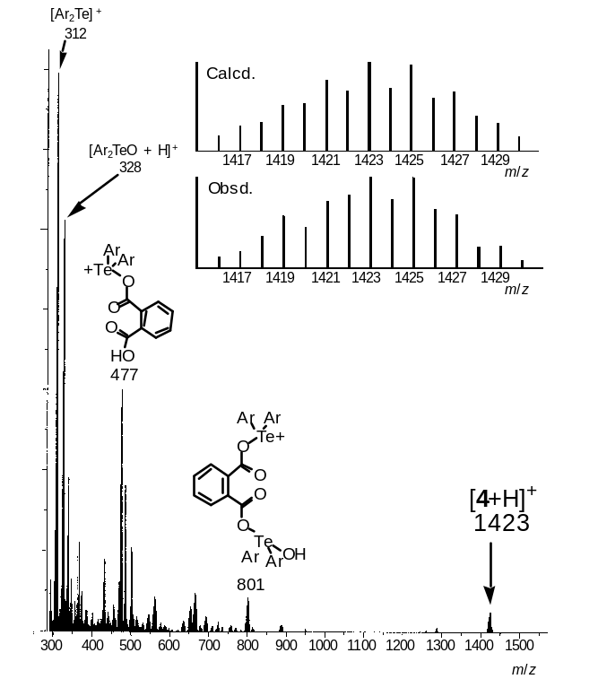

ORTEP draw of 4 (50% probability thermal ellipsoids).
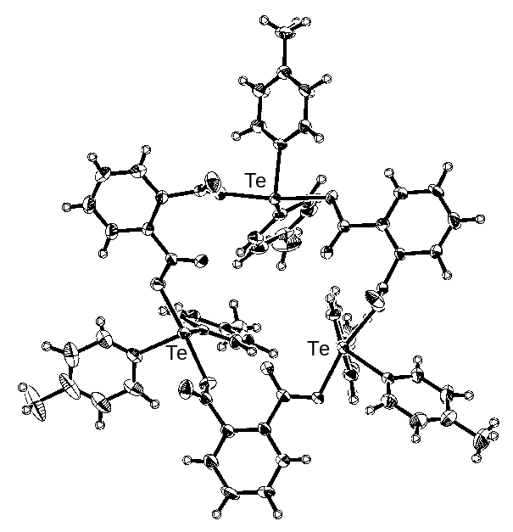

Macrocyclic multi-tellurane (5): A heterogeneous mixture of 2 (120.0 mg, 0.13 mmol) and 3 (27.0 mg, 0.13 mmol) in dry CH₃CN (4 mL) under an argon atmosphere was stirred at room temperature for 24 h, which gradually changed to a homogeneous pale orange solution. After evaporation of solvent, the residue was triturated with benzene (10 mL) and then filtered. The filtrate was evaporated, recrystallized from benzene-hexane (diffusion), and dried in vacuo to give 5 (14.6 mg, 14% yield) as a white powder. Single crystals were prepared by slow diffusion of p-xylene into a solution of 5 in benzene.
M.p. 172-174 °C (decomp); ¹H NMR (270 MHz, CD₂Cl₂, 23 °C) δ 2.32 (s, 24H), 7.13 (d, J = 8.1 Hz, 16H), 7.31 (dd, J = 3.2 and 5.7 Hz, 4H), 7.50 (dd, J = 3.2 and 5.7 Hz, 4H), 7.76 (d, J = 8.1 Hz, 16H); ¹²⁵Te NMR (85.2 MHz, CD₂Cl₂, 23 °C) δ 1044.4; IR (KBr) ν 1635 (s), 1339 (s), 1187 (m), 798 (s), 639 (m), 489 (s) cm^{–1}; FAB-MS (2-nitrophenyl octyl ether matrix) m/z (%) 1601 (8, [M + H]⁺), 1509 (8, [M – Ar]⁺), 1275 (18, [M – Ar₂TeO + H]⁺), 801 (18, [1/2M + H]⁺), 477 (37, [1/2M – Ar₂TeO + H]⁺), 329 (98, [Ar₂TeO + H]⁺), 312 (100, [Ar₂Te]⁺); Anal. Calcd for C₇₂H₆₄O₁₀Te₄·0.5C₆H₆ (%): C, 54.97; H, 4.12. Found: C, 55.25; H, 4.23.

¹H NMR spectrum of 5 (CD₂Cl₂ at 23 °C).
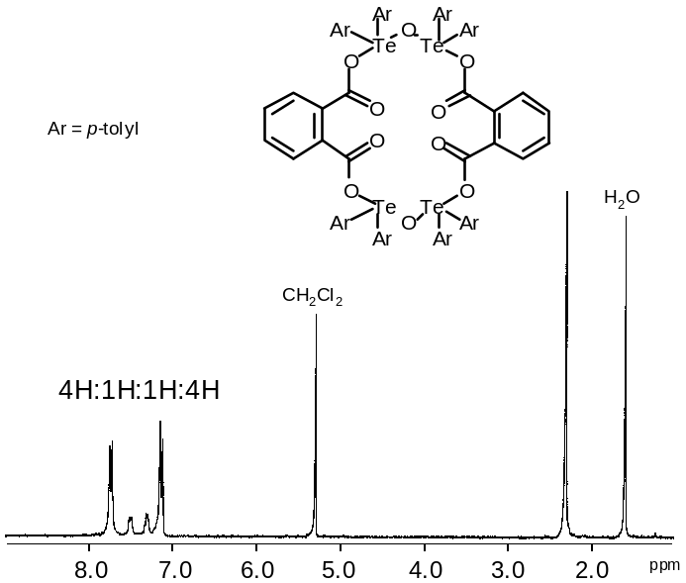

¹²⁵Te NMR spectrum of 5 (CD₂Cl₂ at 23 °C).
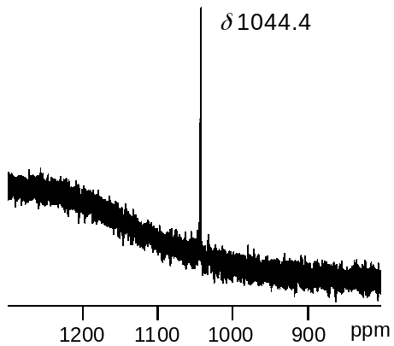

FAB-MS spectrum of 5 (2-nitrophenyl octyl ether as a matrix).
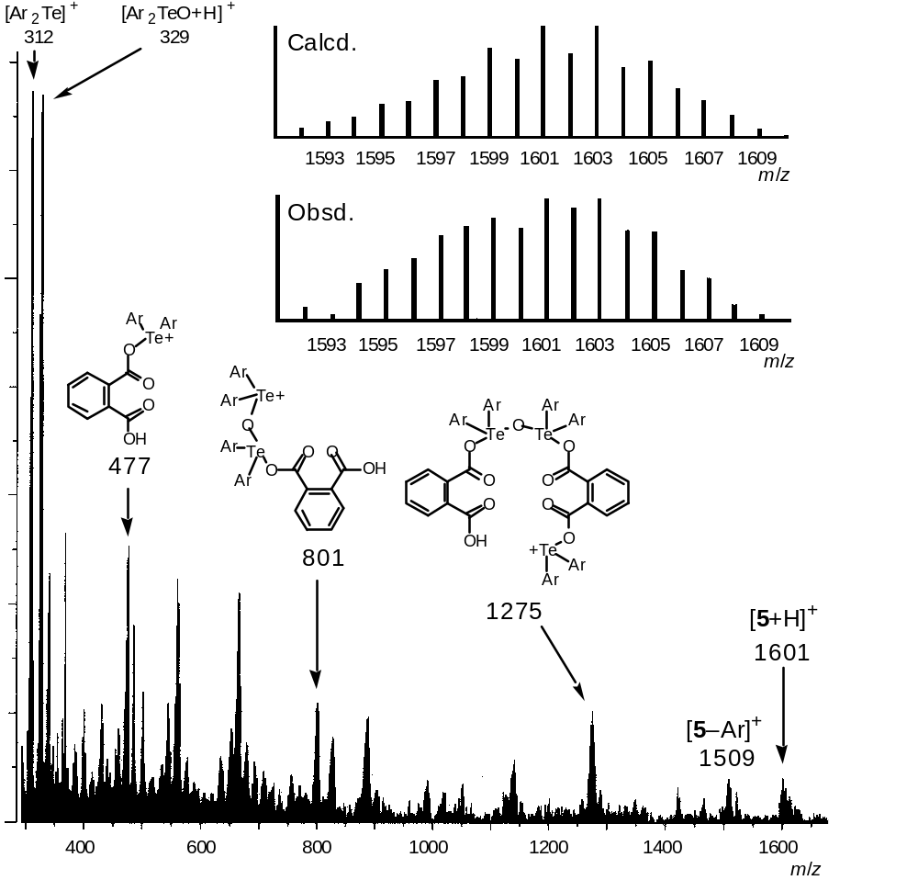

Crystal structure of 5 in the unit cell.


