Supplementary Material

Experimental part :
All operations were carried out using standart Schlenk tube or Fischer-Porter bottle techniques under argon for the synthesis or in a glove box under nitrogen for the preparation of the samples for analysis.
- Synthesis of colloids 2a and 2b :
A solution of Pt₂(dba)₃ (180mg; 0.165 mmol) in 40 mL of freshly distilled and deoxygenated THF in a Fischer- Porter bottle was pressurized with 1 bar of CO during 30 minutes at room temperature under vigorous stirring. During this time, the solution changed color from violet to brown (attesting then of the formation of the Pt_{x}(CO)_{y}(THF)_{z} intermediate colloid) and the medium remained homogeneous. The mixture was evaporated to dryness and the resulting solid was washed with pentane to eliminate the dba (5x20mL; until the solution turned colorless). The colloid was then dried under vacuum before redissolution with a THF solution containing the dithiol ligand (0.1 eq. per introduced Pt) : propanedithiol (3.5μL; 0.035 mmol) for colloid 2a and octanedithiol (6μL; 0.0496 mmol) for colloid 2b. The dissolution of the Pt colloid was very fast and the resulting mixture was a homogeneous brown solution. After evaporation to dryness, colloids 2a and 2b could be isolated as dark-brown powders.

- Pt particles connected to gold :
The connexion of Pt particles to Au particles was realized by mixing together a solution of colloid 2b with a gold colloidal solution (prepared following the Turkevich method³⁰ in the ratio Pt/Au 10/1.

- Synthesis of colloids 3a, 3b and 3c :
The synthesis of colloids colloids 3a, 3b and 3c was realized in the same way as the colloids 2a or 2b, the only difference being the quantity of the ligand (0.15 eq. per introduced Pt).

- Condensation products of 3a and 3c with 3b :
The condensation products of 3a and 3c with 3b were obtained by mixing together an equal volume of a 3a (or 3c) solution with a 3b solution.

Schemes
Scheme 1 : synthesis of Pt colloids stabilized by bifunctional ligands and [Pt]_{o} self-assemblies trough hydrogen bonding networks

Scheme 2 : Pt octanedithiol stabilized particles connected to gold particles
Figures with captions

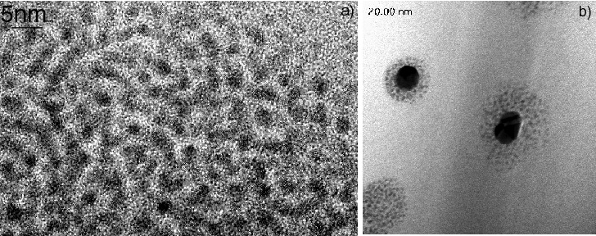
Fig 1 HREM micrograph of Pt particles stabilized by propanedithiol (a) and TEM micrograph of [Pt]_{o}(S-S)[Au]_{o} assemblies (b)

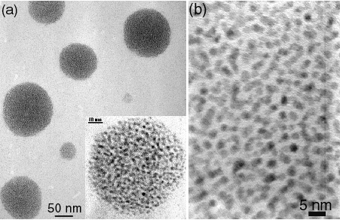
Fig 2 TEM (a) and HREM (b) micrographs of disks resulting from the condensation of 3a and 3b in the presence of water

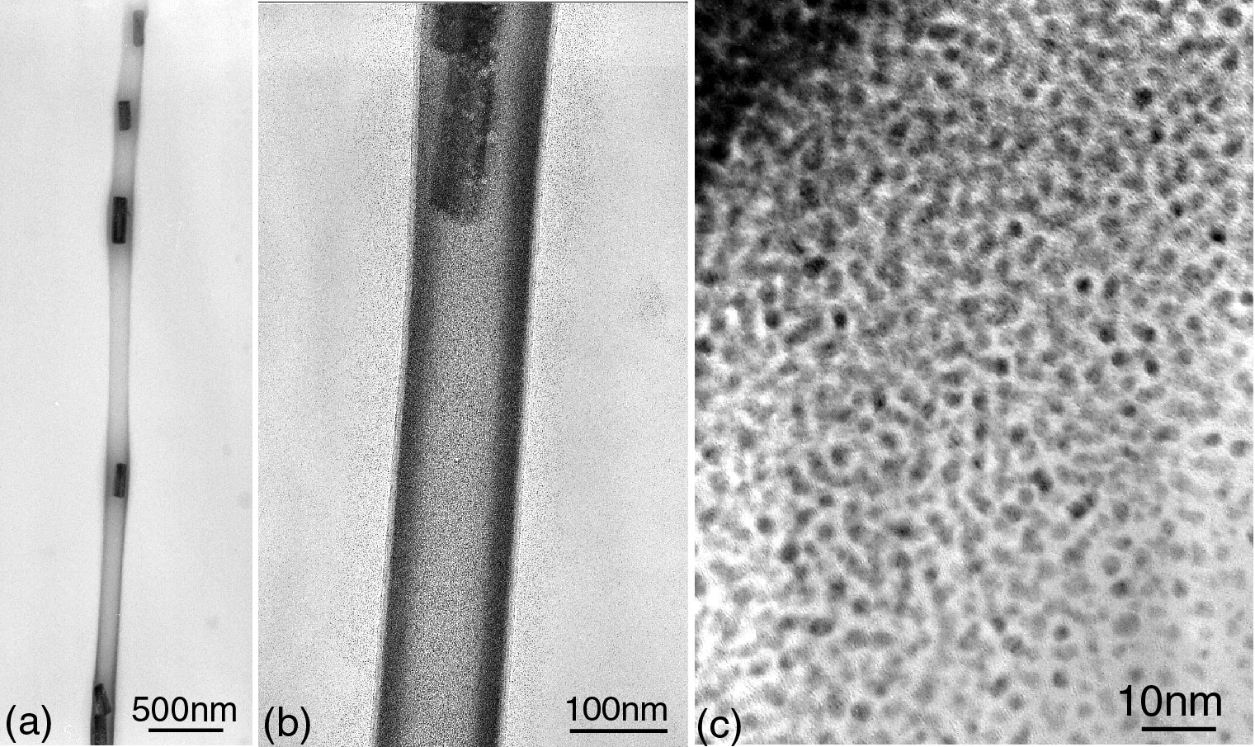
Fig. 3 TEM and HREM micrographs of platinum nanotubes at different magnifications (a) X15000 (b) X100000K (c) X600000

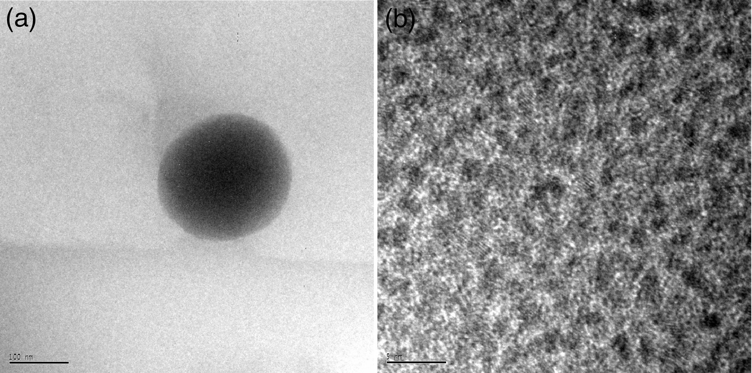
Fig 4 TEM (a) and HREM (b) micrographs of Pt particles stabilized by HS-C₆H₄-OH(colloid 3a)

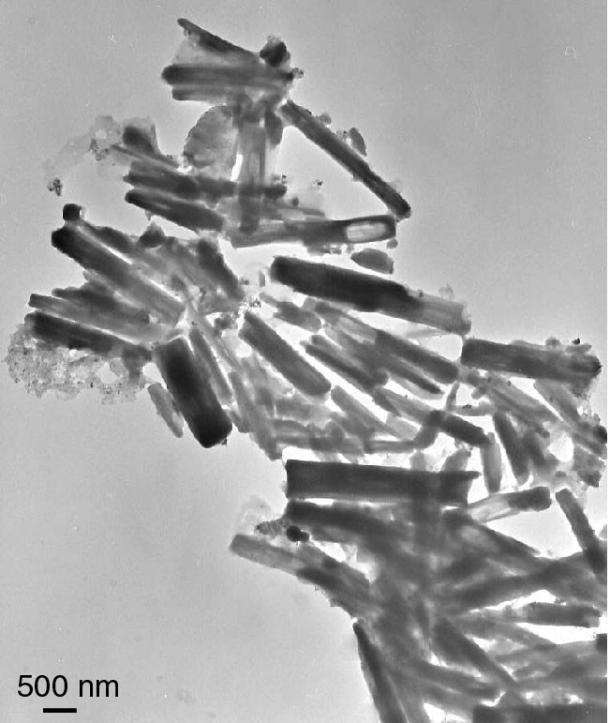
Fig 5 (Graphical Abstract figure) TEM micrographs of platinum nanotubes

