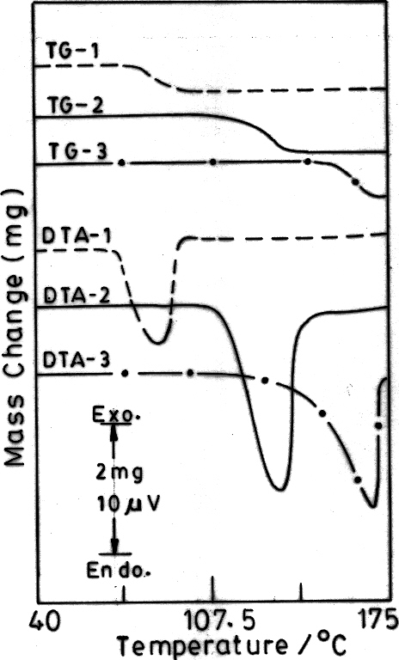
Fig.6. TG-DTA curves of 1 (sample mass, 9.15 mg)(-----), 1a (sample mass 10.71mg)(—) and 1b (sample mass 10.4 mg) (-·-·-·-·-).

