Supplementary Data

Synthesis and Structure of an Unprecedented High-symmetry
[Fe₄S₄Cl₄] Cubane-type Unit in Supramolecular [K₄(FeCl₄)(C₁₂H₂₄O₆)₄][Fe₄S₄Cl₄].

Johannes B. Willems and Martin Köckerling*

Institut für Synthesechemie, Fachbereich 6, Gerhard-Mercator-Universität, Lotharstr. 1, D-47057 Duisburg, Germany, email: hi356ko@uni-duisburg.de

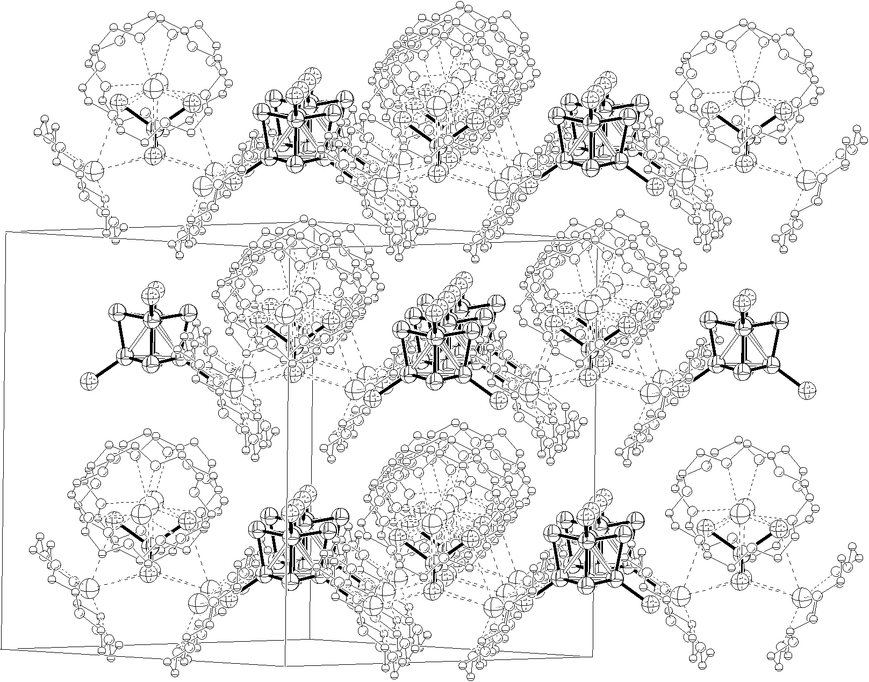

Figure S1: Packing diagram of the molecular units in crystals of [K₄(FeCl₄)- (C₁₂H₂₄O₆)₄][Fe₄S₄Cl₄] (approximate [110] view).

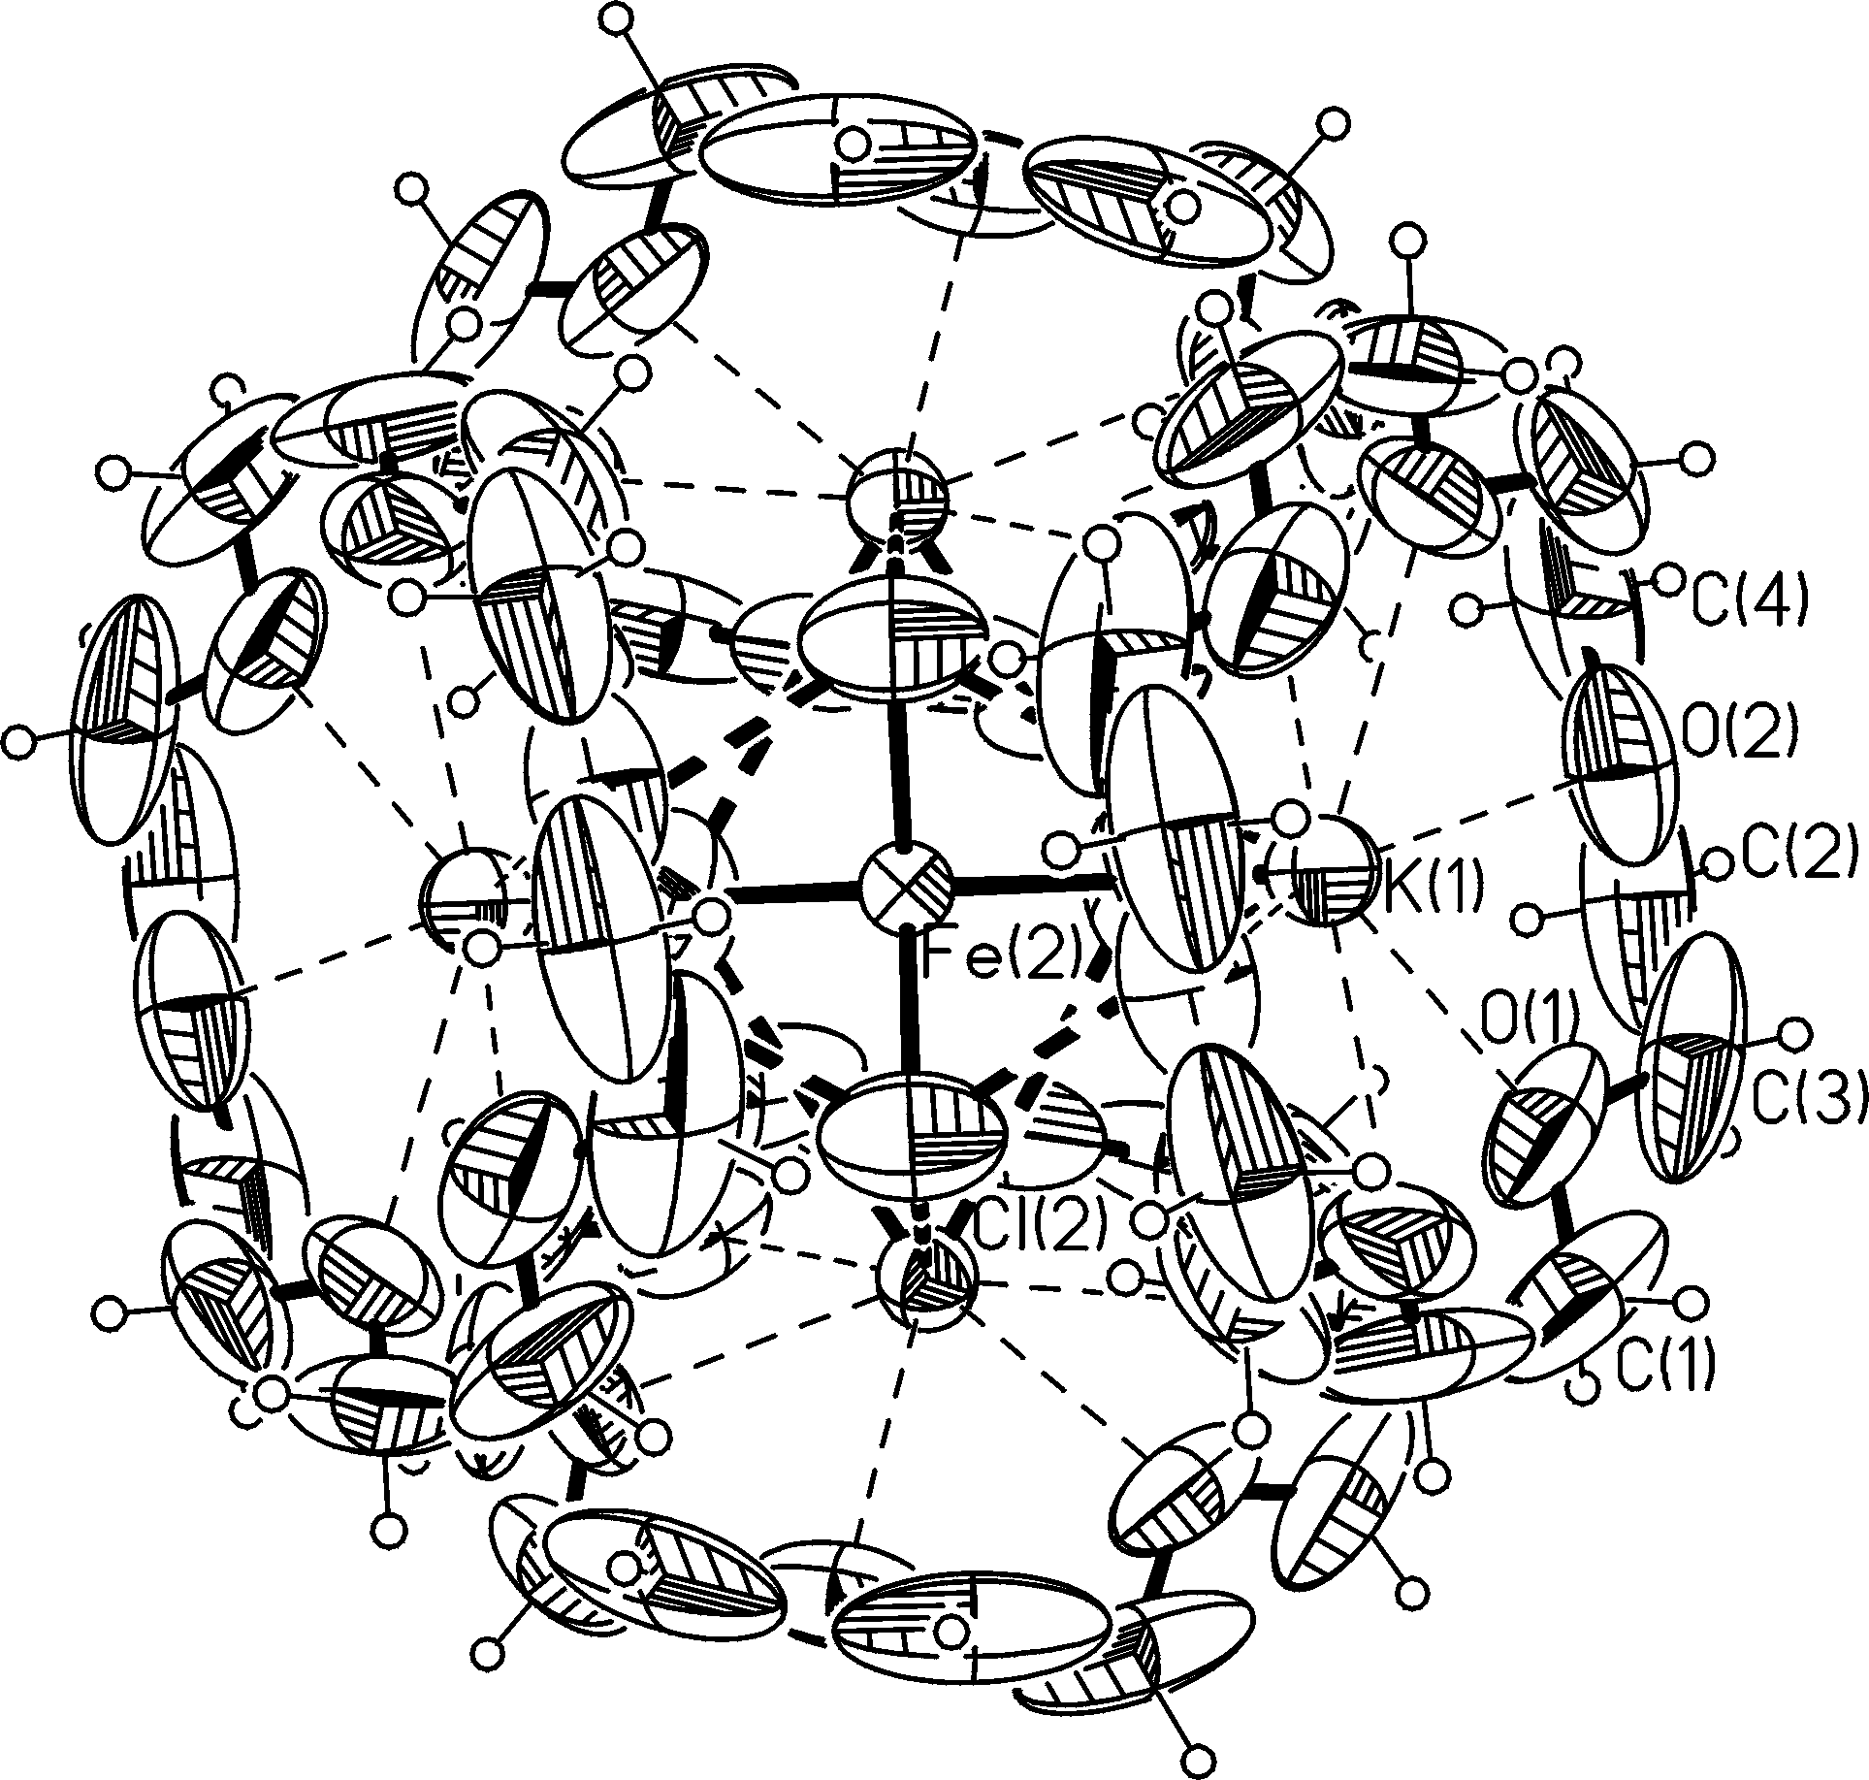

Figure S2: Structure of the supramolecular [K₄(FeCl₄)(C₁₂H₂₄O₆)₄] cation in crystals of [K₄(FeCl₄)(C₁₂H₂₄O₆)₄][Fe₄S₄Cl₄] (thermal ellipsoids with 50% probability).

