Experimental

2,2',2''-Tripyrrylethane, 2

2,2',2''-Tripyrrylethane (2) was prepared by the method of Lindsey^{[1]} as modified by Bruce.^{[2]} Triethyl orthoacetate (7.7 ml) was dissolved in an excess of freshly distilled pyrrole (50 ml). TFA (0.5 ml) was added and the mixture stirred under nitrogen - the solution turned dark red in colour. After 5 minutes, the reaction was quenched with 0.2M NaOH (50 ml) giving a bright yellow emulsion. Ethyl acetate (50 ml) was added and the organic phase separated and dried over anhydrous MgSO₄. Ethyl acetate and unreacted pyrrole were removed under reduced pressure to yield the crude product, which was stirred in cold ethanol, filtered, washed with cold ethanol and dried under vacuum to give 5.56 g (24.7 mmole, 59 %) of 2 as a white powder; calculated C 74.6, H 6.7, N 18.7 for C₁₄H₁₅N₃, found C 74.0, H 6.6, N 18.3 %; ¹H NMR (CDCl₃): δ 2.00 (s, 3H, CH₃-), 6.06 (m, 3H, H4 + 4' + 4''), 6.19 (m, 3H, H3 + 3' + 3''), 6.65 (m, 3H, H5 + 5' + 5''), 7.87 (s, 3H, H1 + 1' + 1'').

2,2',2''-Tripyrrylpropane, 3

The procedure followed was identical to that for the preparation of 2, except that triethyl orthopropionate (8.2 ml) replaced triethyl orthoacetate. 5.91 g (24.7 mmole, 60 %) of 3 was isolated as a white powder; calculated C 75.3, H 7.2, N 17.6 for C₁₅H₁₇N₃, found C 74.7, H 6.8, N 17.5 %; ¹H NMR (CDCl₃): δ 0.92 (t, 3H, J 7.3 Hz, CH₃-), 2.32 (q, 2H, J 7.3 Hz, CH₃-CH₂-), 6.18 (m, 6H, H3 + 3' + 3'' overlapping H4 + 4' + 4''), 6.65 (q, 3H, H5 + 5' + 5''), δ 7.89 (s, 3H, H1 + 1' + 1'').

5,5',5''-Triformyl-2,2',2'' tripyrrylethane, 4

5,5',5''-Triformyl-2, 2', 2'' tripyrrylethane (4) was prepared using a modification of previously reported methods ^{[3,4]}. 2,2',2'' Tripyrrylethane (1) (3.15 g, 14.0 mmole) was dissolved in dry DMF (130 ml) and cooled to 0ºC. POCl₃ (7.7 ml) was added dropwise. The mixture was heated to 60ºC for 1 h after which time the imine salt precipitated out as a fluffy yellow solid - toluene (100 ml) was added to ensure complete precipitation. The solid was filtered off and dissolved in 70 % aqueous EtOH (110 ml) containing Na₂CO₃ (4.4 g). The resulting solution was heated to 80 ºC at which point the aldehyde precipitated out. This was filtered off and dried under vacuum to give 3.64 g (11.8 mmole, 84 %) of 4 as a sandy-coloured powder; calculated C 66.0, H 4.9, N 13.6 for C₁₇H₁₅N₃O₃, found C 64.8, H 5.3, N 13.0 %; ¹H NMR (d₆-DMSO): δ 2.14 (s, 3H, CH₃-), 5.79 (d, 3H, J 3.4 Hz, H4 + 4' + 4''), 6.89 (s, 3H, J 3.4 Hz, H3 + 3' + 3''), 9.43 (s, 3H, CHO), 11.98 (s, 3H, H1 + 1' + 1'').

5,5',5''-Triformyl-2,2',2'' tripyrrylpropane, 5

5,5',5''-Triformyl-2,2',2'' tripyrrylpropane (5) was prepared using a modification of a previously reported method ^{[3]}. 2,2',2'' Tripyrrylpropane (3) (5.0 g, 20.9 mmole) was dissolved in dry DMF (190 ml) and cooled to 0ºC. POCl₃ (11.5 ml) was added dropwise. The mixture was heated to 60ºC for 2 h and then hydrolysed (80 ºC) in water (1.9 l) containing NaOH (32 g). The product precipitated out as a brown solid after 1 h and was filtered off, dried under vacuum and purified by column chromatography over silica (50:1 DCM: MeOH) to give 4.73 g of 5 (14.6 mmole, 70 %) as a fluffy white solid; calculated C 66.9, H 5.3, N 13.0 for C₁₈H₁₇N₃O₃, found C 63.4, H 5.2, N 12.8 %; ¹H NMR (CDCl₃): δ 1.00 (t, 3H, J 6.8 Hz, CH₃-), 2.60 (q, 2H J 6.8 Hz, CH₃-CH₂-), 6.22 (s, 3H, H4 + 4' + 4''), 6.88 (s, 3H, H3 + 3' + 3''), 9.08 (s, 3H, CHO), 11.53 (s, 3H, H1 + 1' + 1'').

Procedure for preparation of the tripyrryl-based cryptands 6 and 7

5,5',5''-Triformyl-2,2',2''-tripyrrylpropane (4) (104 mg, 0.323 mmole) was dissolved in freshly distilled acetonitrile and 2 equivalents of the diaminoalkane (1,2-diaminoethane for 6, 1,4-diaminobutane for 7) added. The mixture was stirred under nitrogen for 10 h. The cryptands (each encapsulating a single molecule of the relevant diaminoalkane) precipitated out as white solids and were recrystallized from DCM/hexane to give 101 mg (0.130 mmole, 81 %) of 6(en) and 105 mg (0.117 mmole, 73 %) of 7(bn) respectively.

6(en): calculated C 67.8, H 7.0, N 25.2 for C₄₄H₅₄N₁₄, found C 66.3, H 7.6, N 23.3 %; ¹H NMR (CDCl₃): δ 0.87 (t, 6H, J 7.3 Hz, CH₃-), 2.09 (s, 4H, en), 2.47 (q, 4H, J 7.3 Hz, CH₃-CH₂-), 3.64 (s, 12H, -CH₂-N), 6.04 (d, 6H, J 3.5 Hz, H4 + 4' + 4''), 6.35 (d, 6H, J 3.5 Hz, H3 + 3' + 3''), 7.92 (s, 6H, -N=CH-); ¹³C NMR (CDCl₃): δ 10.00 (1), 32.00 (2), 43.62 (en), 45.98 (3), 63.10 (9), 108.24 (6), 114.95 (5), 130.42 (7), 139.44 (4), 152.95 (8).
6(en)
Stirring 6 in MeOH for 10 h gave the amine-free cryptand: ¹H and ¹³C NMR spectra no longer showed the peaks assigned to en but were otherwise unchanged.

7(bn): Calculated C 70.1, H 7.9; N 22.0 for C₅₂H₇₀N₁₄, found C 66.8, H 7.5, N 20.5; ¹H NMR (CDCl₃): δ 0.75 (q, 6H, J 6.8 Hz, CH₃-), 0.94 (s, 4H, bn), 1.62 (s, 12H, CH₂-CH₂-N), 2.24 (s, 4H, bn), 2.38 (q, 4H, J 7.3 Hz, CH₃-CH₂-), 3.42 (s, 12H, -CH₂-N), 5.96 (d, 6H, J 3.4 Hz, H4 + 4' + 4''), 6.28 (d, 6H, J 3.4 Hz, H3 + 3' + 3''), 7.88 (s, 6H, -N=CH-); ¹³C NMR (CDCl₃) : δ 9.96 (1), 29.74 (10), 29.86 (bn), 32.14 (2), 40.24 (bn), 45.95 (3), 61.89 (9), 108.39 (6), 115.12 (5), 130.52 (7), 139.35 (4), 152.14 (8).
7(bn)
Free bn: ¹H NMR (CDCl₃): δ 1.45 (s, 4H, -CH₂-CH₂-NH₂), 2.68 (s, 4H, -CH₂-NH₂); ¹³C NMR (CDCl₃): 31.37 (-CH₂-CH₂-NH₂), 42.33 (-CH₂-CH₂-NH₂).

Procedure for preparation of the tripyrryl-based cryptand 8

5,5',5''-Triformyl-2,2',2''-tripyrrylethane (4) (101 mg, 0.327 mmole) was stirred in freshly distilled acetonitrile and 2 equivalents of 1,2-diaminoethane added. The mixture was stirred under nitrogen for 10 h. The cryptand (encapsulating a single molecule of 1,2-diaminoethane) precipitated out as a white solid to give 113 mg (0.150 mmole, 92 %) of 8(en) as a white solid: calculated C 67.2, H 6.7, N 26.1 for C₄₂H₅₀N₁₄, found C 67.0, H 6.4, N 26.2 %; ¹H NMR (CDCl₃): δ 2.02 (s, 6H, CH₃-), 2.04 (s, 4H, en), 3.63 (s, 12H, -CH₂-N), 6.05 (d, 6H, J 3.4 Hz, H4 + 4' + 4''), 6.33 (d, 6H, J 3.4 Hz, H3 + 3' + 3''), 7.92 (s, 6H, -N=CH-); ¹³C NMR (CDCl₃) : δ 28.20 (1), 41.20 (2), 43.15 (en), 63.12 (8), 107.69 (5), 114.85 (4), 130.75 (6), 140.64 (3), 152.97 (7).
8(en)

Stirring 8 in MeOH for 10 h gave the amine-free cryptand: ¹H and ¹³C NMR spectra no longer showed the peaks assigned to en but were otherwise unchanged.

References

[1] B. J. Littler, M. A. Miller, C.-H. Hung, R. W. Wagner, D. F. O'Shea, P. D. Boyle and J. S. Lindsey, J. Org. Chem. 1999, 64, 1391-1396
[2] Q. M. Wang and D. W. Bruce, Synlett, 1995, 1267-1268
[3] R. Guilard, M. A. Aukauloo, C. Tardieux and E. Vogel, Synthesis, 1995, 1480-1482.
[4] J. A. de Groot, R. van der Steen, R. Fokkens and J. Lugtenburg, Recueil, 1982, 101/1, 35-40

Titration protocol

Solution of guest (1E-3 M), solution A, was made up. A known quantity of host was dissolved in solution A to give solution B, containing both host (5E-3 M) and guest (1E-3M). An nmr tube was charged with 0.5 ml of solution A and aliquots of solution B were added. The total volume of solution B added was 1 ml, corresponding to a host:guest ratio of 10:1. This method keeps the concentration of guest constant during the titration. The shift in the methylene protons of the guest was recorded and a binding constant calculated using the curve-fitting program EQNMR. The usual method for the study of host-guest interactions with calix[4]pyrroles by ¹H NMR titration is to monitor the shift in the NH of the pyrrole and add the guest to host. We were unable to use the pyrrole NHs or the guest NHs to monitor binding because these resonances simply become too broad.

X-Ray data

X-Ray data were collected with MoKα radiation using the MARresearch Image Plate System at room temperature. The crystals were positioned at 70 mm from the Image Plate respectively. For 7.bn 8259 data were obtained from 100 frames were measured at 2º intervals with a counting time of 10 m. For 6.en 7874 data were obtained similarly but with a counting time of 5 m. Data analysis was carried out with the XDS program.[1] The structure was solved using direct methods with the SHELX86 program.^{[2]} The non-hydrogen atoms were refined with anisotropic thermal parameters. The hydrogen atoms on the nitrogen atoms in the diaminoalkanes were located in difference Fourier maps and refined.. Hydrogen atoms bonded to carbon were included in geometric positions and given thermal parameters equivalent to 1.2 times those of the atom to which they were attached. In 7.bn a water molecule and a dichloromethane each with 50% occupancy were also included.

References

[1] W. Kabsch, J.Appl.Cryst., 1988, 21, 916.
[2] SHELX86, G. M. Sheldrick, Acta Cryst., 1990, A46, 467.

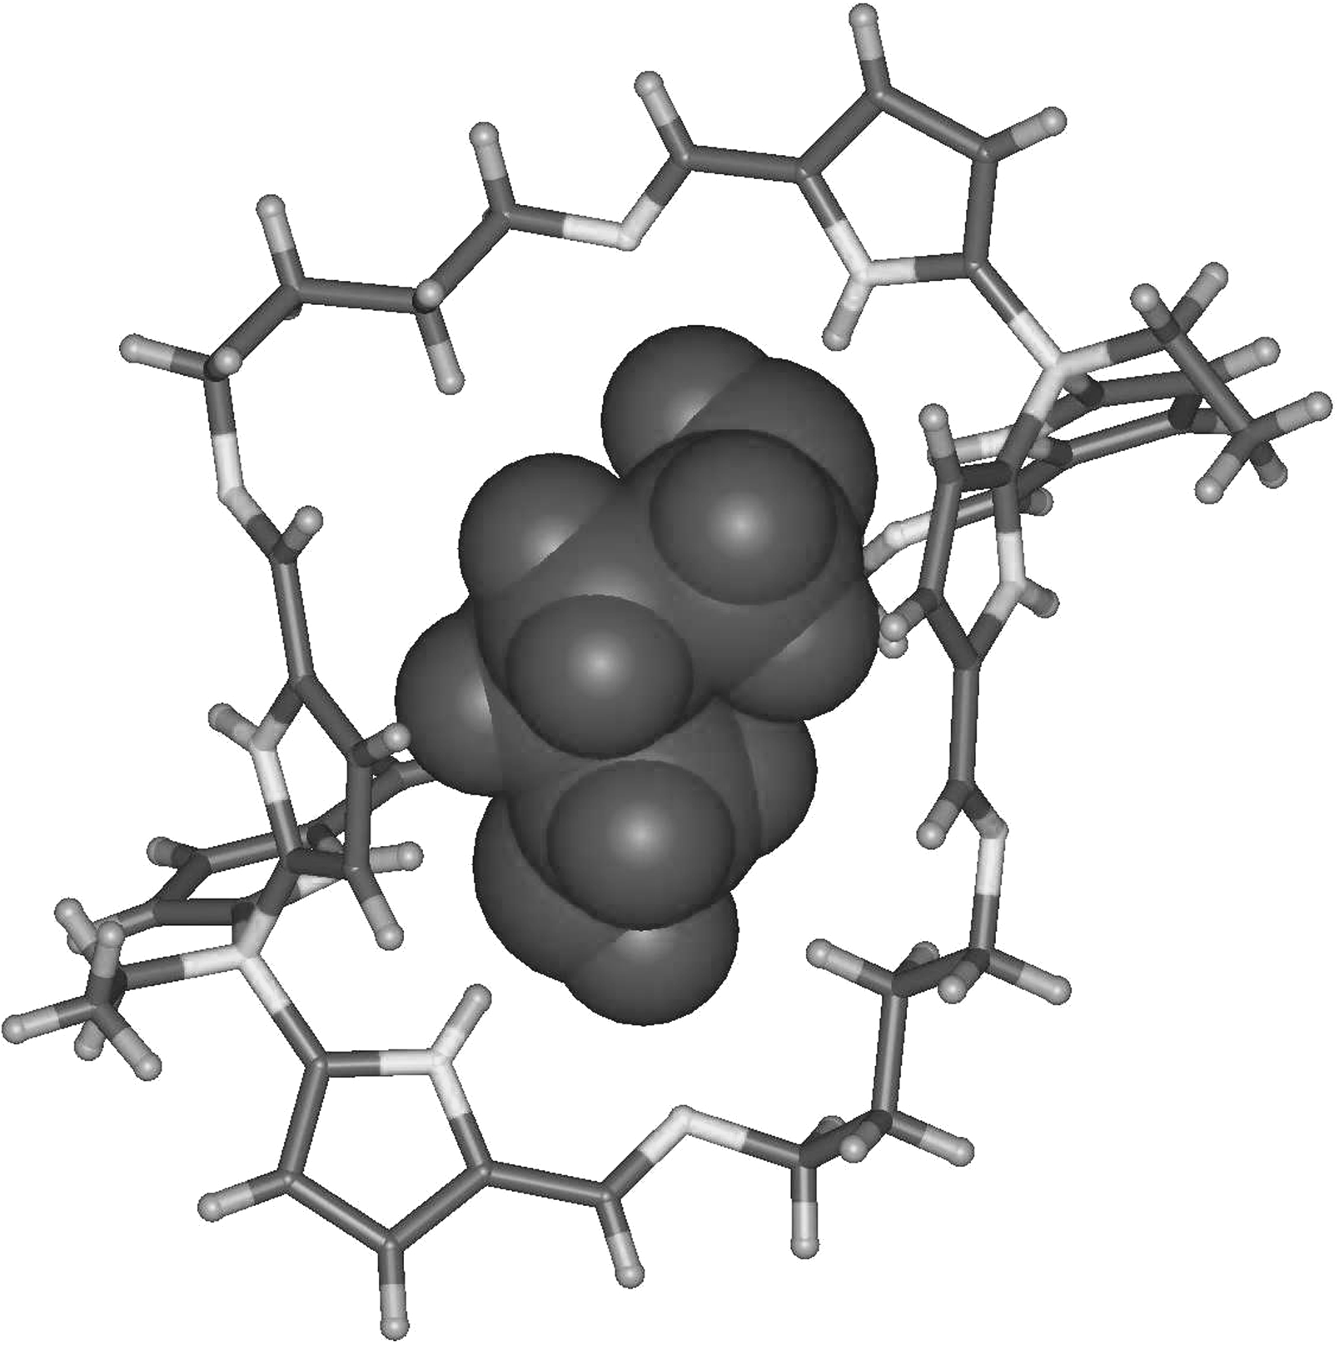

A CPK-guest and wire-frame-host model of 7.bn based on the crystal structure coordinates.

