Supplementary information
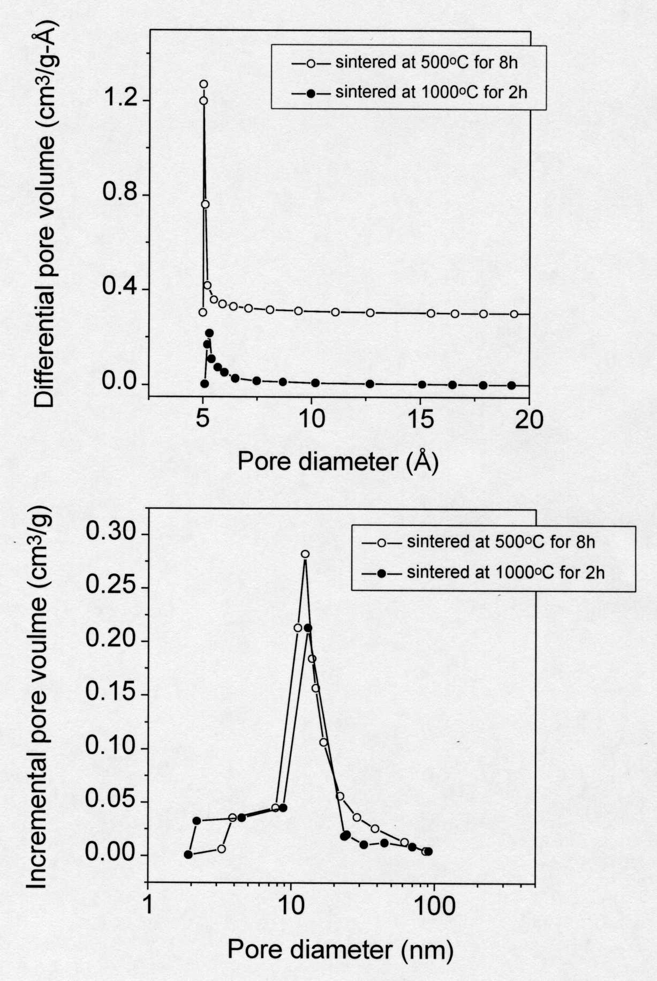
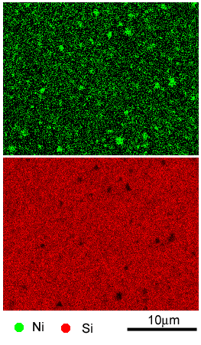

S-Figure 1. Pore size distribution of hierarchical tubular silicalite structure (HTSS) measured by N₂ adsorption-desorption. Top: micropore size distribution calculated with HK method, and bottom: mesopore size distribution calculated with BJH method.

Nickel was incorporated into hierarchical zeolite structures by the following procedure. Nickel nitrate hexahydrate was dissolved into ammonia hydroxide aqueous solution to form ammonia-coordinated Ni complex, which prevents precipitation of nickel hydroxide in colloidal silicalite suspension that is weakly alkaline (pH=7-8). Ammonia-coordinated Ni complex was added into the colloidal suspension with a weight ratio of NiO: SiO₂ =15:85. Then the same gelcasting procedure was followed. The dried gelcast with nickel was calcined at 500°C for 8h under air to obtain NiO. Ni doped silicalite structure was obtained by reduction of NiO under H₂ at 400°C for 24h. Elemental mapping technique was used to study Ni distribution in the silicalite matrix. The Ni-doped HTSS was cut and a small piece (2-3 mm) was imbedded into an epoxy matrix. The sample was polished sequentially with sand paper and eventually with 0.02 μm diameter alumina suspension. As expected, Ni and Si mapping images (S-Figure 2) clearly show Ni (light green dots) is uniformly distributed in the silicalite matrix (red dots stand for Si).

S-Figure 2. Nickel and silicon element mapping images of nickel-doped silicalite structure.

