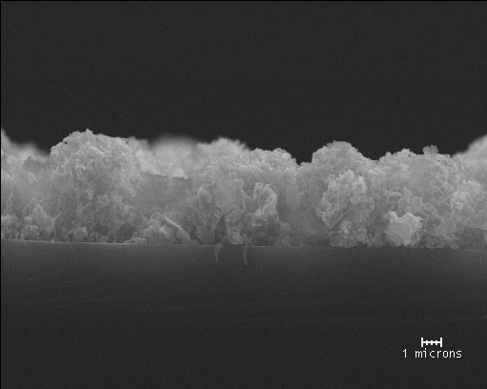
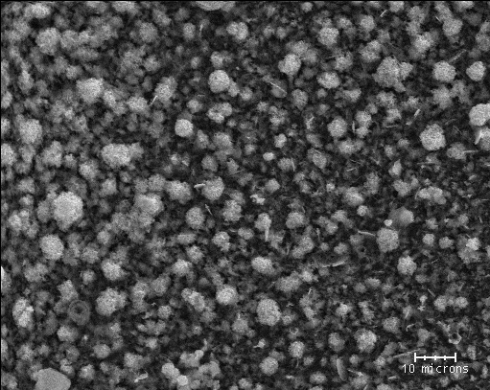
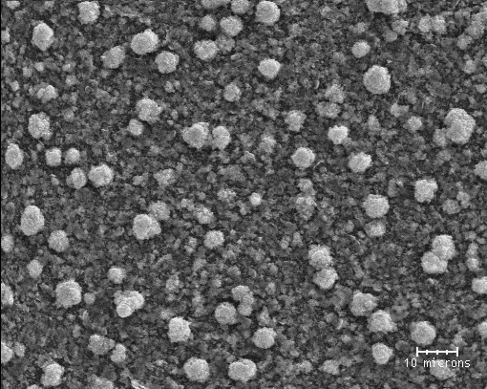
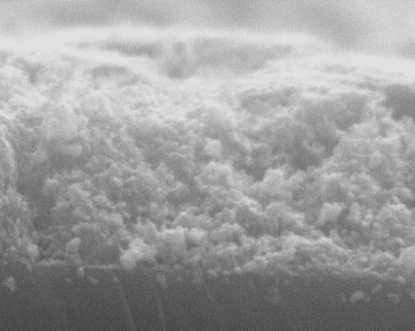
(a)
(b)
(c)
(d)
1 microns

Figure S6. Cross-sectional and plan SEM views of ZnO film prepared by process 1 [(a), (b)] and process 2 [(c), (d)]. The scale bars are 1 micron in (a) and (c) and10 microns in (b) and (d).

