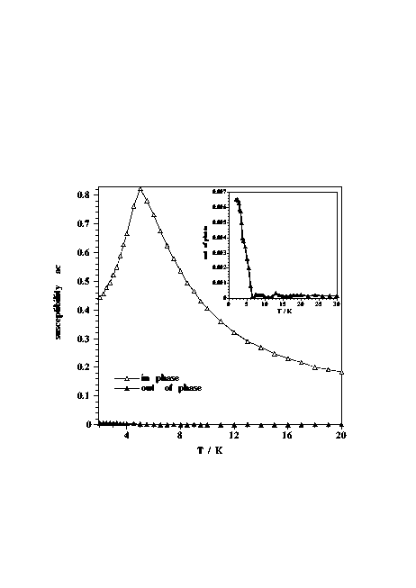
This figure indicates an out-of-phase signal (AC measurements) occurs at ca. 5 K. In-phase (open triangle) and out-of-phase (filled triangle).

