General experimental details

All experiments were carried out in a dry nitrogen atmosphere using an MBraun glovebox and/or standard Schlenk techniques. 4A molecular sieves were activated in vacuo at 180 ºC for 24 h. Dry toluene was purchased from Aldrich and was stored over activated 4A molecular sieves. Benzene, diethyl ether, tetrahydrofuran (THF) and pentane were distilled before use from sodium/benzophenone and dichloromethane was distilled from calcium hydride. All deuterated solvents were sparged with nitrogen, dried over activated 4A molecular sieves and stored under nitrogen. ¹H and ¹³C NMR spectra were recorded on Mercury Varian 300 MHz spectrometer (300 and 75.4 MHz, respectively) at 25 °C unless otherwise noted. The NMR spectra were indirectly referenced to TMS using residual solvent signals as internal standards. Infrared spectra were recorded on a Perkin Elmer Spectrum One FTIR spectrometer using an attenuated internal reflectance sample holder and UV-Vis spectra taken with an Agilent 8453 diode array spectrometer.
CuBr was obtained from Strem, TlOAc and styrene from Acros, and SMe₂ from Aldrich; all were used as received. A suspension of KH in mineral oil obtained from Aldrich was thoroughly washed with pentane and dried in vacuo to afford dry, powdered KH used in the synthesis of Tl[Me₂NN]. O₂ obtained from MG Industries was passed through a drying tube packed with CaCl₂ immediately before use. CuBr•SMe₂¹ and 2,4-bis(2,6-dimethylphenyllimido)pentane (H[Me₂NN])² were synthesized according to literature procedures.

Synthesis of Tl[Me₂NN] and 1-3 with corresponding analytical and spectroscopic details

Tl[Me₂NN]. Dry, powdered KH (1.35 g, 31.3 mmol) was added with stirring to a solution of H[Me₂NN] (7.15 g, 23.3 mmol) in 50 mL THF. Slow evolution of H₂ ensued and the reaction mixture was stirred overnight. After filtering through Celite to remove excess KH, TlOAc (6.14 g, 23.3 mmol) was added to the clear yellow filtrate and the solution turned immediately dark. After stirring overnight, the volatiles were removed in vacuo and the residue was extracted with ether (50 mL) and filtered through Celite. The filtrate was concentrated and then allowed to stand at –35˚C. The yellow crystals that had formed were collected on a frit, washed with cold ether and dried in vacuo to afford 10.0 g (84.1%) of the product. ¹H NMR (C₆D₆): δ 7.08 - 6.91 (m, 6, Ar-H), 4.822 (s, 1, backbone-CH), 2.137 (s, 12, Ar-CH₃), 1.673 (s, 6, backbone-CH₃); ¹³C{¹H} NMR (C₆D₆): δ 161.69, 150.05, 130.91, 128.58, 123.58, 99.92 (³J_{Tl-C} = 44.7 Hz, backbone-CH), 24.76 (⁴J_{Tl-C} = 9.4 Hz, Ar-CH₃), 19.20 (³J_{Tl-C} = 43.4 Hz, backbone-CH₃).
[Me₂NN]Cu(C₂H₄) (1). Powdered CuBr•SMe₂ (0.19 g, 0.94 mmol) was added to a solution of Tl[Me₂NN] (0.48 g, 0.94 mmol) in 20 mL toluene at room temperature and the reaction mixture was subsequently stirred under ethylene (1 atm) for 2h. The volatiles were removed in vacuo and the residue was extracted with ether (15 mL) and the extracts filtered through Celite. The filtrate was diluted with acetonitrile, concentrated, and cooled to –35 ˚C to afford 0.29 g (77%) of a light yellow powder. Recrystallization from pentane afforded light yellow crystals of 1 • 0.5 pentane suitable for X-ray diffraction. ¹H NMR (C₆D₆): δ 7.05 - 6.94 (m, 6, Ar-H), 4.938 (s, 1, backbone-CH), 2.919 (s, 4, C₂H₄), 2.127 (s, 12, Ar-CH₃), 1.649 (s, 6, backbone-CH₃); ¹³C{¹H} NMR (C₆D₆): δ 162.57, 151.75, 130.06, 128.19, 123.48, 94.75 (¹J_{CH} = 156 Hz, backbone-CH), 74.74 (¹J_{CH} = 158 Hz, C₂H₄), 22.51 (backbone-Me), 19.02 (Ar-CH₃). Due to facile but incomplete loss of solvated pentane, elemental analysis results were not reproducible.
[Me₂NN]Cu(styrene) (2). Powdered CuBr•SMe₂ (0.19 g, 0.94 mmol) was added to a solution of Tl[Me₂NN] (0.48 g, 0.94 mmol) in 15 mL benzene and styrene (0.12 g, 1.2 mmol) was added to the suspension. After stirring overnight, the volatiles were removed in vacuo and the residue was extracted with pentane (15 mL) and filtered through Celite. The filtrate was concentrated and cooled to –35˚C to afford 0.28 g (62 %) of pale yellow crystals. Recrystallization from pentane afforded pale yellow crystals of 2 suitable for X-ray diffraction. ¹H NMR (C₆D₆): δ 6.87 – 6.97 (m, 6, Ar-H), 6.45 (m, 2, styrene o-H), 4.986 (s, 1, backbone-CH), 4.47 (dd, ³J_{HH} = 15.0 and 9.3 Hz, CH=CH₂), 3.30 (dd, ³J_{HH} = 15.0 Hz and ²J_{HH} = 1.5 Hz 1, CH=CH₂), 3.00 (dd, ³J_{HH} = 9.3 Hz and ²J_{HH} = 1.5 Hz, 1, CH=CH₂), 2.218 (br, 6, Ar-CH₃), 1.734 (br, 6, Ar-CH₃), 1.591 (s, 6, backbone-CH₃); ¹³C{¹H}NMR (C₆D₆): δ 162.66, 151.09, 137.61, 130.82, 130.27, 128.58, 128.37, 128.32, 126.70, 125.53, 123.41, 94.87 (¹J_{CH} = 156 Hz, backbone-CH), 92.39 (¹J_{CH} = 154 Hz, CH=CH₂), 67.08 (¹J_{CH} = 155 Hz, CH=CH₂), 22.73 (backbone-CH₃), 19.170 (Ar-CH₃), 18.355 (Ar-CH₃). Anal. Calcd for C₂₉H₃₃N₂Cu: C, 73.62; H, 7.03; N, 5.92. Found: C, 73.50; H, 7.02; N, 6.05.
The activation barrier for styrene rotation in 2 was calculated using the following partial ¹H NMR data (toluene-d₈, 203 K): δ 2.197 (s, 3, Ar-CH₃), 2.152 (s, 3, Ar-CH₃), 2.118 (s, 3, Ar-CH₃), 1.574 (s, 3, backbone-CH₃), 1.489 (s, 3, backbone-CH₃), 1.195 (s, 3, Ar-CH₃). Coalescence of the backbone-CH₃ peaks at δ 1.574 and 1.489 (Δv = 25.5 Hz, T_{c} = 215 K) corresponds to an activation barrier ΔG≠ = 10.7(3) kcal / mol at 215 K.
Addition of styrene to [Me₂NN]Cu(C₂H₄) (1). Styrene (8.8 mg, 8.8 μL, 0.077 mmol) was added to a solution of 1 (30 mg, 0.076 mmol) in 1.0 mL of benzene-d₆ and an aliquot (ca. 0.7 mL) was rapidly transferred to an NMR tube that was sealed with a Teflon stopper. Formation of 2 and free ethylene was immediately apparent by ¹H NMR analysis and the reaction mixture was monitored every hour at room temperature until no further change in the relative concentrations of 1, 2, ethylene, and styrene was detected. After 3h, an equilibrium mixture of 1 and 2 in the ratio of 1:2.3 was reached. Accounting for the relative concentrations of ethylene and styrene in solution, however, afforded the equilibrium constant K_{eq} = 0.33(2) at room temperature for the exchange reaction below (eq 1).
{[Me₂NN]Cu}₂(μ-OH)₂ (3). With a syringe, 35 mL (1.56 mmol) of dry O₂ was slowly bubbled into a solution of 1 (0.39 g, 0.98 mmol) in 20 mL diethyl ether at room temperature. The solution turned increasingly dark and a brown microcrystalline solid began to precipitate immediately. The solid was isolated via filtration and was washed with both ether and pentane to afford 0.31 g (83 %) of the product. Crystals of 3 for X-ray diffraction were obtained via slow diffusion of dioxygen into an ethereal solution of 1. ¹H NMR (C₆D₆, partial data, all signals broad): δ 9.7, 7.9, 2.3, -3.7; μ_{eff} = 1.39 B.M. (CDCl₃); IR (solid, cm⁻¹) 3646 (O-H); UV-Vis (CH₂Cl₂, c = 0.039 mM): λ_{max} (nm) 343 (ε = 2.4 × 10⁴ M⁻¹cm⁻¹).

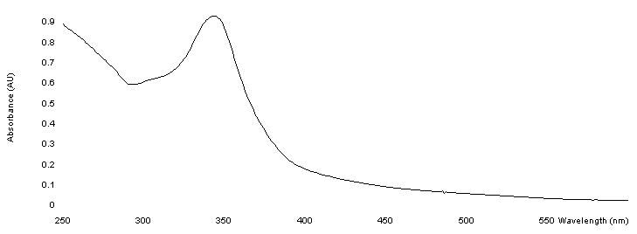
Fig. 1 UV-Vis spectrum of 3 (CH₂Cl₂, 25 °C).

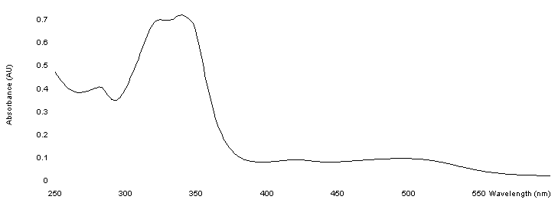

Fig. 2 UV-Vis spectrum (CH₂Cl₂, 25 °C) of a solid mixture of 3 with proposed μ-oxo intermediate 4 that was prepared by addition of O₂ to 1 at –78 °C and then immediately isolated.

Fig. 3 UV-Vis spectrum of 1 with added air (THF, 25 °C) – first 15 minutes (note increasing absorbances at 315 and 420 nm).

Fig. 4 UV-Vis spectrum of 1 with added air (THF, 25 °C) – after 40 minutes (note decreasing absorbances at 315 and 420 nm).

References

H. O. House, C.-Y. Chu., J. M. Wilkins and M. J. Umen J. Org. Chem. 1975, 40, 1460.
2 H[Me₂NN] was prepared in an identical fashion to the more sterically hindered 2,4-bis(2,6-diisopropylphenyllimido)pentane: J. Feldman, S. J. McLain, A. Parthasarathy, W. J. Marshall, J. C. Calabrese and S. D. Arthur, Organometallics 1997, 16, 1514.

