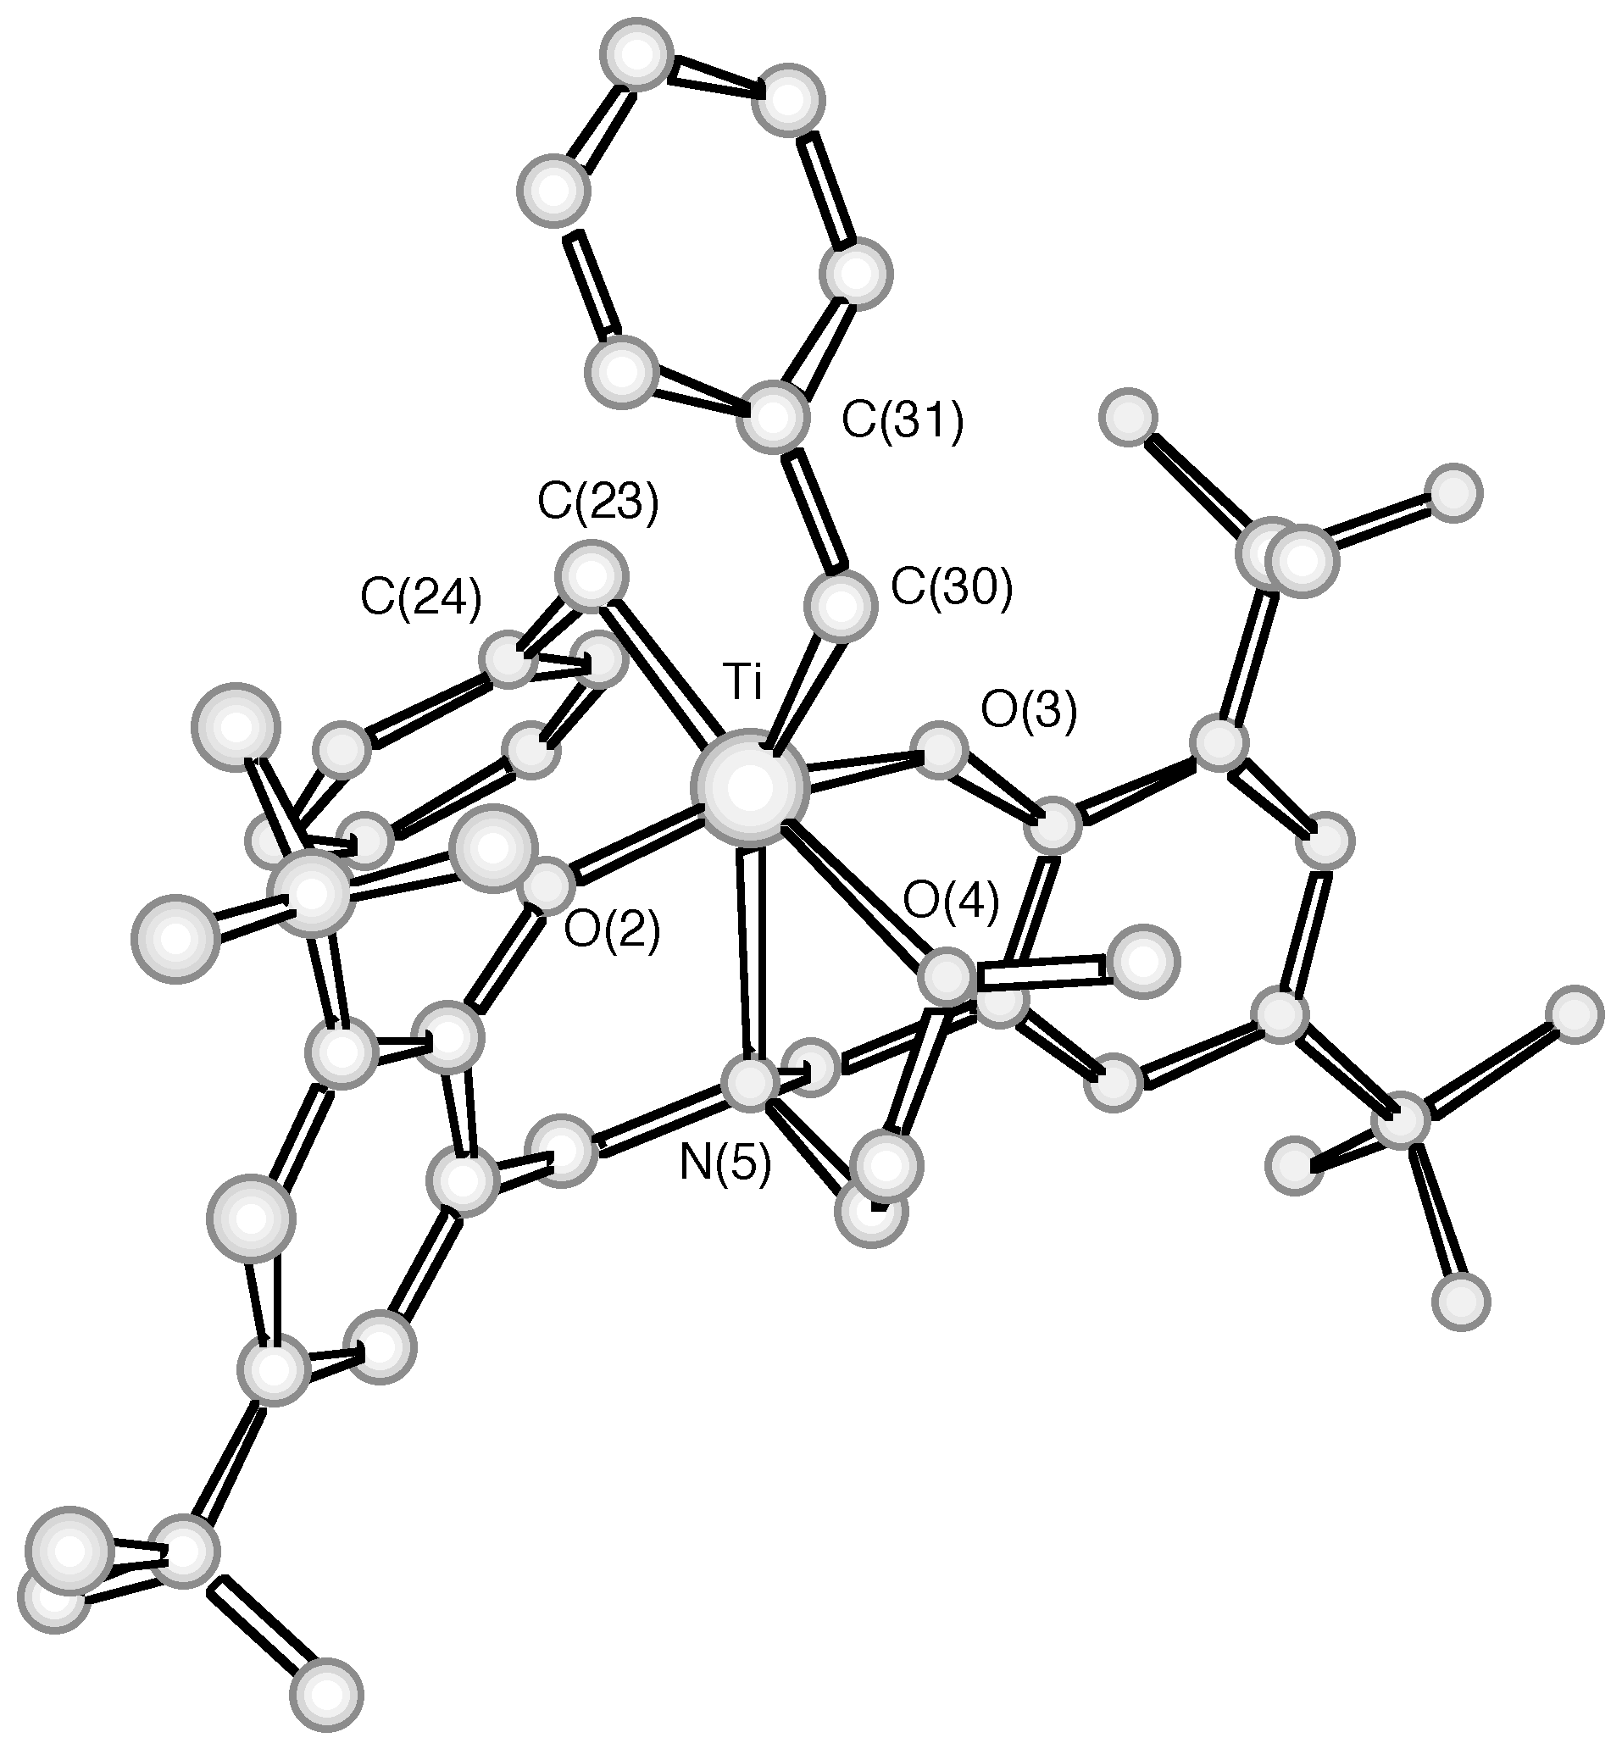
Fig. 1 Molecular structure of 1a (bond lengths (Å) and angles (°)) (H atoms, crystallization solvent and disorder omitted for clarity): Ti-O(2) 1.865(2), Ti-O(3) 1.865(2), Ti-O(4) 2.433(2), Ti-N 2.366(2), Ti-C(23) 2.141(3), Ti-C(30) 2.180(2); O(2)-Ti-O(3) 163.92(7), N-Ti-O(4) 72.03(6), C(30)-Ti-C(23) 92.3(1), Ti-C(23)-C(24) 104.8(2), Ti-C(30)-C(31) 118.3(2).

