Supplementary Materials

Solid State Coordination Chemistry: Construction of 2D Networks and 3D Frameworks from Phosphomolybdate Clusters and Binuclear Cu(II) Complexes. The Syntheses and Structures of [{Cu₂(tpypyz)(H₂O)₂}Mo₅O₁₅(HOPO₃)₂]·nH₂O (n = 2 and 3; tpypyz = tetra(2-pyridyl)pyrazine)

Eric Burkholder and Jon Zubieta
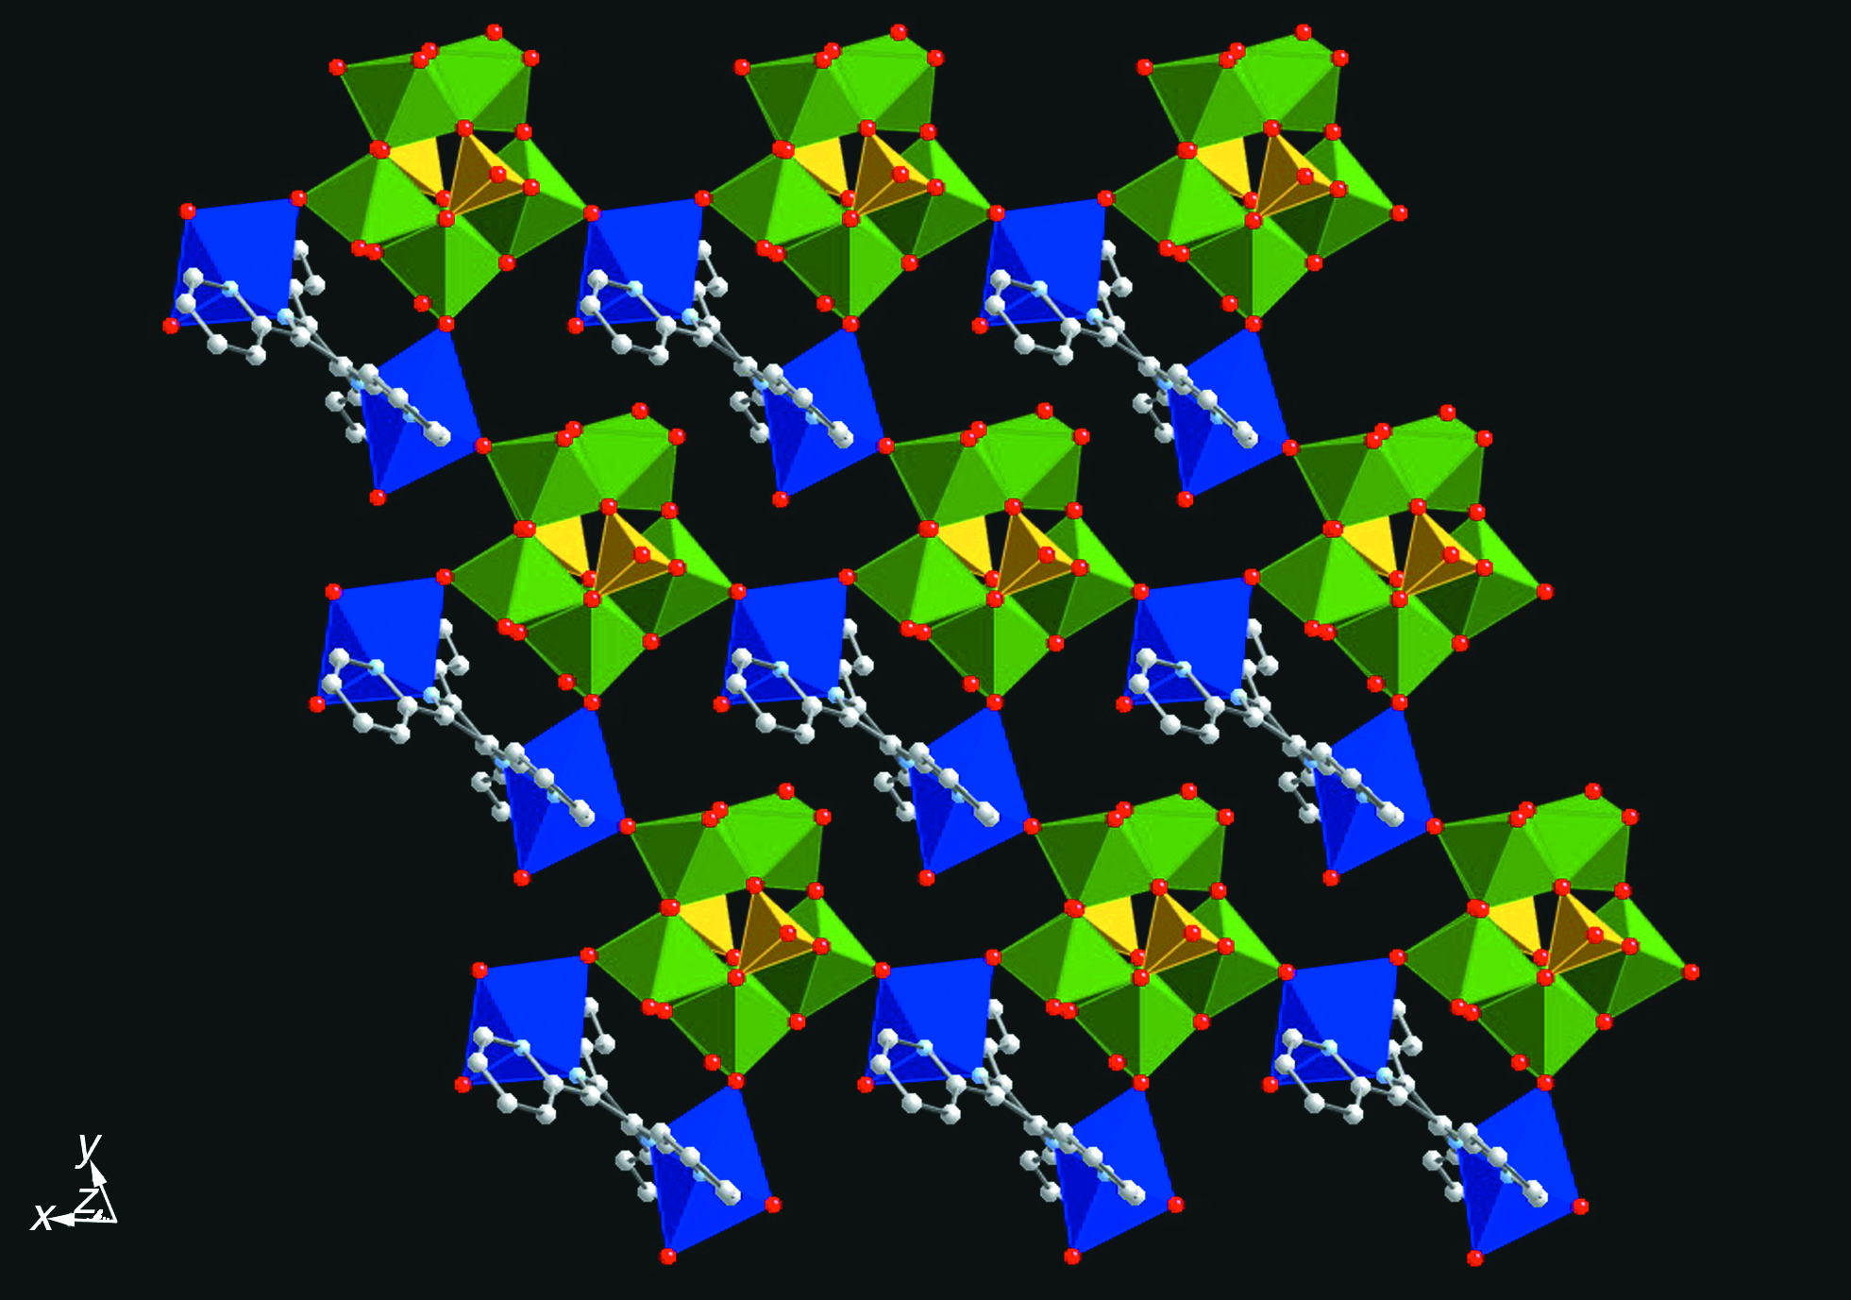
Fig. 1 Polyhedral view of the network structure of 1·2H₂O parallel to the crystallographic c axis. Color scheme: molybdenum, green; copper, blue; phosphorus, yellow; carbon, gray spheres; nitrogen, blue spheres; oxygen, red spheres.

