Supplementary Materials

Solid State Coordination Chemistry: Construction of 2D Networks and 3D Frameworks from Phosphomolybdate Clusters and Binuclear Cu(II) Complexes. The Syntheses and Structures of [{Cu₂(tpypyz)(H₂O)₂}Mo₅O₁₅(HOPO₃)₂]·nH₂O (n = 2 and 3; tpypyz = tetra(2-pyridyl)pyrazine)

Eric Burkholder and Jon Zubieta
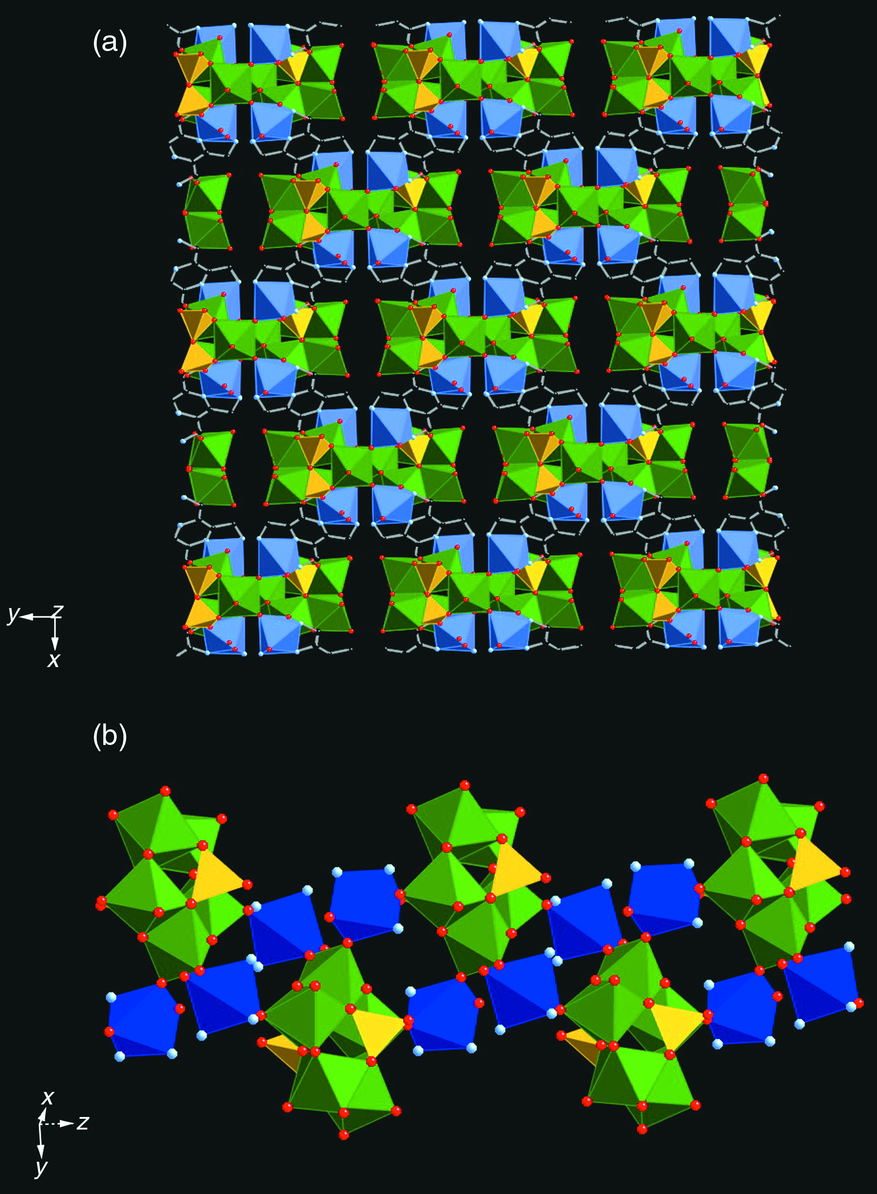
Fig. 2 (a) Polyhedral representation of the 3D structure of 2·3H₂O viewed parallel to the c axis. (b) View of the 1D chain {Cu₂Mo₅O₁₅(HOPO₃)₂} substructure of 2. Color scheme as for Fig. 1.

