SUPPLEMENTARY INFORMATION

1) Experimental procedure
The SPG sample (M_{w} = 450000) was kindly supplied by Taito Co., Japan and it was used without further purification. SPG (100 mg) was dissolved in distilled water. NaIO₄ solution (0.04 equivalent against the side chain of SPG) was poured into the SPG solution. The mixture was stirred for 2 days at 4 ˚C. After dialysis with water, it was lyophilized.
The white solid thus obtained by lyophilization was dissolved in DMSO and added 2-aminoethanol 2 ml into the solution. The solution was stirred for 2 days at room temperature. Then, NaBH₄ (excess) was added into the solution and stirred for 1 day. Excess NaBH₄ was quenched by AcOH and dialyzed in acidic water, basic water, and then distilled water. After the solution was lyophilized, the resultant SPG was modified with the amino groups. The content of the introduced amino group was identified by nitrogen elemental analysis, which was estimated to be 2.1 – 2.8 %.
All samples for spectral measurements were prepared by mixing a poly(C)/water with a s-SPG/DMSO solution, according to a reported method. Thus prepared mixture was left at 4 ˚C for 1 day to allow the complexation to complete. The final concentrations were controlled as follows; V_{w}=0.92, poly(C)=2.55×10⁻⁴ mol dm⁻³ (monomer unit), [s-SPG]=2.57×10⁻³ mol dm⁻³ (glucose unit), [Tris]=0 - 0.08 mol dm⁻³ (pH 8.0).

2) Tris concentration dependence of [θ]₂₄₂ of +N-s-SPG.

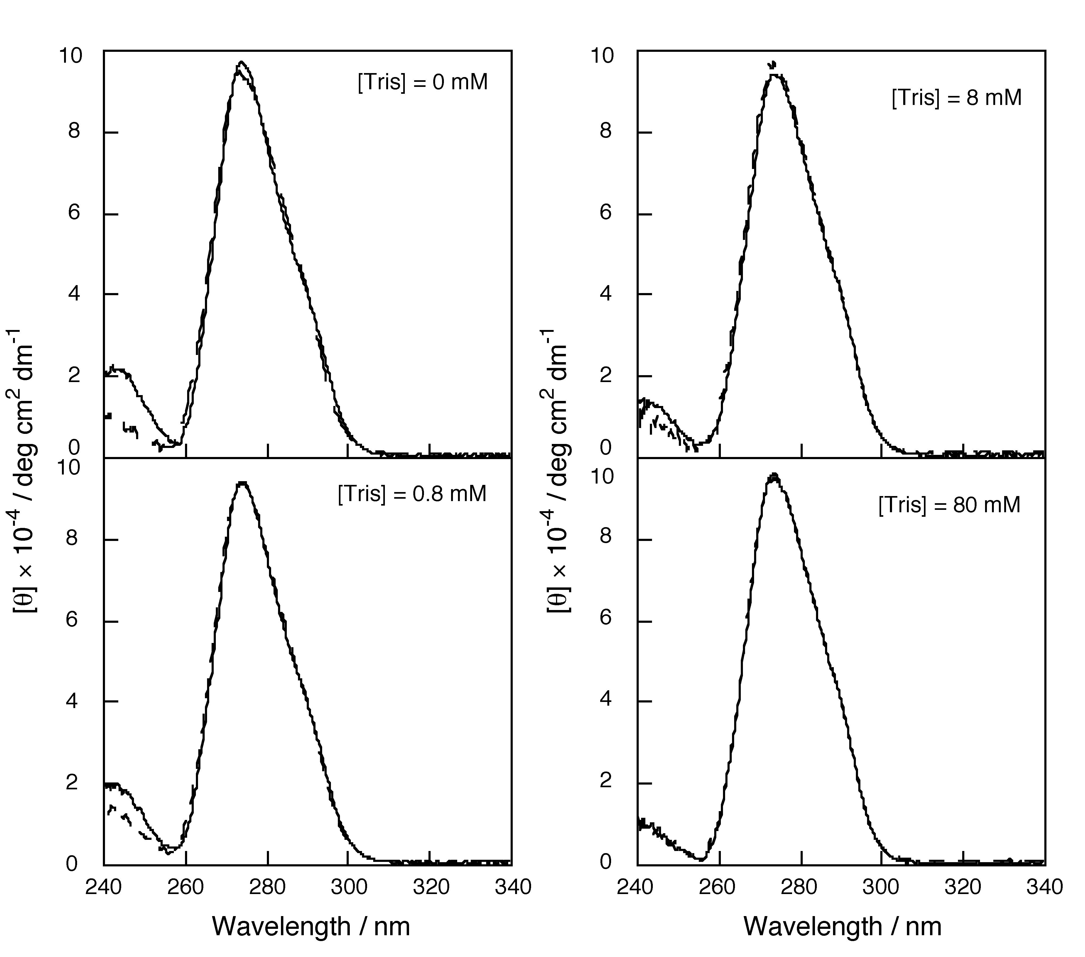

Fig. S1 Comparison of the CD spectra between +s-SPG and +N-s-SPG with increasing Tris concentration. Solid line: +N-s-SPG, dash line: +s-SPG.

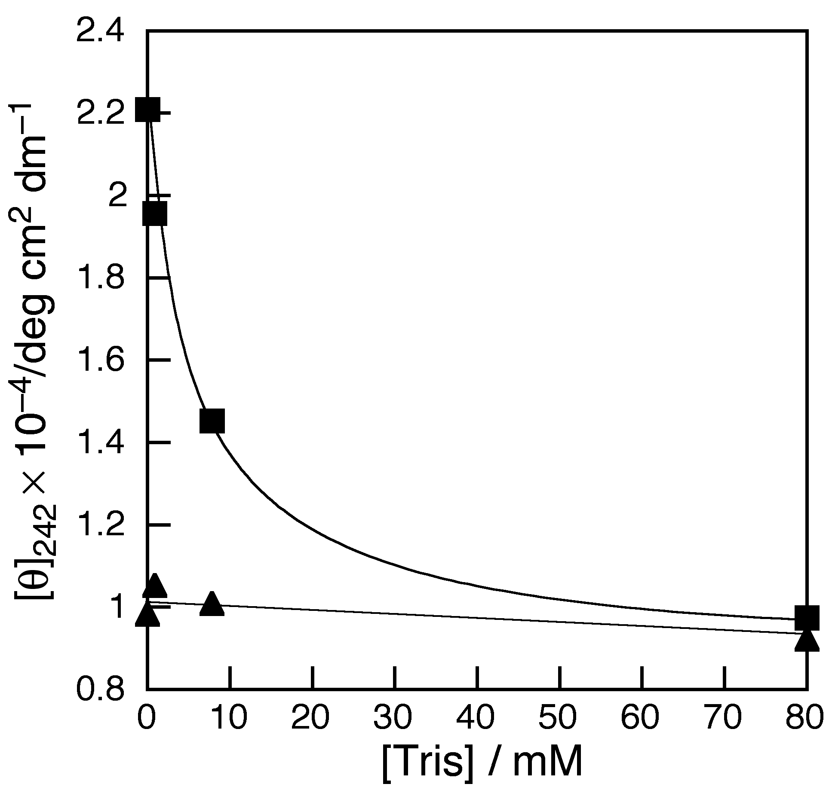
Fig. S2 Tris concentration dependence of [θ]₂₄₂ for +s-SPG (H) and +N-s-SPG (B).

