Supplementary information

1a : ¹H NMR (200 MHz, CDCl₃): δ = 1.38-1.68(m,24H, cyclohexyl), 1.88-2.12(m,16H, cyclohexyl), 5.86 (br.d, 8H; pyrrole-βH),6.95 (br.s, 4H, pyrrole NH), ¹³C NMR (50 MHz,CDCl₃): δ = 22.75, 26.04, 37.17, 39.63, 103.44 (pyrrole-βH), 136.50(pyrrole-αH); HR-MS(EI) for C₄₀H₅₂N₄ (M^{+.}): calcd:588.4191; found: 588.4169.
1b : ¹H NMR (200 MHz, CDCl₃): δ = 1.36-1.65(m,6H, cyclohexyl),1.95-2.12(m,4H,cyclohexyl),6.01-6.12(m,4H,pyrrole-βH), 6.45(br.d, 2H; pyrrole-αH), 7.32-7.68(br.s, 2H, pyrrole NH);¹³C NMR(50 MHz,CDCl₃):δ = 22.17,26.32,37.65,41.21,104.64, 108.27,116.99,139.21; HR-MS(EI) for C₁₄H₁₈N₂ (M^{+.}): calcd:214.1469; found: 214.1460.
1d: HR-MS (EI) for C₃₄H₄₄N₄ (M^{+.}):calcd: 508.3546; found = 508.3565.
2a: ¹HNMR (200 MHz, CDCl₃) : δ= 1.55-1.8 (m, 16H, cyclopentyl), 1.85-2.01 (m, 16H, cyclopentyl), 5.8 (br, d, J=0.38 Hz, 8H, pyrrole-βH),7.0 (br, s, 4H, pyrrole-NH); ¹³C NMR: ( 50 MHz, CDCl₃): 23.91,39.02, 46.93, 103.04 (pyrrole-βH),137.20 (pyrrole-αH),; HR-MS (EI) for C₃₆H₄₄N₄ (M^{+.}): calcd: 532.3565, found: 532.6575.
3a: ¹HNMR (200 MHz, CDCl₃): δ= 1.45-1.72 (m, 32H, cycloheptyl), 1.94-2.12 (m,16H, Cycloheptyl), 5.83 (br, d,8H, pyrrole-βH), 6.78-6.88 (br,s,4H,NH); ¹³C NMR: ( 50 MHz, CDCl₃): 23.23,29.67,39.45,42.88, 103.06 (pyrrole-βH),138.33(pyrrole-αH),;HR-MS (EI) for C₄₄H₆₀N₄ (M^{+.}): calcd: 644.4817, found: 644.4752.
3b: ¹HNMR (200 MHz, CDCl₃): δ=2.12-2.26(m,8H,cycloheptyl), 2.42-2.58 (m,4H, cycloheptyl), 6.01-6.13 (m, 4H,pyrrole-βH), 6.52-6.61 (m,2H, pyrrole-αH),7.51-7.71 (br,s,2H, pyrrole-NH),; HR-MS (EI) for C₁₅H₂₀N₂ (M^{+.}): calcd: 228.1626, found 228.1616.
4a: ¹HNMR (200 MHz, CDCl₃): δ=1.18-1.82 (m, 56H, cyclooctyl), 5.93 (br,d,8H, pyrrole-βH), 6.91-6.99 (br,s,4H, pyrrole-NH); ¹³C NMR: ( 50 MHz, CDCl₃): 22.33, 25.04, 28.51, 33.59, 42.89, 104.10 (pyrrole-βH), 137.18(pyrrole-αH),; HR-MS (EI) for C₄₈N₆₈N₄ (M^{+.}): calcd; 700.5443, found: 700.5456.
4b: ¹HNMR (200 MHz, CDCl₃): δ=1.42-1.80(m,10H, cyclooctyl), 2.09-2.21(m,4H, cyclooctyl), 5.99-6.16 (m,4H,pyrrole-βH), 6.48-6.57 (m,2H,pyrrole-αH),7.42-7.69(br,s,2H,pyrrole-NH),; HR-MS(EI) for C₁₆N₂₂N₂ (M^{+.}): calcd: 242.1782, found: 242.1777.
5a: ¹HNMR (200 MHz, CDCl₃): δ=0.88-0.98(d,12H,CH₃),1.21-2.18 (m ,36H,cyclohexyl),6.22-5.74(m,8H,pyrrole βH), 6.92(br,s,4H, pyrrole-NH); HR-MS (EI) for C₄₄H₆₀N₄ (M^{+.}): calcd: 644.4817, found 644.4847.
5b: ¹HNMR (200 MHz, CDCl₃): δ=0.8(d,3H,J(H,H)=7.2 Hz,CH₃), 1.24-2.34(m,9H,cyclohexyl), 6.01-6.14 (m,4H,pyrrole-βH), 6.42-6.54 (m,2H ,pyrrole-αH),7.48(br,s,2H,pyrrole-NH); HR-MS (EI) for C₁₅H₂₀N₂ (M^{+.}): calcd: 228.1626, found:228.1634.
6a: ¹HNMR (200 MHz, CDCl₃): δ=1.34-2.16(m,32H,CH₃,Cyclohexyl), 5.98(d,2H,pyrrole-βH), 6.08(d,2H, pyrrole-βH), 6.46-6.58(br s,2H,pyrrole-NH), 6.84(br,s,2H,pyrrole-NH); m/z (EI) : 508, 442, 361,295,228.
7a: ¹HNMR (200 MHz, CDCl₃): δ= 1.49 (s, 24H, -CH₃), 5.85 (br, d, 8H; (pyrrole-βH), 6.89-6.99 (br, S, 4H, pyrrole-NH); ¹³C NMR (50 MHz,CDCl₃): δ = 29.07, 35.23, 102.83 (pyrrole-βH), 138.48 (pyrrole-αH) HR-MS(EI): for calcd for C₂₈ H₃₆ N₄ (M^{+.}): calcd: 428.2939; found:428.2938.
8a: HR-MS (EI) for C₄₀H₅₂N₄O₈ (M^{+.}): calcd: 716.3785, found: 716.3791
9a: ¹HNMR (200 MHz, CDCl₃): δ= 0.63-0.80(t, J(H,H)=2Hz, 12H), 1.34-1.48 (br, s, 12H, -CH₃), 1.86-1.96 (q, 8H, CH₂CH₃), 5.85 (br, d, 8H), 6.89-7.09 (br, s, 4H, NH); ¹³C NMR ( 50MHz, CDCl₃): 8.65,26.04, 33.21, 39.18, 103.75(pyrrole-βH), 137.26 (pyrrole-αH); HR-MS (EI) for C₃₂H₄₄N₄ (M^{+.}): calcd: 484.3565, found: 484.3561.
10a: ¹HNMR (200 MHz, CDCl₃): δ= 0.51-0.71(t, J(H,H)=2Hz,24H, CH₂CH₃),1.62-1.79(q,16H, CH₂-CH₃), 5.85-5.93 (br, d, J (H,H)=2.27 Hz, 8H, pyrrole-βH), 6.96-7.05 (br, s, 4H, pyrrole-NH); HR-MS (EI) for C₃₆H₅₂N₄ (M^{+.}): calcd: 540.4191, found:540.4194.
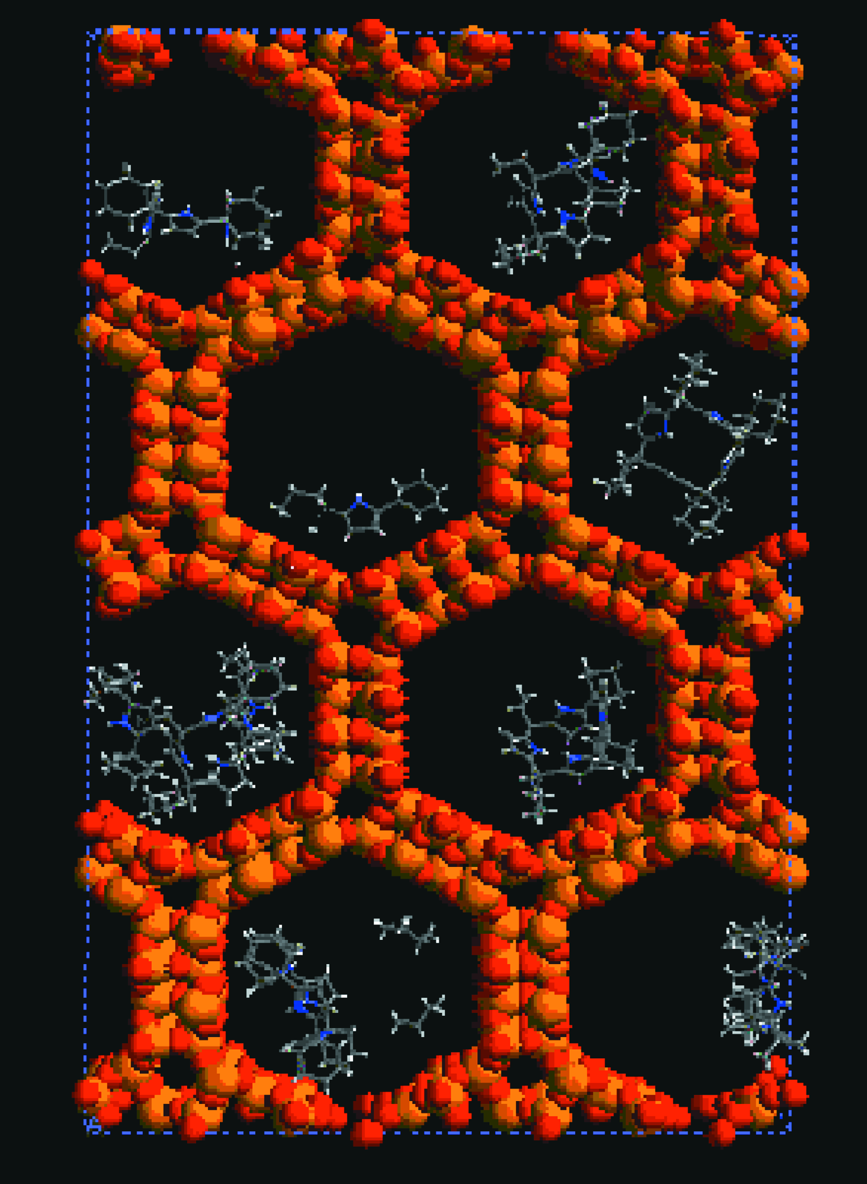

Fig. 1 Cross-sectional view of the supercell of Al-MCM-41 in which relative orientations of 1a and other molecules are seen.

