Figure S1

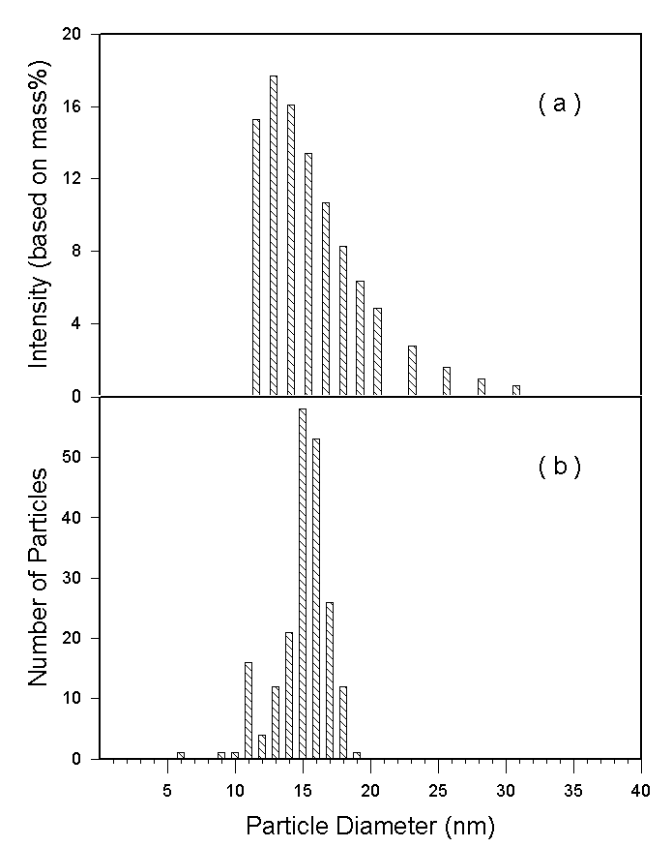

Figure S1. Size histogram of bismuth nanocrystallites determined using (a) dynamic light scattering technique and (b) TEM image.

