Electronic Supplementary Information for:

Colloidal Cobalt Nanoparticles: A Highly Active and Reusable Pauson-Khand Catalyst
Sang-Wook Kim,ª Seung Uk Son,^{b} Su Seong Lee, ª
Taeghwan Hyeon* ª and Young Keun Chung* ^{b}

1. Experimental Details for the catalytic Pauson-Khand reactions
In a typical reaction, the enyne shown in Equation 1 (0.10 g, 0.42 mmol) and colloidal cobalt nanoparticles (25 mg, 45 wt% cobalt) in 5 mL of THF was heated under CO pressure of 5 atm at 130°C for 12 h. After the reaction mixture was cooled to room temperature, 5 mL of MeOH was added to get a black precipitate. The precipitated cobalt nanoparticles were removed by filtration. The final cyclopentenone product was obtained by column chromatography on a silica gel eluting with 10:1 volume ratio of hexane and diethyl ether. For the recycling experiments, the retrieved powder form of the cobalt nanoparticles was re-dispersed in THF and was applied as catalyst.

2. Transmission electron micrographs (TEM) of colloidal cobalt nanoparticles before the reaction (a) and after running four reaction cycles (b).

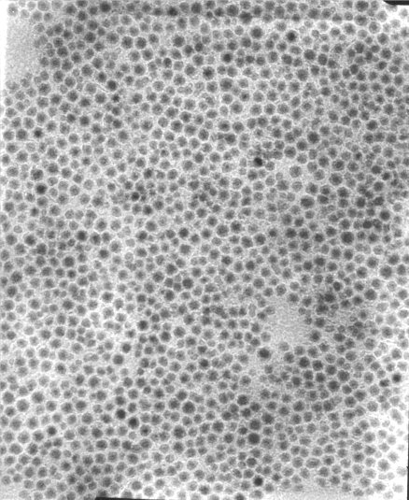
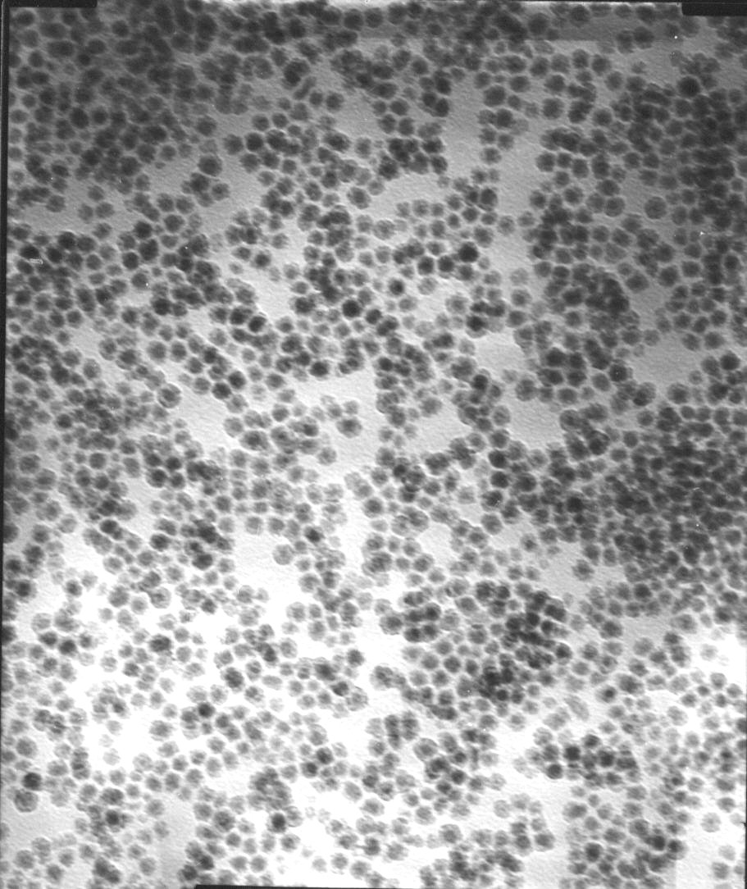
20 nm
20 nm

(a) (b)

