Electronic Supplementary Material (ESI)
SIZE QUANTIZED FORMATION AND SELF-ASSEMBLY OF GOLD ENCASED SILVER NANOPARTICLES

Eliza Hutter and Janos H. Fendler
Center for Advanced Materials Processing, Clarkson University,
Potsdam, NY 13699-5814, USA, e-mail: fendler@clarkson.edu

EXPERIMENTAL:

Gold chloride trihydrate, sodium citrate, EDTA, (Sigma), aminobutyldimethylmethoxy-silane (United Chemical Technologies, Inc.), sulfuric acid, hydrogen peroxide (30%), sodium hydroxide, (FISHER), silver nitrate (Spectrum, Chemical Mfg) were used as received. Fisher finest premium microscope slides (BK7, 3' x 1") were purchased from Fisher Scientific. The nylon bottle-top filter system with the pore size of 0.2 m (Corning) was obtained from Fisher. Ultrapure water, with resistivity greater than 18.3 /cm² was obtained from a Millipore Milli-QTM colums system provided with a Milli-pak filter of 0.22 m pore size at the outlet.
Thiocyanate coated 2.80.8 nm diameter gold nanoparticles were prepared by mixing 50 mL of 0.01 % HAuCl₄ and 0.75 mL of 0.2 M K₂CO₃ at room temperature. Under vigorous stirring 0.3 mL of 1.0 M NaSCN was added to this solution. Subsequent to the prompt development of a yellowish color the colloid was allowed to incubate at room temperature for 12-14 hours prior to use. This particles remained stable at least for a week.
Citrate ion coated 3.00.6 nm diameter gold nanoparticles (max = 512 nm) were prepared by the reduction of a 20 mL aqueous solution containing 2.5x10⁻⁴ M HAuCl₄ and 2.5x10⁻⁴ M trisodium citrate by the quick addition of 0.6 mL ice cold 0.1 M NaBH₄solution with stirring. Other citrate ion coated gold nanoparticles were prepared in 3 different sizes by varying the amount of capping agent added. Typically, 200 mL of 0.01 % (w/v ) HAuCl₄ was brought to boil, then different amounts of 1% (w/v) aqueous trisodium citrate were added under vigorous stirring. Additions of 7.0 mL, 3.5 mL, and 2.0 mL aqueous trisodium citrate lead to the formation of 11.60.6 nm (max = 518 nm), 17.92.4 nm (max = 520 nm) and 44.7.10 nm (max = 532 nm) citrate coated gold nanoparticles. These particles remained stable for several weeks.
The exchange of citrate ion coating on the 11.60.8 nm diameter gold nanoparticles to thiocyanate ions was accomplished by adding 12 L of 1.00 M NaSCN to 2.00 mL of 2.4 x 10⁻² M colloidal gold.nanoparticle dispersion. The ligand exchange was confirmed by the changes in the spectrum: a decrease of the intensity and increase of the width of the surface plasmon absorption band.
Silver nanoparticles were prepared by reduction of AgNO₃ with EDTA. Briefly, 200 mL of 1.6 x 10⁻⁴ M EDTA and 8 mL of 0.1 M NaOH was brought to boil, then 2 mL of 2.6 x 10⁻² M AgNO₃ was added under vigorous stirring. A faint yellow color appeared and intensified after a couple of minutes. The colloid was let to cool down and filtered through 0.2 m nylon bottle-top filter system to yield 22.85.8 nm silver nanoparticles (max = 406 nm). A slight modification of the method (adding only 4 mL of 0.1 M NaOH and 1 mL of 2.6 x 10⁻² M AgNO₃ for 200 ml of solution) resulted in bigger, 37.89 nm silver nanoparticles (max = 428nm). Both preparations were stable for months.
Self-assembly was performed on BK7 glass substrates (n = 1.51), cleaned by immersing them into freshly made piranha solution (75% H₂SO₄, 25% H₂O₂) for 1-2 minutes, followed by thorough rinsing with copious amount of Nanopure water and ethanol. Subsequent to overnight exposure to 0.3 M aminobutyldimethylmethoxysilane (ABDMS) in toluene, placed in a vial in a desiccator, the substrate was washed by toluene, ethanol and water, and exposed to the aqueous solution of silver nanoparticles for 6 hours, then washed with water, dried and immersed into the aqueous solution of the gold encased silver nanoparticles (or immersed sequentially into the silver nanoparticle dispersion, washed and immersed into the 2.80.8 nm gold particle dispersion).
Absorption and emission spectra were taken on an HP diode array spectrophotometer and a Perkin Elmer spectrofluorimeter, respectively. Transmission Electron Microscopic Images were taken on a Philips CM30 Analytical TEM, equipped with a Link LZ-5 detector and a Gatan P666EELS detector. Image analyses were performed by using an Image Tool version alpha 2.0.
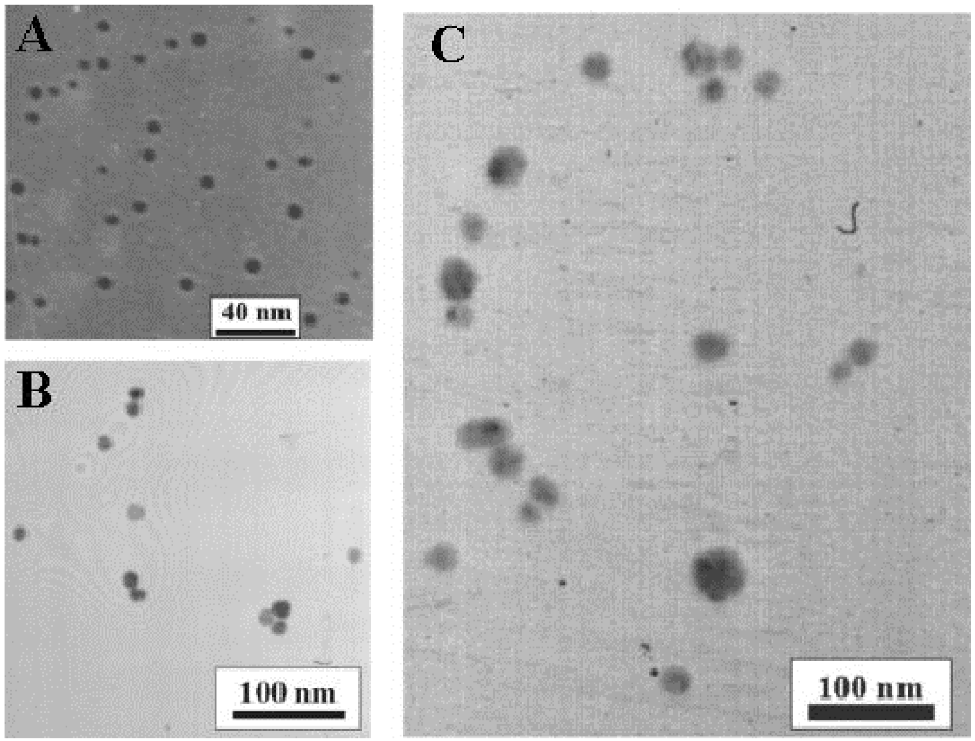
Figure S1 TEM images of 2.80.8 nm diameter thiocyanate ion coated gold (A); 11.60.8 nm diameter thiocyanate ion coated gold (B) and 22.85.8 nm diameter EDTA coated silver nanoparticles (C).
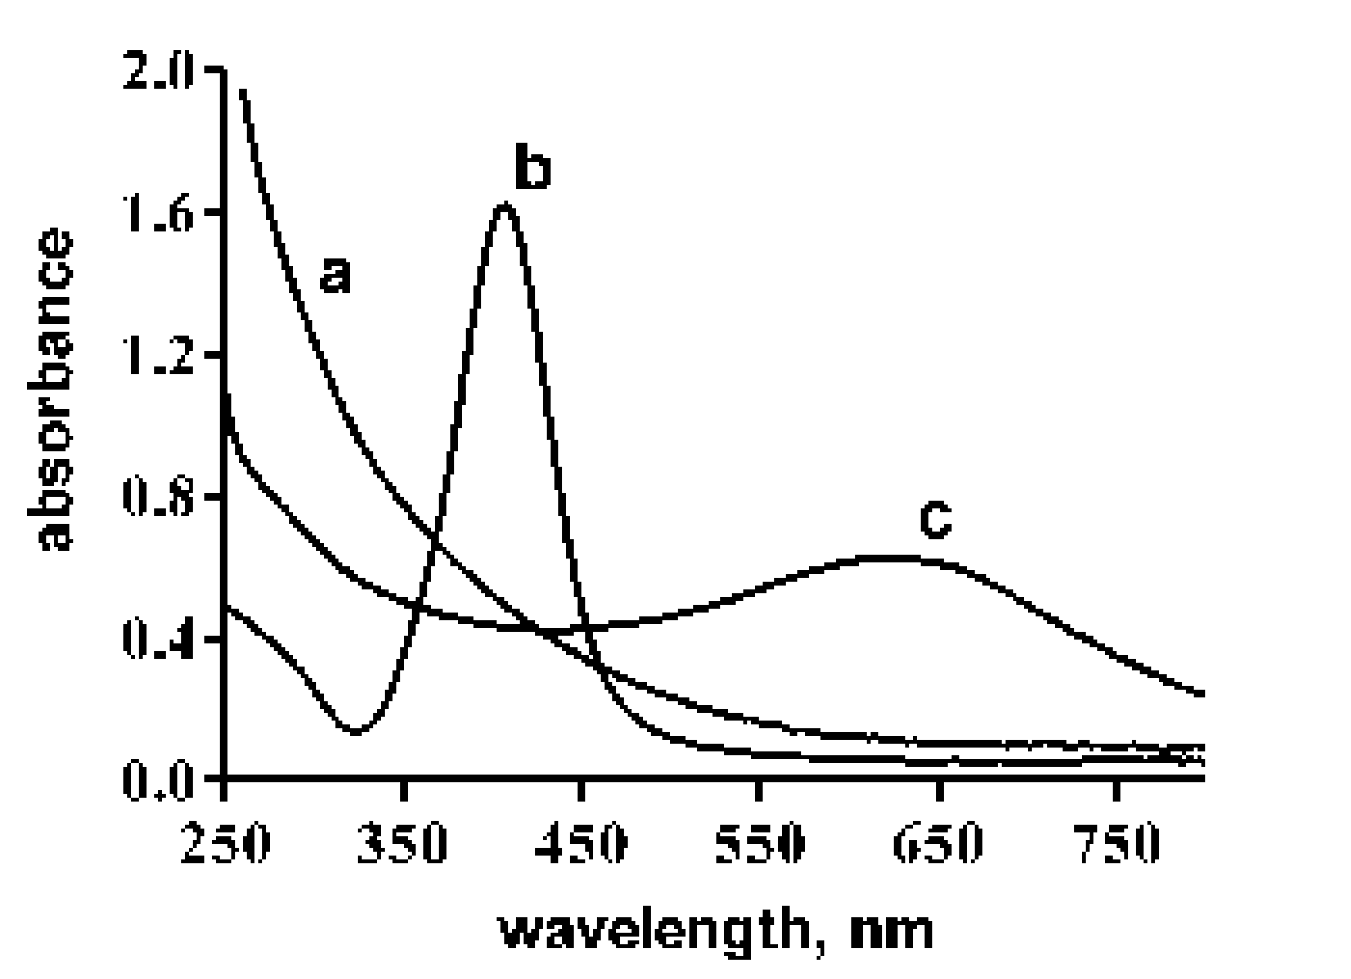
Figure S2 Absorption spectra of 2.80.8 nm thiocynate ion coated gold (a), 37.89.0 nm EDTA coated silver nanoparticles (b). c is the absorption spectrum of the 1:1 mixture of a + b following 24 hours of incubation
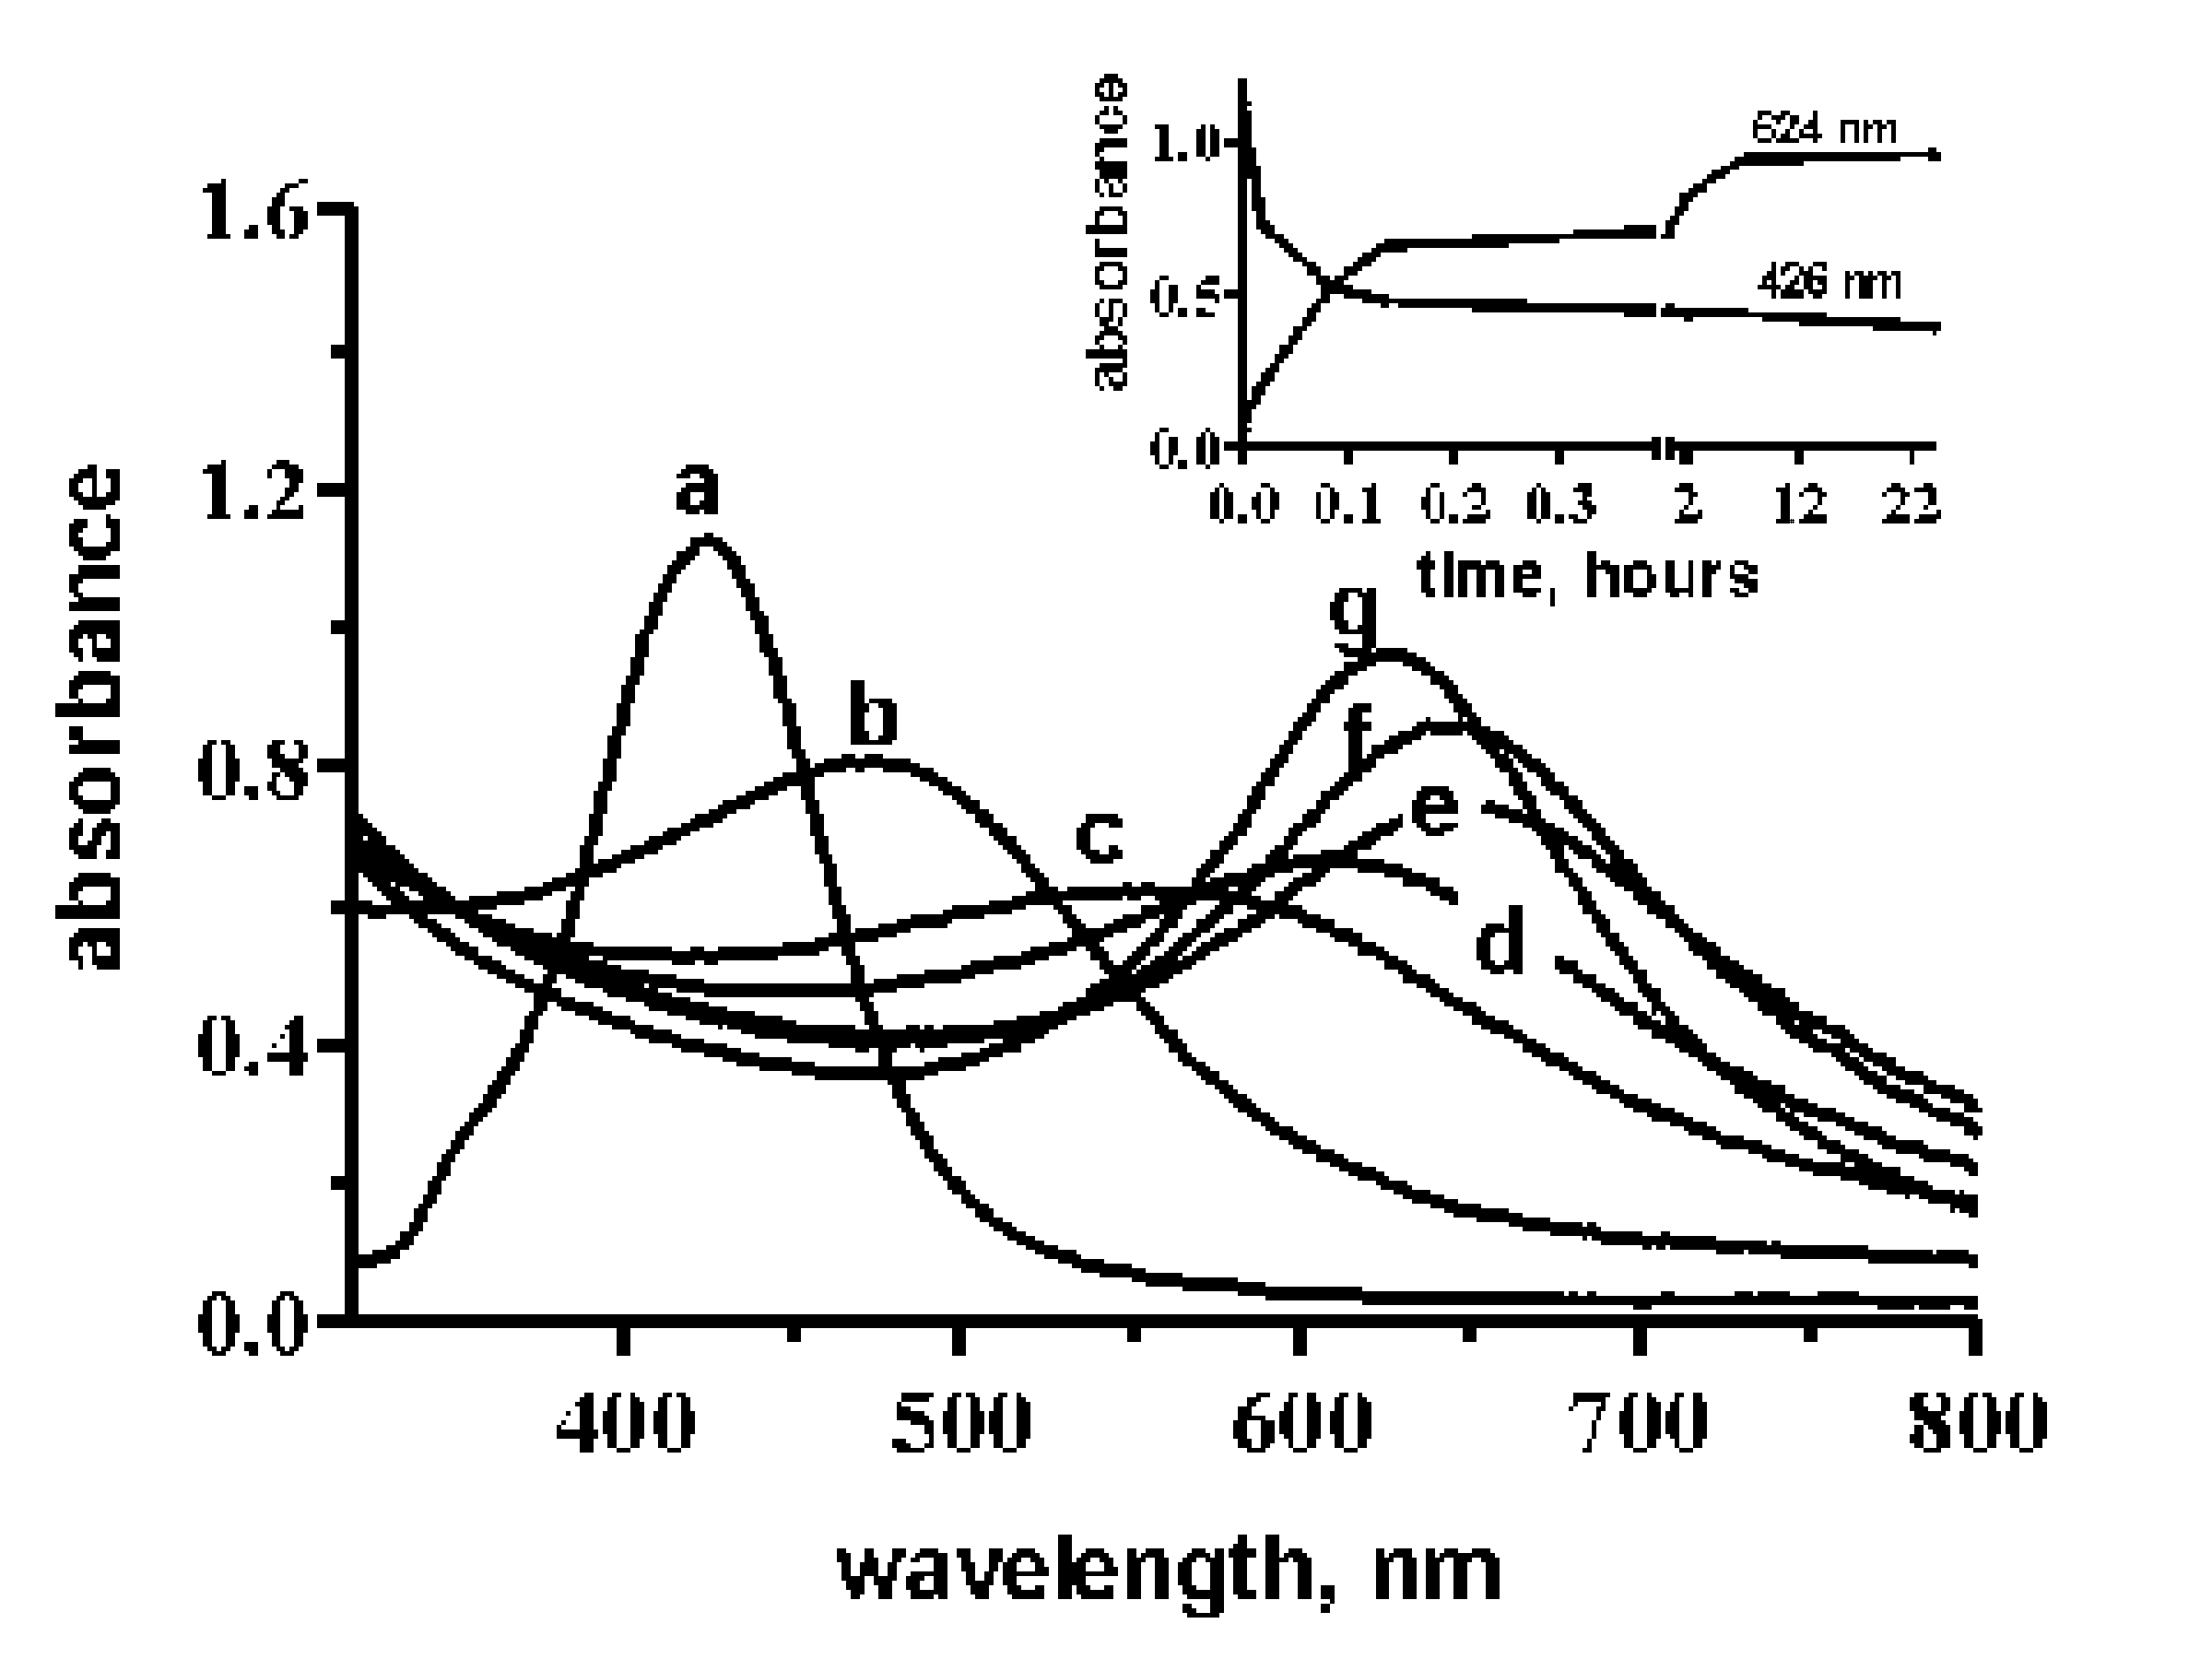
Figure S3 Absorption spectra of a 1 : 1 mixture of 1.3x10⁻⁴M 37.89.0 nm diameter EDTA protected silver nanoparticle and 2.6x10⁻⁴M thiocyanate-ion protected 2.80.8 nm diameter gold nanoparticle dispersions, taken at 0.1 (b), 5 (c), 8 (d) 33 (e) 130 (f) minutes and 24 hours (g) subsequent to mixing. a = absorption spectrum of 1.3x10⁻⁴M 37.89.0 nm diameter EDTA protected silver nanoparticle dispersions in water. The insert shows the time dependent changes of the absorbances at 424 nm and 624 nm. All concentrations are expressed in terms of the metal ions.
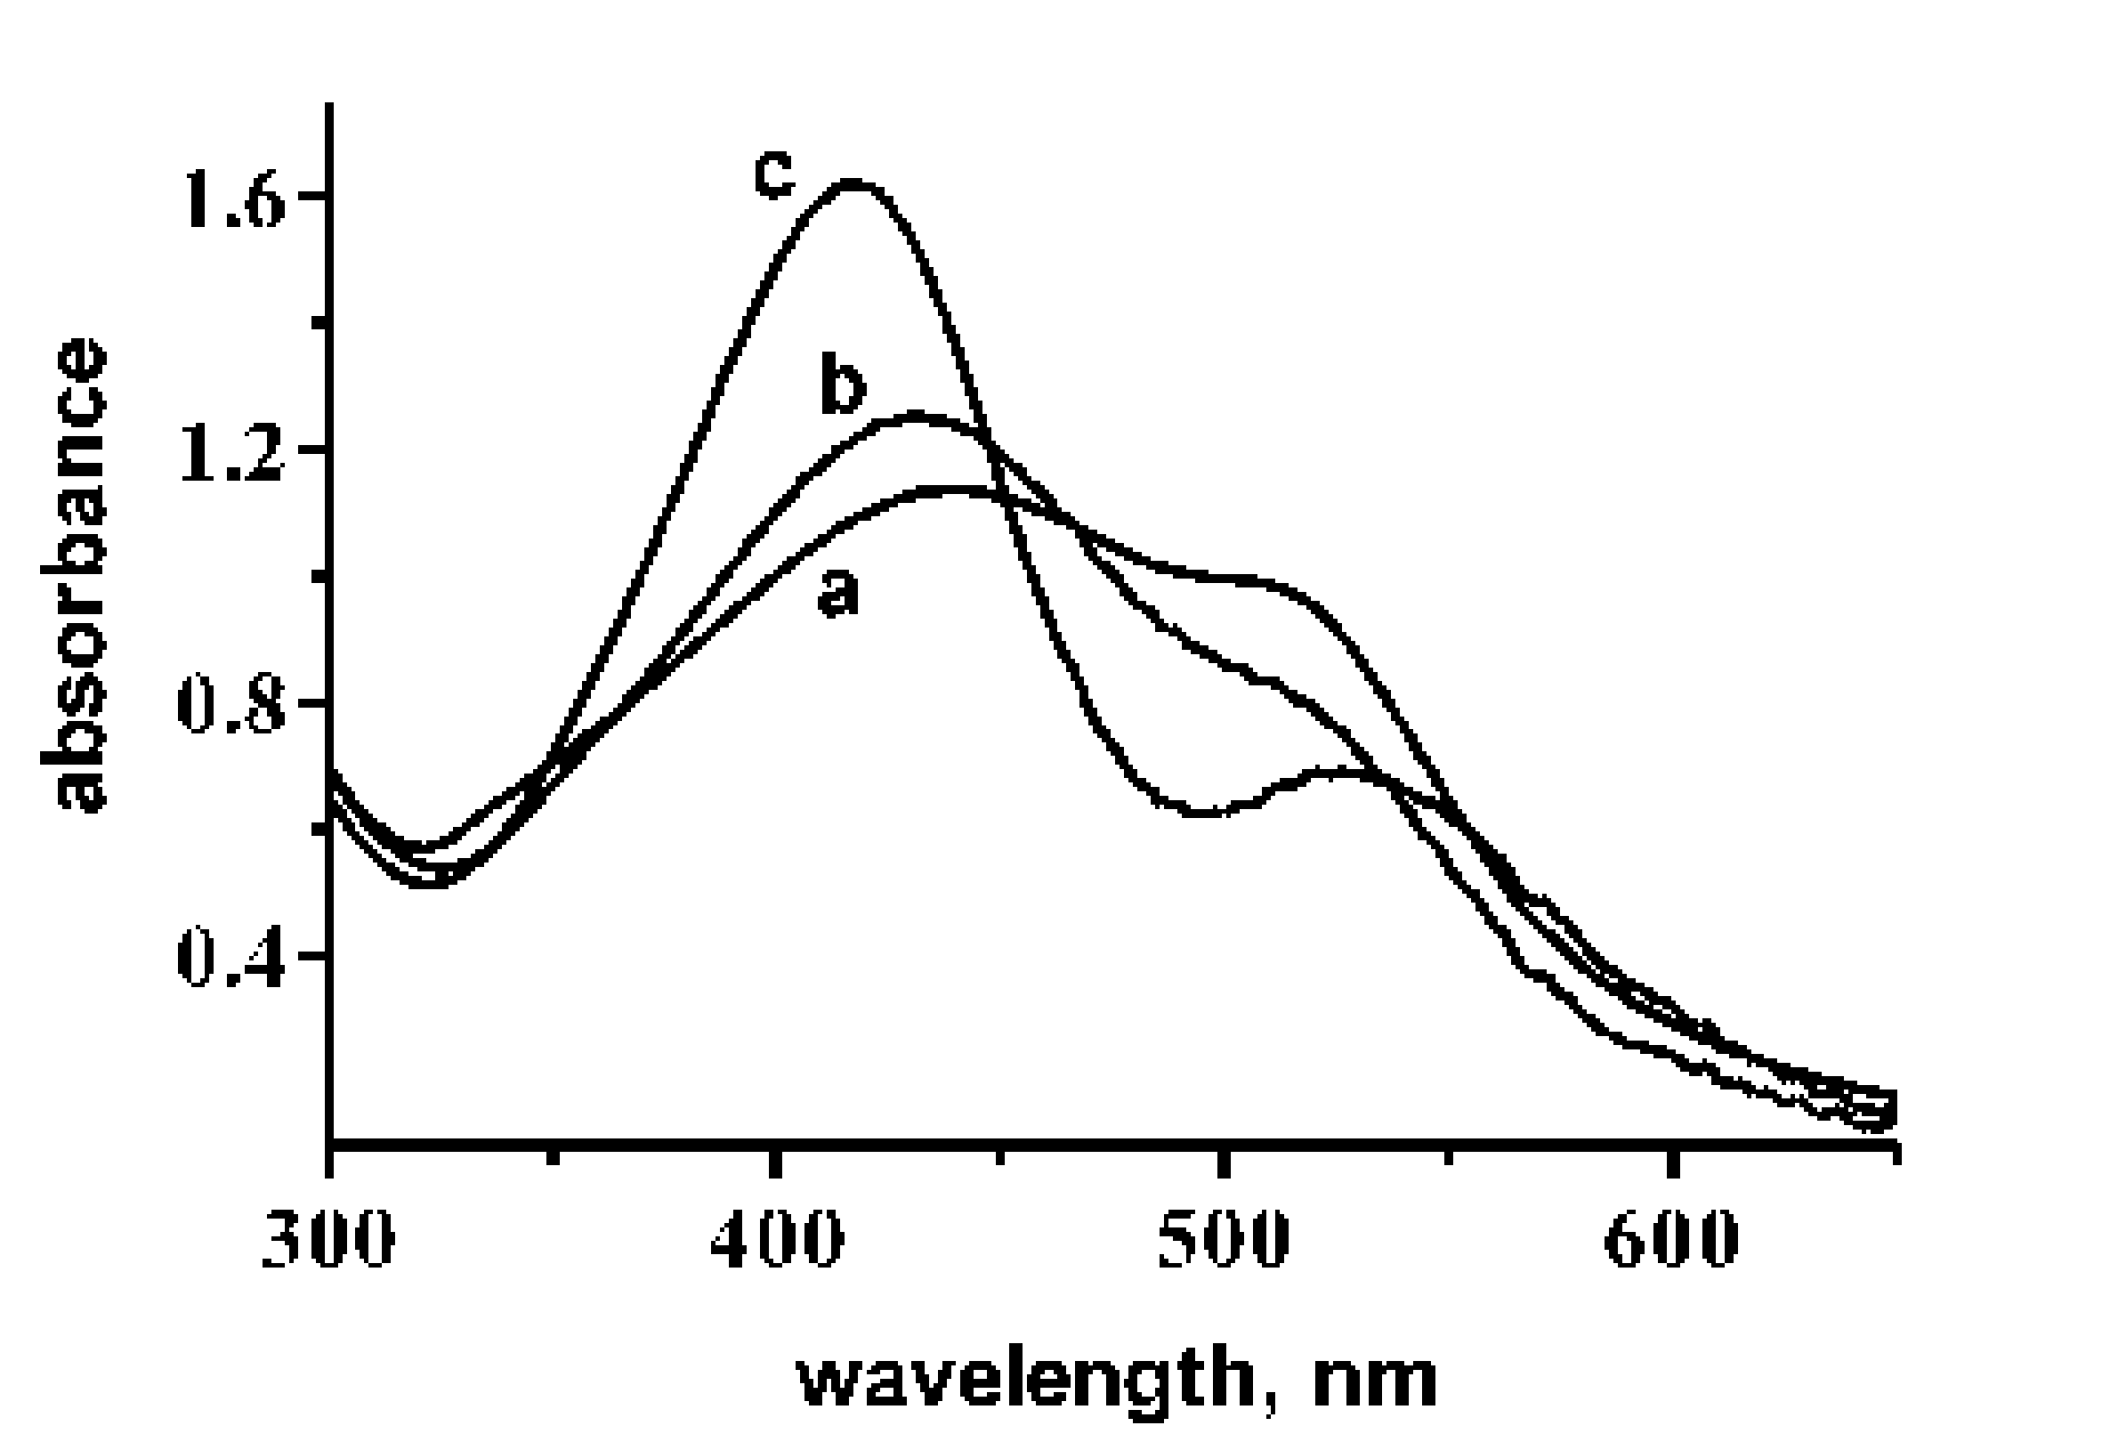
Figure S4 Absorption spectra of mixtures of larges thiocyanate ion covered Au and EDTA coated Ag particles. a = 11.60.8 nm diameter Au + 22.85.8 nm diameter Ag; b = 17.92.4 nm diameter Au + 22.85.8 nm diameter Ag; c = 44.77.0 nm diameter Au + 22.85.8 nm diameter Ag;
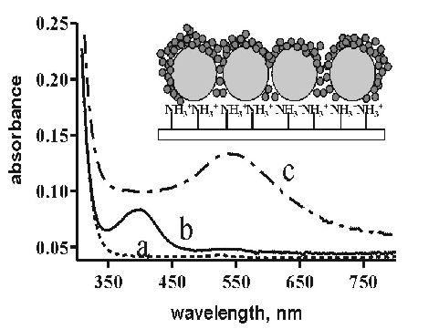
Figure S5 Absorption spectra of self-assembled aminobutyldimethylmethoxysilane (a), amino-butyldimethylmethoxysilane and silver nanoparticles (b) and aminobutyldimethylmethoxysilane and gold decorated silver nanoparticles (c) self assembled onto a glass slide. The insert shows a schematics of the self-assembled film.
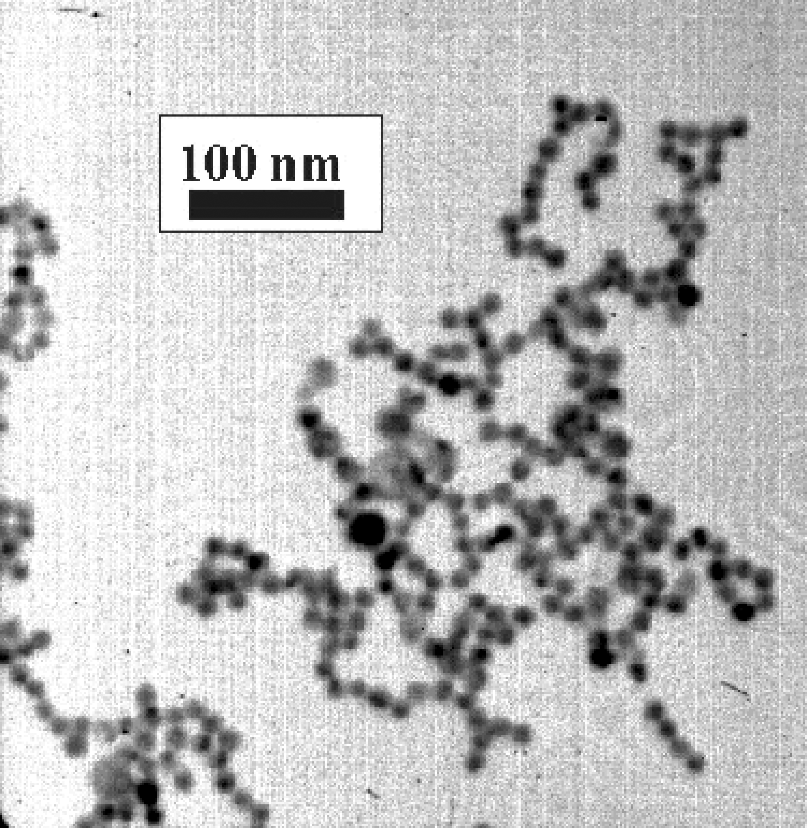
Figure S6 TEM image of a mixture of 11.60.8 nm diameter thiocyanate ion coated Au and EDTA coated 22.85.8 nm diameter Ag nanoparticles (corresponding to spectrum a in Figure S4.

