SUPPORTING INFORMATION:

Materials:

Nucleic Acids. DNA polymers were purchased from Pharmacia Biotech, Inc. (Piscataway, NJ) and were used without further purification. DNA used include poly(dA), lot number: 9017836021; poly(dT), lot numbers: 8107834021 and 9107834021; poly(dA)(dT): lot number: 9067860021; Poly(rA): lot number: 7104110011, Poly(rU): lot number: 9034440021;. The concentrations of all the polymer solutions were determined spectrophotometrically using the following extinction coefficients (in units of mol of nucleotide/L)⁻¹ cm⁻¹: ε ₂₅₇ = 8900 for poly(dA), ε₂₆₅ = 9000 for poly(dT), ε ₂₆₀ = 6000 for poly(dA)•poly(dT), ), ε ₂₅₈ = 9800 for poly(rA), ε ₂₆₀ = 9350 for poly(rU)..

Chemicals: Neomycin B, 1-pyrenebutyric acid N-hydroxysuccinimide ester, 2,4,6-Triisopropylbenzenesulfonyl chloride, Di-tert-butyl dicarbonate, 2-aminoethanethiol hydrochloride, 4-dimethyl-aminopyridine and 1-aminopyrene were purchased from Acros (New Jersey) and were used without further purification. 4M HCl/disoxane was purchased from Aldrich and was used without further purification. Methylene chloride, DMF, dioxane were used as received. Pyridine was purified by CaH₂ with distillation before using.
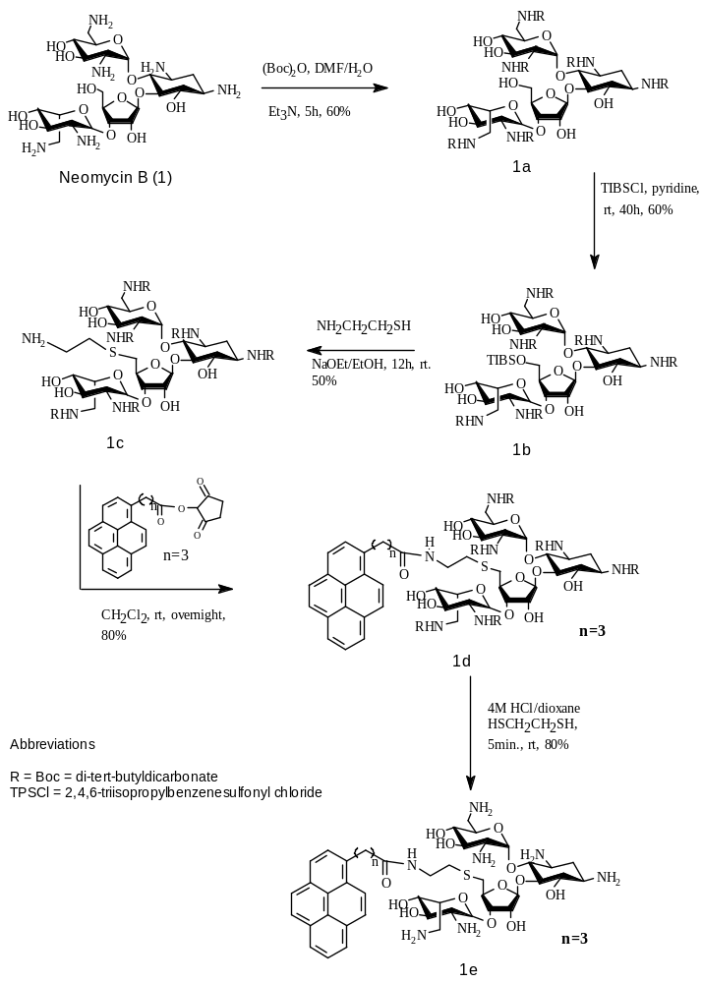

Figure S1. Synthesis of Pyrene-Neomycin
Pyrene-neomycin Synthesis -Experimental
Compound 1a-1c have previously been reported (Kirk, S. R., Luedtke, N. W., Tor, Y., J. Am. Chem. Soc., 2000, 122, 980-981).

Compound 1d. Compound 1c (70mg, 0.055mmol) and 4-dimethyl-aminopyridine (1mg) were dissolved in 5ml anhydrous methylene chloride at room temperature. 1-pyrenebutyric acid N-hydroxysuccinimide ester (64mg, 0.165mmol, 3 equiv.) was added into the solution. The reaction mixture was kept stirring overnight. Organic solvent was then removed by vacuum. Flash column chromatography (5% CH₃OH in CH₂Cl₂) afforded the desired product as a white solid. (62mg, 73%). Rf 0.48 (10% CH₃OH in CH₂Cl₂); ¹HNMR (500MHz, methanol-d₄, 25°C): 7.9-8.3 (m, 9H, Acr), 5.48 (br, 1H), 5.37 (1H), 5.13 (1H), 4.92 (1H), 4.23 (1H), 4.09(2H), 3.89 (2H), 3.76 (2H), 3.44-3.56 (6H), 3.0-3.3 (9H), 2.86 (2H), 2.7 (4H), 2.38 (2H), 2.18 (2H), 1.94 (1H), 1.4 (m, 54H).

Compound 1e. Compound 1d (10mg) was dissolved in dioxane (0.6ml, treated over alumina). 1, 2-ethanedithiol (0.002 ml) was added followed by 4M HCl/dioxane (0.6ml). The solution was swirled for 5 min by hand upon which a pale yellow precipitate formed. Further precipitation was induced by adding ether and hexane (0.6ml each). Precipitate was recovered by centrifugation and several washes with ether and hexane. The pale-yellow solid was redissolved in water and lyophilized overnight (6mg, 80% yield). λ_{max} =342nm; ε₃₄₂ = 16778 cm⁻¹•M⁻¹ HRMS (MALDI) m/z [M+2H]⁺ 946, calcd for C₄₅H₆₆N₇O₁₃S 944.

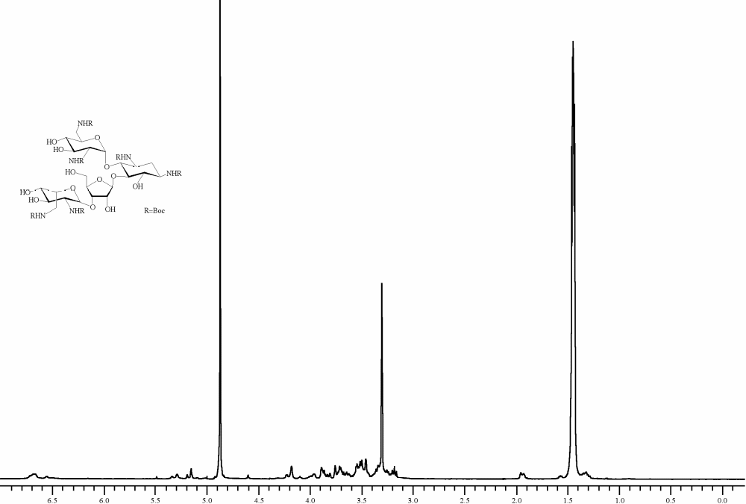
¹H NMR of 1a in CD₃OD
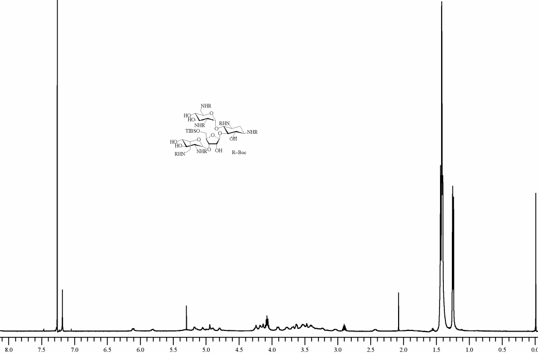
¹H NMR of 1b in CDCl₃
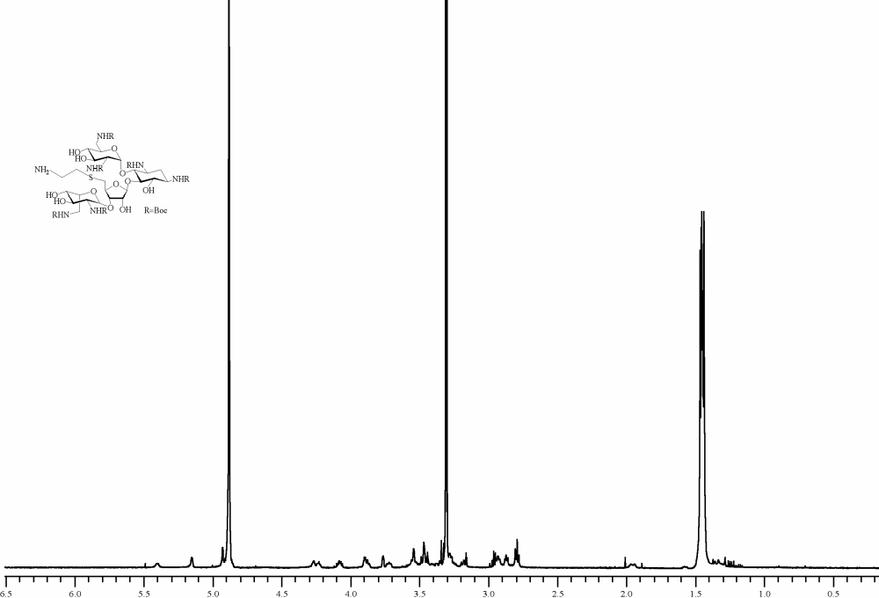
¹H NMR of 1c in CD₃OD
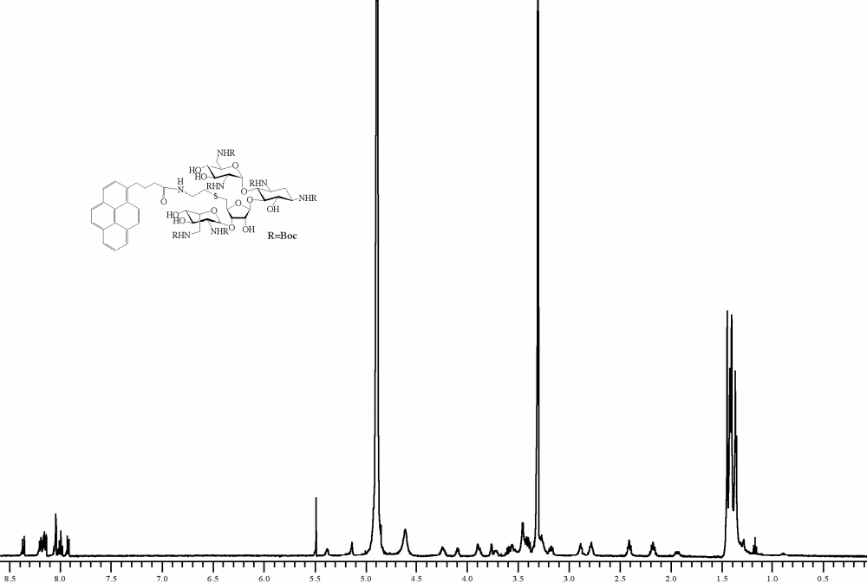
¹H NMR of 1d in CD₃OD
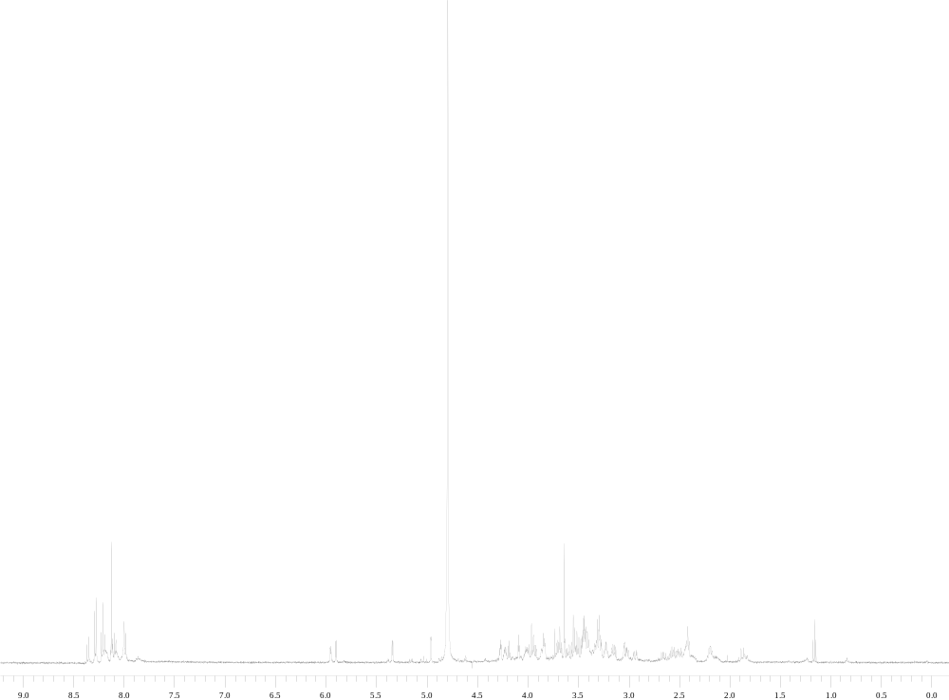
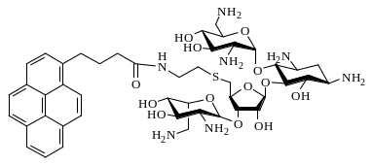

¹H NMR of 1e in D₂O

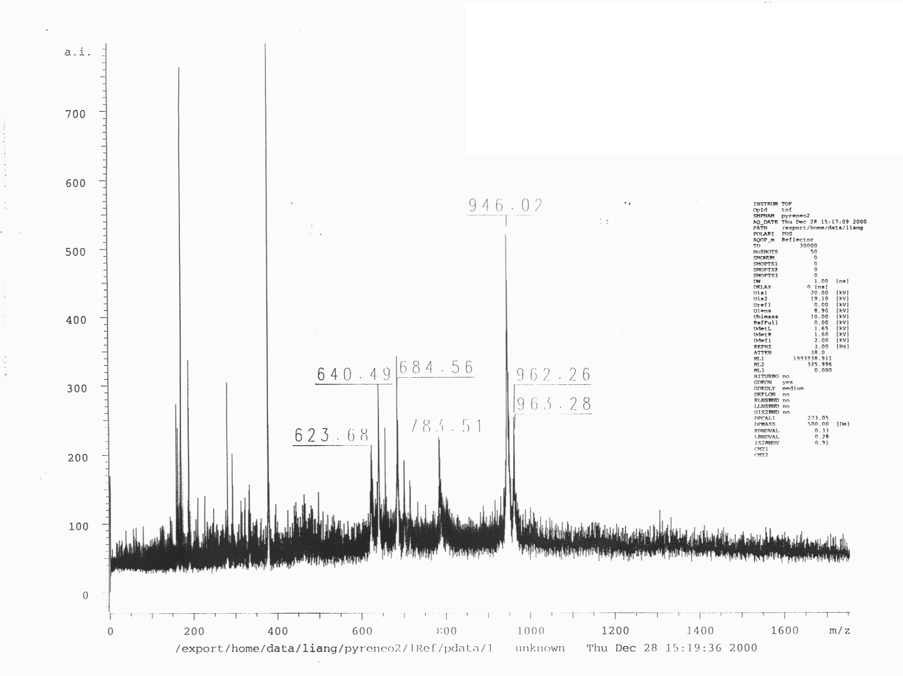
MS (MALDI) Spectrum of 1e
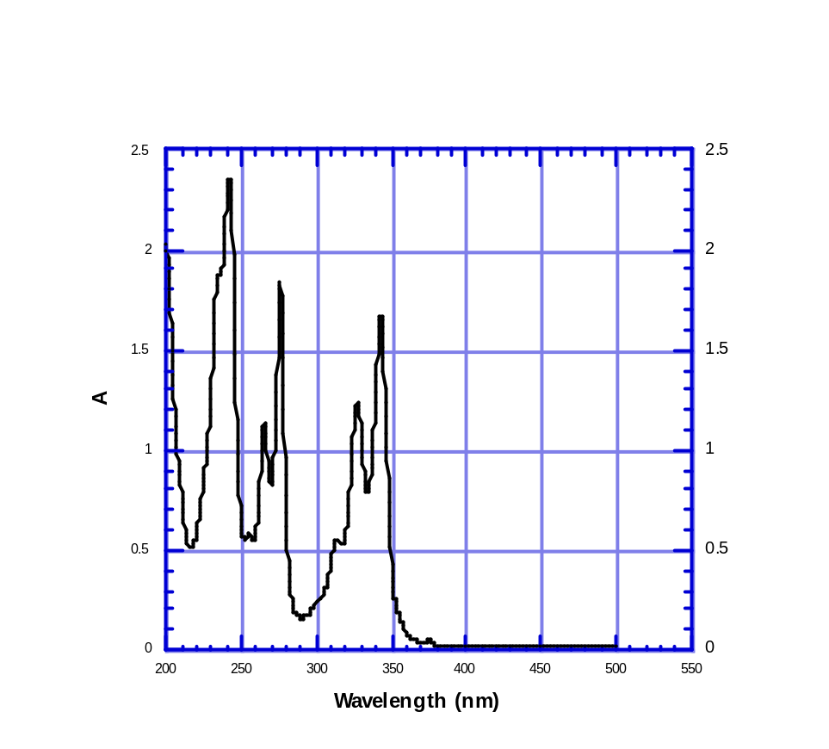
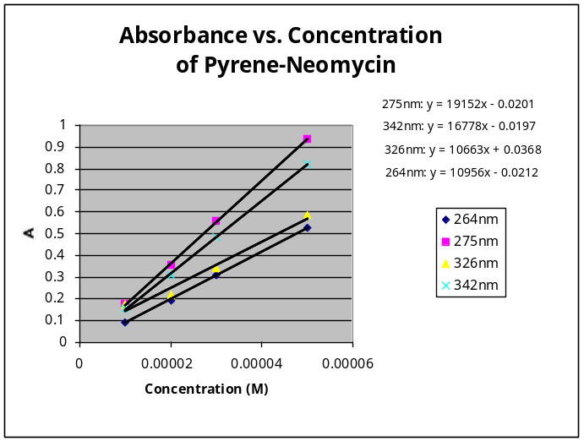UV spectrum of Pyrene-neomycin
ε₂₆₄ = 10956 cm⁻¹•M⁻¹; ε₂₇₅ = 19152 cm⁻¹•M⁻¹;
ε₃₂₆ = 10663 cm⁻¹•M⁻¹; ε₃₄₂ = 16778 cm⁻¹•M⁻¹.
Melting Curves

UV melting profiles of the poly(dA)•2poly(dT) in the presence of 150mM KCl at the indicated ligand concentrations. [DNA]=15μM base triplet. Solution conditions: 10 mM sodium cacodylate buffer, 0.5 mM EDTA, pH 7.2. Samples were heated from 20 to 90°C at 5 deg/min, the annealing(90-5°C) and the melting (5-90°C) were conducted at 0.2 deg/min, and the samples were brought back to 20°C at a rate of 5 deg/min.
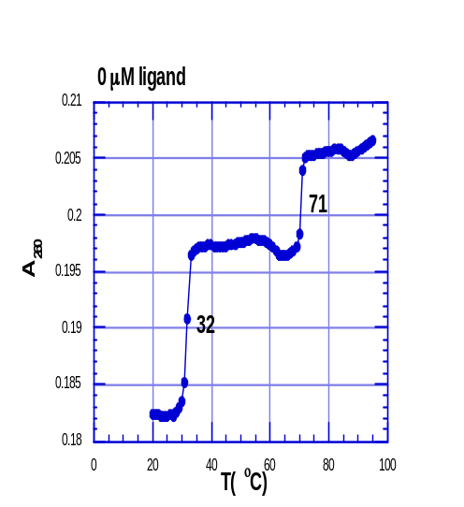 | 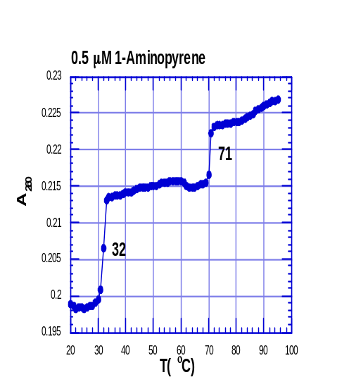
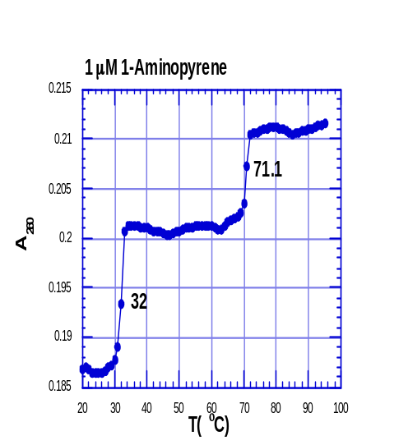 | 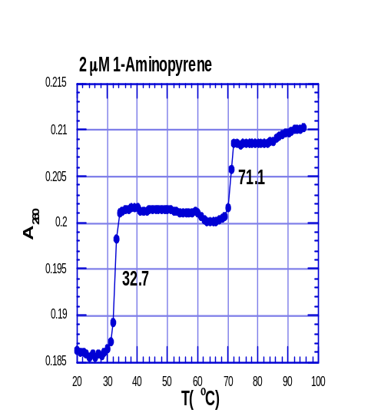
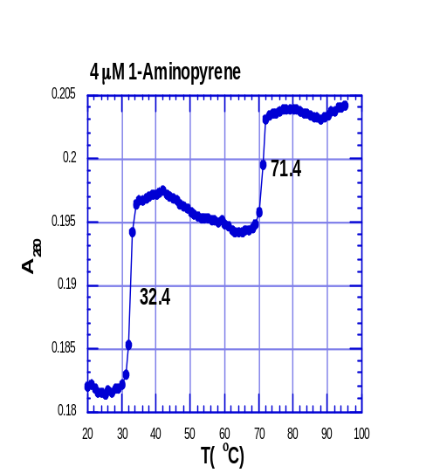 | 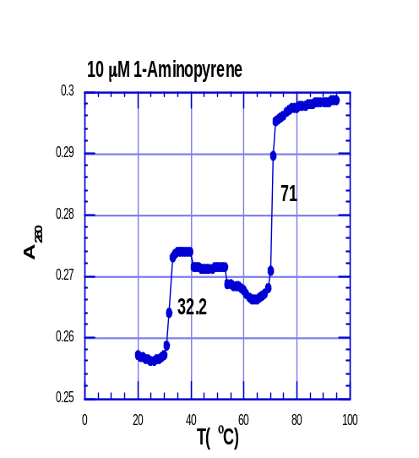
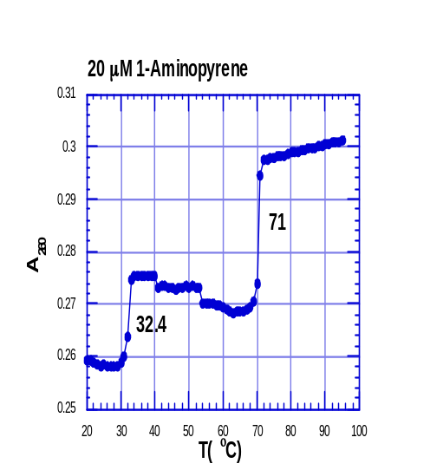

UV melting profiles of the poly(dA)•2poly(dT) in the presence of 150mM KCl at the indicated ligand concentrations. [DNA]=15μM base triplet. Solution conditions: 10 mM sodium cacodylate buffer, 0.5 mM EDTA, pH 7.2. Samples were heated from 20 to 90°C at 5 deg/min, the annealing(90-5°C) and the melting (5-90°C) were conducted at 0.2 deg/min, and the samples were brought back to 20°C at a rate of 5 deg/min.
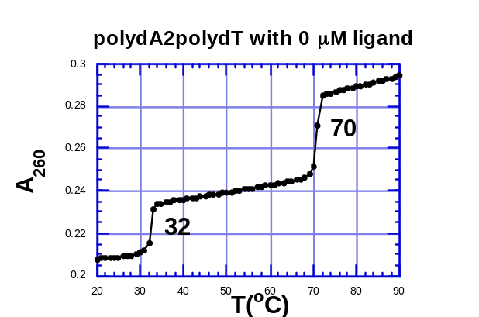 | 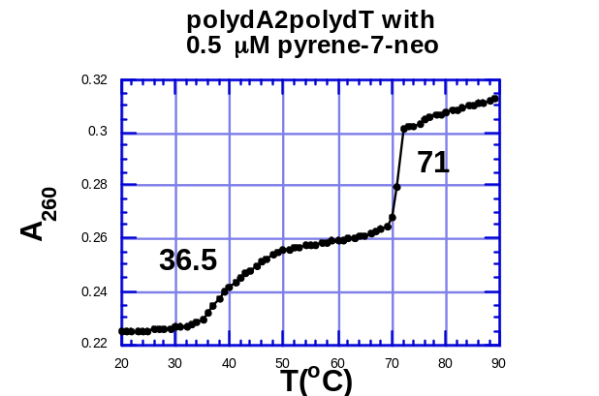
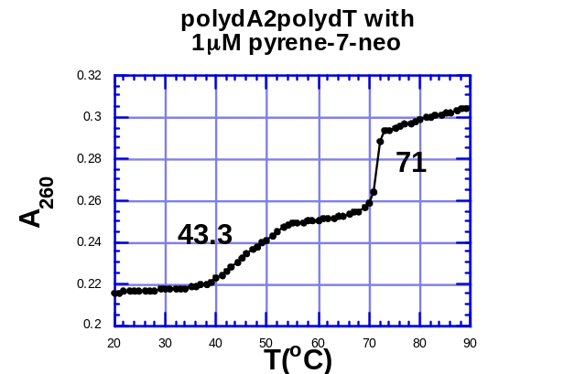 | 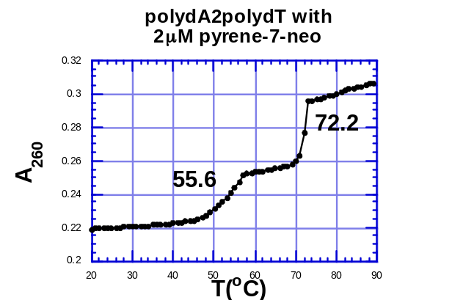
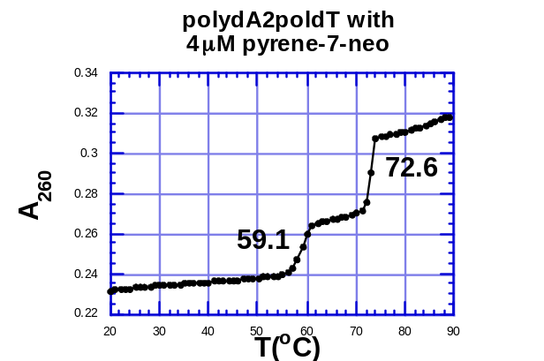 | 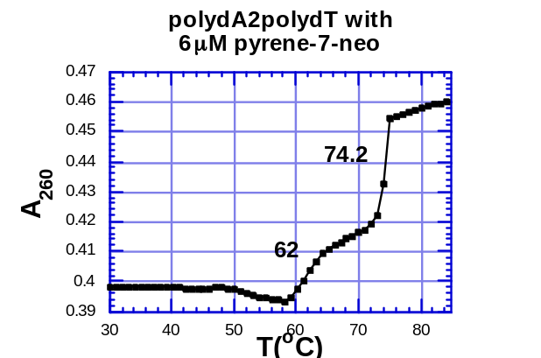

UV melting profiles of the poly(dA)•2poly(dT) in the presence of 150mM KCl at the indicated ligand concentrations. [DNA]=15μM base triplet. Solution conditions: 10 mM sodium cacodylate buffer, 0.5 mM EDTA, pH 7.2. Samples were heated from 20 to 90°C at 5 deg/min, the annealing(90-5°C) and the melting (5-90°C) were conducted at 0.2 deg/min, and the samples were brought back to 20°C at a rate of 5 deg/min.
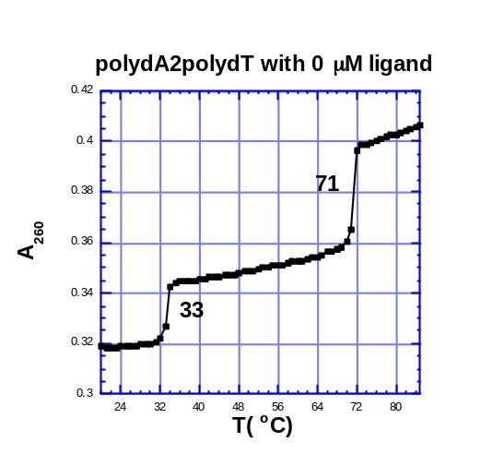 | 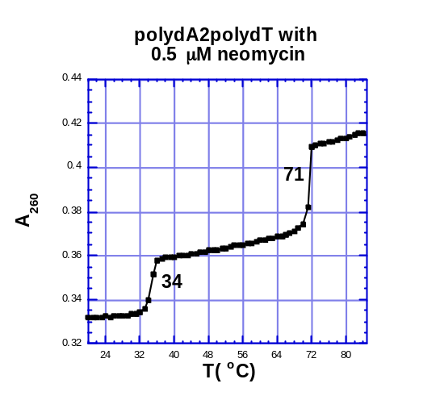
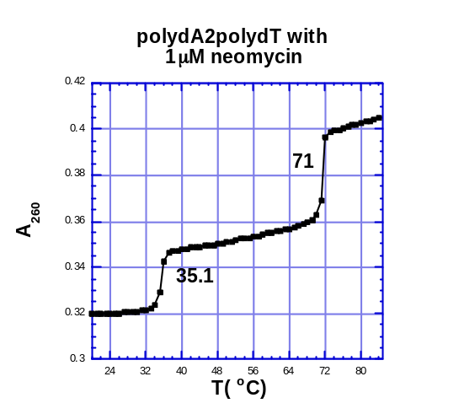 | 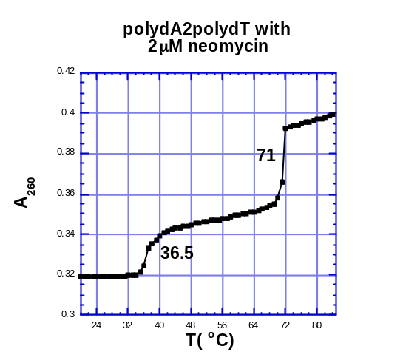
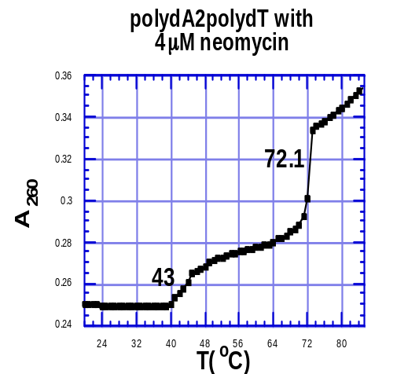 | 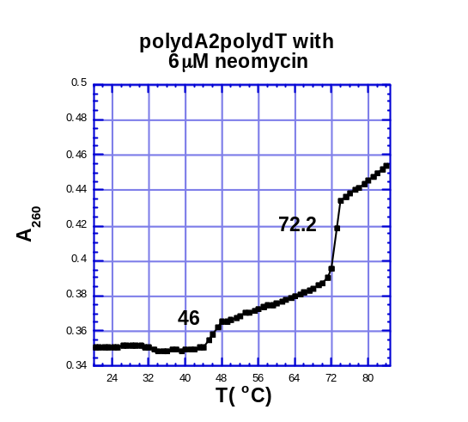
UV melting profiles of the poly(dA)•2poly(dT) in the presence of 150mM KCl at the indicated ligand concentrations. [DNA]=15μM base triplet. Solution conditions: 10 mM sodium cacodylate buffer, 0.5 mM EDTA, pH 7.2. Samples were heated from 20 to 90°C at 5 deg/min, the annealing(90-5°C) and the melting (5-90°C, curves shown below) were conducted at 0.2 deg/min, and the samples were brought back to 20°C at a rate of 5 deg/min.
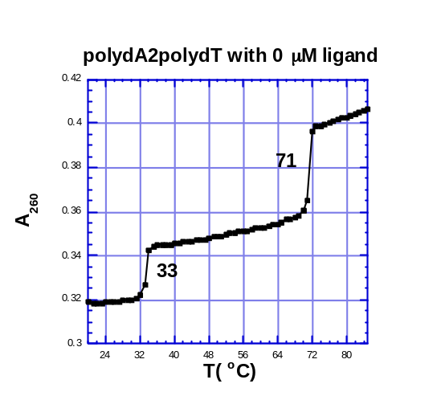 | 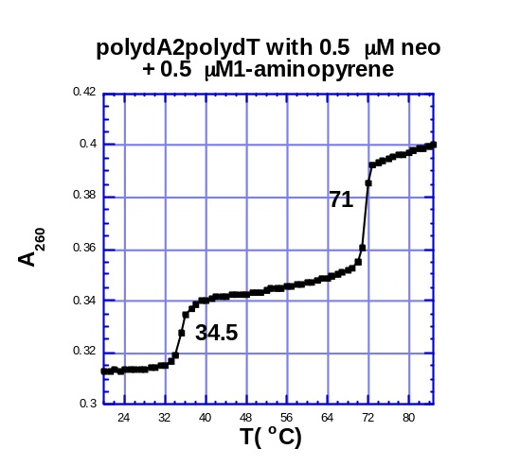
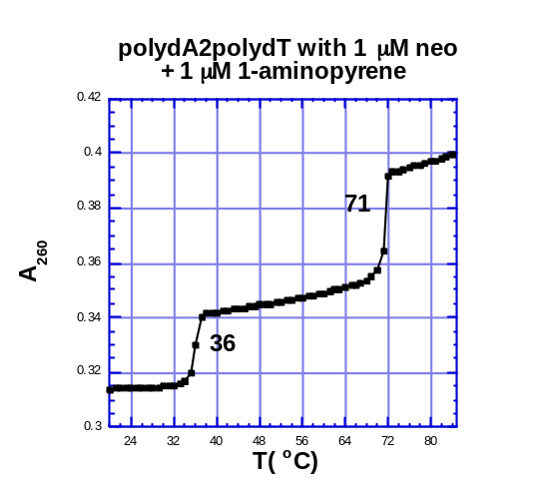 | 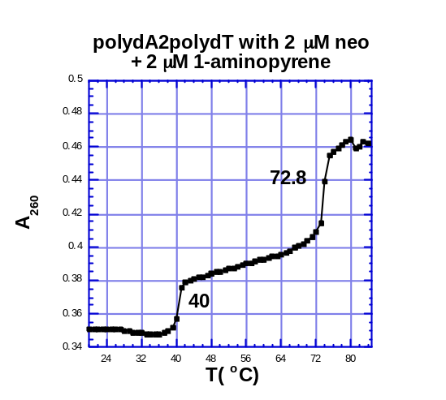
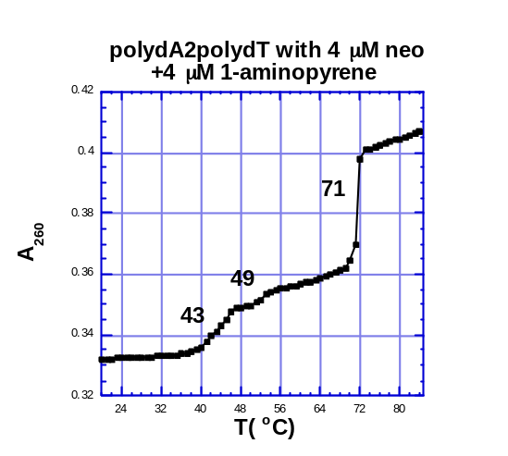 | 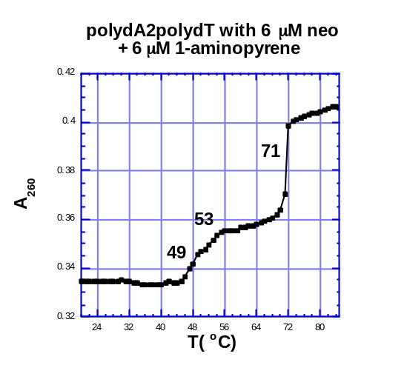

UV melting profiles (287nm) of the poly(rA)•poly(rU) and poly(rA)•2poly(rU) in the presence of 35mM NaCl at the indicated ligand concentrations. [RNA]=30μM base triplet. Solution conditions: 10 mM sodium cacodylate buffer, 0.1 mM EDTA, pH 6.8. Samples were heated from 20 to 90°C at 0.2 deg/min.
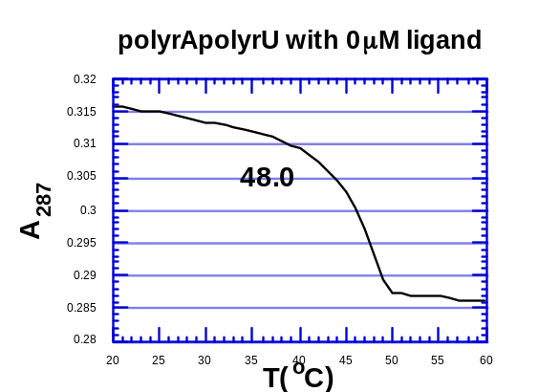 | 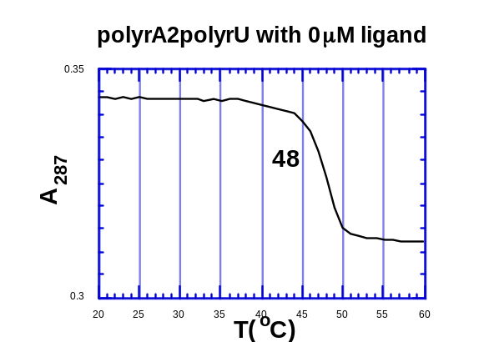
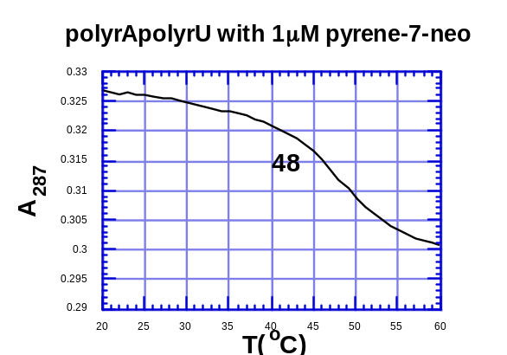 | 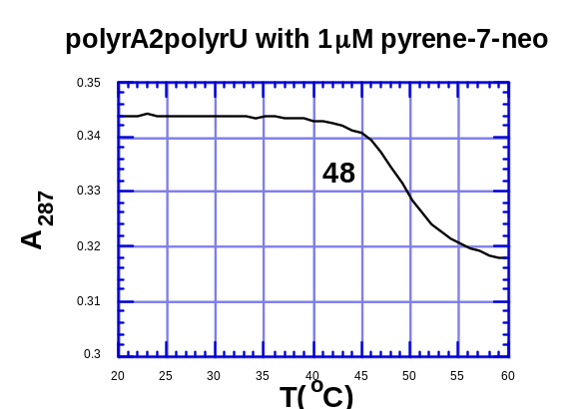
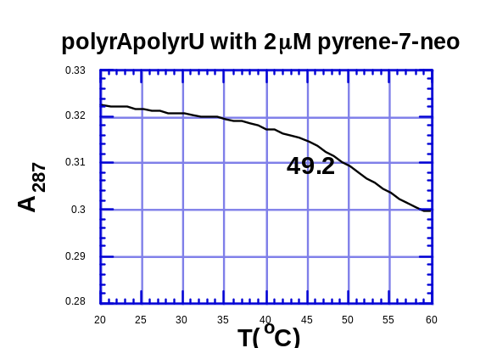 | 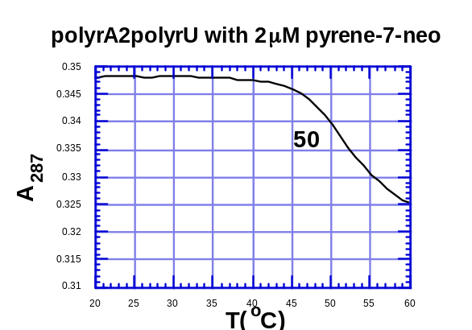
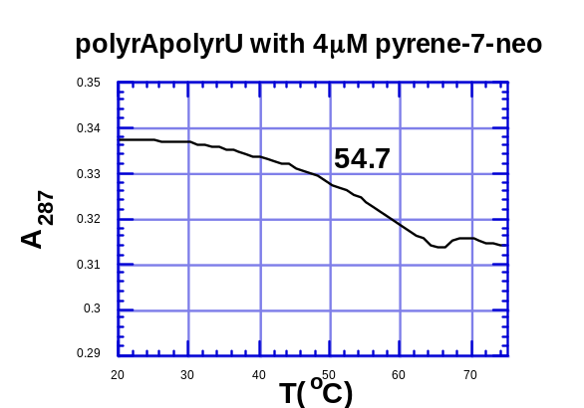 | 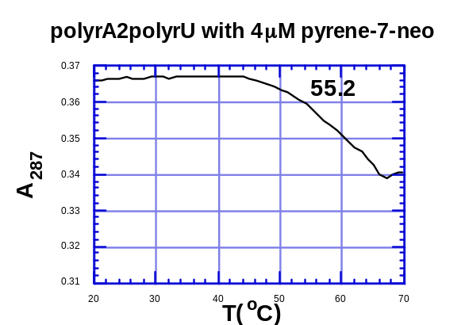

UV melting profiles (280nm) of the poly(rA)•poly(rU) and poly(rA)•2poly(rU) in the presence of 35mM NaCl at the indicated ligand concentrations. [RNA]=30μM base triplet. Solution conditions: 10 mM sodium cacodylate buffer, 0.1 mM EDTA, pH 6.8. Samples were heated from 20 to 90°C at 0.2 deg/min.
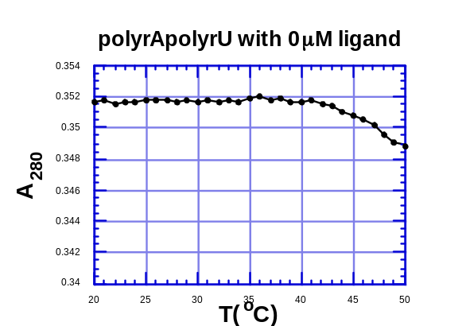 | 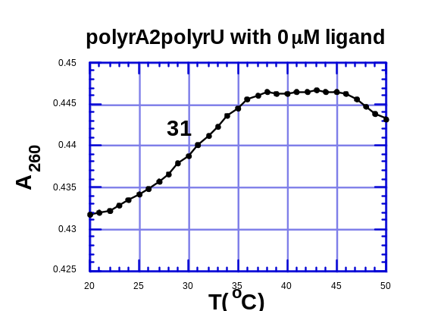
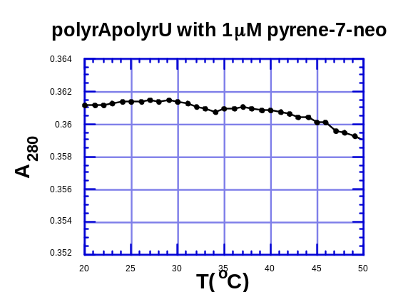 | 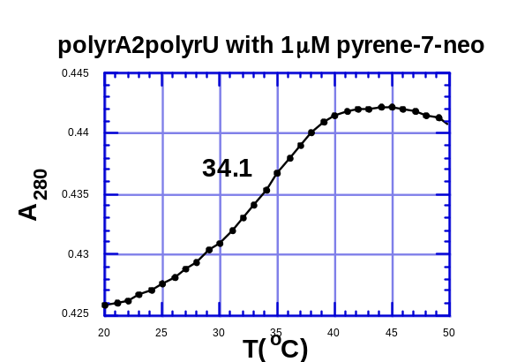
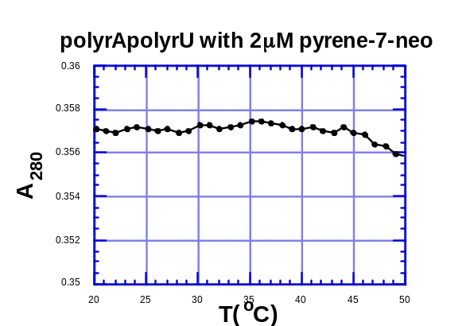 | 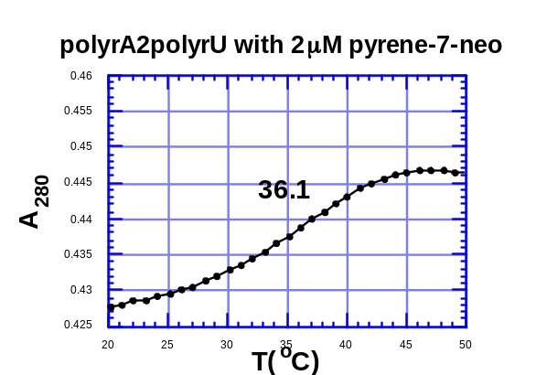
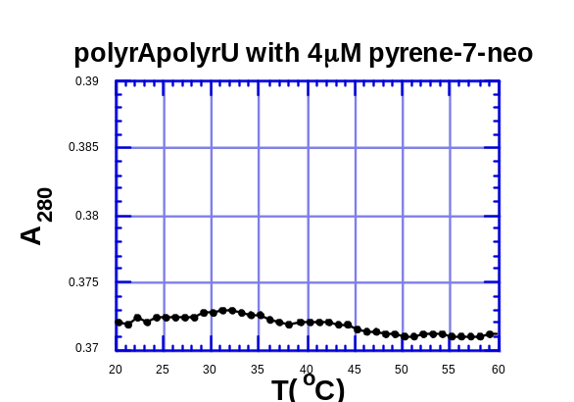 | 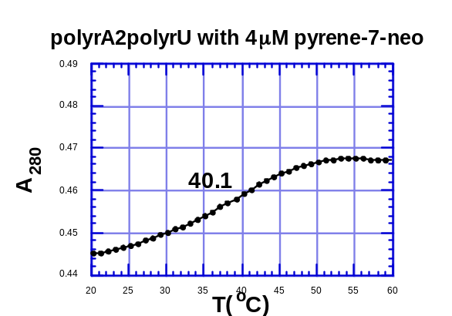

UV melting profiles (284nm) of the poly(rA)•poly(rU) and poly(rA)•2poly(rU) in the presence of 35mM NaCl at the indicated ligand concentrations. [RNA]=30μM base triplet. Solution conditions: 10 mM sodium cacodylate buffer, 0.1 mM EDTA, pH 6.8. Samples were heated from 20 to 90°C at 0.2 deg/min.
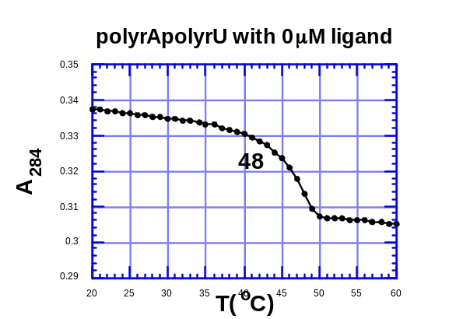 | 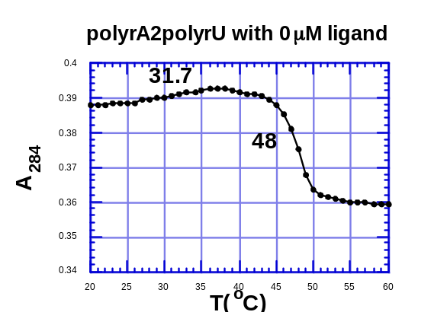
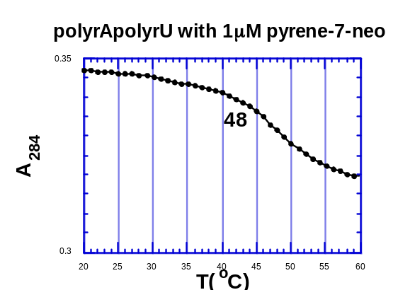 | 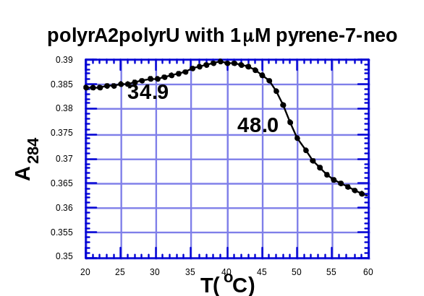
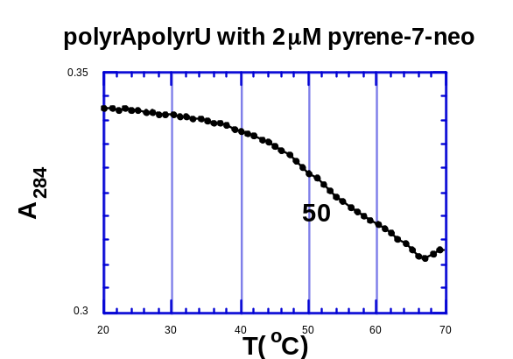 | 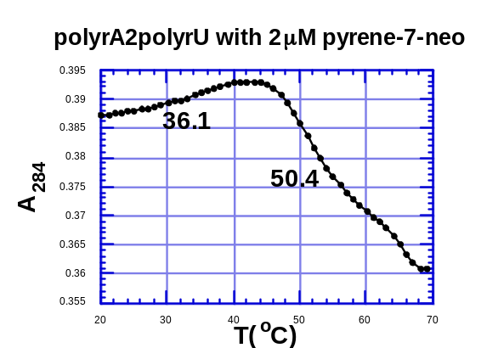
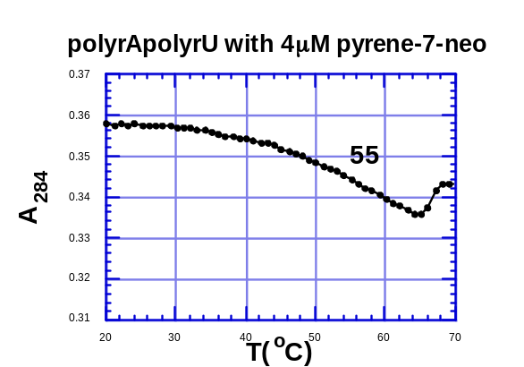 | 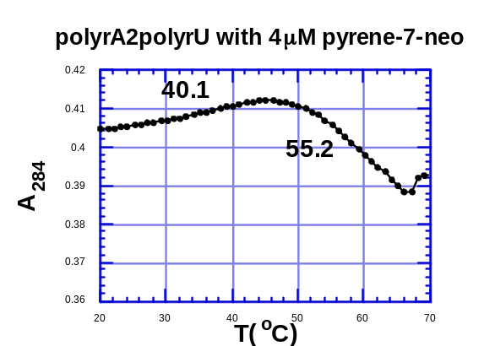

UV melting profiles (280nm) of the poly(rA)•poly(rU) and poly(rA)•2poly(rU) in the presence of 35mM NaCl at the indicated ligand concentrations. [RNA]=30μM base triplet. Solution conditions: 10 mM sodium cacodylate buffer, 0.1 mM EDTA, pH 6.8. Samples were heated from 20 to 90°C at 0.2 deg/min.
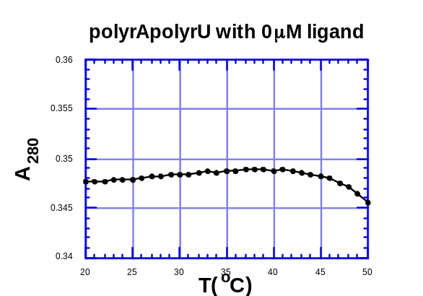 | 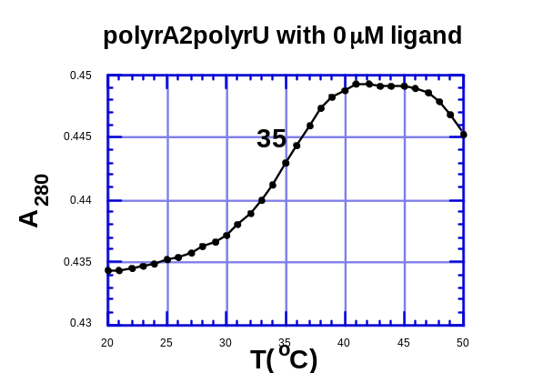
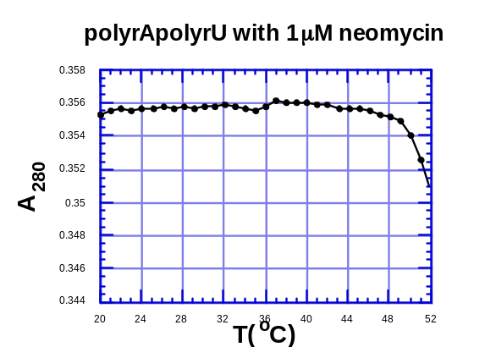 | 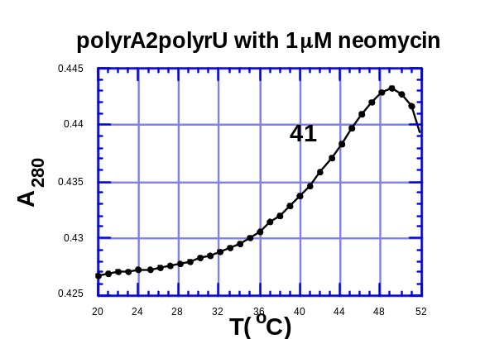
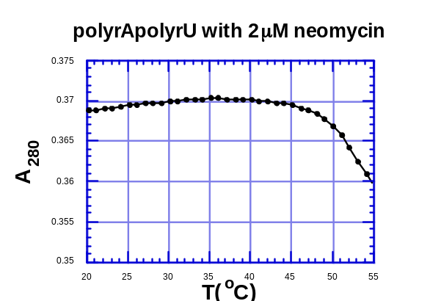 | 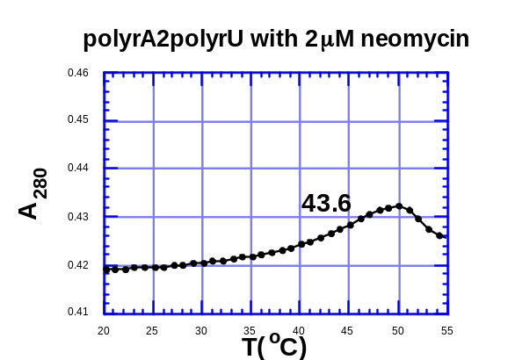
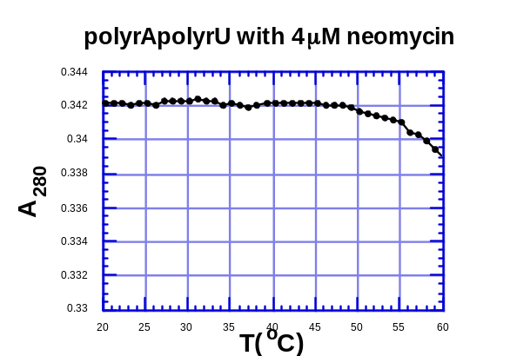 | 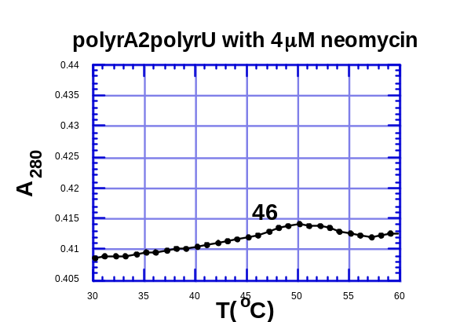

UV melting profiles (284nm) of the poly(rA)•poly(rU) and poly(rA)•2poly(rU) in the presence of 35mM NaCl at the indicated ligand concentrations. [RNA]=30μM base triplet. Solution conditions: 10 mM sodium cacodylate buffer, 0.1 mM EDTA, pH 6.8. Samples were heated from 20 to 90°C at 0.2 deg/min.
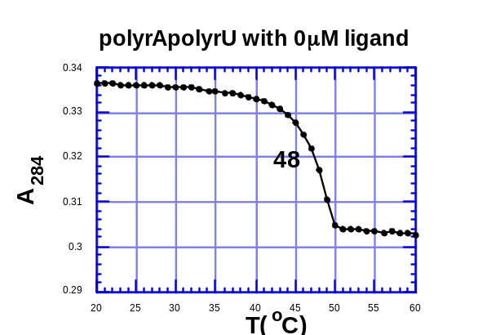 | 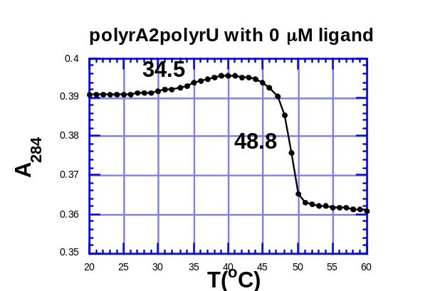
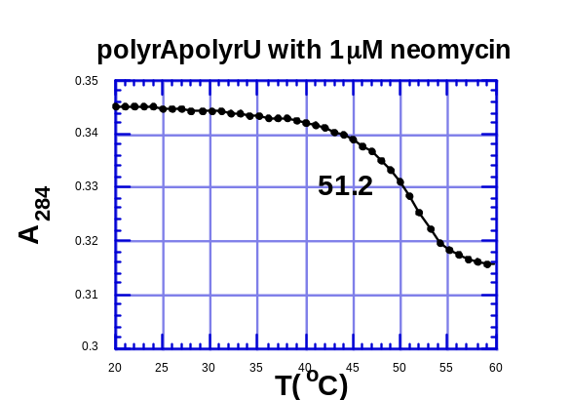 | 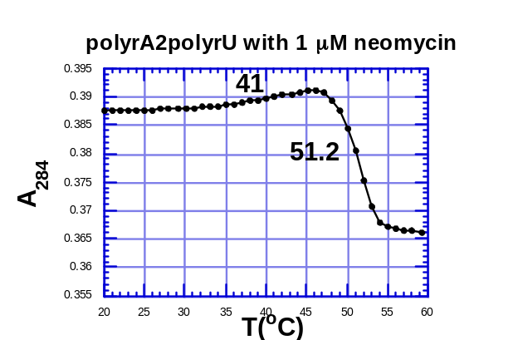
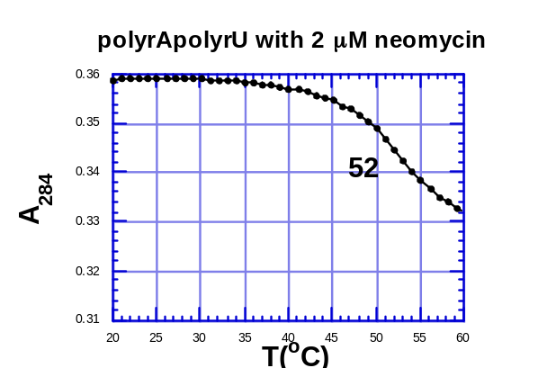 | 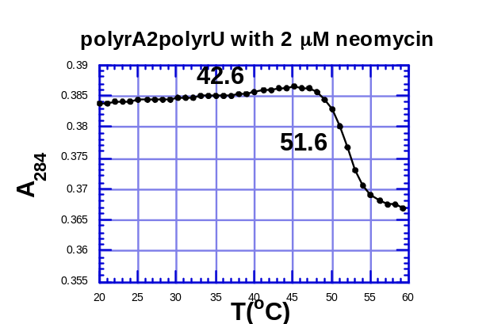
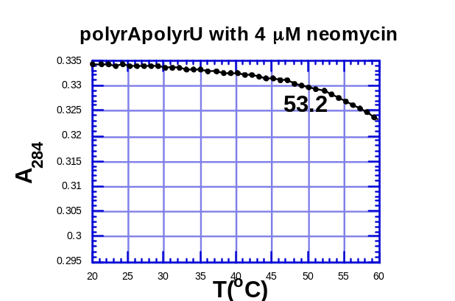 | 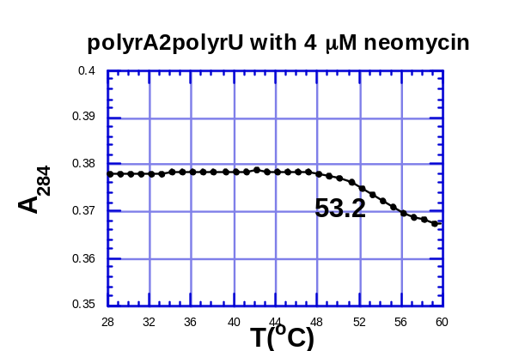

UV melting profiles (287nm) of the poly(rA)•poly(rU) and poly(rA)•2poly(rU) in the presence of 35mM NaCl at the indicated ligand concentrations. [RNA]=30μM base triplet. Solution conditions: 10 mM sodium cacodylate buffer, 0.1 mM EDTA, pH 6.8. Samples were heated from 20 to 90°C at 0.2 deg/min.
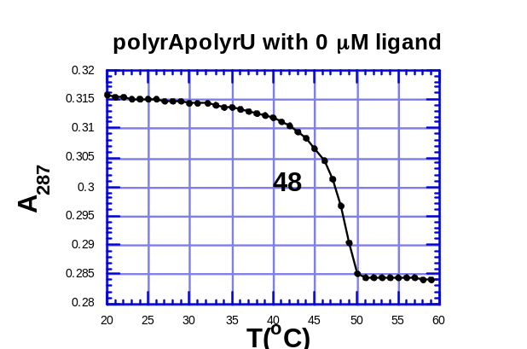 | 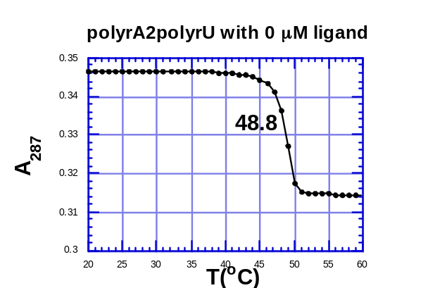
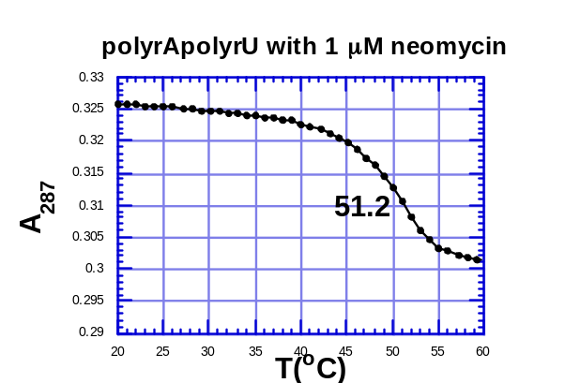 | 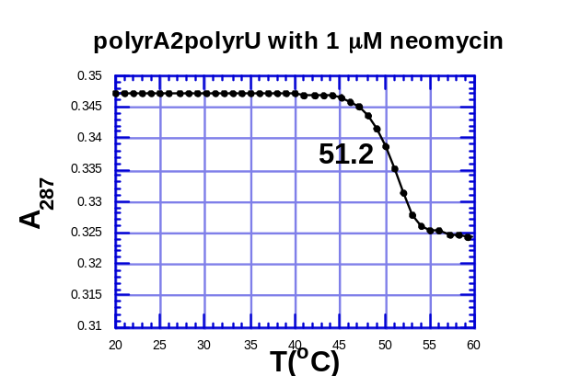
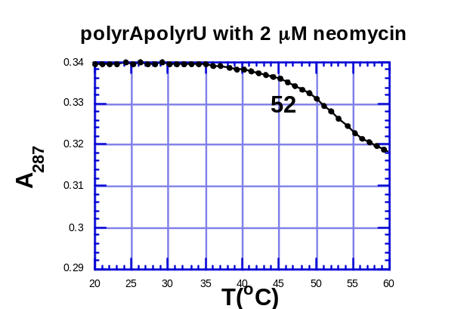 | 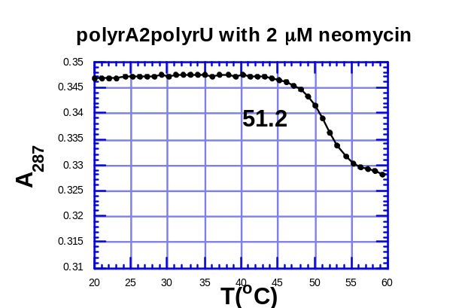
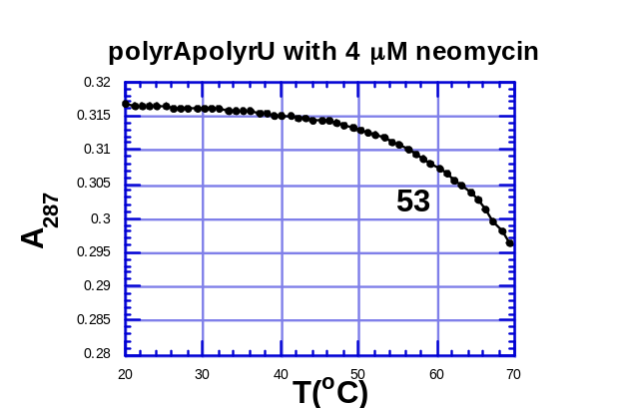 | 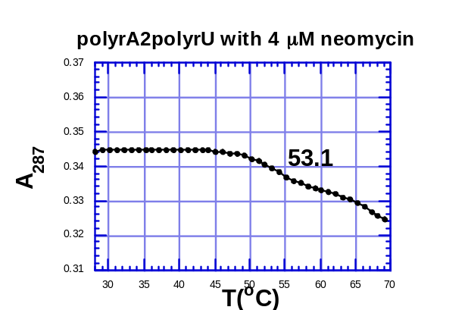

UV melting profiles (280nm) of the poly(rA), poly(rU) and poly(rA)•2poly(rU) in the presence of 35mM NaCl at the indicated ligand concentrations. [RNA]=30μM base triplet. Solution conditions: 10 mM sodium cacodylate buffer, 0.1 mM EDTA, pH 6.8. Samples were heated from 20 to 90°C at 0.2 deg/min.
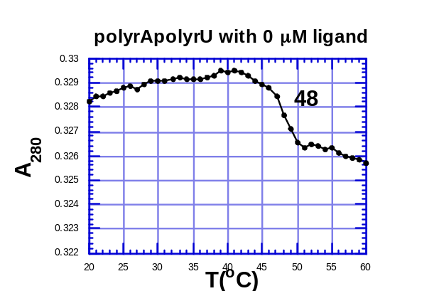 | 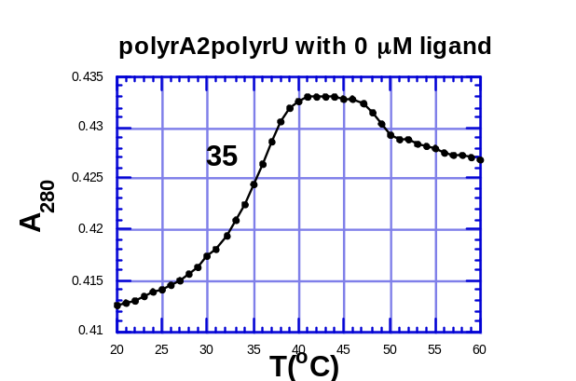
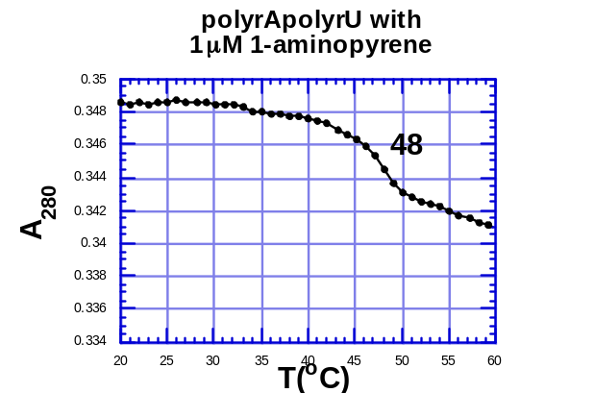 | 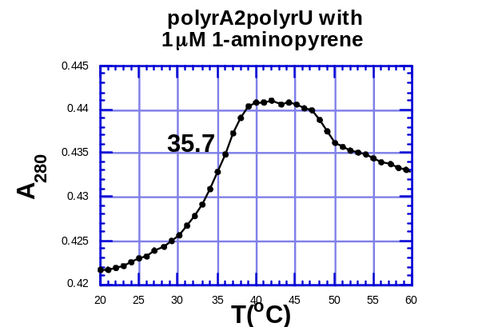
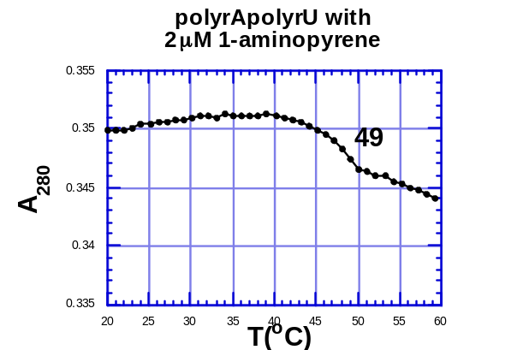 | 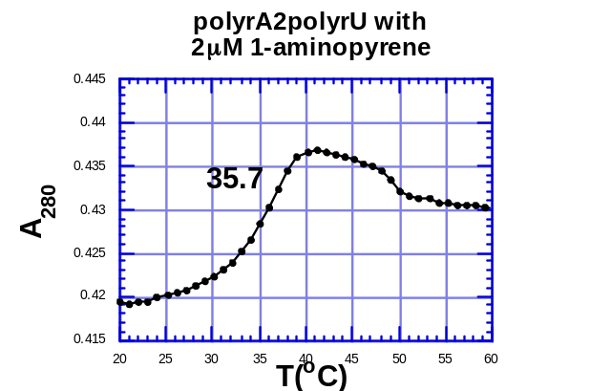
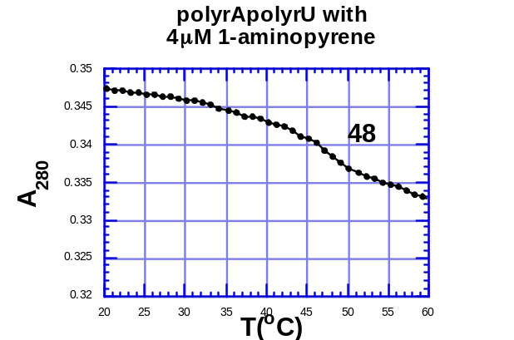 | 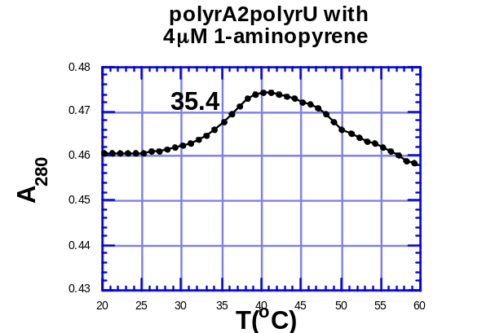

UV melting profiles (284 nm) of the poly(rA), poly(rU) and poly(rA)•2poly(rU) in the presence of 35mM NaCl at the indicated ligand concentrations. [RNA]=30μM base triplet. Solution conditions: 10 mM sodium cacodylate buffer, 0.1 mM EDTA, pH 6.8. Samples were heated from 20 to 90°C at 0.2 deg/.
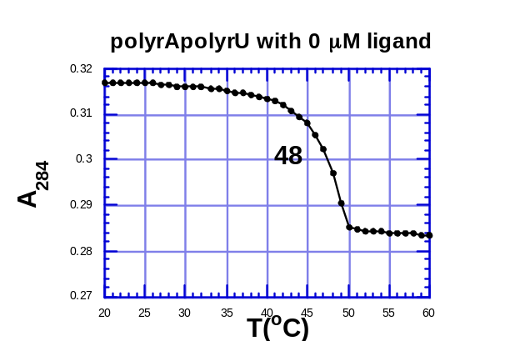 | 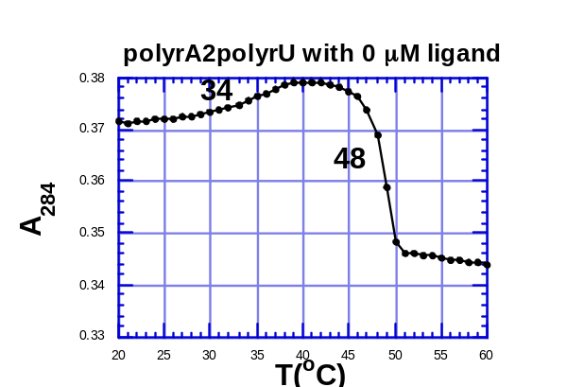
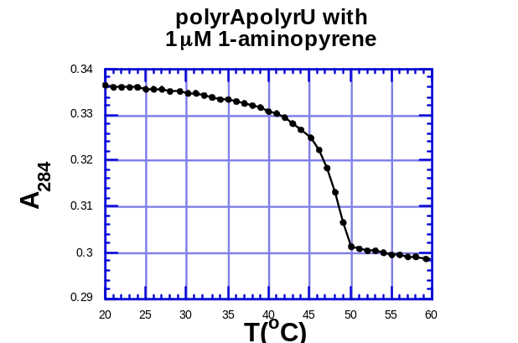 | 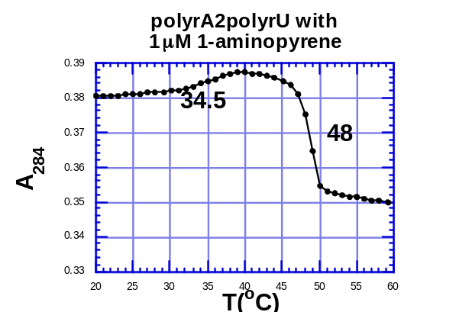
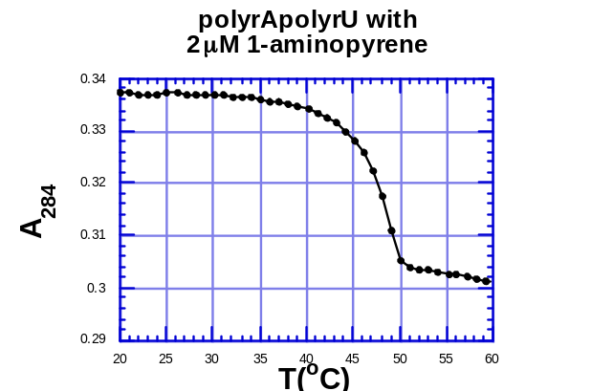 | 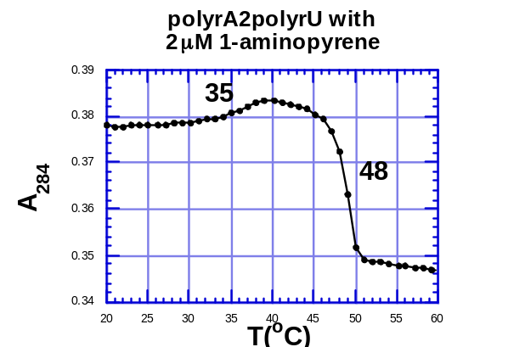
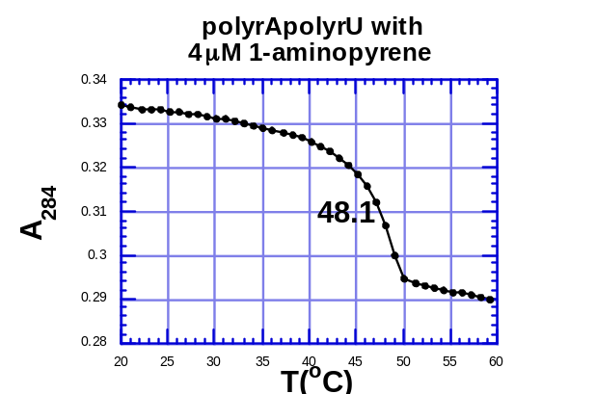 | 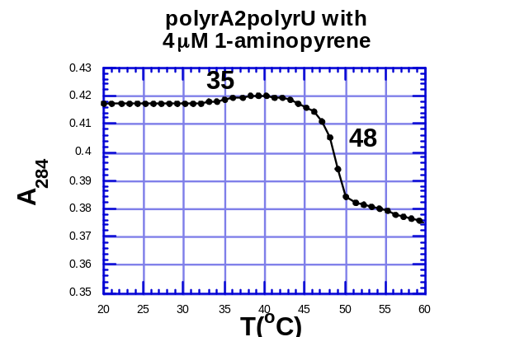

UV melting profiles (287 nm)of the poly(rA), poly(rU) and poly(rA)•2poly(rU) in the presence of 35mM NaCl at the indicated ligand concentrations. [RNA]=30μM base triplet. Solution conditions: 10 mM sodium cacodylate buffer, 0.1 mM EDTA, pH 6.8. Samples were heated from 20 to 90°C at 0.2 deg/min and the samples were brought back to 5°C at a rate of 5 deg/min.
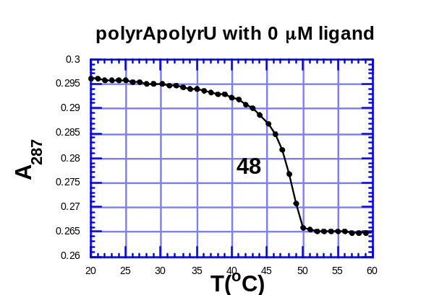 | 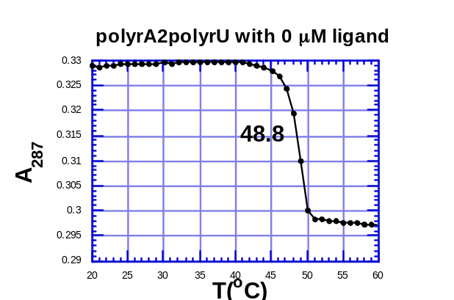
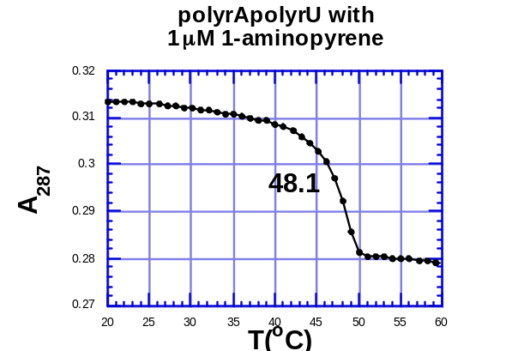 | 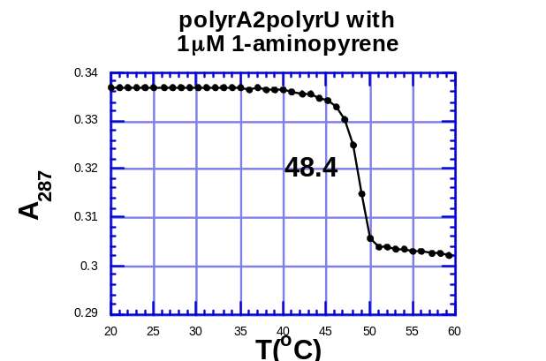
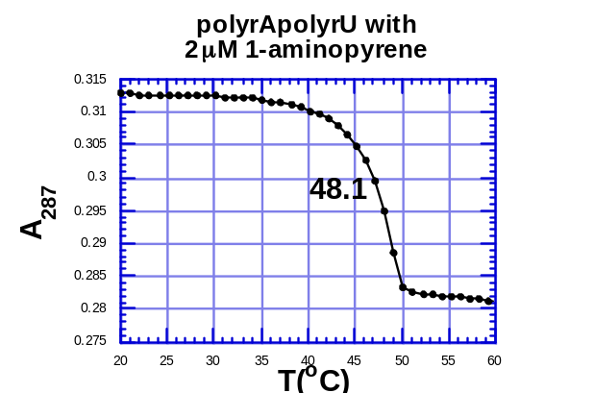 | 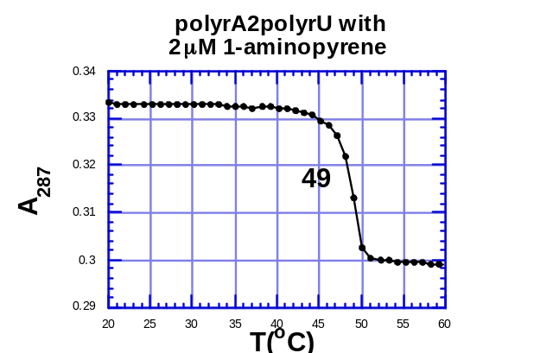
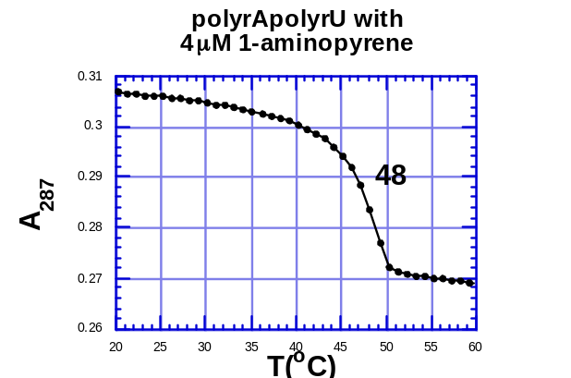 | 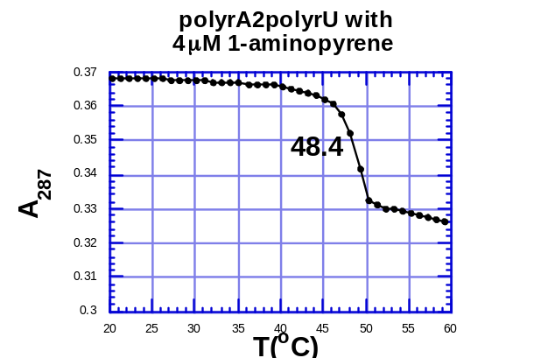

Computer Modeling

Step I: DNA (TAT) triplex conformation

The original structure of dT₁₀dA₁₀dT₁₀ triplex was obtained from the NMR structure reported by Feigon (Biochemistry 1998). 27 sodium ions were added to neutralize the structure. The conformation was then optimized by AMPER* force field, in water, to within a gradient of 0.5 kJ/molÅ. The movements of the atoms of the external bases were restricted during minimization.

Step II: Neomycin conformation

Neomycin structure was built and optimized with MacroModel and SYBYL programs using AMBER* force field. The all atom AMBER* force field has been used since it contains parameters for both neomycin and the DNA triplex. In accordance with NMR experiments, five of the six-neomycin amines were protonated. Conformational searching was done with Monte Carlo routine from MacroModel, using all atom AMBER* force field, the force field charges, and the continuum GB/SA model of water as implemented in MacroModel. All the flexible bonds were selected.
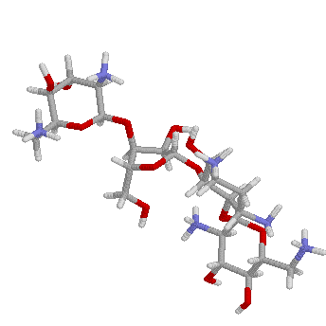
Conformation of neomycin bound to W-H groove.

Step III Pyrene-neomycin conformation

Pyrene-neomycin conformation was generated based on neomycin conformation. The generated conformation was then optimized by AMPER* force field and water as a solvent.

Step IV Docking

After optimizing the pyrene-neomycin conformation, the structure was docked into Waston-Hoogsteen groove of TAT triplex in different orientations. Restricting the movement of the triplex, the structure of the complex was optimized using AMBER* force field and water as a solvent.

