Electronic supplementary information

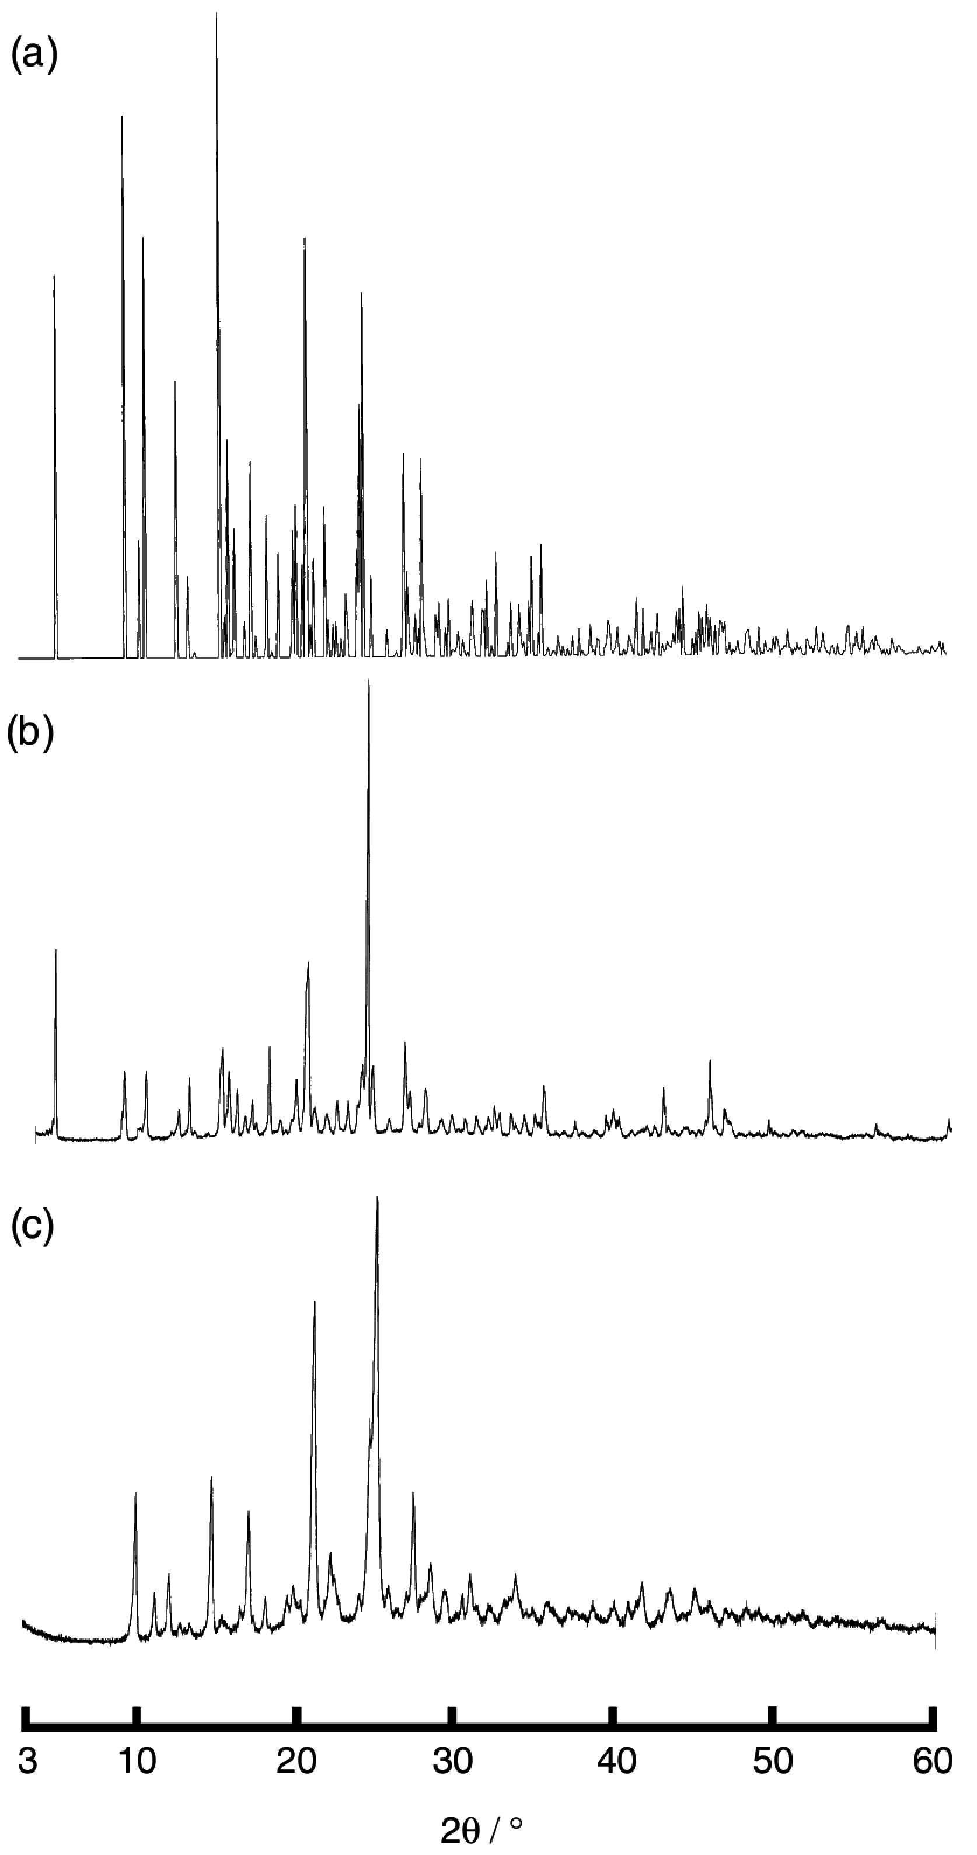

Figure S1. XRPD data : (a) simulation pattern of 2, (b) observed pattern of 2, and (c) observed pattern of 3 replaced by H₂O molecules.

