Direct observation of η²-imine formation through β-H abstraction between amide ligands. Neutron and X-ray diffraction structure of a dihydride imine ditantalum complex

Hu Cai,ª Tianniu Chen,ª Xiaoping Wang,^{b} Arthur J. Schultz,^{b,}* Thomas F. Koetzle,^{c,}* Ziling Xue^{a,}*
ª Department of Chemistry, The University of Tennessee, Knoxville, TN 37996, USA. E-mail: xue@novell.chem.utk.edu
^{b} Intense Pulsed Neutron Source, Argonne National Laboratory, Argonne, IL 60439, USA, E-mail: ajschultz@anl.gov
^{c} Chemistry Department, Brookhaven National Laboratory, Upton, NY 11973, USA, E-mail: koetzle@bnl.gov

Supplementary Information
Synthesis of 1. H₂SiMePh (0.244 g, 2.0 mmol) in pentane was added dropwise at 23 °C with stirring to Ta(NMe₂)₅ (0.803 g, 2.0 mmol) in pentane under N₂. The mixture was stirred overnight, and volatiles were removed in vacuo to give an oily liquid containing yellow solids. The mixture was cooled in a freezer for several days. The yellow solid was collected and dissolved in Et₂O. The ether solution was concentrated and cooled to about –30 °C to yield yellow crystals of 1 (0.343 g, 51%). Reactions monitored by NMR showed almost quantitative formation of 1 in solution. ¹H NMR (d₈-toluene, 23 °C, 400.1 MHz): δ 8.47 (br, 1H, Ta-H_{a}), 6.57 (br, 1H, Ta-H_{b}), 3.81 (s, 6H, NMe₂), 3.47 (br, 7H, NMe₂, N-CH_{c}H_{d}-Ta), 3.35 (s, 18H, NMe₂), 3.10 (s, 6H, NMe₂), 2.96 (s, 3H, CH₃-N-CH₂-), 2.64 (br, 1H, N-CH_{c}H_{d}-Ta). ¹³C NMR (d₈-toluene, 23 °C, 100.6 MHz): δ 90.19 (N-CH₂-Ta), 50.20 (NMe₂), 48.33 (CH₃-N-CH₂-, NMe₂), 46.83 (NMe₂). ²H NMR of 1-d₂ (benzene, 23 °C, 61.4 MHz): δ 8.47 (s, 1D, Ta-D_{a}), 6.55 (s, 1D, Ta-D_{b}). Found: C, 24.86; H, 6.45; N, 14.47. C₁₄H₄₃N₇Ta₂ requires C, 25.04; H, 6.46; N, 14.60%.

Low-temperature NMR of 1. ¹H NMR (toluene-d₈, 400.13 MHz, -28 °C) δ 8.42 (d, 1H, Ta-H_{a}), 6.45 (m, 1H, Ta-H_{b}), 3.94 (s, 3H, NMe_{e}Me_{f}), 3.85 (s, 3H, NMe_{e}Me_{f}), 3.54 (s, 6H, NMe₂), 3.44 (m, 1H, N-CH_{c}H_{d}-Ta), 3.31 (s, 18H, NMe₂), 3.11 (s, 6H, NMe₂), 2.90 (s, 3H, CH₃-N-CH₂-), 2.62 (m, 1H, N-CH_{c}H_{d}-Ta). ¹³C NMR (toluene-d₈, 100.63 MHz, 23 °C) δ 89.68 (N-CH₂-Ta), 53.94 (NMe_{e}Me_{f}), 50.68 (NMe_{e}Me_{f}), 48.45 (NMe₂, CH₃-N-CH₂-), 46.97 (NMe₂).
HNMe₂ confirmation: HNMe₂ was observed in NMR spectra of the reaction mixture to prepare 1. In a separate experiment to prepare 1, the gases above the liquid solution of the reaction mixture in a Schlenk flask were removed by a N₂ flow, and the gas mixture was then bubbled through a solution of 1 M DCl/D₂O or (p-MeC₆H₄)C(O)Cl/pyridine. H(D)NMe₂Cl/(D₂NMe₂)Cl and (p-MeC₆H₄)C(O)NMe₂ were observed as the products, respectively. In the H(D)NMe₂Cl/(D₂NMe₂)Cl solution in DCl/D₂O, no Si-containing species were observed in ¹H and ¹³C{¹H} NMR.
Neutron structure determination of 1a at 20 K. Neutron diffraction data were collected from a single crystal of Ta₂(μ-H)₂(μ-N-η²-N,C-CH₂NMe)(NMe₂)₆ (1a) at the Intense Pulsed Neutron Source (IPNS), Argonne National Laboratory. The single-crystal diffractometer (SCD) is a time-of-flight (TOF) instrument with a time- and position-sensitive detector. Neutrons were produced by the pulsed (30 Hz) spallation source at IPNS, and the SCD instrument used the entire thermal spectrum of neutrons from each pulse. The SCD position-sensitive neutron detector contained a ⁶Li glass scintillator with dimensions of 30 × 30 cm². For a given crystal setting, data were stored in a three-dimensional histogram in which each point had coordinates x, y, and t. These quantities were the horizontal and vertical detector positions and the TOF, respectively. t is related to the neutron wavelength λ by the de Broglie equation λ = (h/m)(t/l), in which h is Planck's constant, m is the neutron mass, and l is the path length traversed in time t. There were 120 time-of-flight channels in each histogram, constructed in such a way that Δt/t had a constant value of 0.015. Each histogram comprised measurements of a three-dimensional block of reciprocal space, from neutrons in the wavelength range of 0.71-4.2 Å. A detailed description of the SCD instrument and data collection and analysis procedures has been published.^{S1,S2} The sample temperature is controlled by a Displex® closed-cycle helium refrigerator (Air Products and Chemicals, Inc., Model CS-202).

An auto-indexing algorithmS3 was used to obtain an initial orientation matrix from the peaks in one histogram. For intensity data collection, 12 histograms were measured - each for a different crystal setting - in order to cover an octant of reciprocal space. Bragg peaks were integrated in three dimensions about their predicted locations and were corrected for the incident neutron spectrum, detector efficiency, and dead-time loss. Lorenz and absorption corrections were also applied. The GSAS software packageS4 was used for structural analysis. The refinement was based on F using reflections with⏐F_{o}⏐ > 3σ(F_{o}). Weights were assigned as wF_{o} = 2F_{o}/(σ_{c}²(F_{o}²) +(0.002F_{o}²)²) where σ_{c}²(F_{o}²) is the variance based on counting statistics. In the final least-squares cycles, all hydrogen atoms were refined with anisotropic atomic displacement parameters. Non-hydrogen atoms were refined isotropically.
Neutron crystal data for 1a: orthorhombic, space group Pbca, a = 14.811(3), b = 16.555(3), c = 18.985(4) , V = 4655(2) ³, T = 20 K, Z = 8, ρ_{calcd} = 1.916 g.cm⁻³, 2775 reflections with I > 3σ(I), R = 0.101, R_{w} = 0.057, GOF = 1.90.
X-ray crystal structure determination of Ta₂(μ-H)₂(μ-N-η²-N,C-CH₂NMe)(NMe₂)₆ (1). Two different unit cells in the X-ray crystal structures (1a and 1b) of 1 were found in crystals from two separate batches of crystallization, and both were solved. The two X-ray structures 1a and 1b were found to be similar, and the orthorhombic structure 1a is analogous to that from neutron diffraction. Data were collected at 173(2) K on a BRUKER AXS Smart 1000 X-ray diffractometer equipped with a CCD area detector and a graphite-monochromated Mo Source (K_{α} radiation, 0.71073 Å). The structure 1a was solved by direct methods while automatic Patterson interpretation was applied to the structure 1b. Non-hydrogen atoms were refined anisotropically. All hydrogen atoms in the X-ray structures 1a and 1b were treated as idealized contributions except for the two bridged hydrogen atoms attached directly to the Ta atoms, which were located from the electron density maps and refined isotropically. Empirical absorption correction was conducted with SADABS.^{S5} In addition the global refinements for the unit cells and data reductions in the X-ray structures 1a and 1b were performed under Saint program (Version 6.02) and all calculations were performed using the SHELXTL (Version 5.1) proprietary software package.^{S5} For X-ray structures of both 1a and 1b, R = Σ ||F_{o}| - |F_{c}||/Σ|F_{o}|; R_{w} = (Σ[w(F_{o}² – F_{c}²)²]/Σ[wF_{o}²)²]^{1/2}. ORTEP drawings of 1a and 1b are given in Figures S1 and S2, respectively.
X-ray crystal data for 1a: crystal dimension = 0.41 × 0.22 × 0.12 mm, orthorhombic, Pbca, a = 14.8544(6), b = 16.5918(7), c = 19.2122(8) , V = 4735.1(3) ³, Z = 8, ρ_{calcd} = 1.884 gcm⁻³, θ = 2.12-26.4, μ = 9.246 mm⁻¹, -18 ≤ h ≤ 18, -20 ≤ k ≤ 20, -24 ≤ I ≤ 23, 44653 measured reflections, 4858 independent reflections (R_{int} = 0.0614), 4858 observed reflections with I > 2σ(I), 229 parameters were refined, R = 0.0256, R_{w} = 0.0603, GOF = 1.122.
X-ray crystal data for 1b: crystal dimension = 0.15 × 0.12 × 0.09 mm, monoclinic, P2₁/c, a = 13.004(4), b = 11.211(4), c = 15.801(5) , β = 96.866(5), V = 2287.2(13) ³, Z = 4, ρ_{calcd} = 1.950 gcm⁻³, θ = 1.58-23.36, μ = 9.571 mm⁻¹, -14 ≤ h ≤ 14, -12 ≤ k ≤ 12, -17 ≤ I ≤ 17, 13943 measured reflections, 3306 independent reflections (R_{int} = 0.0782), 3306 observed reflections with I > 2σ(I), 229 parameters were refined, R = 0.0260, R_{w} = 0.0621, GOF = 0.964.

Additional References
S1. Schultz, A. J.; Van Derveer, D. G.; Parker, D. W.; Baldwin, J. E. Acta Crystallogr., Sect. C, 1990, C46, 276.
S2. Schultz, A. J. Trans. Am. Crystallogr. Assoc., 1987, 23, 61.
S3. Jacobson, R. A. J. Appl. Crystallogr., 1986, 19, 283.
S4. Larson, A. C.; Von Dreele R. B. GSAS General Structural Analysis System. Los Alamos National Laboratory, New Mexico, U.S.A., 2000.
S5. (a) Sheldrick, G. M. SADABS, Aprogram for Empirical Absorption Correction of Area Detector Data; University of Gottingen, Gottingen, Germany, 1996. (b) Sheldrick, G. M. SHELXL-97, A Program for the Refinement of Crystal Structures, University of Gottingen, Gottingen, Germany, 1997.

Figure S1. ORTEP of 1a, showing 50% thermal ellipsoids.

Figure S2. ORTEP of 1b, showing 50% thermal ellipsoids.
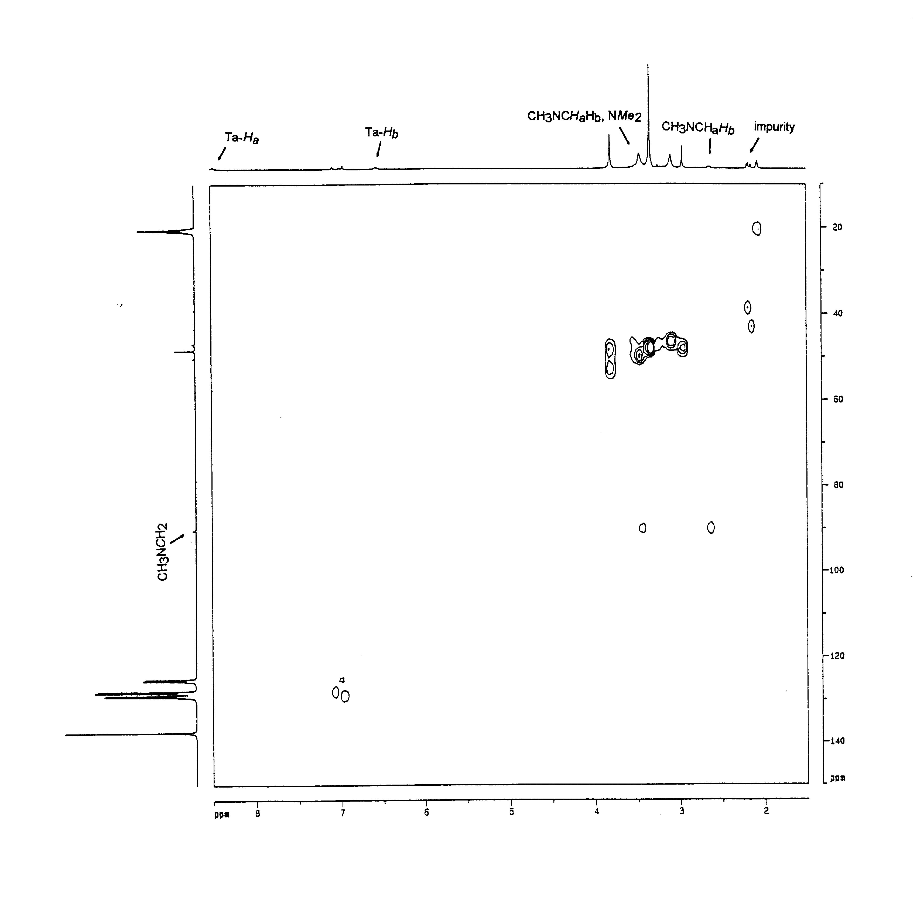

Figure S3. HMQC spectrum of 1 at 23 ˚C.
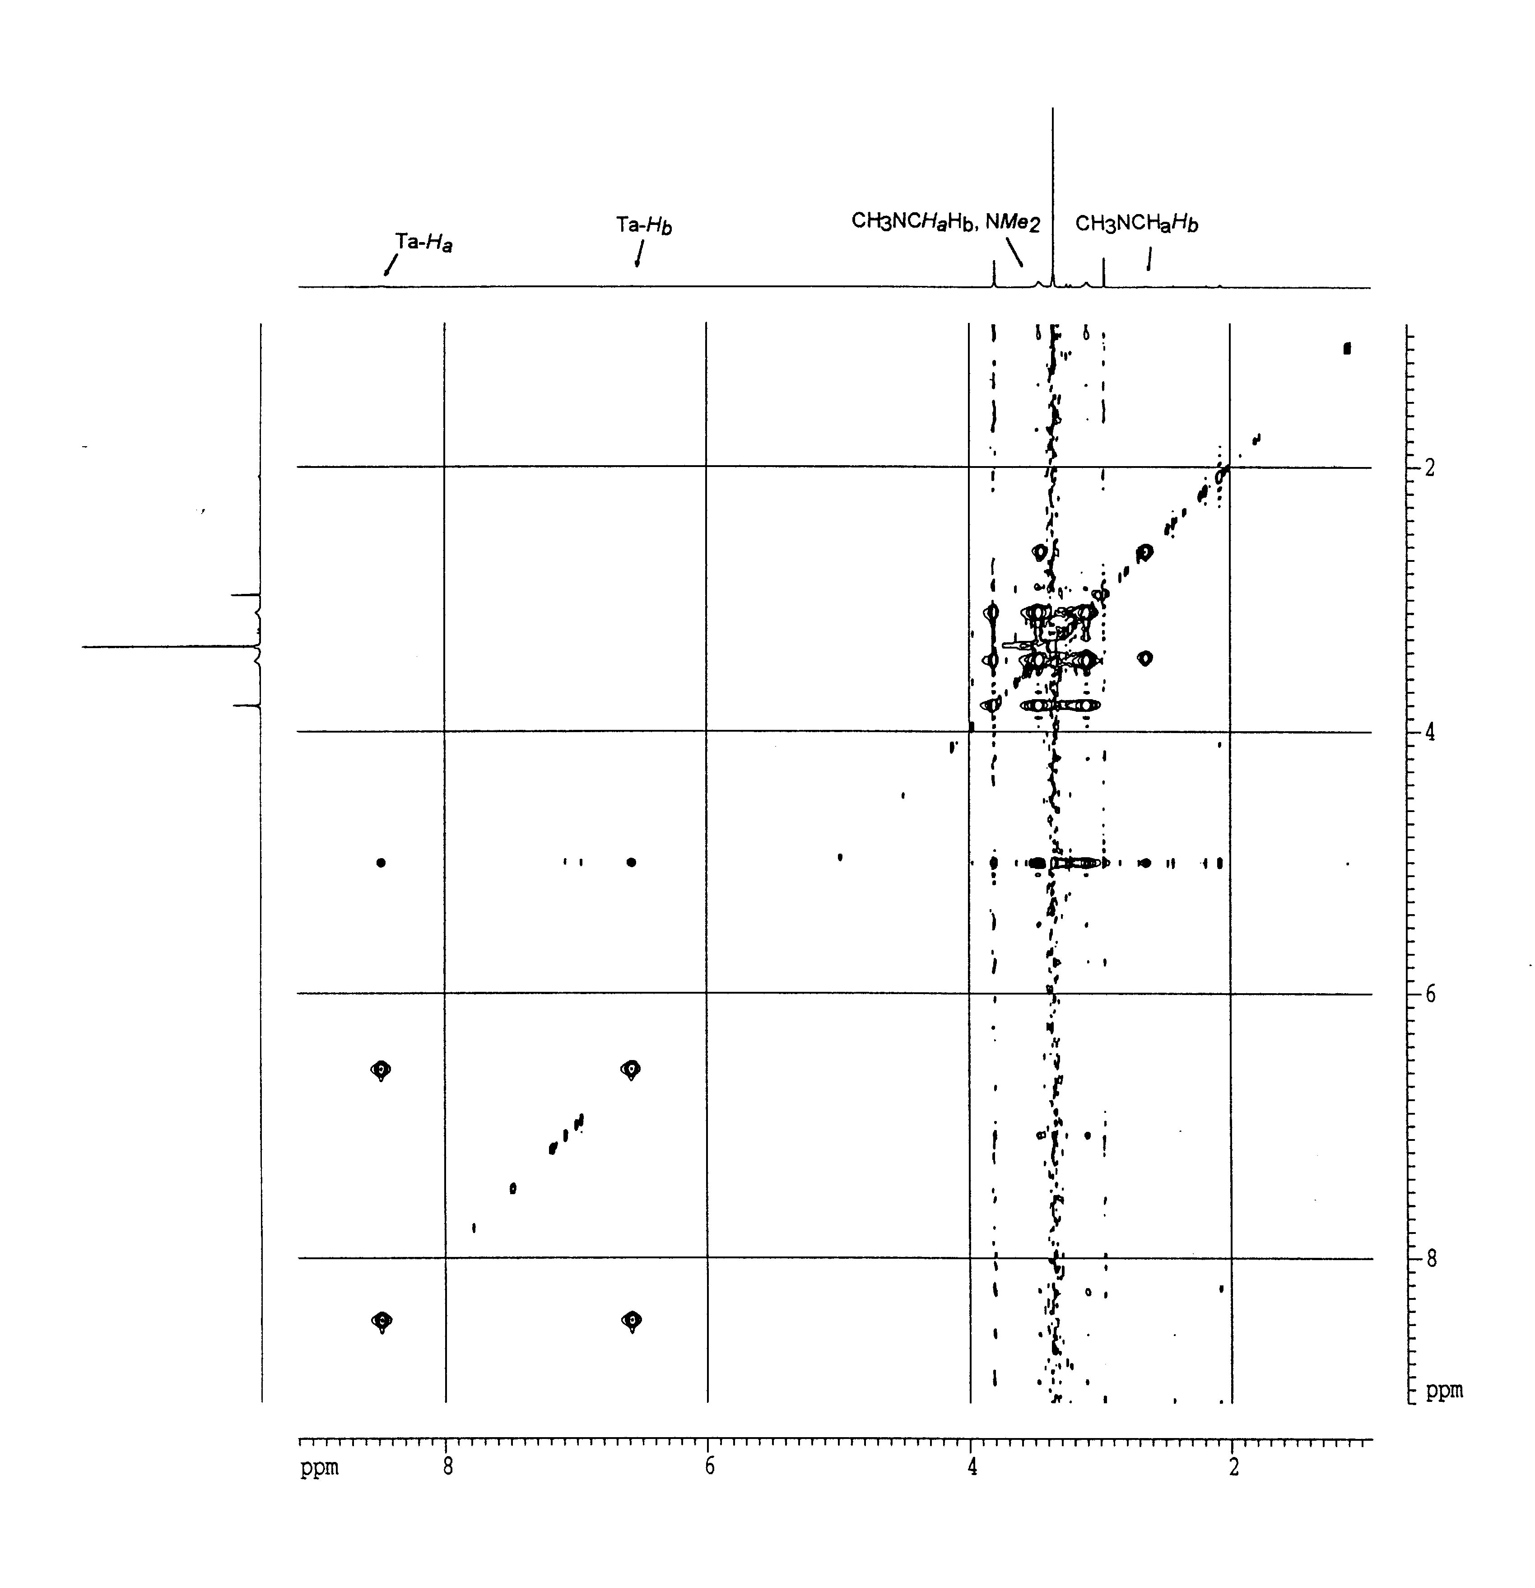

Figure S4. Positive peaks in NOESY spectrum of 1 at 23 ˚C (t_{mix} = 2 s).

