Light-harvesting metal dendrimers appended with additional organic chromophores: a tetranuclear heterometallic first-generation dendrimer exhibiting unusual absorption features.

Nathan D. McClenaghan, Frédérique Loiseau, Fausto Puntoriero, Scolastica Serroni and Sebastiano Campagna.
Manuscript no. B109068B

SUPPLEMENTARY INFORMATION

Synthesis of 4-methyl-4’-[2-(1-pyrenyl)ethyl]-2,2’-bipyridine

The ligand 4,4’-Dimethyl-2,2’-bipyridine (0.50 g) was dissolved in dry THF (40 ml) under nitrogen atmosphere. After cooling to –10 °C, lithium diisopropylamide (Aldrich, 2 M; 1.2 ml) was added dropwise in a 5 min period via syringe. After stirring for an additional 45 min period, a solution of 1-(chloromethyl)pyrene (0.48 g) in THF (25 ml) was introduced dropwise by cannula. The reaction mixture was stirred at –10 °C for 30 min, and then allowed to warm to ambient temperature and reacted furtherly for 20 h. After this time, water (5 ml) was added dropwise and solvents were removed under reduced pressure. The residue was then dissolved in dichloromethane and washed with water. The separated organic phase was dried over magnesium sulfate, filterered and the solvent was removed. The residue was then triturated with methanol:water, 4:1 v/v (20 ml). The resulting solid was collected and then triturated with methanol (25 ml). The product, which was collected by filtration and dried under vacuum, was an off-white powder (yield = 63%).

1H NMR (CDCl3): 8.58 - 8.55 (m, 2H), 8.40 - 7.81 (m, 11H), 7.17 - 7.10 (m, 2H), 3.73 (t, 2H, J = 8 Hz), 3.26 (t, 2H, J = 8 Hz), 2.45 (s, 3H). Elemental analysis data (for C29H22N2), calc. (found): C, 87.40 (87.28); H, 5.57 (5.59); N, 7.03% (6.99%). #

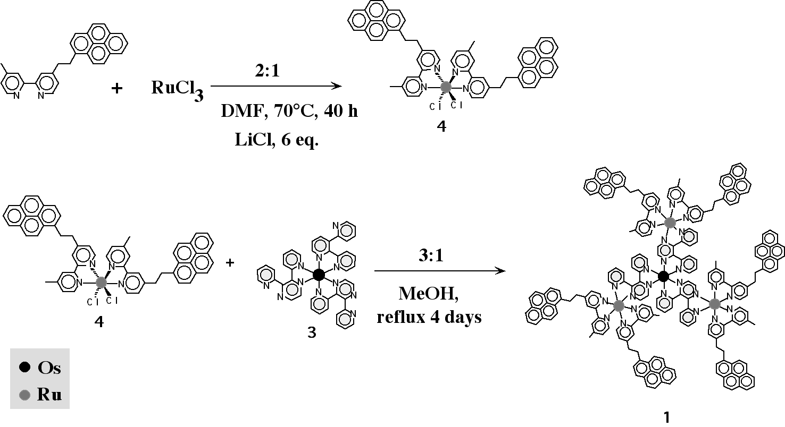

Fig. S1 Synthetic scheme for 1. Charges are omitted for clarity.

