Supplementary Information

- TGA Studies

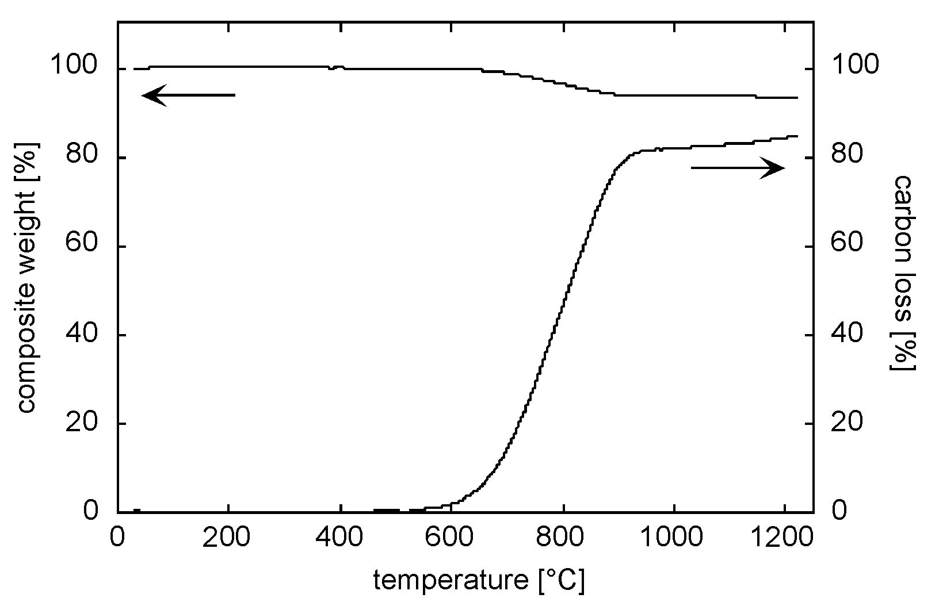

The TGA plot shows the upper curve as the total weight loss, whereas the other plot represents the total carbon loss relative to the total C-content exhibiting saturation at ca. 84 %.

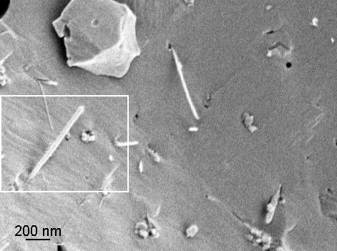

This SEM image depicts a cracked surface of the MWNT/SiO_{x} composite after the TGA measurement (carried out up to 1220 °C) of this particular sample. It is noteworthy that the coated tubes have survived oxidation, fact that is commensurate with the TGA curve.

* Mechanical Properties

4-point bending tests of the bulk MWNT/SiOx composite revealed a bending strength between 10 and 24 MPa and a Young’s-modulus of ca. 31 GPa. We believe that these values can be enhanced further if the MWNT-content is increased and the microstructure of the matrix optimised.

