Supplementary Information

Experimental section:

- Synthesis of the anodic aluminum oxide (AAO) membrane:

High purity (99.999%) aluminum plate was annealed in vacuum (500 ℃ ) for 5 hours and degreased in acetone. Aluminum foils were electropolished at 0~5 ℃ in a mixed electrolyte of perchloric acid and ethanol (20/80 by volume). The foils were then anodized galvanostatically, without current decay, in various conditions at a constant voltage.¶ When the anodization was complete, porous membrane was detached by the voltage reduction method, and washed with deionized water.

¶ Anodization condition: 5% sulfuric acid at 18 V for 20 nm diameter, 2% oxalic acid at 40 V for 70 nm, and at 60 V for 130 nm diameter nanochannels.

- Insertion of organic luminants into AAO nanochannels:

The AAO membrane was dried in vacuum at 100 ℃ for 2 hours. Organic luminants were sublimated under vacuum(~10⁻² torr) for ca. 2 hours until the AAO nanochannels were completely filled. The sublimation temperature was 80~90 ℃ for pyrene and 150~160 ℃ for POPOP. After the sublimation was completed, the excess organic molecules on the surface was washed out with acetone and chloroform.

POPOP molecule

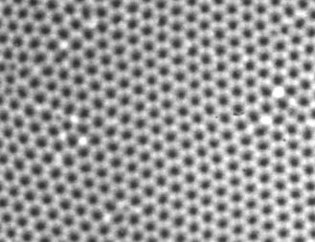
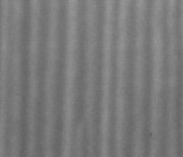

Fig. S1 SEM micrograph of the vacant AAO membrane with 70 nm channels (scale bar = 1 μm, the inset shows crosssectional view of AAO membrane.)

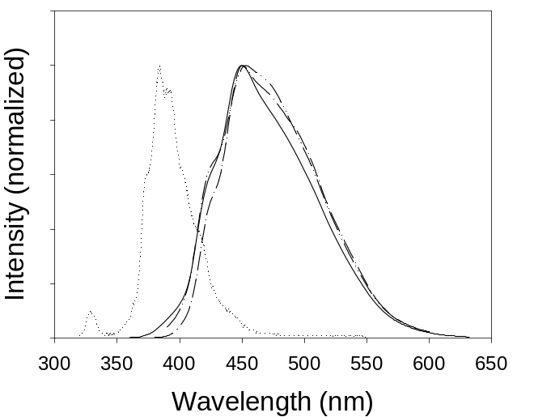

Fig. S2 Emission spectra of various pyrene samples in the AAO membranes: in solution (dotted), 20 nm nanowires (dash-double dotted), 70 nm nanowires (dash-dotted), and bulks (solid)

