Supplementary data
Zipping up ‘the crushed fullerene’ C₆₀H₃₀: C₆₀ by fifteen-fold, consecutive intramolecular H₂ losses†

Berta Gómez-Lor,^{a,b} Carola Koper,^{c} Roel H. Fokkens,^{d} Edward J. Vlietstra,^{c} Thomas J. Cleij,^{c} Leonardus W. Jenneskens,^{c*} Nico M. M. Nibbering^{e} and Antonio M. Echavarrenª

ª Departamento de Quimica Orgánica, Universidad Autónoma de Madrid, Cantoblanco, 28049 Madrid, Spain.
^{b} Instituto de Ciencia de Materiales de Madrid, CSIC, Cantoblanco, 28049 Madrid, Spain.
^{c} Debye Institute, Department of Physical Organic Chemistry, Utrecht University, Padualaan 8, 3584 CH Utrecht, The Netherlands. Email: jennesk@chem.uu.nl
^{d} Supramolecular Chemistry and Technology, MESA⁺ Research Institute, University of Twente, P.O. Box 217, 7500 AE Enschede, The Netherlands.
^{e} Laser Centre and Chemistry Department, Vrije Universiteit, De Boelelaan 1083, 1081 HV Amsterdam, The Netherlands.
Chart_sd 4,5-Dihydro[l]benzacephenanthrylene (2, C₂₀H₁₂), decacyclene (3, C₃₆H₁₈) and benzo[1,2-e:3,4-e’:6,5-e’’]triacephenanthrylene (4, C₄₈H₂₄), and the C₆₀ Schlegel diagram with recommended numbering schemeª commencing in the central hexagon.

ª See R. Taylor, J. Chem. Soc, Perkin Trans 2, 813 (1993).
Fig. 1_sd. AM1¹³ optimised geometries, heats of formation (ΔH_{f}⁰ in kcal/mol) and first ionisation potentials (I_{v,1} = -ε₁ in eV) of 1a (C₆₀H₃₀), C₆₀H₂₄, C₆₀H₁₈, C₆₀H₁₂, ring-opened C₆₀H₆, C₆₀H₄ and C₆₀H₂ (5,6) and, ring-closed C₆₀H₆, C₆₀H₄ (5,6; 5,6 and 6,6; 6,6) and C₆₀H₂ (5,6 and 6,6) and C₆₀ with their corresponding Schlegel diagrams (see also Chart_sd).

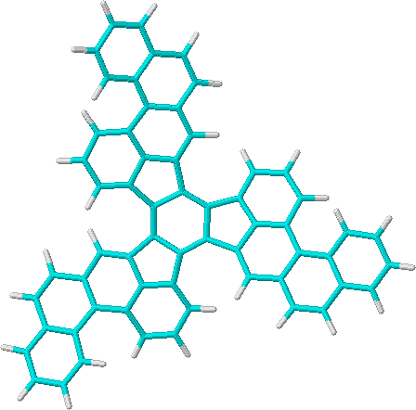

1a, C₆₀H₃₀
ΔH_{f}⁰ 344.6 (C₃) kcal/mol (I_{v,1} 8.12 eV)

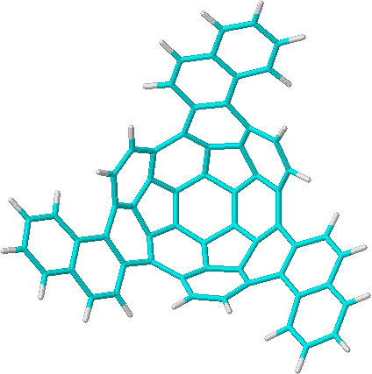

C₆₀H₂₄
ΔH_{f}⁰ 481.0 (C₃) kcal/mol (I_{v,1} 8.47 eV)

Fig. 1_sd continued.

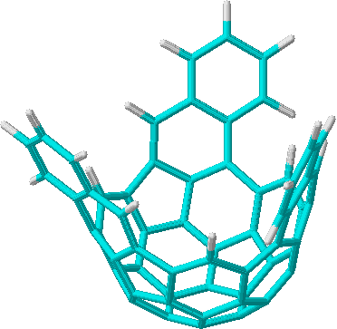

C₆₀H₁₈
ΔH_{f}⁰ 625.7 (C₃) kcal/mol (I_{v,1} 8.60 eV)

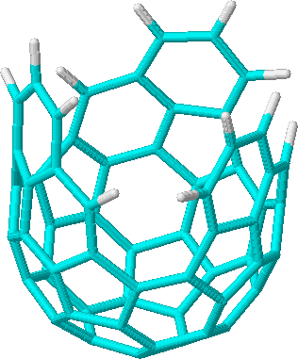

C₆₀H₁₂
ΔH_{f}⁰ 777.2 (C₃) kcal/mol (I_{v,1} 8.89 eV)

Fig. 1_sd continued.

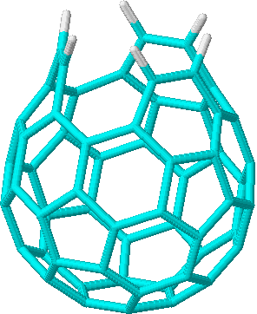

ring-opened C₆₀H₆
ΔH_{f}⁰ 874.3 (C_{3v}) kcal/mol (I_{v,1} 9.15 eV)

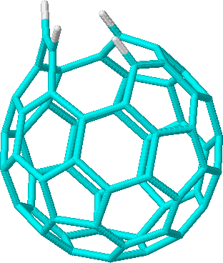

ring-opened C₆₀H₄
ΔH_{f}⁰ 930.5 (C_{s}) kcal/mol (I_{v,1} 9.13 eV)

Fig. 1_sd continued.

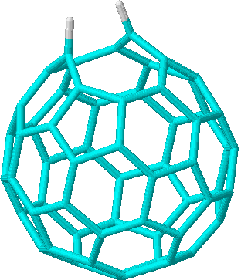

ring-opened (5,6) C₆₀H₂ (not a proper minimum¶)
ΔH_{f}⁰ 977.5 (C_{s}) kcal/mol (I_{v,1} 9.22 eV)

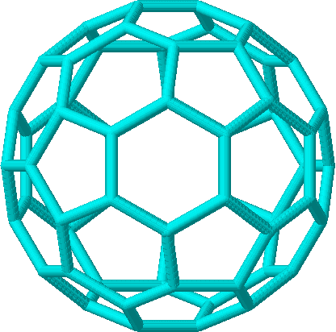

C₆₀
ΔH_{f}⁰ 973.4 (I_{h}) kcal/mol (I_{v,1} 9.64 eV)

Fig. 1_sd continued.

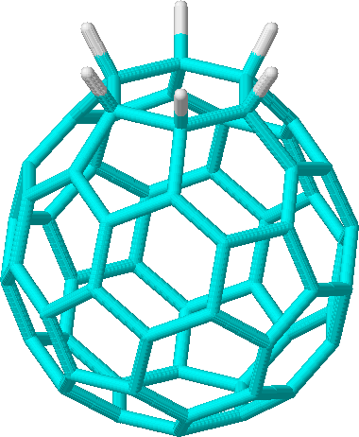

ring-closed C₆₀H₆ from ring-opened C₆₀H₆ via a thermally allowed 2+2+2 cycloaddition (see text).
ΔH_{f}⁰ 865.3 (C_{3v}) kcal/mol (I_{v,1} 9.06 eV)

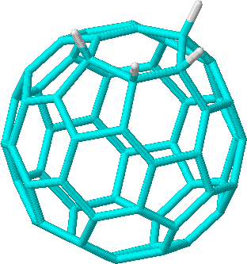

ring-closed (5,6; 5,6) C₆₀H₄
ΔH_{f}⁰ 892.2 (C_{s}) kcal/mol (I_{v,1} 9.21 eV)

Fig. 1_sd continued.

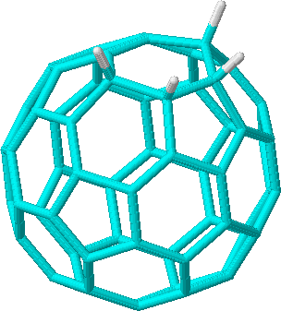

ring-closed (6,6; 6,6) C₆₀H₄
ΔH_{f}⁰ 901.1 (C_{s}) kcal/mol (I_{v,1} 9.16 eV)

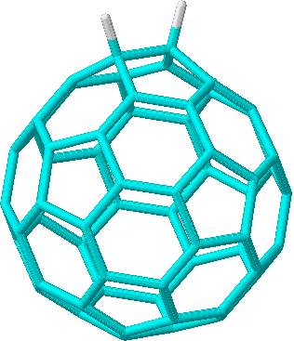

ring-closed (5,6) C₆₀H₂
ΔH_{f}⁰ 950.0 (C_{s}) kcal/mol (I_{v,1} 8.93 eV)

Fig. 1_sd continued.

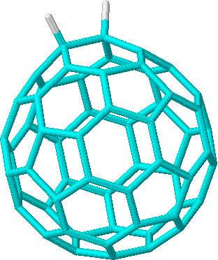

ring-closed (6,6) C₆₀H₂
ΔH_{f}⁰ 931.2 (C_{2v}) kcal/mol (I_{v,1} 9.26 eV)

Fig. 2_sd. Post-source-decay (PSD) MALDI TOF-MS (positive-ion mode) spectrum of 1a^{.+} (m/z 750, laser fluence of ca. 440 μJ/pulse).

