Supplementary data

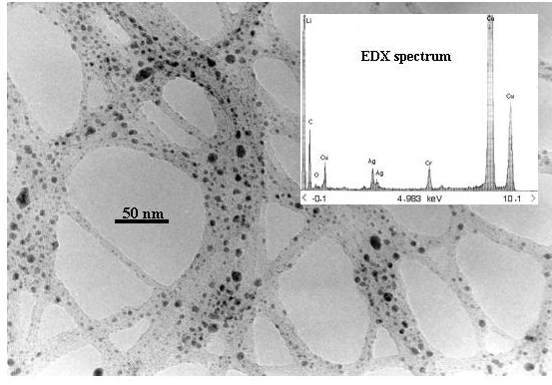

TEM image (JEOL 2000FX) of SWNTs decorated with silver colloids. Inset is the energy dispersive X-ray (EDX) spectrum, which clearly shows the presence of silver.

