Supplementary data

Heterogeneous enantioselective epoxidation of olefins catalysed by unsymmetrical (salen)Mn(III) complexes supported on amorphous or MCM-41 silica through a new triazine-based linker.

Franca Bigi,* Leni Moroni, Raimondo Maggi and Giovanni Sartori
Department of Organic and Industrial Chemistry, University of Parma, Parco Area delle Scienze 17/A, 43100 Parma, Italy. Fax: ++390521905472; Tel: ++390521905411; E-mail: bigi@unipr.it

Synthesis of compound 1. A solution of n-octanol (2.6 g, 20 mmol) in toluene (5 mL) was dropped to a mixture of cyanuric chloride (3.69 g, 20 mmol), K₂CO₃ (2.76 g, 20 mmol) and 18-crown-6 (0.16 g ,0.6 mmol) in dry toluene (20 mL). The mixture was stirred at room temperature for 20 h and the reaction could be checked by GC-MS analysis. Then N,N-diisopropylethylamine (2.59 g, 3.42 mL, 20 mmol) and (3-aminopropyl)triethoxysilane (4.43 g, 4.7 mL, 20 mmol) were added. After stirring at room temperature for 1 h the reaction mixture was filtered from celite. The removal of the solvent under reduced pressure gave a viscous oil which was purified by silica gel chromatography using a hexane/ethyl acetate mixture (85/15) as eluant. Compound 1 was obtained (7.41 g, 80%) as a colourless oil. MS (CI) (m/z; int. rel. %): 462 (M+, 10), 381 (20), 285 (25), 173 (25), 163 (100).

The ¹H NMR spectrum of this 1,3,5-triazine derivative presents more signals than expected; we have attributed this to the presence of rotational isomerism. We observed the same phenomena for all of the compounds reported in this paper. Indeed the spectrum of salen 4A recorded at higher temperature is simpler, as it can be see in Fig.6 and 7.
A deeper investigation of this isomerism will be presented in a next paper.

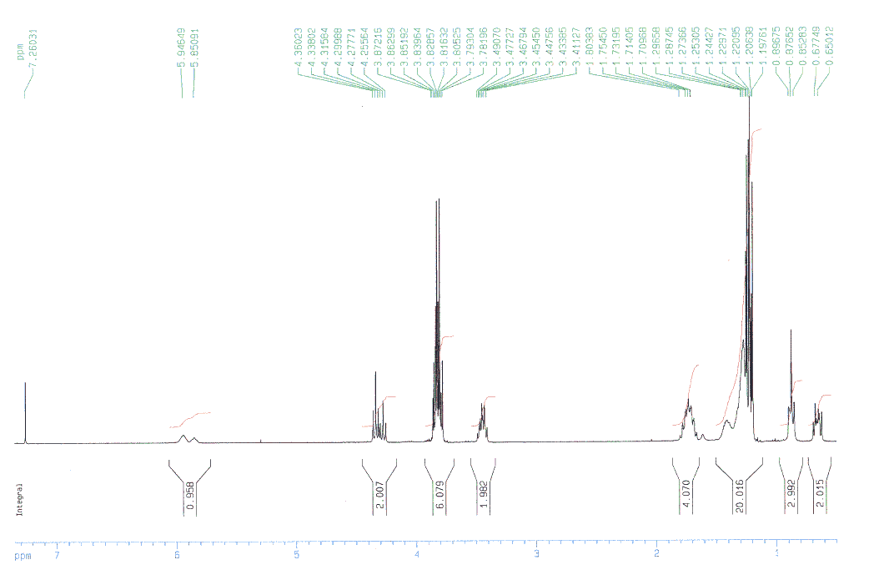

Fig. 1 ¹H NMR (300 MHz) of compound 1 in CDCl₃ at 300K

Synthesis of compound 3A. To a stirred solution of 2,4-dihydroxybenzaldehyde (0.69 g, 5 mmol) in tetrachloroethene (100 mL) [or in 1,1,1-trichloroethane (40 mL)] n.butyllithium (3.13 mL of 1.6 M solution in hexane) was slowly added under nitrogen. Then N,N,N’,N’-tetramethylethylenediamine (0.58 g, 0.75 mL, 5 mmol) and a solution of compound 1 (2.32 g, 5 mmol) in the same solvent (15 mL) were added. The mixture was refluxed for 45 min [or 90 min]. After cooling to room temperature the reaction was filtered and the solvent removed under reduced pressure. The column chromatographic separation using an hexane/ethyl acetate mixture (80/20) as eluant gave compound 3A (1.84 g, 65%) as viscous oil, accompanied by the regio-isomer due to the reaction of hydroxy group in 2-position (0.37 g, 13%). Anal. Calc. For C₂₇H₄₄N₄O₇Si: C, 57.42; H, 7.85; N 9.92. Found: C 57.30; H 7.73; N 9.61%.

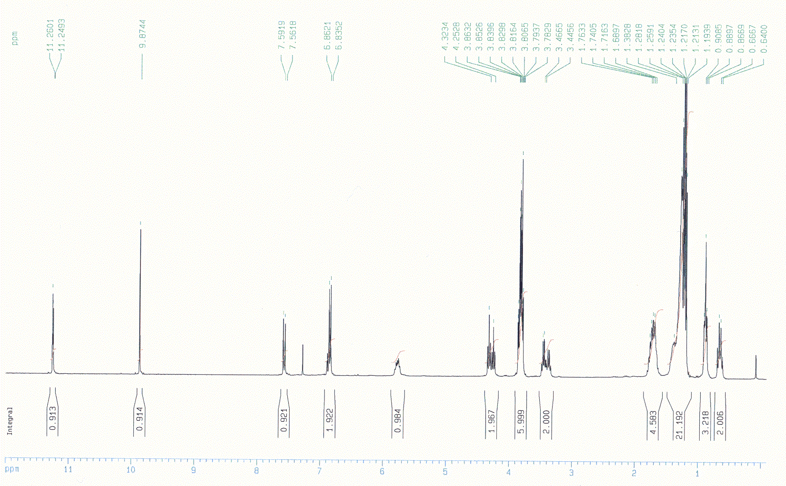
Fig. 2 ¹H NMR (300 MHz ) of compound 3A in CDCl₃ at 300K

Synthesis of compound 3B. To a stirred solution of 2,5-dihydroxy-3-tert-butylbenzaldehyde (0.97 g, 5 mmol) in tetrachloroethene (20 mL) n.butyllithium (3.13 mL of 1.6 M solution in hexane, 5 mmol) was slowly added under nitrogen. Then N,N,N’,N’-tetramethylethylenediamine (0.58 g, 0.75 mL, 5 mmol) and a solution of compound 1 (2.32 g, 5 mmol) in tetrachloroethane (15 mL) were added. The mixture was refluxed for 45 min. After cooling to room temperature the reaction was filtered and the solvent removed under reduced pressure. The column chromatographic separation using an hexane/ethyl acetate mixture (70/30) as eluant gave compound 3B (2.55 g, 82%) as viscous oil which solidified upon standing in refrigerator. Anal. Calc. For C₃₁H₅₂N₄O₇Si: C, 59.97; H, 8.44; N, 9.02. Found: C, 59.88; H, 8.43; N, 8.68% .

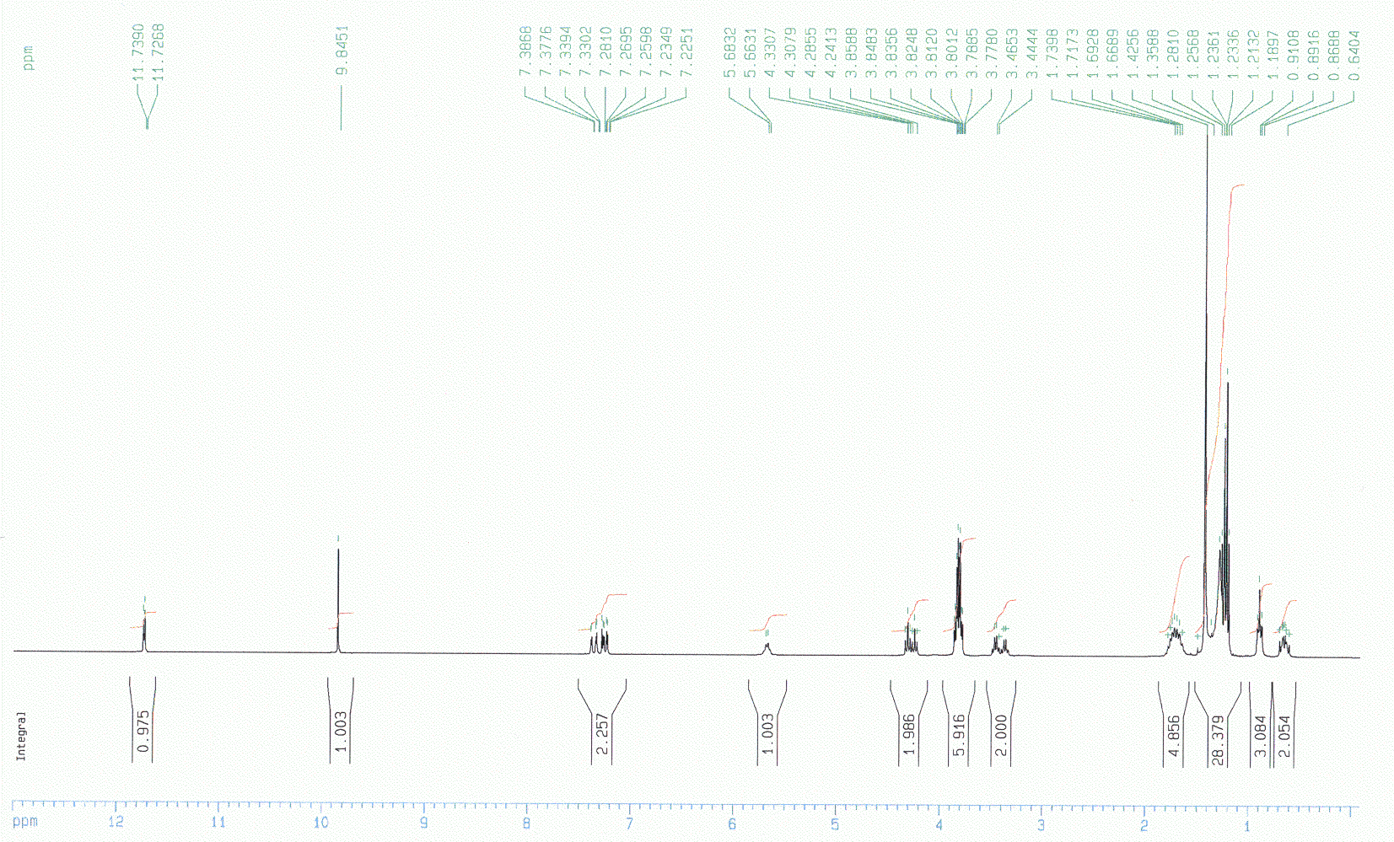

Fig. 3 ¹H NMR (300 MHz ) of compound 3B in CDCl₃ at 300K

Synthesis of compounds 4A and 4B. To a solution of 3,5-di-tert-butyl-2-hydroxybenzaldehyde (2.81 g, 12 mmol) and 4 mmol of compound 3A or 3B in CH₂Cl₂ (30 mL) was added (1S,2S) or (1R, 2R)- 1,2-diaminocyclohexane (0.91 g, 8 mmol). The reaction mixture was stirred at room temperature for 12 h, then concentrated to yield a yellow foam. This product mixture could be used without further purification in the preparation of 6A or 6B. The mixture of salen ligands could be separated by silica gel chromatography. The purification of imines 4A and 4B was not an easy task, due to the hydrolysis of the imine bond. Thus the yields obtained after chromatography using hexane/ethyl acetate mixtures (70/30 or 75/25 + 1% Et₃N) as eluant were lower than expected (56% theoretical yield^{Ref.6}).

Compound 4A: Anal. Calc. For C₄₈H₇₆N₆O₇Si: C,65.72; H, 8.73; N, 9.58. Found: C, 65.39; H, 8.54; N, 9.32%.

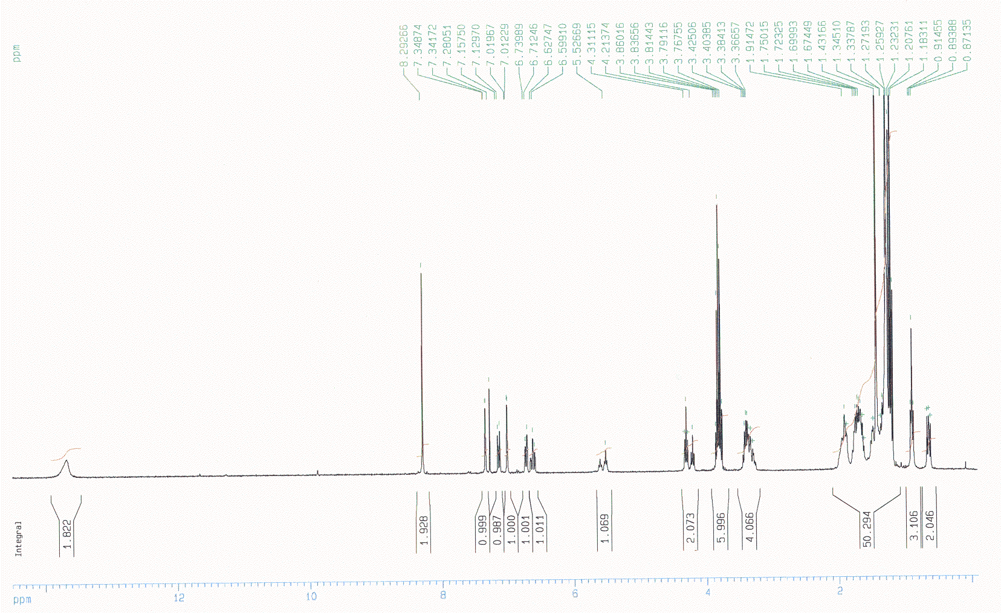

Fig. 4 ¹H NMR (300 MHz) of compound 4A in CDCl₃ at 300K

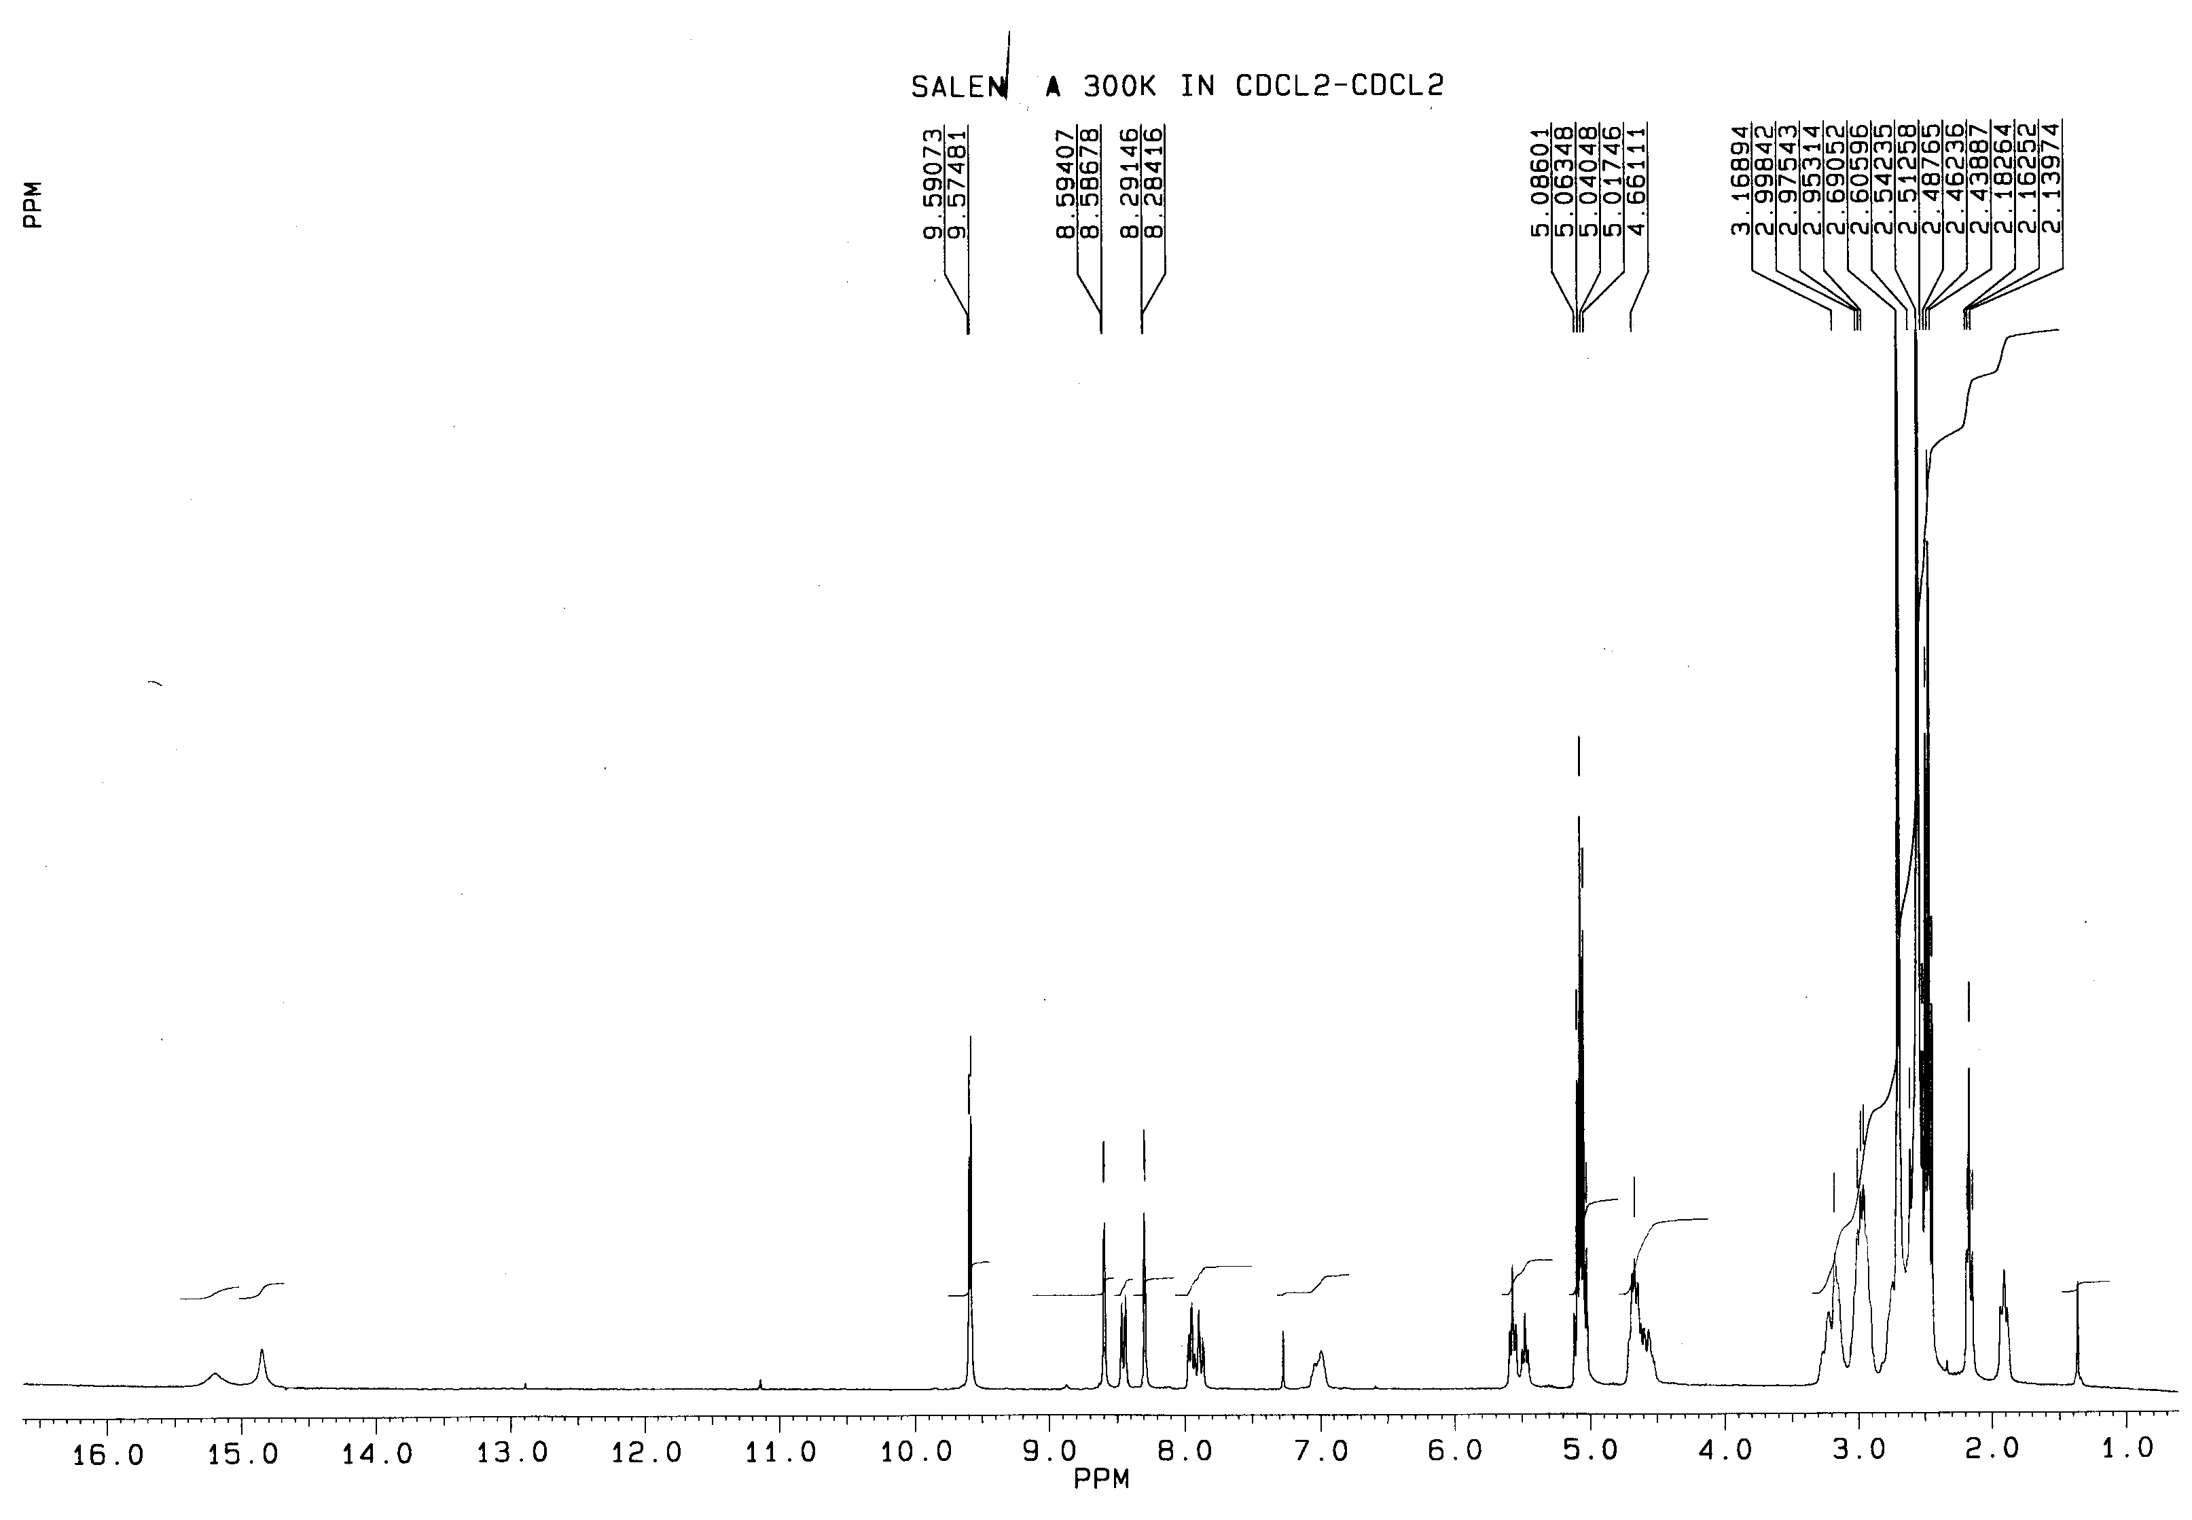

Fig. 5 ¹H NMR (300 MHz) of compound 4A in (CDCl₂)₂ at 300K

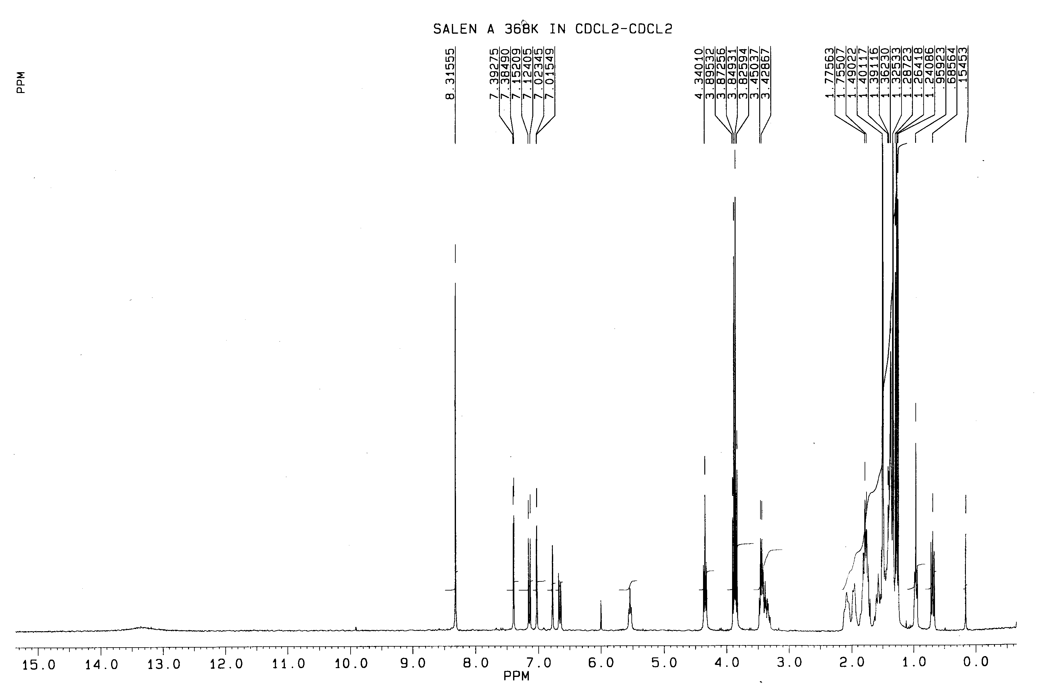
Fig. 6 ¹H NMR (300 MHz) of compound 4A in (CDCl₂)₂ at 368K

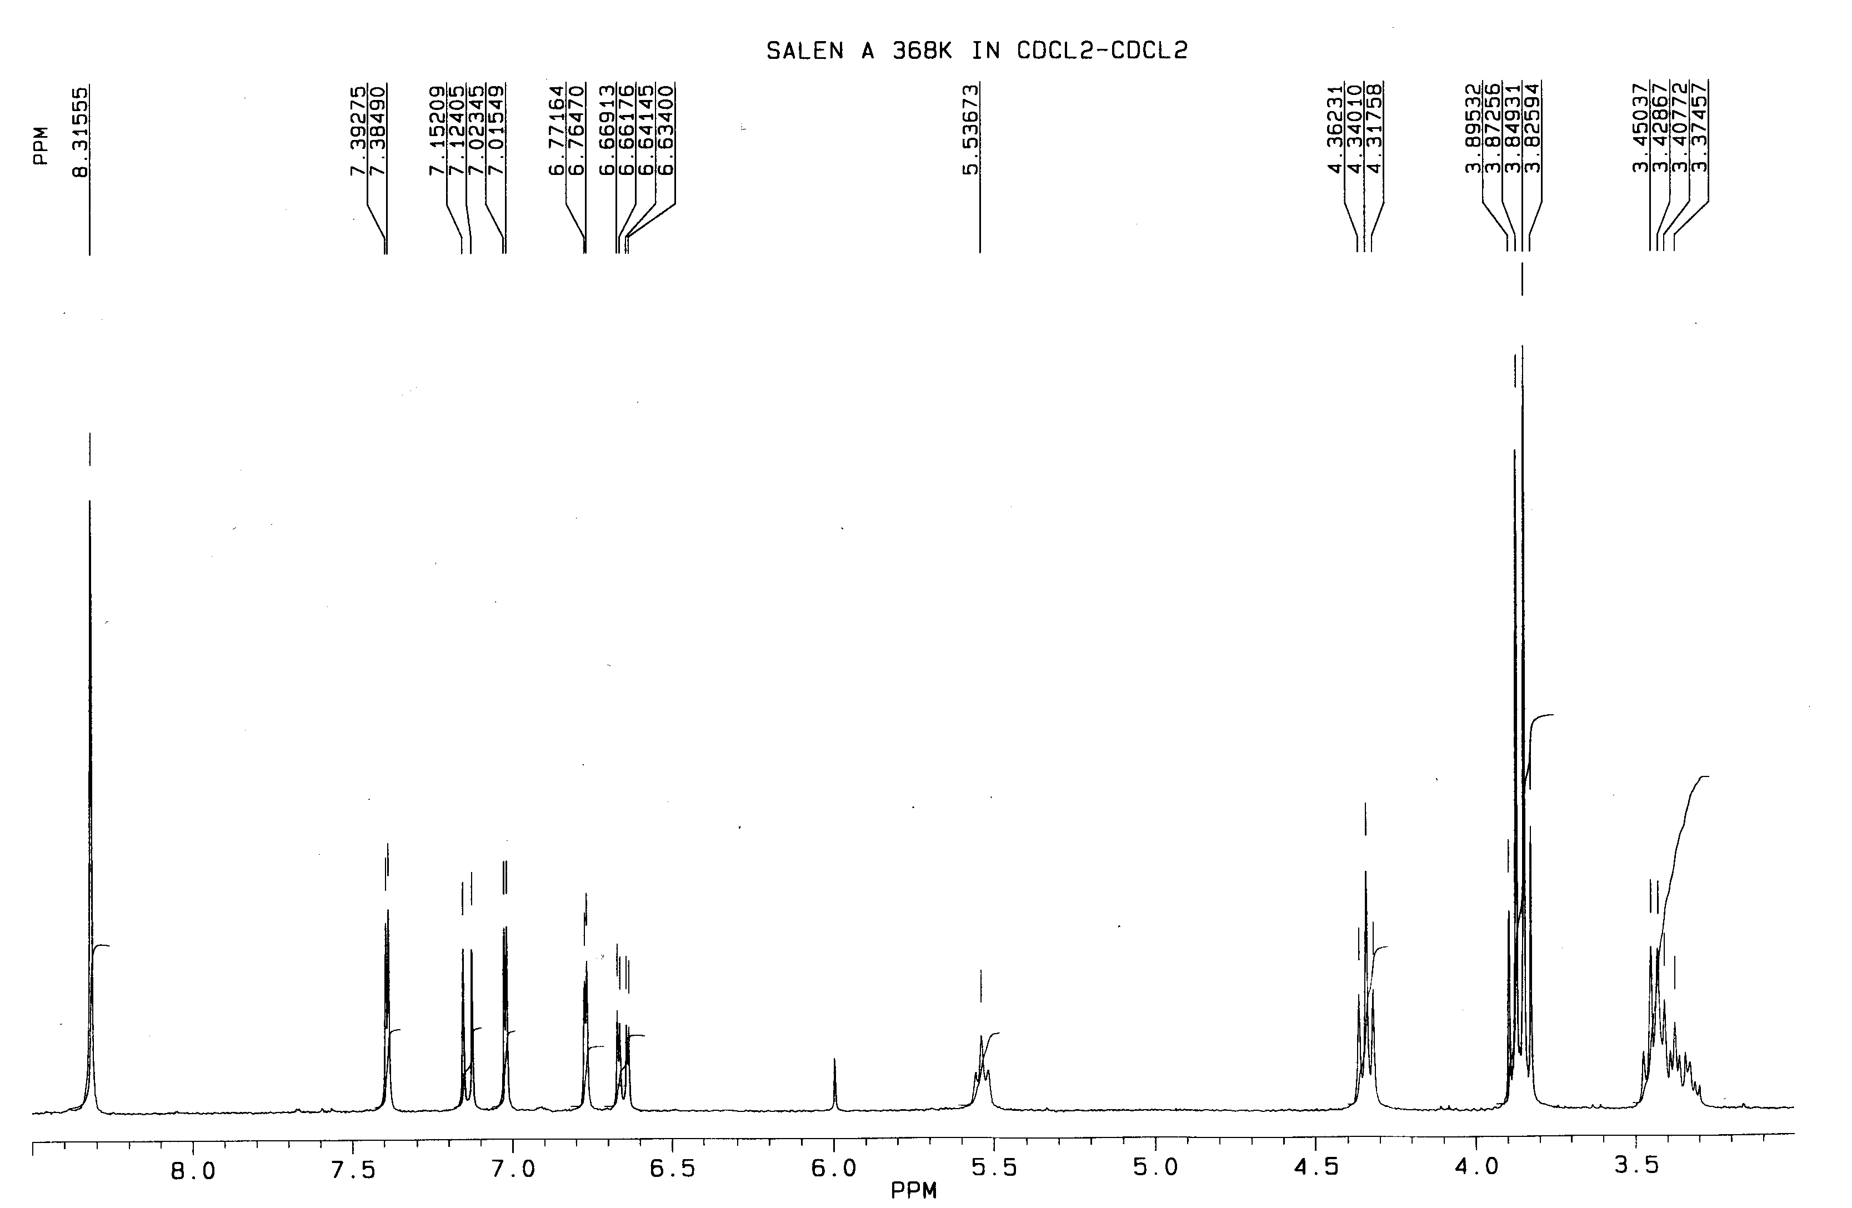
Fig. 7 Portion of ¹H NMR (300 MHz) of compound 4A in (CDCl₂)₂ at 368K

Compound 4B: Anal. Calc. For C₅₂H₈₄N₆O₇Si: C, 66.92; H, 9.07; N, 9.00. Found: C, 66.59; H, 8.96; N, 8.61%.

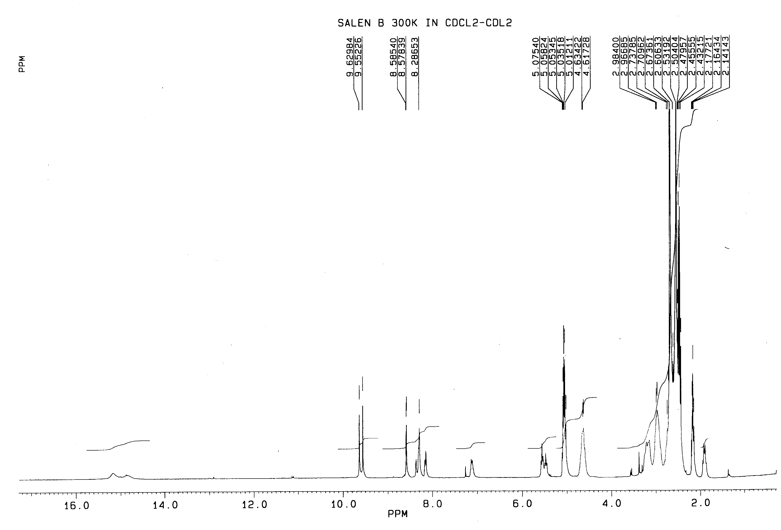

Fig. 8 ¹H NMR (300 MHz )of compound 4B in (CDCl₂)₂ at 300K

Catalyst recycling.

The study of the recovered catalyst 7B supported on MCM-41 evidenced that after 3 cycles the Mn loading decreased from 0.1 to 0.06 mmol g⁻¹. Besides the metal leaching, additional catalyst modification could explain the deactivation of the catalyst. Indeed the comparison of the IR spectra of the catalyst before and after the reaction evidenced a change in the complex structure. The recovered catalyst shows a broadening of the signals with a slight decrease of the relative intensity of the band at 1540 cm⁻¹ and an increase of the band at 1450 cm⁻¹ (see Fig.9).
The elemental analyses of recovered catalyst supported on both MCM-41 and silica gel (see Table) showed a higher contents of both C and N, suggesting the entrapment of reactants (e.g. NMO) within the silica matrix.

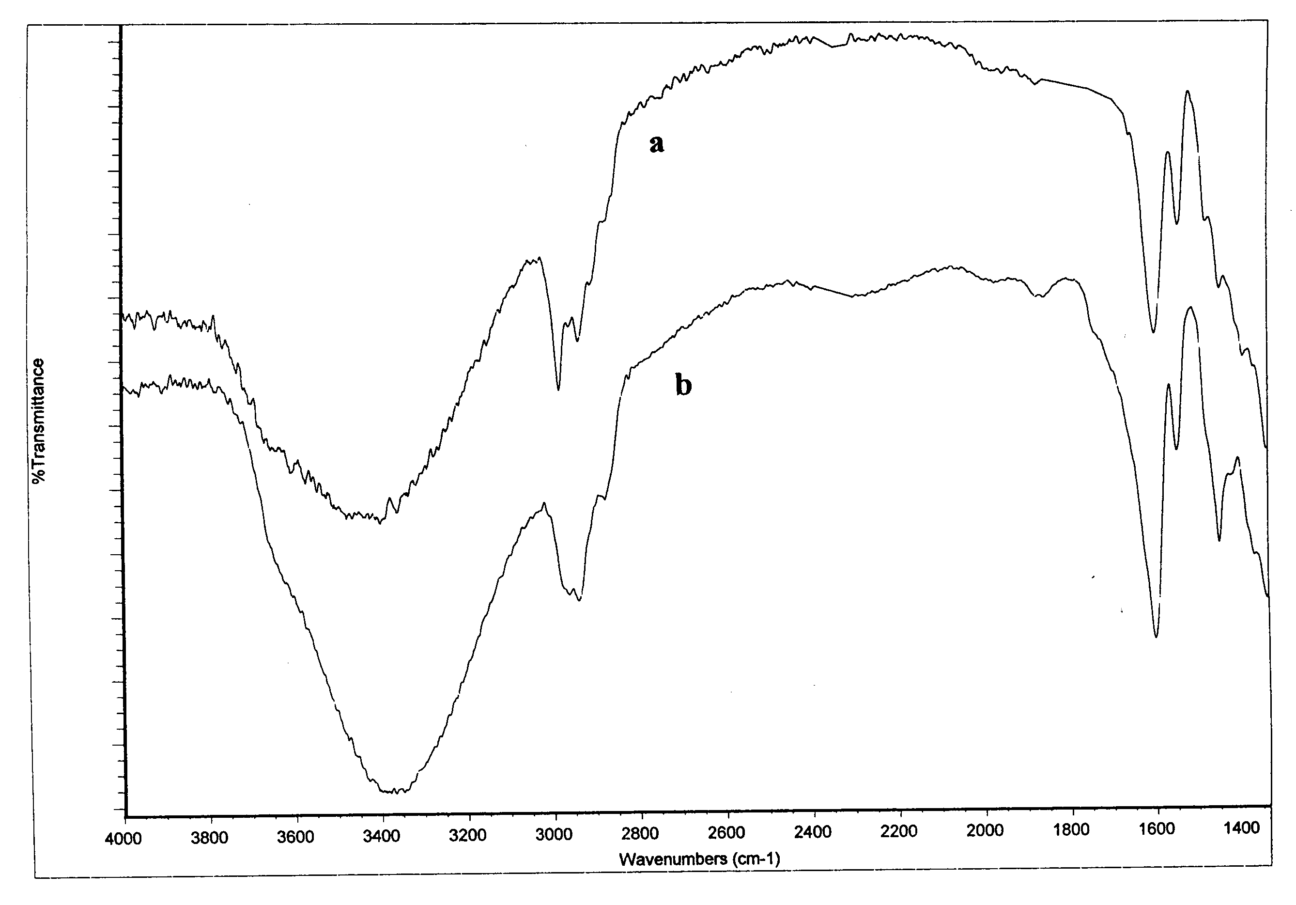

Fig.9 IR spectra of the catalyst 7B supported on MCM-41 (Mn loading = 0.1 mmol g⁻¹) (a) before and (b) after the reaction.

Table. Elemental analyses of catalyst 7B before and after reaction.

CAT. | Run | Elemental analysis (mmol g⁻¹)
 |  | Mn | C | N | C/N | ligand
MCM-41- 7B | 0 | 0.1 | 6.33 | 0.88 | 7.19 | 0.14
 | 3 | 0.06 | 10.66 | 1.86
KG60- 7B | 0 | 0.06 | 4.09 | 0.53 | 7.7 | 0.088
 | 2 | n.d. | 6.37 | 0.99

