Supplementary data

Palladium catalysed copolymerisation of ethylene with alkylacrylates: polar comonomer built into the linear polymer chain.

Robert. I. Pugh*, Bart van Oort, Rudmer van Dijk, Roel van Ginkel and Eite Drent.

Shell Research and Technology Amsterdam, Badhuisweg 3, 1031 CM Amsterdam, The Netherlands. Fax: 0031 (0)206303010; Tel: +31 (0)206303016;
E-mail: Robert.R.Pugh@opc.shell.com

Electronic Supplementary Information

Detailed and representative copolymer structural analysis by NMR spectroscopy is given for entry 1, plus ¹³C{¹H} NMR spectra for the other C₂H₄/alkylacrylate polymers (entries 9, 10 and 12).

Size exclusion chromatographic data (or GPC data) from the C₂H₄/methylacrylate (25ml) copolymers made in ethanol (entry 1), toluene (entry 3) and diglyme (entry 8) are shown, plus the C₂H₄/t-butylacrylate copolymer (entry 12).
¹³C{¹H} NMR spectrum of C₂H₄/MA copolymer (entry 1)
1
2
3
4
5
6
q
p
o
a
b
c
k
l
e
f

¹H NMR spectrum of C₂H₄/MA copolymer (entry 1)

n
q
p
r
k
e
a
b
c

¹H COSY NMR spectrum of C₂H₄/MA copolymer (entry 1)
c,d
c,d
e,f
e,f
k,l
r,s
r,s
k,l

¹H COSY NMR spectrum (inc. olefinic region) of C₂H₄/MA copolymer (entry 1)
a,b
a,b
p,q
p,q
q,r

¹³C-¹H correlation NMR spectrum of C₂H₄/MA copolymer (entry 1)
o
q
p

¹³C-¹H correlation NMR spectrum of C₂H₄/MA copolymer (entry 1)
f
i
j

¹³C{¹H} NMR spectrum of C₂H₄/^{i}PrA copolymer (entry 9)
6
5
4
3
1
2
7

¹³C{¹H} NMR spectrum of C₂H₄/^{n}BuA copolymer (entry 10)
6
5
4
1
9
8
7
3
2

¹³C{¹H} NMR spectrum of C₂H₄/^{t}BuA copolymer (entry 12)
6
5
4
3
1
2
7

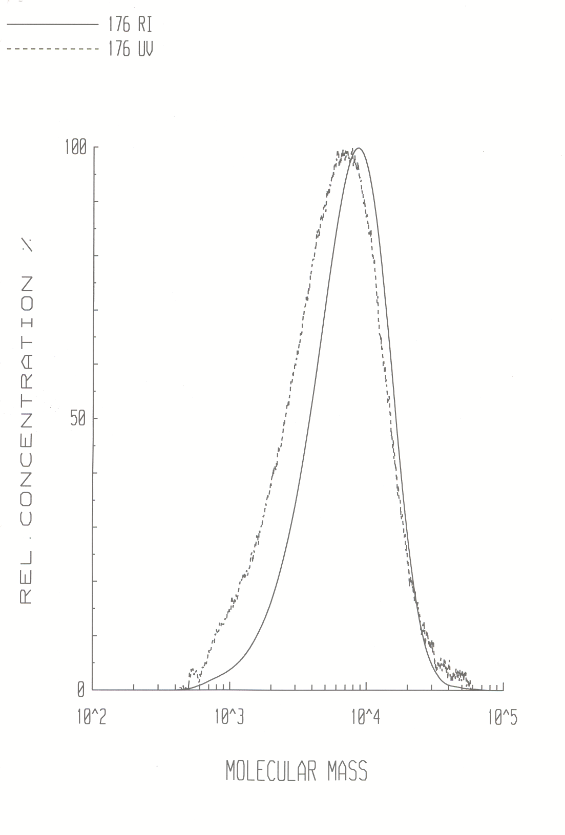
GPC data for entry 1
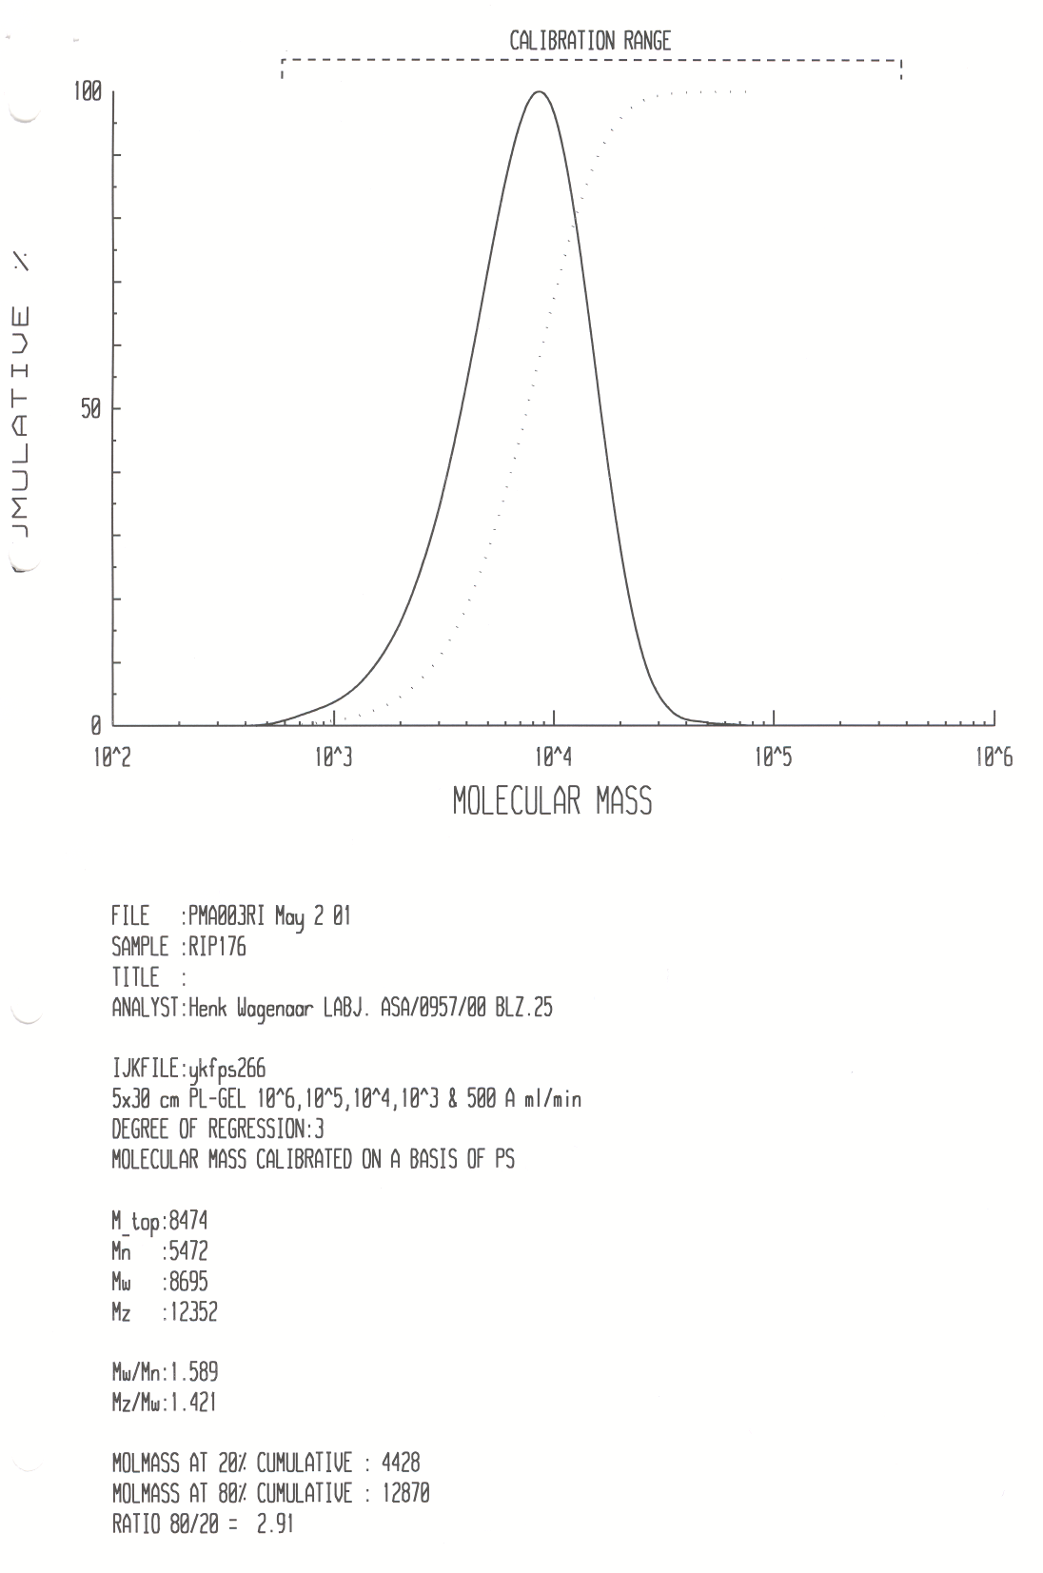
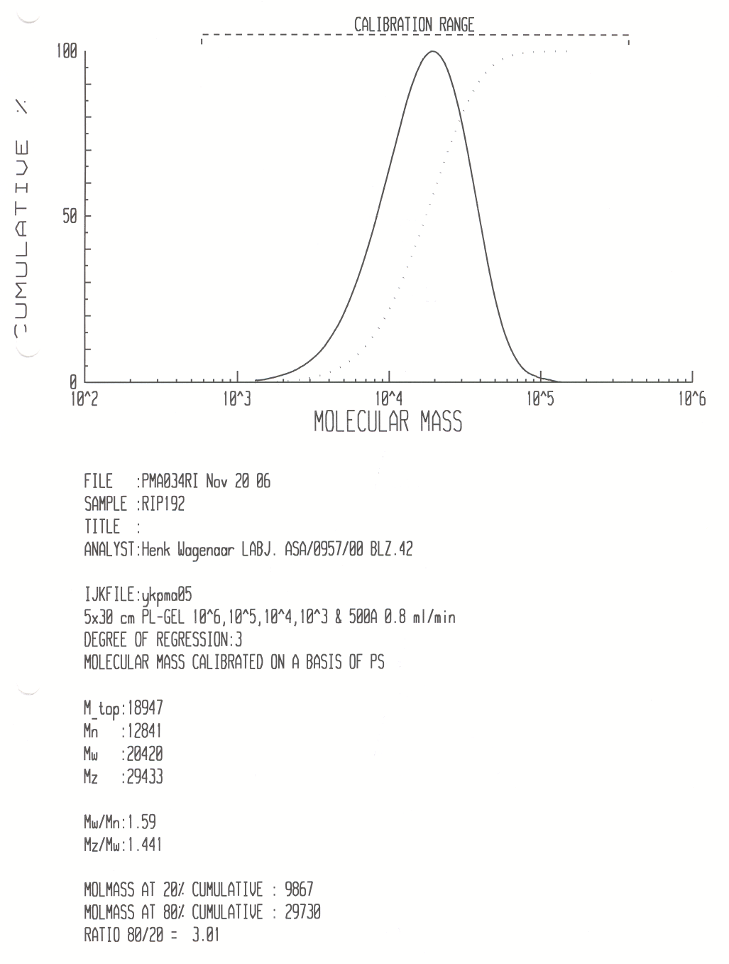
GPC data for entry 3

GPC data for entry 8

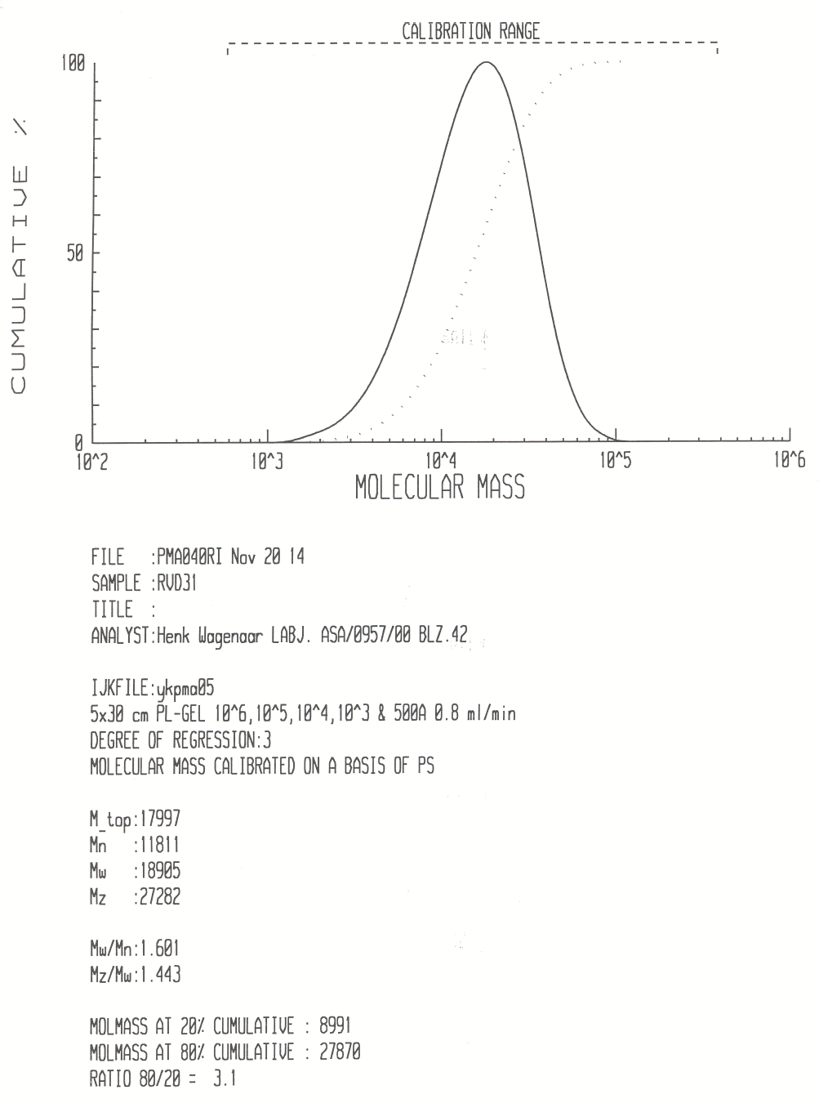

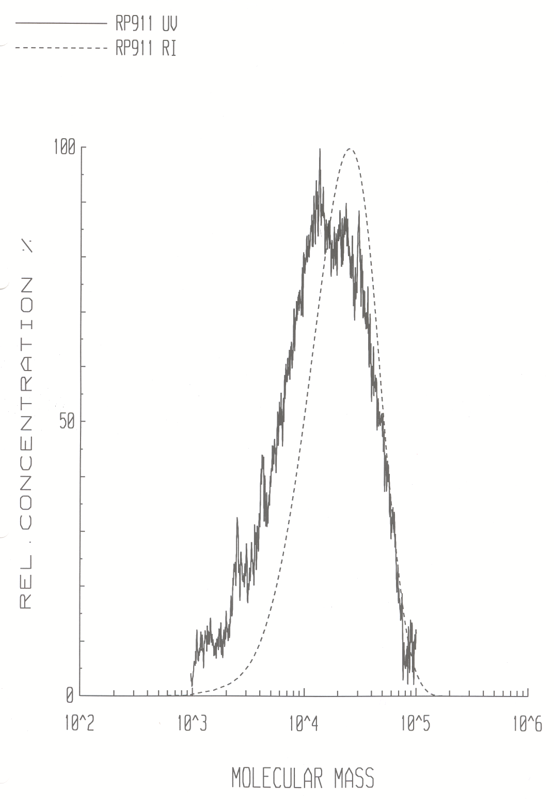
GPC data for entry 12
