SUPPLEMENTARY DATA
A new supramolecular isomer of [Zn(nicotinate)₂]_{n}: a novel 4².8⁴ network that is the result of self-assembly of 4-connected nodes

Beth Rather, Brian Moulton, Rosa D. Bailey Walsh and Michael J. Zaworotko *
Department of Chemistry, University of South Florida, 4202 E Fowler Ave (SCA 400), Tampa, FL, 33620, USA.

Materials and Methods
Each synthesis was conducted using materials as received from chemical sources (Sigma-Aldrich); solvents were purified and dried by distillation. Thermogravimetric analysis was performed under nitrogen on TA Instruments TGA 2950 Hi-Res. XRPD data were recorded on a Rigaku RU15 diffractometer at 30kV, 15mA for Cu_{Kα} (λ = 1.5418 Å), with a scan speed of 1°/min and a step size of 0.02° in 2θ at room temperature. The simulated XRPD patterns were produced using Materials Studio program package and Powder Cell for Windows Version 2.3.

Table of contents
Figure S1. Thermogravimetric analysis of (a) 1b, (b) 1c and (c) 2.

Figure S2. X-ray powder diffraction pattern calculated from the single crystal structure of 1a.

Figure S3. X-ray powder diffraction patterns of 1b (a) fresh sample, (b) calculated from the single crystal structure, (c) sample heated to 220ºC and (d) calculated from the single crystal structure without guest.

Figure S4. X-ray powder diffraction patterns of 1c (a) fresh sample, (b) calculated from the single crystal structure, (c) sample heated to 250ºC and (d) calculated from the single crystal structure without guest.

Figure S5. X-ray powder diffraction patterns of 2 (a) fresh sample, (b) calculated from the single crystal structure, (c) sample heated to 250ºC and (d) calculated from the single crystal structure without guest.

Figure S6. X-ray powder diffraction patterns of the products of the reaction Zn(NO₃)₂ + Nicotinate in different conditions: (a) first product of the reaction in PhNO₂, (b) MeOH only, (c) PhH, (c) PhCl, (d) o- and p-Ph(CH₃), (e) p-H₂NPhNO₂ and (f) PhOCH₃.
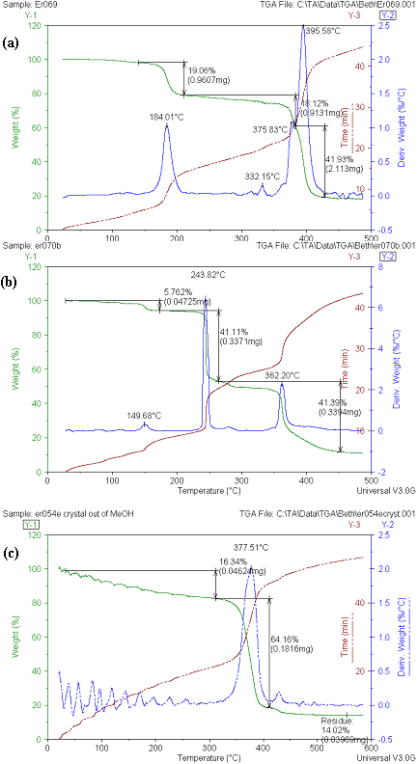

Figure S1. Thermogravimetric analysis of (a) 1b, (b) 1c and (c) 2.

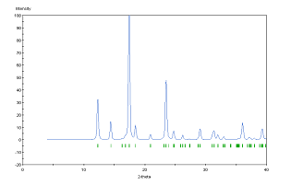

Figure S2. X-ray powder diffraction pattern calculated from the single crystal structure of 1a.

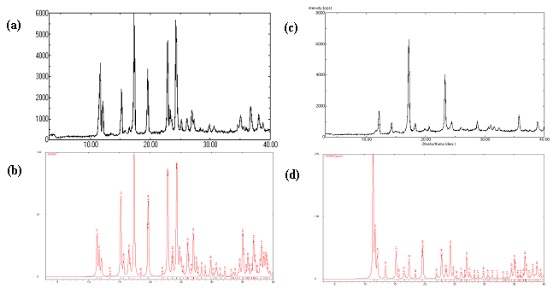

Figure S3. X-ray powder diffraction patterns of 1b (a) fresh sample, (b) calculated from the single crystal structure, (c) sample heated to 220ºC and (d) calculated from the single crystal structure without guest.

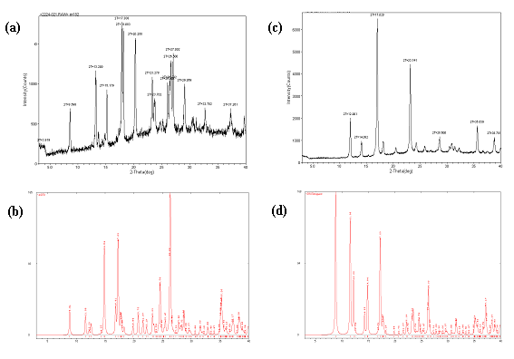

Figure S4. X-ray powder diffraction patterns of 1c (a) fresh sample, (b) calculated from the single crystal structure, (c) sample heated to 250ºC and (d) calculated from the single crystal structure without guest.

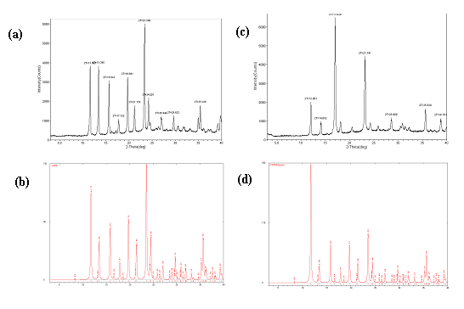

Figure S5. X-ray powder diffraction patterns of 2 (a) fresh sample, (b) calculated from the single crystal structure, (c) sample heated to 250ºC and (d) calculated from the single crystal structure without guest.

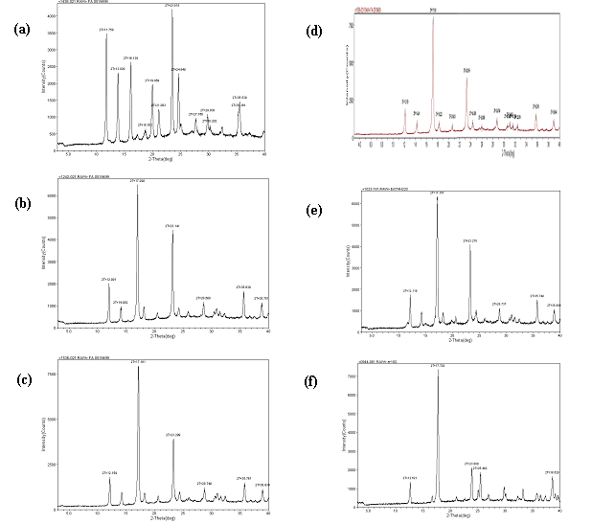

Figure S6. X-ray powder diffraction patterns of the products of the reaction Zn(NO₃)₂ + Nicotinate in different conditions: (a) first product of the reaction in PhNO₂ (compound 2), (b) MeOH only, (c) PhH, (c) PhCl, (d) o- and p-Ph(CH₃), (e) p-H₂NPhNO₂ and (f) PhOCH₃.

