Supplementary Material (ESI) for Chemical Communications
This journal is © The Royal Society of Chemistry 2002
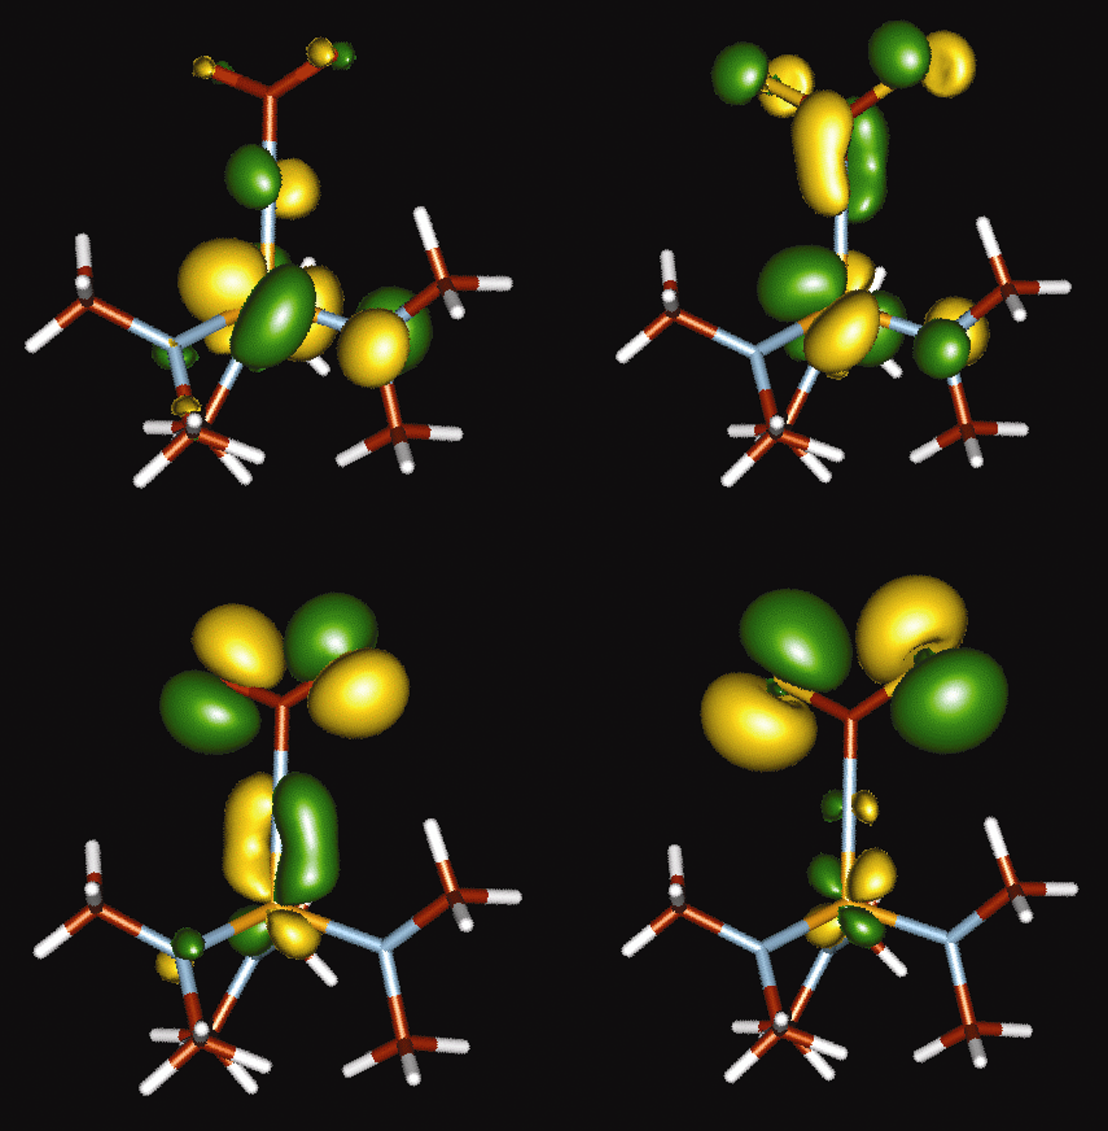

Fig. S1 Frontier orbitals of the model anions (Me₂N)₃V(NCE₂)⁻ (E = O or S). Top left: LUMO for (Me₂N)₃V(NCO₂)⁻. Bottom left: HOMO for (Me₂N)₃V(NCO₂)⁻. Top right: LUMO for (Me₂N)₃V(NCS₂)⁻. Bottom right: HOMO for (Me₂N)₃V(NCS₂)⁻.

