Supplementary Material (ESI) for Chemical Communications
This journal is © The Royal Society of Chemistry 2002
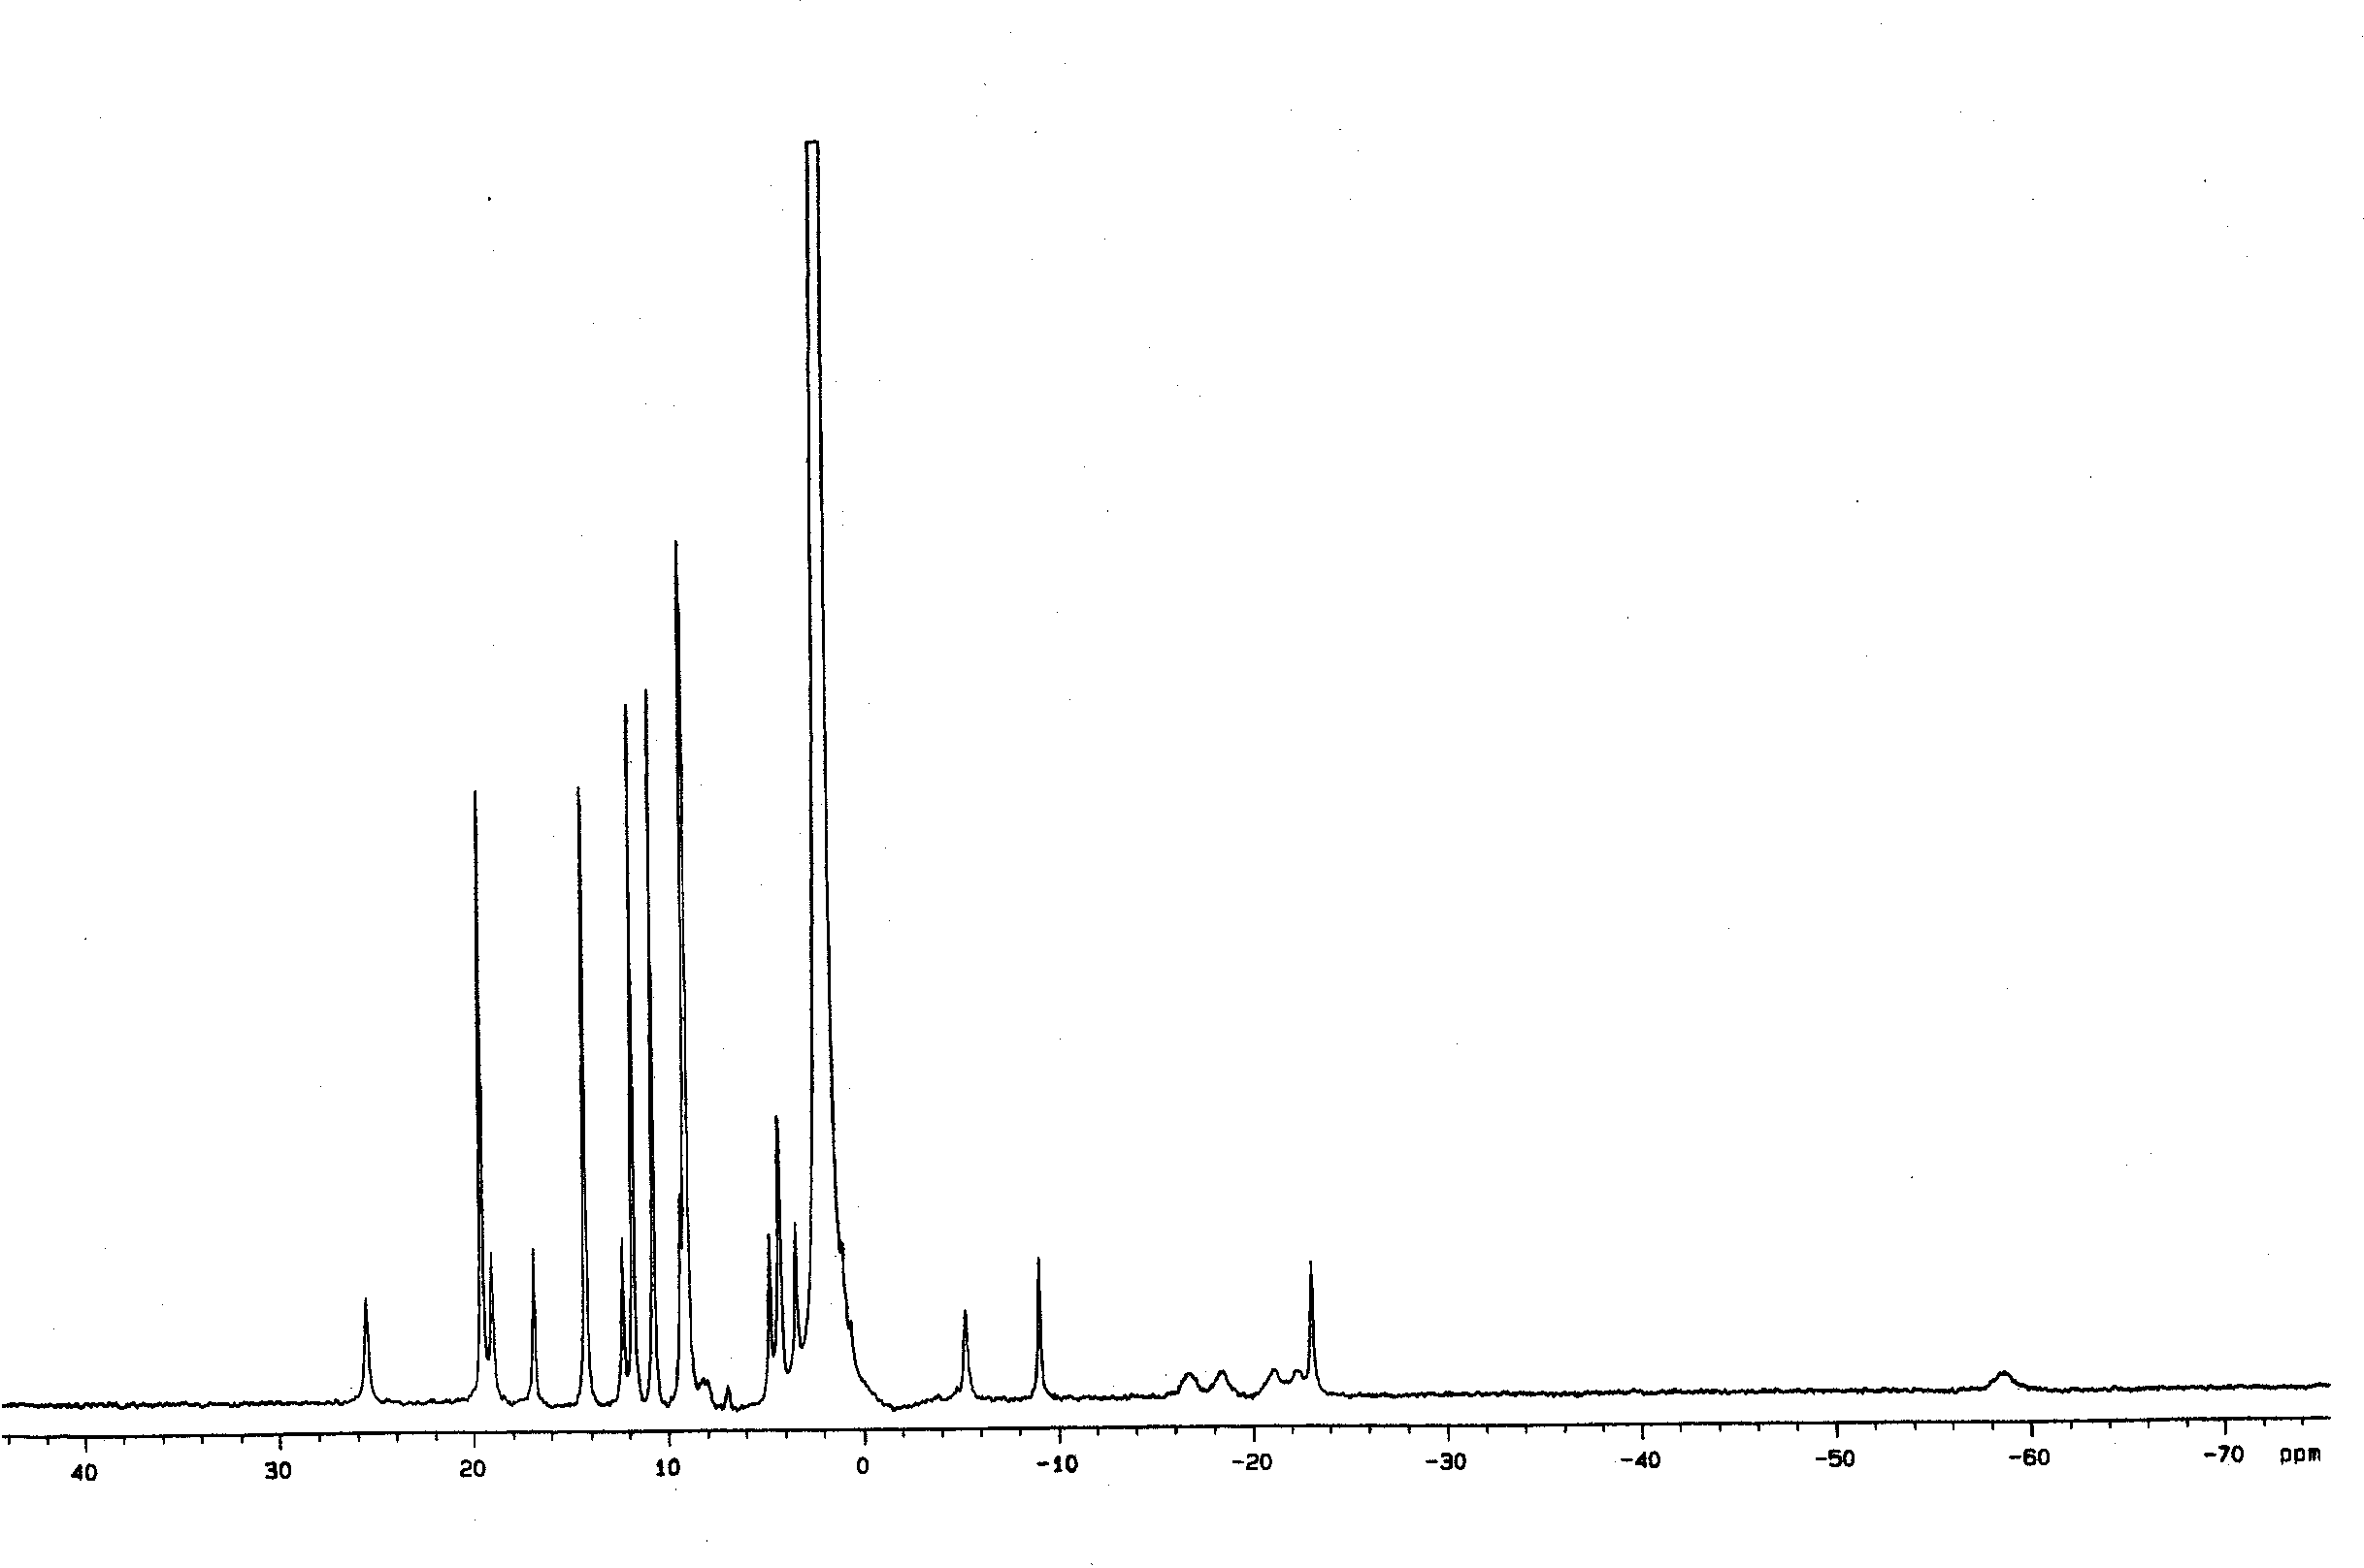
¹H NMR Spectrum of [Mn₄(μ-O)₅(dmb)₄(dmbO)₂](ClO₄)₄ in CD₃CN

