Materials
Styrene and divinylbenzene(DVB) were used as monomers after purification using Aldrich inhibitor(hydroquinone) remover column. Potassium persulfate(KPS) was used as initiator for thermally induced polymerization after recrystallization in methanol. Monomers and initiator were purchased from Aldrich chemical company. Cetyl- trimethylammonium bromide (CTAB), dodecyltrimethylammonium bromide (DTAB), octyltrimethylammonium bromide (OTAB), sodium dodecyl sulfate (SDS) were used as surfactants. CTAB and DTAB were purchased from Fluka, OTAB from Fluka and SDS from Junsei Chemical Company. Methanol was used for precipitation of crosslinked polystyrene (PS).

Energy dispersive X-ray spectra (EDAX)
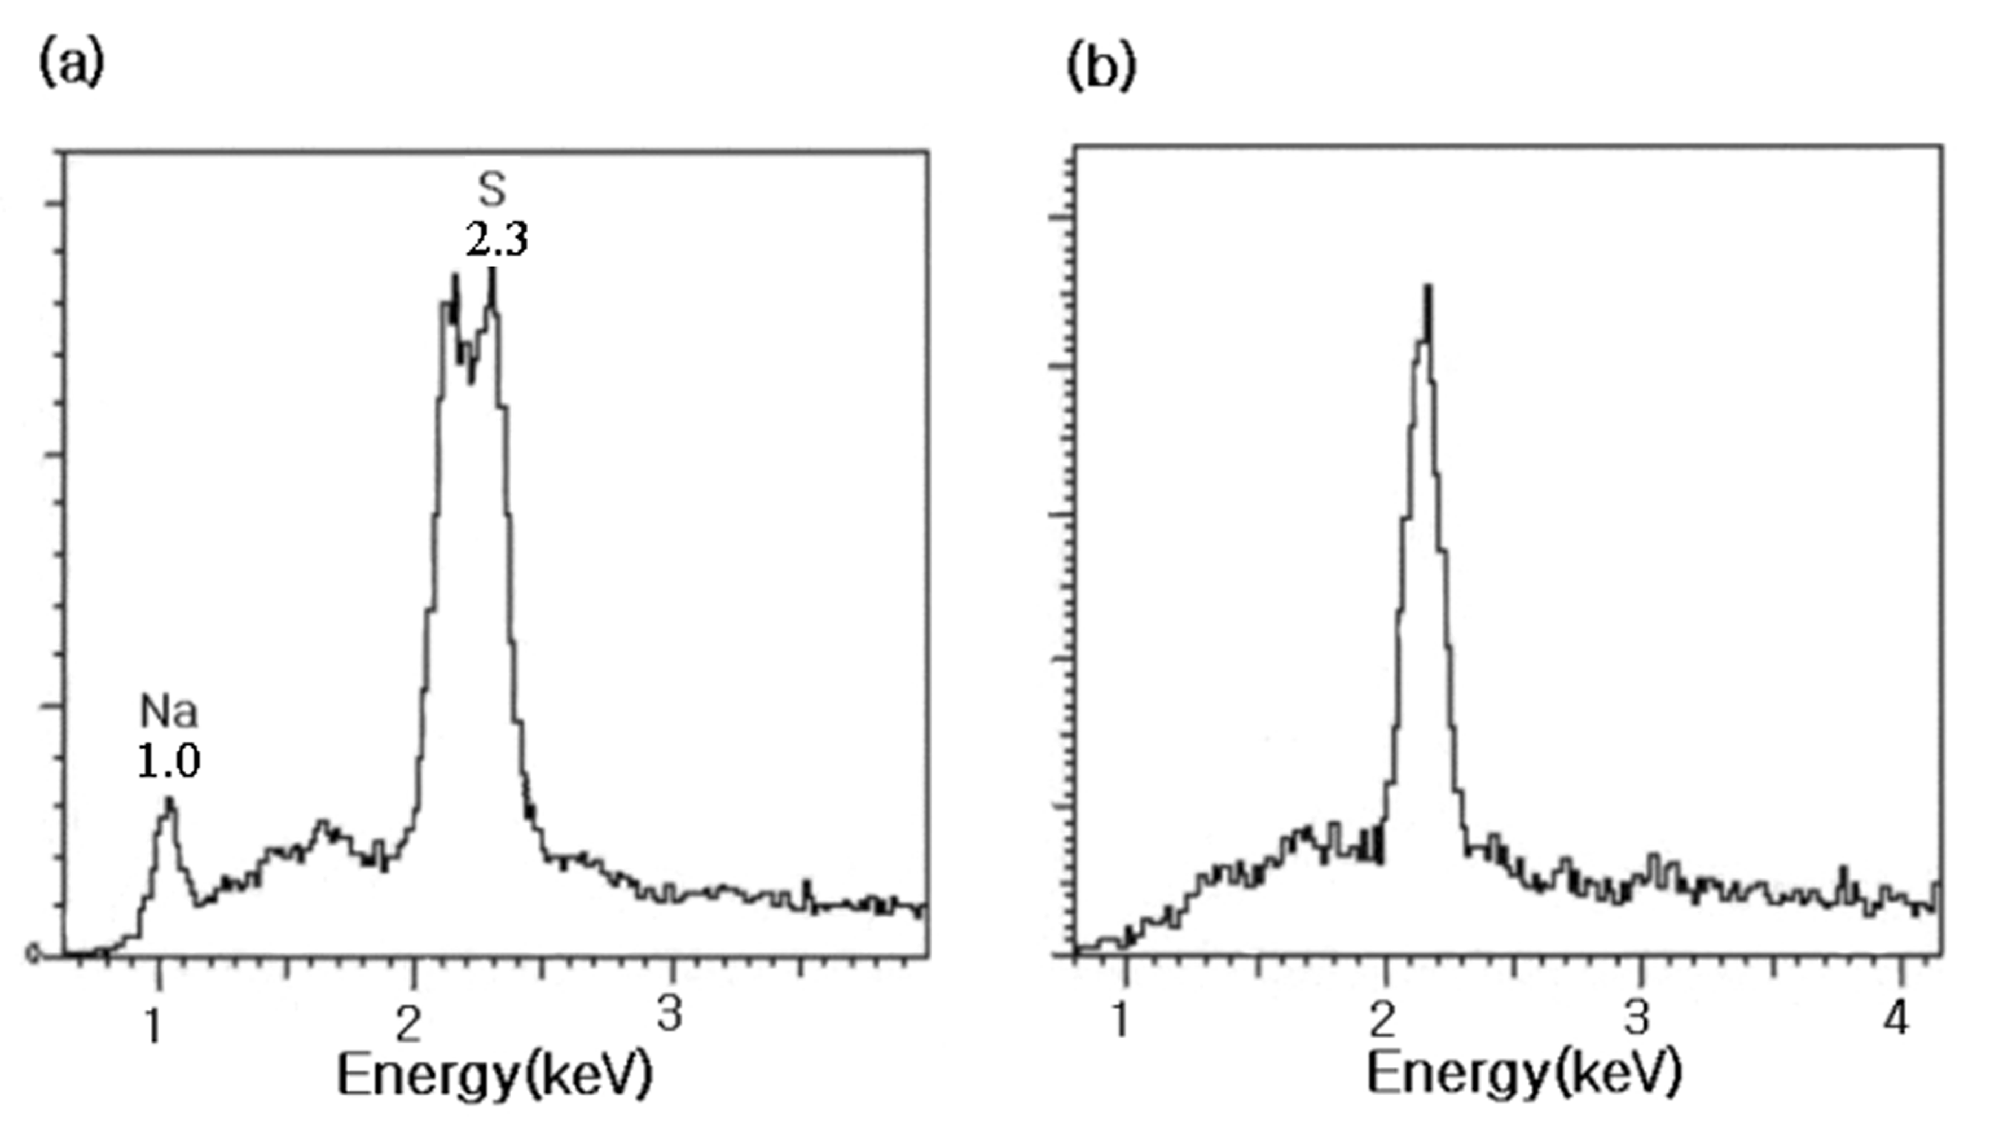
Energy dispersive X-ray spectra: of polystyrene nanocapsules (a) before washing in methanol (b) after washing in methanol. (A surfactant is sodium dodecyl sulfate.)
The peak at 2.1 keV is associated with gold coated for EDX sampling.

