Supplementary Material

Crystallographic tables

SI 1 Single crystal data collection details
SI 2 Atomic coordinates
SI 3 Bond lengths
SI 4 Possible H-bond interactions to place N and C’s
TGA and TG-MS
le Bail plot
Rietveld fit

Table SI.1 Crystal data and structure refinement for cyclen-ScS/PO

Identification code cyclen-ScS/PO
Empirical formula Sc₅₆(SO₄)₉₈(PO₄)₂₂.[C₈N₄H₂₄]₁₅.34[H₃O⁺].23H₂O
Formula weight 17722
Temperature 293(2) K
Wavelength 0.71073 Å
Crystal system, space group Cubic, Pn-3n
Unit cell dimensions a = 25.2469(3) Å
Volume 16092.5(3) Å3
Density (calculated) 1.829 g/cm3
Absorption coefficient 1.093 mm-1
F(000) 8424
Crystal size 0.05 x 0.05 x 0.05 mm3
Theta range for data collection 1.61 to 23.26°.
Index ranges -28<=h<=27, -26<=k<=28, -28<=l<=26
Reflections collected 74745
Independent reflections 1945 [R(int) = 0.3526]
Completeness to theta = 23.26° 99.9 %
Refinement method Full-matrix least-squares on F2
Data / restraints / parameters 1945 / 0 / 155
Goodness-of-fit on F2 1.364
Final R indices [I>2sigma(I)] R1 = 0.1225, wR2 = 0.3397

R indices (all data) R1 = 0.1816, wR2 = 0.3897
Largest diff. peak and hole 7.498 and -0.887 e.Å-3

Table SI.2 Atomic coordinates and equivalent isotropic displacement parameters (Å²) for cyclen-ScS/PO. U(eq) is defined as one third the orthogonalised U_{ij} tensor

x y z U(eq)

Sc(1) 0.0000 0.5000 0.0000 0.013(2)
Sc(2) 0.1025(1) 0.6683(1) 0.0423(1) 0.015(1)
S(1) 0.0685(2) 0.5531(2) 0.1024(2) 0.017(1)
S(2) 0.0956(2) 0.7884(2) -0.0163(2) 0.017(1)
S(3) 0.1425(2) 0.7500 0.1425(2) 0.065(3)
O(1) 0.0974(5) 0.6031(4) 0.0913(5) 0.025(3)
O(2) 0.0585(4) 0.5254(4) 0.0528(5) 0.025(3)
O(3) 0.1152(5) 0.7338(4) -0.0053(5) 0.032(3)
O(4) 0.1776(5) 0.6423(5) 0.0208(6) 0.038(3)
O(5) 0.0654(6) 0.7897(5) -0.0655(5) 0.042(4)
O(6) 0.0283(4) 0.6940(5) 0.0629(5) 0.030(3)
O(7) 0.1010(5) 0.5205(5) 0.1362(5) 0.042(4)
O(8) 0.0185(5) 0.5659(5) 0.1283(5) 0.034(3)
O(9) 0.1410(20) 0.1957(11) 0.7681(9) 0.360(40)
O(10) 0.1363(5) 0.7061(5) 0.1059(5) 0.042(4)
C(1) 0.1291(8) 0.7649(6) 0.8361(7) 0.028(4)
C(2) 0.1074(8) 0.7094(6) 0.8497(7) 0.029(5)
N(1) 0.0880(6) 0.8037(5) 0.8224(5) 0.024(3)

Table 3 Anisotropic displacement parameters for cyclen-ScS/PO. The anisotropic displacement factor takes the form :
-2π²[h²a^{*2}U₁₁+…+2hka*b*U₁₂]
Sc(1) 0.013(2) 0.013(2) 0.013(2) -0.002(2) 0.002(2) -0.002(2)
Sc(2) 0.014(2) 0.010(2) 0.022(2) -0.004(1) 0.006(1) -0.001(1)
S(1) 0.018(2) 0.015(2) 0.017(2) -0.001(2) -0.002(2) -0.003(2)
S(2) 0.022(2) 0.013(2) 0.017(2) -0.001(2) 0.006(2) -0.002(2)
S(3) 0.079(5) 0.035(4) 0.079(5) -0.036(4) -0.060(5) 0.036(4)
O(1) 0.029(7) 0.017(6) 0.028(7) 0.006(5) -0.004(5) -0.008(5)
O(2) 0.023(7) 0.020(6) 0.031(7) -0.005(5) -0.001(5) -0.007(5)
O(3) 0.028(7) 0.012(6) 0.057(9) 0.004(6) 0.017(6) 0.002(5)
O(4) 0.026(7) 0.021(7) 0.066(10) -0.004(6) 0.022(7) 0.011(5)
O(5) 0.056(9) 0.046(9) 0.025(7) -0.001(6) -0.003(6) -0.021(7)
O(6) 0.019(7) 0.024(7) 0.045(8) -0.003(6) 0.010(6) 0.009(5)
O(7) 0.054(9) 0.024(7) 0.047(9) 0.001(6) -0.020(7) 0.005(6)
O(8) 0.030(7) 0.041(8) 0.031(7) -0.006(6) 0.011(6) -0.005(6)
O(9) 0.840(110) 0.0150(30) 0.080(20) 0.074(19) -0.200(40) -0.330(50)
O(10) 0.056(9) 0.032(8) 0.039(8) -0.025(6) -0.007(7) -0.003(7)
C(1) 0.047(12) 0.017(10) 0.021(10) 0.000(7) 0.008(8) -0.007(8)
C(2) 0.052(13) 0.015(9) 0.020(10) -0.001(7) 0.002(8) -0.011(8)
N(1) 0.031(9) 0.023(8) 0.020(8) 0.005(6) 0.016(7) 0.005(6)

Table 4 Bond lengths (Å) and angles (°) for cyclen-ScS/PO

Sc(1)-O(2)#1 2.089(11)  Sc(1)-O(2) 2.089(11)  Sc(1)-O(2)#2 2.089(11)  Sc(1)-O(2)#3 2.089(11)  Sc(1)-O(2)#4 2.089(11)  Sc(1)-O(2)#5 2.089(11)  Sc(2)-O(8)#2 2.055(12)  Sc(2)-O(1) 2.064(11)  Sc(2)-O(10) 2.054(12)  Sc(2)-O(6) 2.049(11)  Sc(2)-O(3) 2.067(12)  Sc(2)-O(4) 2.078(11)  S(1)-O(7) 1.442(13)  S(1)-O(2) 1.456(12)  S(1)-O(8) 1.458(12)  S(1)-O(1) 1.487(11)  S(2)-O(5) 1.458(13)  S(2)-O(6)#6 1.464(12)  S(2)-O(4)#7 1.466(12)  S(2)-O(3) 1.492(12)  S(3)-O(9)#8 1.42(3)  S(3)-O(9)#9 1.42(3)  S(3)-O(10) 1.452(12)  S(3)-O(10)#6 1.452(12)  O(4)-S(2)#10 1.466(12)  O(6)-S(2)#6 1.464(12)  O(8)-Sc(2)#3 2.055(12)  O(9)-S(3)#11 1.42(3)  C(1)-N(1) 1.47(2)  C(1)-C(2) 1.54(2)  C(2)-N(1)#9 1.49(2)  N(1)-C(2)#12 1.49(2)  O(2)#1-Sc(1)-O(2) 180.0(7)  O(2)#1-Sc(1)-O(2)#2 87.8(4)  O(2)-Sc(1)-O(2)#2 92.2(4)  O(2)#1-Sc(1)-O(2)#3 87.8(4)  O(2)-Sc(1)-O(2)#3 92.2(4)  O(2)#2-Sc(1)-O(2)#3 87.8(4)  O(2)#1-Sc(1)-O(2)#4 92.2(4)  O(2)-Sc(1)-O(2)#4 87.8(4)  O(2)#2-Sc(1)-O(2)#4 92.2(4)  O(2)#3-Sc(1)-O(2)#4 180.000(1)  O(2)#1-Sc(1)-O(2)#5 92.2(4)  O(2)-Sc(1)-O(2)#5 87.8(4)  O(2)#2-Sc(1)-O(2)#5 180.0(6) | O(2)#3-Sc(1)-O(2)#5 92.2(4)  O(2)#4-Sc(1)-O(2)#5 87.8(4)  O(8)#2-Sc(2)-O(1) 91.6(5)  O(8)#2-Sc(2)-O(10) 176.7(5)  O(1)-Sc(2)-O(10) 85.7(5)  O(8)#2-Sc(2)-O(6) 86.3(5)  O(1)-Sc(2)-O(6) 92.4(5)  O(10)-Sc(2)-O(6) 91.9(5)  O(8)#2-Sc(2)-O(3) 91.7(5)  O(1)-Sc(2)-O(3) 174.5(5)  O(10)-Sc(2)-O(3) 91.1(5)  O(6)-Sc(2)-O(3) 92.1(5)  O(8)#2-Sc(2)-O(4) 93.4(5)  O(1)-Sc(2)-O(4) 87.8(5)  O(10)-Sc(2)-O(4) 88.4(5)  O(6)-Sc(2)-O(4) 179.6(6)  O(3)-Sc(2)-O(4) 87.7(5)  O(7)-S(1)-O(2) 109.6(7)  O(7)-S(1)-O(8) 110.7(8)  O(2)-S(1)-O(8) 110.1(7)  O(7)-S(1)-O(1) 108.5(7)  O(2)-S(1)-O(1) 109.4(7)  O(8)-S(1)-O(1) 108.7(7)  O(5)-S(2)-O(6)#6 110.7(8)  O(5)-S(2)-O(4)#7 110.0(8)  O(6)#6-S(2)-O(4)#7 109.6(8)  O(5)-S(2)-O(3) 110.6(8)  O(6)#6-S(2)-O(3) 109.0(7)  O(4)#7-S(2)-O(3) 106.8(7)  O(9)#8-S(3)-O(9)#9 99(4)  O(9)#8-S(3)-O(10) 109.2(17)  O(9)#9-S(3)-O(10) 110.6(11)  O(9)#8-S(3)-O(10)#6 110.6(11)  O(9)#9-S(3)-O(10)#6 109.2(17)  O(10)-S(3)-O(10)#6 116.5(12)  S(1)-O(1)-Sc(2) 145.2(7)  S(1)-O(2)-Sc(1) 144.9(8)  S(2)-O(3)-Sc(2) 142.6(7)  S(2)#10-O(4)-Sc(2) 144.1(8)  S(2)#6-O(6)-Sc(2) 160.3(9)  S(1)-O(8)-Sc(2)#3 165.1(8)  S(3)-O(10)-Sc(2) 153.8(9)  N(1)-C(1)-C(2) 114.1(15)  C(1)-C(2)-N(1)#9 115.6(14)  C(1)-N(1)-C(2)#12 114.4(14)

Table 5 Distances (Å) between dangling oxygens and carbons and nitrogens on the cyclen.

 | N1 | C1 | C2
O5  O7  O9_$1  O9_$2 | 3.13  2.908  3.923  4.597 | 4.508  3.03  3.184  3.672 | 3.131  3.121  3.186  4.526

TGA and TG-MS data

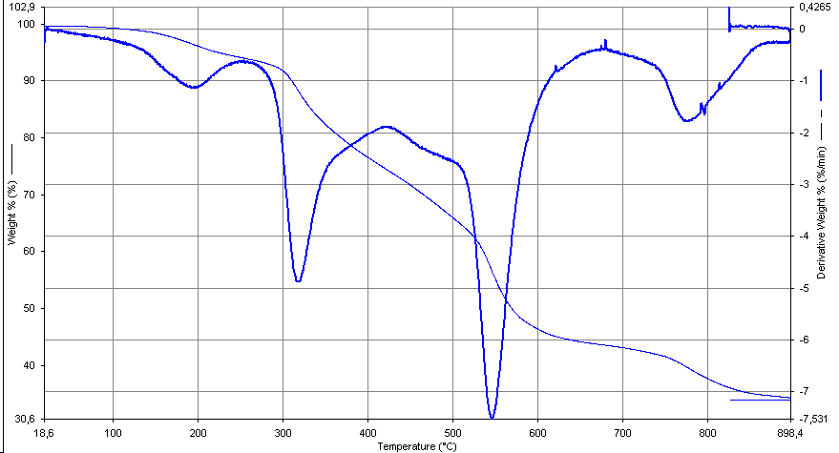
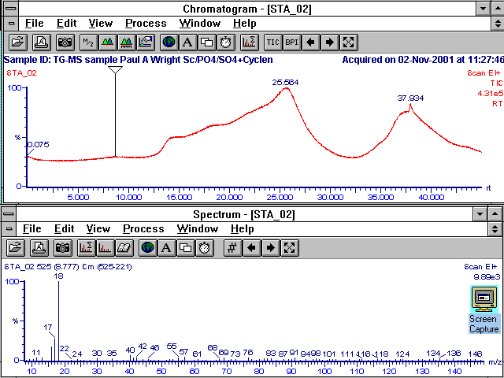

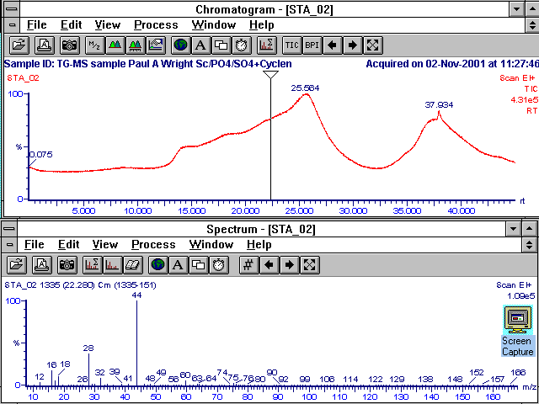
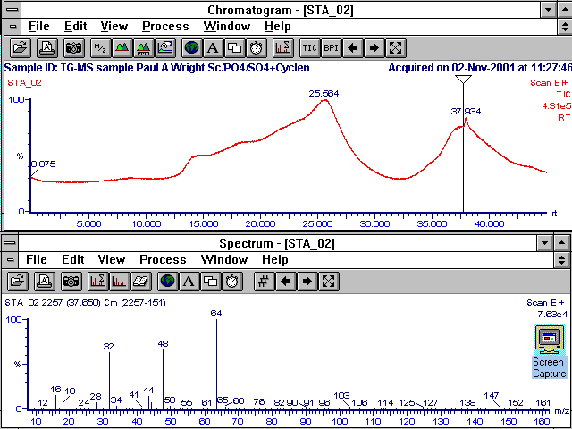
Analysis

TGA reveals loss of 5.8 wt% water below 250 °C.

CHN reveals 8.04 wt% C. Assuming this is all from tetraprotonated cyclen [C8N4H24]⁴⁺, then the total weight of cyclen will be 14.7 wt%. (calculated N wt% 4.68 cf measured 4.63)

This leaves 79.5 wt% protonated cyclen scandium sulphate phosphate. Assuming pure, and that there is no occluded sulphate, then the formula, based on crystallographic framework and allowing some additional cyclen, would be

Sc₅₆(SO₄)₉₈(PO₄)₂₂(H⁺)₃₄

The measured S/P ratio and the crystallographic Sc/(S/P) ratio are included in the calculation, and the charge is balanced.

If this accounts for the 79.5wt% not accounted for by physisorbed water or cyclen, then per unit cell the composition is

Sc₅₆(SO₄)₉₈(PO₄)₂₂(H⁺)_{34.} 15C₈H₂₄N₄. 57H₂O

