Supplementary Material (ESI) for Chemical Communications
This journal is © The Royal Society of Chemistry 2002

Synthesis and characterization of the complexes
(Me₄N)₂[Cd₂(SPh)₂(S₂TTF(SMe)₂)₂] (1). After de-protecting the ligand [(SMe)₂TTF(SCH₂CH₂CN)₂] (48 mg, 0.1 mmol) in 5 mL THF using Me₄NOH, a redish-brown salt (Me₄N)₂[S₂TTF(SMe)₂]] precipitated. The salt was dissolved in methanol (4 mL) and was added to (Me₄N)₂[Cd₄(Sph)₁₀] (42 mg, 0.025 mmol). The mixture was stirred for 1 h under argon and an orange precipitate formed. It was filtered off, washed with MeOH and finally dried in vacuo (yield 56%). The product was sealed in a glass tube under argon atmosphere to avoid oxidation. Anal. data for C36H46N2S18Cd2: C, 33.08; H, 3.52; N, 2.14. Found: C, 33.47; H, 3.91; N, 2.61%. ¹H NMR (acetone-d₆): 2.40 (s, 12H), 3.42 (s, 24H), 7.31 (tri, 2H), 7.38 (tri, 4H), 7.55 (d, 4H).

(Me₄N)₂[Zn₂(SPh)₂(S₂TTF(SMe)₂)₂] (2). Following the above procedure, the ligand (48 mg, 0.1 mmol) was de-protected in THF and reacted with (Me₄N)₂[Zn₄(Sph)₁₀] (38 mg, 0.025 mmol) in MeOH. Then the binuclear complex 2 precipitated. It was filtered off, washed with MeOH and finally dried in vacuo (yield 54%). Anal. data for C36H46N2S18Zn2: C, 35.64; H, 3.80; N, 2.31%. Found: C, 35.74; H, 4.19; N, 2.54%. ¹H NMR (acetone-d₆): 2.40(s, 12H), 3.42(s, 24H), 7.30(tri, 2H), 7.38(tri, 4H), 7.53(d, 4H).

[Cd(S₂TTF(SMe)₂)₂] (3). It is an oxidation product of the complex 1. To an acetonitrile (7 mL) solution of 1 (20mg, 0.015mmol) was added with stirring an acetonitrile (5 mL) solution of I₂ (15mg, 0.06 mmol) under argon to afford immediately dark brown insoluble solid of 3. It was filtered off, washed with acetonitrile and finally dried in vacuo (yield 81%). Anal. data for C16H12S16Cd: C, 23.19; H, 1.45%. Found: C, 22.82; H, 1.46%.

[Zn(S₂TTF(SMe)₂)₂] (4). It is an oxidation product of the complex 2. Complex 2 was oxidized in the same method as that of 1, to afford immediately dark brown insoluble solid of 4. It was filtered off, washed with acetonitrile and finally dried in vacuo (yield 78%). Anal. data for C16H12S16Zn: C, 24.58; H, 1.54%. Found: C, 24.68; H, 1.77%.

Sup-Fig. 1 ¹H NMR spectrum of the complex 2
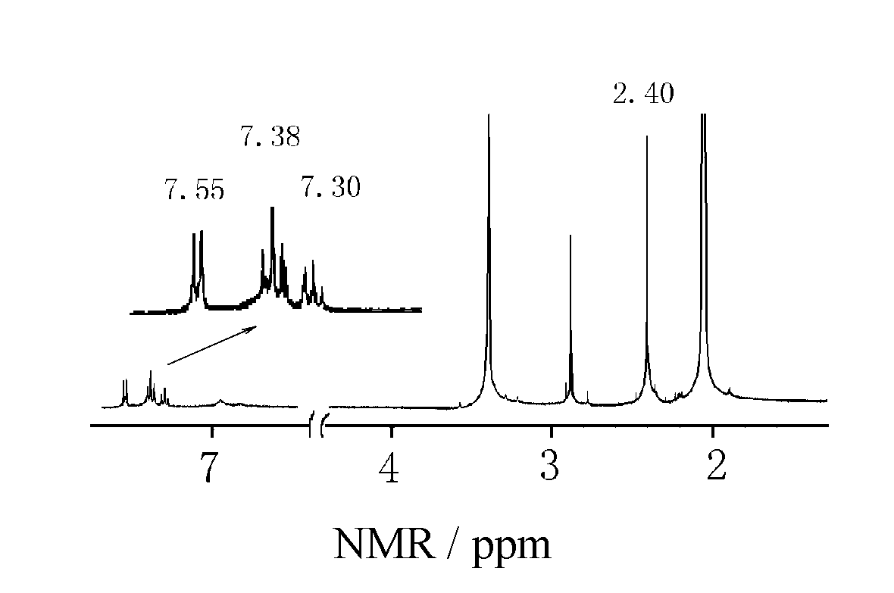

Sup-Fig. 2 Electrospray mass spectrum of the complex 1
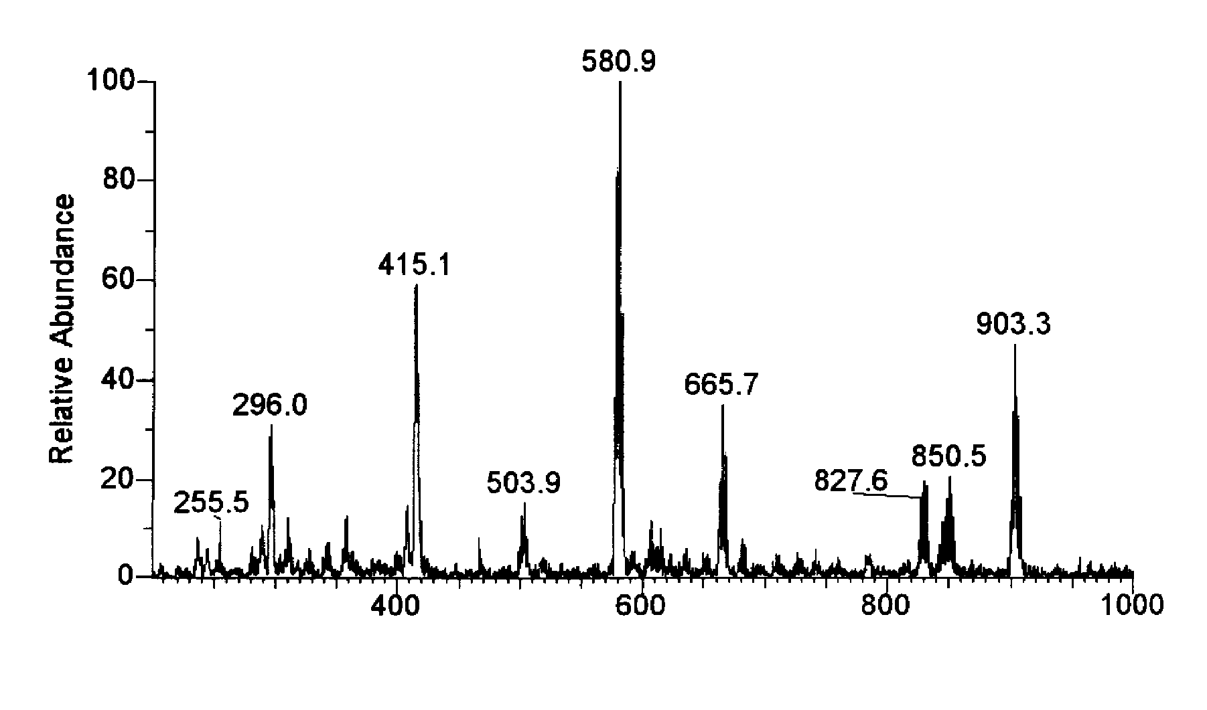

Sup-Fig. 3 PM3 Calculated charges on the sulfur atoms of the relevant ligands

(a) [SPh]⁻ (b) [dmit]²⁻ (c) [S₂TTF(RS)₂]²⁻

