Supplementary Material (ESI) for Chemical Communications
This journal is © The Royal Society of Chemistry 2002
2-D soft ferromagnet based on [W^{V}(CN)₈]³⁻ and Cu^{II} with T_{C} of 34 K

Robert Podgajny, Tomasz Korzeniak, Maria Bałanda, Tadeusz Wasiutyński, William Errington, Terence J.Kemp, Nathaniel W.Alcock and Barbara Sieklucka*

Supplementary material

Contents

- Figure S1. Structure of [Cu(tetren)]²⁺ cation in 1.
- Figure S2. Atom numbering scheme of (NC)₇W-CN-Cu(NC)₄ structural motif of 2: W1-C1 = 2.165(7), W1-C2 = 2.178(9), W1-C3 = 2.146(9), W1-C4 = 2.177(11) , W1-C5 = 2.138(8), C1-N1 = 1.160(11), C2-N2 = 1.121(11), C3-N3 = 1.141(12), C4-N4 = 1.125(17), C5-N5 = 1.159(12), Cu1-N1 = 2.115(7), Cu1-N2B = 1.992(8), Cu1-N3B = 1.971(8) Å; W-C-N = 176-178.5, Cu1-N1-C1 = 174(2), Cu1-N2B-C2B = 169.3(7), Cu1-N3B-C3B = 169.4(8)º. Symmetry transformation used to generate equivalent atoms: B –x+¹/₂, -y+¹/₂, z+¹/₂.
- Table S1. IR spectra of {(tetrenH₅)_{0.8}Cu^{II}₄[W^{V}(CN)₈]₄⋅7.2H₂O}_{n} (1), tetren·5HCl (2), [Cu(tetren)](ClO₄)₂ (3) and tetren (4).
- Figure S3. IR spectra of {(tetrenH₅)_{0.8}Cu^{II}₄[W^{V}(CN)₈]₄⋅7.2H₂O}_{n} (1), tetren·5HCl (2), [Cu(tetren)](ClO₄)₂ (3), and tetren (4) in 400-1800 cm⁻¹ range.
- Figure S4. IR spectra of {(tetrenH₅)_{0.8}Cu^{II}₄[W^{V}(CN)₈]₄⋅7.2H₂O}_{n} (1), tetren·5HCl (2), [Cu(tetren)](ClO₄)₂ (3), and tetren (4) in 1800-4000 cm⁻¹ range.

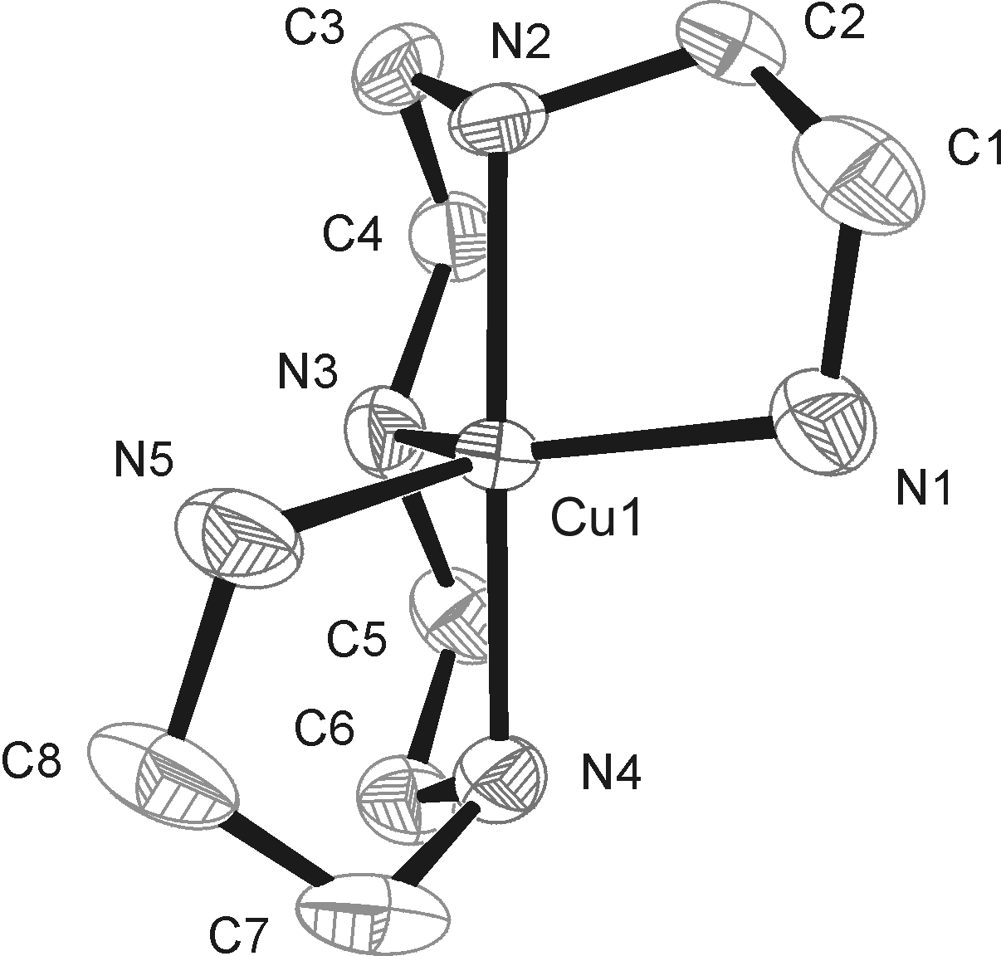

Figure S1. Structure of [Cu(tetren)]²⁺ cation in 1.

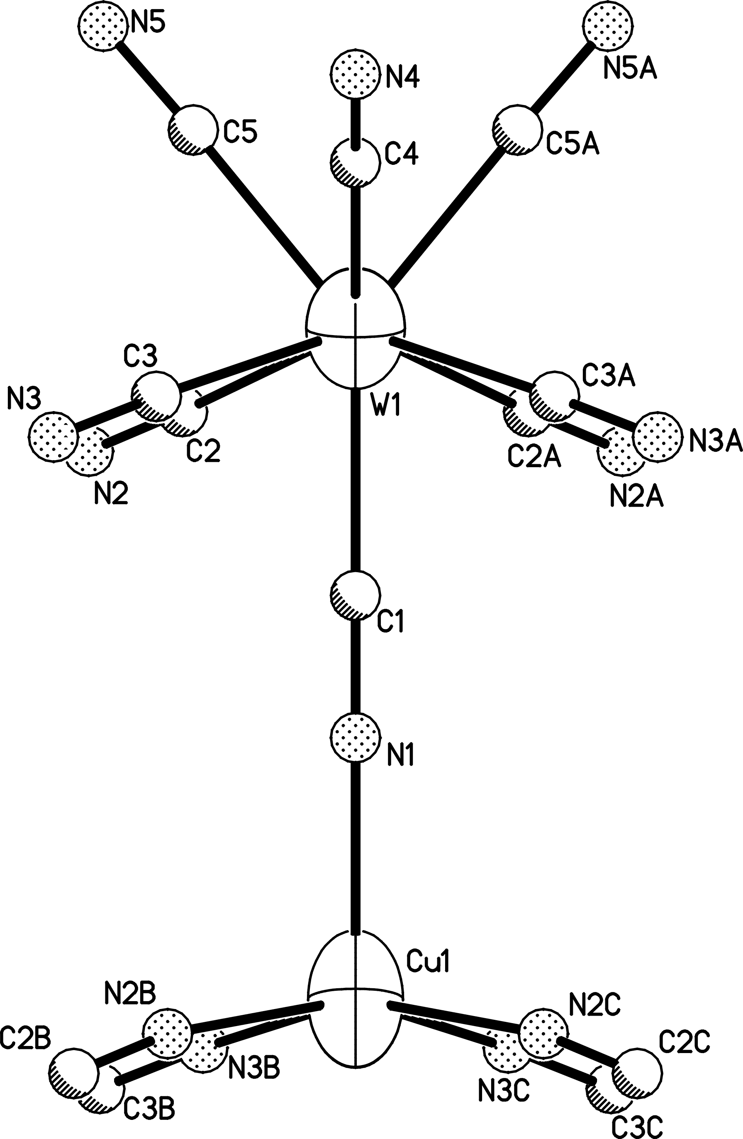

Figure S2. Atom numbering scheme of (NC)₇W-CN-Cu(NC)₄ structural motif of 2: W1-C1 = 2.165(7), W1-C2 = 2.178(9), W1-C3 = 2.146(9), W1-C4 = 2.177(11) , W1-C5 = 2.138(8), C1-N1 = 1.160(11), C2-N2 = 1.121(11), C3-N3 = 1.141(12), C4-N4 = 1.125(17), C5-N5 = 1.159(12), Cu1-N1 = 2.115(7), Cu1-N2B = 1.992(8), Cu1-N3B = 1.971(8) Å; W-C-N = 176-178.5, Cu1-N1-C1 = 174(2), Cu1-N2B-C2B = 169.3(7), Cu1-N3B-C3B = 169.4(8)º. Symmetry transformation used to generate equivalent atoms: B –x+¹/₂, -y+¹/₂, z+¹/₂.
Table. S1. IR spectra of {(tetrenH₅)_{0.8}Cu^{II}₄[W^{V}(CN)₈]₄⋅7.2H₂O}_{n} (1)*, tetren·5HCl (2)*, [Cu(tetren)](ClO₄)₂ (3)* and tetren (4)**(in cm⁻¹)
*in KBr pellet; **in film; Bruker IFS 47.
{(tetrenH₅)_{0.8}Cu^{II}₄ W^{V}(CN)₈]₄⋅2H₂O}_{n} | tetren·5HCl | [Cu(tetren)](ClO₄)₂ | tetren | Interpretation | Reference
3620s(sh,br) |  |  |  | ν (O–H) isolated | 1
3437s(br) | 3431s | 3425s(sh) | 3356s | ν (N–H) secondary | 1,2,3
 | 3218s(sh), 144s(sh) | 3349s, 3281s, 3142m | 3281s | ν (N–H) primary | 1,2,3
3023m, 2848m | 2986–2822vs(br) | 2954s, 2892 | 2935vs, 2816vs(sh) | ν (C–H) | 1
2732m(br) | 2691–2383vs(br) |  |  | ν (N⁺–H) | 1
2204s,  2164m, 2148m(sh) |  |  |  | ν (C≡N) bridging  ν (C≡N) terminal | 4  5
1618s | 1611s,1601s, 1535s | 1628s(sh), 1584s | 1599s | δ (N–H) | 1,3
1501w, 1452m | 1493s, 1479s | 1469s | 1461s | δ (CH₂) in plane | 1,3
1344w, 1237w,  983m | 1357s, 1335m, 1291s, 1100w, 1059s, 998m,  969s | 1391w, 1362w, 1313w, 1281w | 1348m, 1304m, 1128s, 1070m, 1015m | ν(C–N), ν (C–C)  skeletal stretching,  δ (C–H) | 1,3
 |  | 1096vs(br), 1017w, 990m |  | ν(Cl–O) | 3
812m,  793m | 817s | 881w, 849m, 820w | 908s, 846s, 777s (br) | γ (N–H) out of plane | 1
 |  | 625vs |  | δ (Cl–O) | 3
498s |  |  |  | ν (W–C) | 5
 |  | 583m, 549m, 529m, 456m |  | ν (Cu–N) | 2

- M. Szafran (ed.), Spectroscopic methods in determination of the structure of organic compounds. Tables and exercises. (in polish), Warszawa PWN 1988.
- Z. Lu, C. Duan, Y. Tian, Z. Wu, Y. You, Z. Zhou, T. Mak, Polyhedron 1997, 16, 909.
- R. Parker, L. Spiccia, B. Moubaraki, K. Murray, B. Skelton, A. White, Inorg. Chim. Acta 2000, 300, 922.
- This work.
- W. P. Griffith, J. Chem. Soc., Dalton Trans. 1975, 2489.

Fig. S3. IR spectra of {(tetrenH₅)_{0.8}Cu^{II}₄[W^{V}(CN)₈]₄⋅7.2H₂O}_{n} (1), tetren·5HCl (2), [Cu(tetren)](ClO₄)₂ (3), and tetren (4) in 400-1800 cm⁻¹ range.

Fig. S4. IR spectra of {(tetrenH₅)_{0.8}Cu^{II}₄[W^{V}(CN)₈]₄⋅7.2H₂O}_{n} (1), tetren·5HCl (2), [Cu(tetren)](ClO₄)₂ (3), and tetren (4) in 1800-4000 cm⁻¹ range.

