Electronic Supplementary Information
Diels-Alder reactions of nickel(II) N-confused porphyrins as dienophiles
Ziwei Xiao, Brian Patrick and David Dolphin*
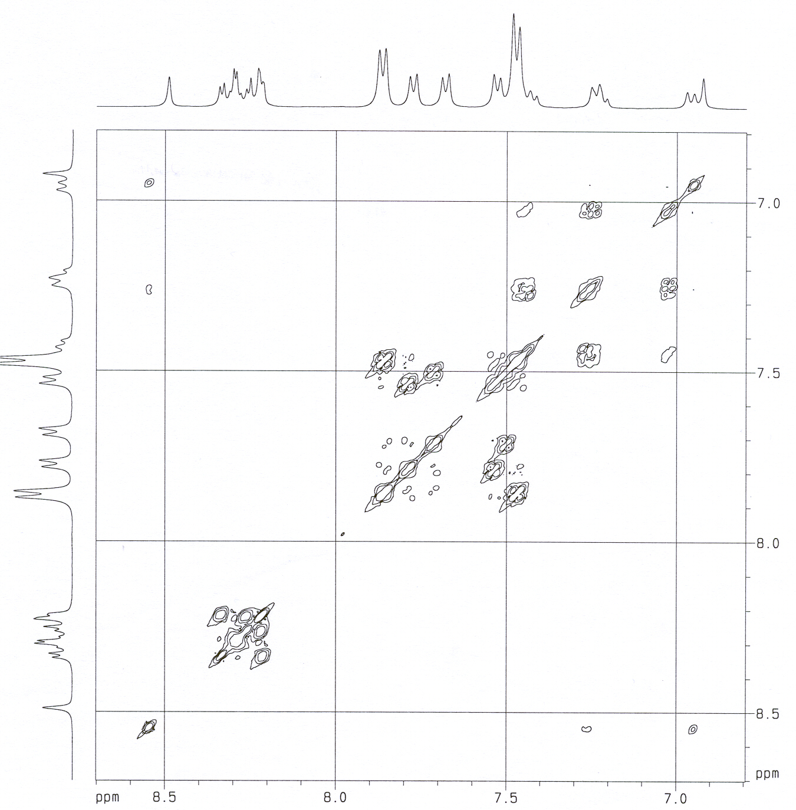

Figure 7. COSY spectrum of 5b (400 MHz, CD₂Cl₂).

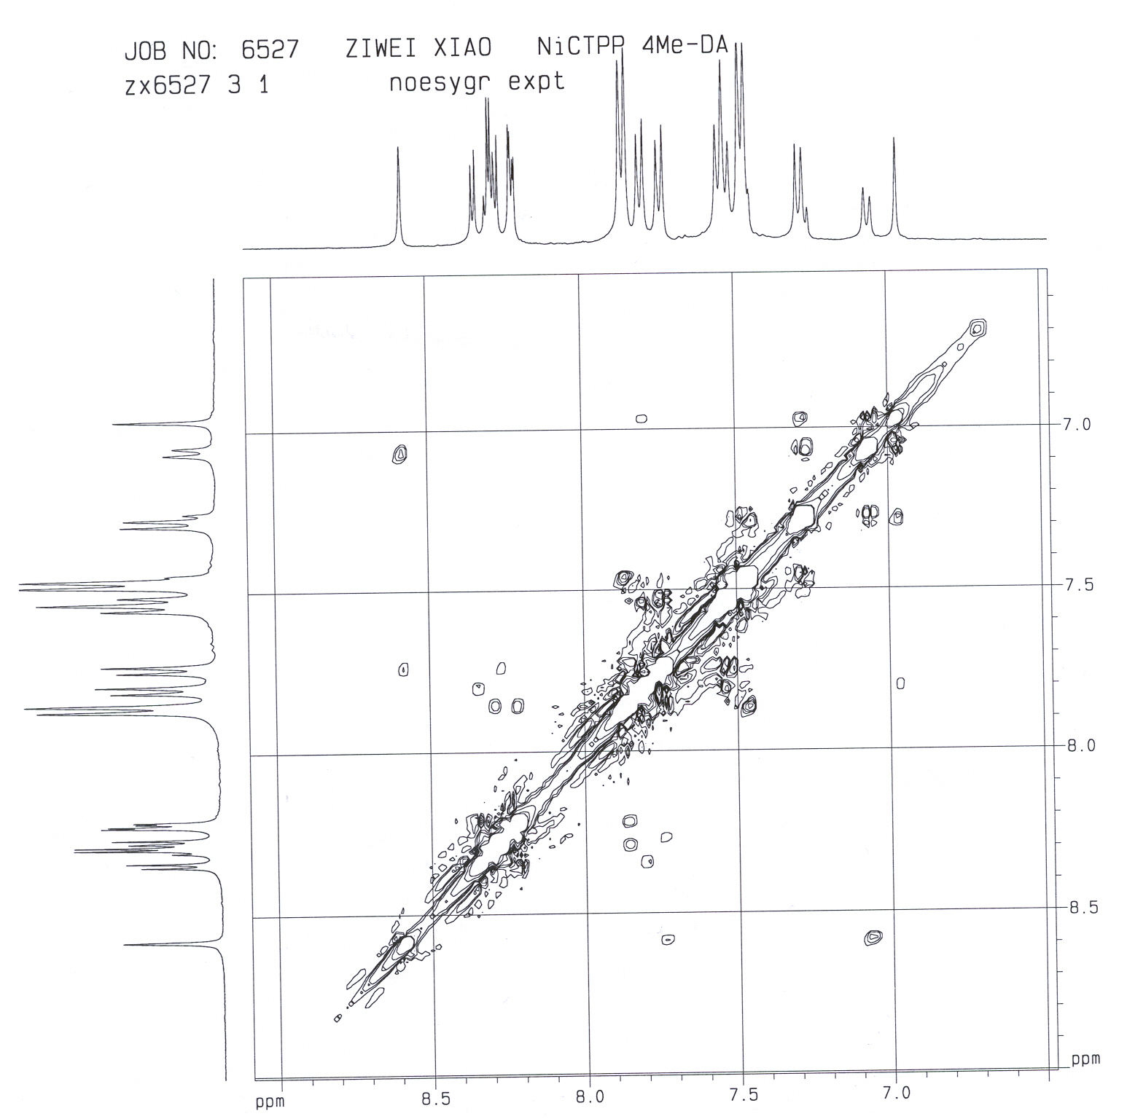

Figure 8. NOESY spectrum of 5b (400 MHz, CD₂Cl₂).

