Supplementary Material (ESI) for Chemical Communications
This journal is © The Royal Society of Chemistry 2002

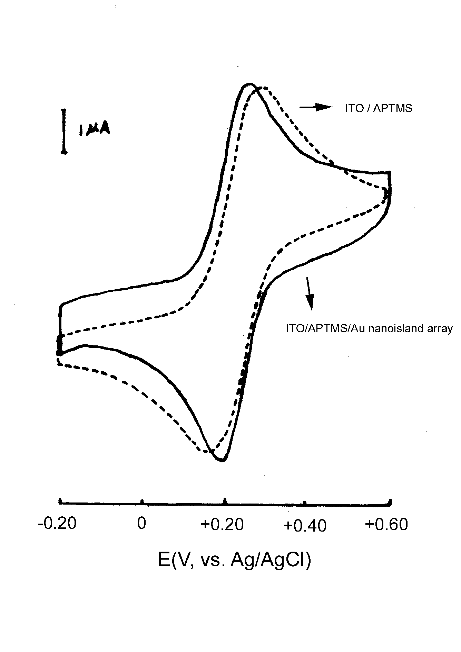
Figure 1. Cyclic Voltammograms at a ITO/APTMS and a ITO/APTMS/Au nanoisland array electrode with an area of ~0.40 cm² recorded in 0.5 mM K₃Fe(CN)₆ + 0.10 M KCl at 100 mV/s.

Figure 2. Cyclic Voltammogram at a ITO/APTMS/ Au(2.5 nm) monolayer electrode with an area of ~0.40 cm² recorded in 0.10 M H₂SO₄ at 10 mV/s.

