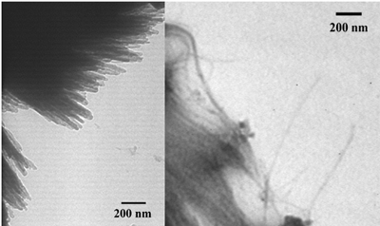

Figure S1: TEM views of functionalized nanotubes 1, aggregated in thick bundles (left side image)
and less aggregated ones (right side image)

