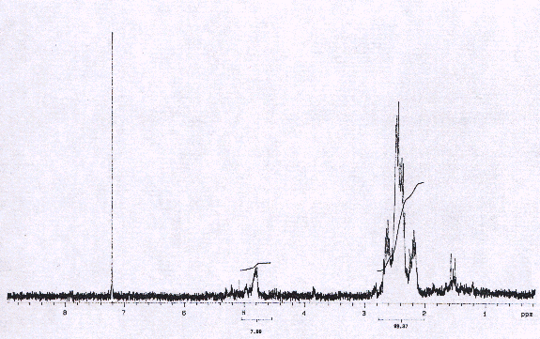

Figure S2: ¹H NMR spectrum of functionalized SWNTs 2 material.

