Supplementary Information for

Two-point Contact Chiral Distinction - A Theoretical Appraisal

T. P. Radhakrishnan,*ª Sid Topiol,*^{b} P. Ulrich Biederman, ^{c}
Sarit Garten ^{c} and Israel Agranat^{*c}

ªSchool of Chemistry, University of Hyderabad, Hyderabad-500 046, India. Fax: 91-40-3012460; Tel: 91-40-3011068; E-mail: tprsc@uohyd.ernet.in
^{b}Core Technologies, Novartis Institute for Biomedical Research, Summit, NJ, USA. Fax: 1-908-277-4910; Tel: 1-908-277-7669; E-mail: sidney.topiol@pharma.novartis.com
^{c}Department of Organic Chemistry, The Hebrew University of Jerusalem, Jerusalem 91904, Israel. Fax: 972-2-6511907; Tel: 972-2-6585221; E-mail: isria@vms.huji.ac.il

Contents
Page 2. Table S1. Energy of CHFClBr computed at various levels.
Page 2. Table S2. NBO charges on CHFClBr computed at various levels.
Page 2. Table S3. Energies of SR and SS dimers and their monomers (with ghost orbitals) in the
counterpoise correction calculations.
Page 3. Figure S1. (a) HF/6-311++G** and (b) MP2/6-311++G** optimized geometries of
CHFClBr.
Table S4. Atomic coordinates in (a) HF/6-311++G** and (b) MP2/6-311++G**
optimized geometries of CHFClBr.
Page 4. Figure S2. HF/6-311++G** optimized geometries of (a) SR and (b) SS - CHFClBr
dimers.
Table S5. Atomic Coordinates in HF/6-311++G** optimized geometries of (a) SR and
(b) SS - CHFClBr dimers.
Page 5. Table S6. Atomic Coordinates in MP2/6-311++G** optimized geometries of (a) SR and
(b) SS - CHFClBr dimers

Table S1. Energy of CHFClBr computed at various levels.

Calculation | Energy (Hartrees)
HF/6-31G** | -3167.236258
HF/6-311G** | -3169.778322
HF/6-31++G** | -3167.258953
HF/6-311++G** | -3169.785355
MP2/6-31G**//HF/6-31G** | -3167.786213
MP2/6-311G**//HF/6-311G** | -3170.388570
MP2/6-31++G**//HF/6-31++G** | -3167.818039
MP2/6-311++G**//HF/6-311++G** | -3170.401327
MP2/6-311++G** | -3170.402098

Table S2. NBO charges on CHFClBr computed at various levels.
Calculation | Charge
Calculation | C | H | F | Cl | Br
HF/6-31G** | 0.1565 | 0.2334 | -0.3913 | -0.0223 | 0.0236
HF/6-311G** | 0.2470 | 0.1511 | -0.3871 | -0.0331 | 0.0222
HF/6-31++G** | 0.1359 | 0.2280 | -0.4019 | -0.0059 | 0.0439
HF/6-311++G** | 0.2044 | 0.1570 | -0.3940 | -0.0123 | 0.0448
MP2/6-311++G** | 0.1872 | 0.1643 | -0.4014 | -0.0018 | 0.0517

Table S3. Energies of SR and SS dimers and their monomers (with ghost orbitals) in the counterpoise correction (CC) calculations; monomer energies
are given in Table 1 of the paper.

Calculation | E (SR) / Hartrees |  | E (SS) / Hartrees
Calculation | Dimer | Monomer (CC corrected) | Dimer | Monomer - left  (CC corrected) | Monomer - right  (CC corrected)
HF/6-31G** | -6334.476159 | -3167.237564 | -6334.477953 | -3167.238814 | -3167.239917
MP2/6-31G**//HF/6-31G** | -6335.579283 | -3167.788527 | -6335.582978 | -3167.789920 | -3167.790889
HF/6-311G** | -6339.560361 | -3169.779410 | -6339.560296 | -3169.779419 | -3169.779328
MP2/6-311G**//HF/6-311G** | -6340.783472 | -3170.390587 | -6340.783383 | -3170.390541 | -3170.390519
HF/6-31++G** | -6334.527534 | -3167.263515 | -6334.527242 | -3167.263676 | -3167.262745
MP2/6-31++G**//HF/6-31++G** | -6335.650850 | -3167.824081 | -6335.650484 | -3167.824372 | -3167.823094
HF/6-311++G** | -6339.573808 | -3169.785960 | -6339.573749 | -3169.785929 | -3169.785929
MP2/6-311++G**//HF/6-311++G** | -6340.809570 | -3170.403374 | -6340.809514 | -3170.403354 | -3170.403354
MP2/6-311++G** | -6340.812054 | -3170.404881 | -6340.811844 | -3170.404497 | -3170.404496
Figure S1. (a) HF/6-311++G** and (b) MP2/6-311++G** optimized geometries of CHFClBr. The atoms are colored, C - black, H - blue, F - green, Cl - orange and Br - brown. Bond distances are indicated in pm.

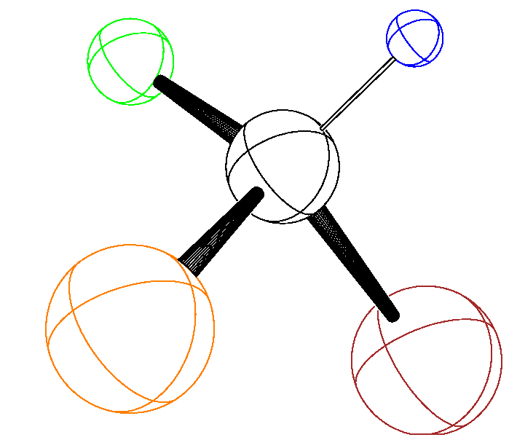
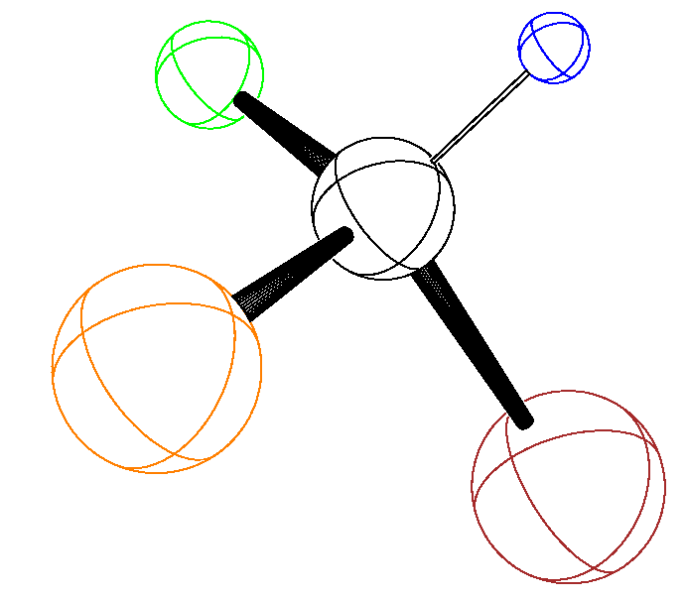
(a) (b)
107.3
192.7
175.9
132.5
108.7
193.3
175.5
135.5

Table S4. Atomic coordinates in (a) HF/6-311++G** and (b) MP2/6-311++G** optimized geometries of CHFClBr.

(a)
Atom | x | y | z
H | -0.608446 | 0.592301 | 1.472138
C | -0.564802 | 0.457412 | 0.408564
F | -0.766414 | 1.619007 | -0.195653
Br | 1.198393 | -0.185318 | -0.029937
Cl | -1.826399 | -0.671865 | -0.065580
(b)
Atom | x | y | z
H | -0.613819 | 0.594896 | 1.486897
C | -0.570184 | 0.448358 | 0.410916
F | -0.779720 | 1.639138 | -0.201309
Br | 1.202731 | -0.184287 | -0.029677
Cl | -1.826069 | -0.681603 | -0.064819

Figure S2. HF/6-311++G** optimized geometries of (a) SR and (b) SS - CHFClBr dimers. The atoms are colored, C - black, H - blue, F - green, Cl - orange and Br - brown. Distances are indicated in pm.
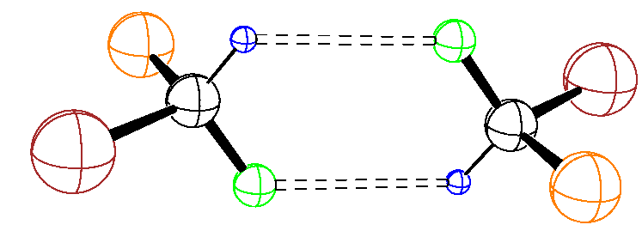
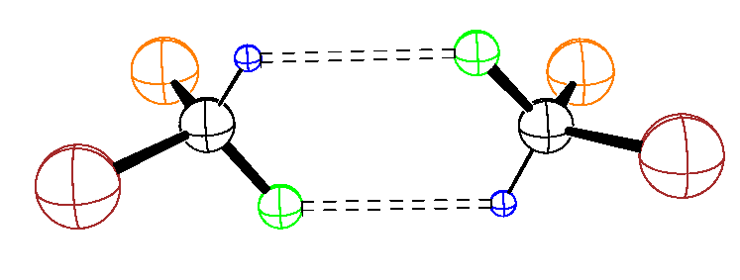
(a) (b)
175.7
192.5
133.1
107.2
267.7
266.0
265.8
107.2
133.1
175.6
192.6
133.1
107.2
175.6
192.5

Table S5. Atomic Coordinates in HF/6-311++G** optimized geometries of (a) SR and (b) SS - CHFClBr dimers.

(a)
Atom | x | y | z
H | -0.010117 | 0.987885 | 1.498111
C | -0.331863 | 0.081120 | 1.970686
F | -0.055981 | -0.952078 | 1.177999
Br | 0.645586 | -0.115553 | 3.617620
Cl | -2.068217 | 0.160950 | 2.224586
H | 0.010117 | -0.987885 | -1.498111
C | 0.331863 | -0.081120 | -1.970686
F | 0.055981 | 0.952078 | -1.177999
Br | -0.645586 | 0.115553 | -3.617620
Cl | 2.068217 | -0.160950 | -2.224586

(b)
Atom | x | y | z
H | -1.460031 | 0.081774 | 1.023079
C | -2.006537 | 0.272262 | 0.120786
F | -1.197649 | 0.117768 | -0.925389
Br | -3.433271 | -1.015471 | 0.002519
Cl | -2.594334 | 1.926701 | 0.152193
H | 1.458760 | 0.080424 | -1.021668
C | 2.006062 | 0.271715 | -0.120033
F | 1.198439 | 0.116669 | 0.927034
Br | 3.434305 | -1.014407 | -0.002952
Cl | 2.592027 | 1.926813 | -0.152520

Table S6. Atomic Coordinates in MP2/6-311++G** optimized geometries of (a) SR and (b) SS - CHFClBr dimers (Figures provided in the paper).

(a)
Atom | x | y | z
H | 0.234986 | 0.995745 | 1.391551
C | -0.168688 | 0.081883 | 1.814944
F | 0.234256 | -0.969179 | 1.048836
Br | 0.552413 | -0.132217 | 3.592636
Cl | -1.920372 | 0.164109 | 1.795793
H | -0.234986 | -0.995745 | -1.391551
C | 0.168688 | -0.081883 | -1.814944
F | -0.234256 | 0.969179 | -1.048836
Br | -0.552413 | 0.132217 | -3.592636
Cl | 1.920372 | -0.164109 | -1.795793

(b)
Atom | x | y | z
H | 1.313167 | -0.111815 | -0.996974
C | 1.862255 | 0.166863 | -0.103961
F | 1.087763 | -0.101120 | 0.984699
Br | 3.458417 | -0.915160 | -0.012464
Cl | 2.206757 | 1.884962 | -0.150946
H | -1.313467 | -0.112854 | 0.997225
C | -1.862107 | 0.166220 | 0.104060
F | -1.087721 | -0.102860 | -0.984408
Br | -3.459443 | -0.914055 | 0.012537
Cl | -2.204702 | 1.884715 | 0.150593

