Supplementary Material (ESI) for Chemical Communications
This journal is © The Royal Society of Chemistry 2002

EXPERIMENTS

Preparation of ODNs and ODN-modified nanospheres. All ODNs used in this study were prepared on a fully automated DNA synthesizer (Oligo 1000M DNA synthesizer, Beckman). Purification, storage, and quantification were carried out following previously described methods (T. Ihara, Y. Maruo, S. Takenaka, M. Takagi, Nucleic Acids Res., 1996, 24, 4273.). The spheres (FluoSphere, Molecular Probes, Inc., Eugene, OR) used in this study have carboxylic groups on their surface (1 carboxylate/9 Å²) (R. P. Haugland, Handbook of fluorescent probes and research chemicals, Edn. 7; Molecular Probes, Inc., OR, 1999.). Amino-terminated oligonucleotides, 5cWT15 or 3cWT15 were anchored onto the spheres using 1-ethyl-3-(3-dimethylaminopropyl) carbodiimide (EDAC) in NaHCO₃/Na₂CO₃ buffer solution (pH 9.8). As a typical procedure, 300 µL of aqueous buffer solution (0.2 M NaHCO₃ /Na₂CO₃ ) containing 120 nmol ODNs (5cWT15 or 3cWT15), 1.1 x 10¹⁴ spheres (carrying 12 µmol of carboxylic groups), and 12 µmol EDAC was shaken for 12 h at room temperature. After the capping of residual activated surface carboxylic groups with 2 mg glycine, the ODN-modified nanospheres were isolated from the free 5cWT15 or 3cWT15 and low-molecular weight by-products by GPC (Sephadex G-200). The unreacted free 5cWT15 and 3cWT15 were quantified using a UV-vis spectrophotometer (Hitachi U-3010) to estimate the surface coverage of the spheres.

Fluorescence microscopy. A fluorescence microscope (Olympus BX51) equipped with a CCD camera was used for observing the aggregates. For selective observation of each sphere, appropriate sets of optical filters were used; the filters sets with the band pass of 470-490 nm for excitation and 515-550 nm for emission, and that of 520-550 nm for excitation and > 580 nm for emission were used to observe the yellow-green and the red spheres, respectively. One µL of the sample solutions containing 5.7 x 10⁸ of both spheres (carrying 210 fmol of 5cWT15 and 3cWT15, respectively) and 40 mM Hepes (pH 7.0) were used for the observation. The solutions of the aggregates also contained 10 mM MgCl₂ and 210 fmol of WT45^{AGG} or MT45^{AGT}. After 10 minutes of making the solutions, these were put between slide and cover glasses, and then subjected to microscope inspection at room temperature. The two photos taken through each of the filter sets were superposed over each other using image processing software (Adobe Photoshop 3.0, Adobe Systems).

Observation of the FRET between the spheres. The emission spectra were measured using a fluorescence spectrophotometer (Hitachi F-2500) with an optical filter to screen (< 500 nm) the intense Rayleigh scattering. The sample solutions used here were the diluted solutions of those used for the fluorescence microscopy for ca. 500 times with the aqueous buffer (40 mM Hepes (pH 7.0), 10 mM MgCl₂) to make 1 mL solutions, which contained 1.0 x 10⁹ of both spheres and, in the aggregates solutions, 400 fmol of WT45^{AGG} or MT45^{AGT} as well. All spectra were obtained by excitation at 470 nm at room temperature just after dilution. The spectra were corrected for the absorption of the sample solution themselves and the optical filter, and the characteristics of the photomultiplier.

SUPPLIMENTARY RESULTS

TEM observation of the spheres. The spheres before and after the ODN modification were observed by transmission electron microscopy (TEM). The spheres were stained with uranyl acetate, which should strongly bind with phosphates in the backbone of the ODNs. The circular rims of the particles appeared to blacken with ODN modification, indicating that the ODNs were anchored onto the spheres and the modification reaction did not cause significant influence on the sphere body itself.
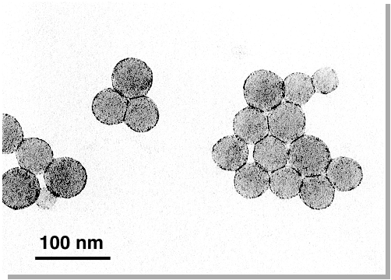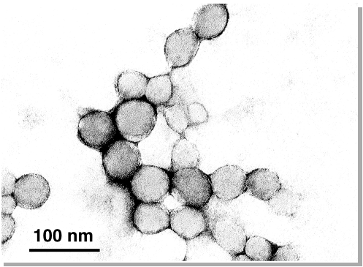
before modification after modification

Preliminary study on hybridization. 5cWT15 was immobilized onto the spheres with 1 μm diameter. These spheres precipitate easily by centrifuge. Two kinds of BODIPY-ODN conjugates were synthesized by ordinary coupling method via activated ester of BODIPY. One of them is the 15mer complementary to 5cWT15 (corresponds to 5’-end 15mer of WT45^{AGG}), other is the 15mer carrying one base mutation (corresponds to 5’-end 15mer of MT45^{AGT}). Hybridization experiments were carried out for 0.1 μM conjugates and immobilized 5cWT15 in
Structure and synthesis scheme

the buffer solution containing 10 mM MgCl₂ and 40 mM Hepes (pH 7). After incubation for 3 h at 25°C, the spheres were precipitated from the dispersed solutions by centrifugation (15,000 rpm for 1 min). Then, the concentrations of free BODIPY-ODN conjugate in supernatants were measured using its fluorescence. The hybridization efficiency of complementary and mutant conjugate, the rate of capturing conjugates, were 72 % and 5 %, respectively. Almost of all captured complementary BODIPY-ODN were recovered from the spheres by the 3 M urea treatment. It means that hybridization takes place on the ODN-modified spheres and fidelity in the recognition is retained in this heterogeneous system.
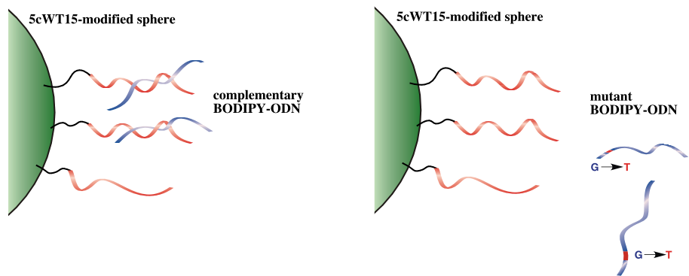
Sequence specific hybridization on the ODN-modified spheres

The spheres carrying short ODNs that have complementary 10mer sequence without spacer such as dT₁₀ was prepared to check the requirements for ODNs that were immobilized onto the spheres. The 10mer-immobilized spheres scarcely captured complementary BODIPY-ODN conjugate. This result indicates that the spacer and/or longer sequence was required for effective hybridization on the spheres.

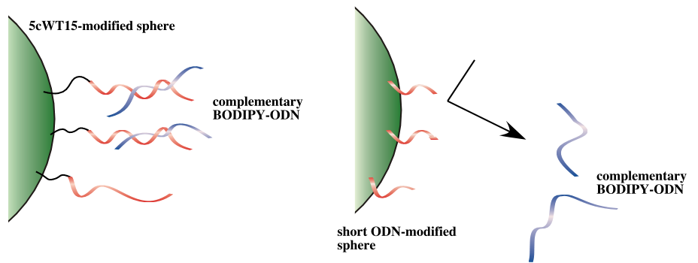
Requirements for ODNs immobilizd onto the spheres

Dependence of the sphere aggregations on the salt concentration. The concentration of salt is one of the critical parameters for the studies of fluorescence microscopy and FRET. The concentration was decided according to the results of salt titrations.
Into the mixed dispersed solutions of the both spheres, concentrated aqueous of MgCl₂ was titrated with monitoring the turbidity at 400 nm at 25 °C. The initial solutions contains 5.7 x 10¹¹ of both of the spheres and 210 nmol of WT45^{AGG} or MT45^{AGT} in 1 mL buffer solutions (40 mM Hepes (pH 7)).
Although the both solutions became turbid with increasing the concentration of Mg²⁺, the turbidity of the solution containing the target, WT45^{AGG}, increased from less Mg²⁺ concentration than that containing the mutant, MT45^{AGT}. The Mg²⁺ concentration that could give the difference in the extent of aggregation between the both solutions ([MgCl₂] = 10 mM) was adopted as one of the conditions in microscopy and FRET studies.

*Much difference in the ionic strength in the two systems (dT₂₀-modified sphere and sphere R-G systems) is not surprising, because divalent cations such as Mg²⁺ have extremely powerful effect compared with monovalent cations such as Na⁺ on duplex formation of nucleic acids (i.e., M. T. Record, C. F. Anderson Jr., T. M. Lohman, Quart. Rev. Biophys. 1978, 11, 103; G. S. Manning, Quart. Rev. Biophys. 1978, 11, 179.).

Dependence of DNA-directed sphere aggregation on MgCl₂ concentration

Aggregation of dT₂₀-modified spheres. These spheres showed aggregation in the presence of complementary RNA homopolymer, polyA under the appropriate conditions (1.0 M NaCl, 40 mM Hepes (pH 7.0)) (b). On the other hand, the spheres were fully dispersed in the presence of polyC and polyU under the same conditions (a). In addition, the aggregation with polyA was entirely suppressed by the addition of 5 M urea. The aggregation was reversible for the change of salt concentration and temperature; this is the feature of hybridization of nucleic acids.

Preliminary aggregation experiment using RNA homopolymer.

FRET imaging. Using appropriate set of optical filters, we could observe the image of FRET. Bright red image was observed for well networked yellow aggregates with WT45^{AGG}. On the other hand, the solution containing the aggregates with MT45^{AGT} gave just slightly emitted points. As mentioned in the manuscript, effective FRET takes place only between the two spheres neighboring each other. These data could be a direct evidence indicating the mutual connection of the experimental data of Figure 2 and Figure 3.

* It is likely that the aggregation in the presence of MT45^{AGT} mostly due to the hydrophobic nonspecific interaction between the spheres in the presence of MgCl₂. Subtle difference in the propensity for aggregation of sphere R from that of sphere G (sensitivity for ionic strength) seems to make the spheres gathered separately; each of the spheres might aggregate sequentially. Prevention of this nonspecific interaction would contribute improvement of the sensitivity of this method. Increasing the number of modified DNAs or hydrophilic chemical modification of sphere surface should help to improve the sensitivity of the present method. Such extensions are in progress.
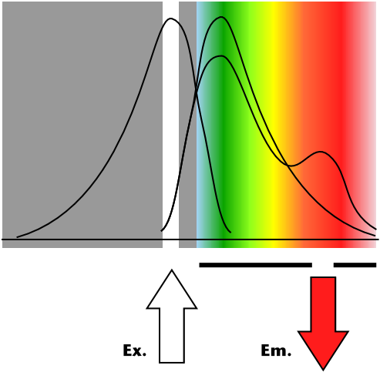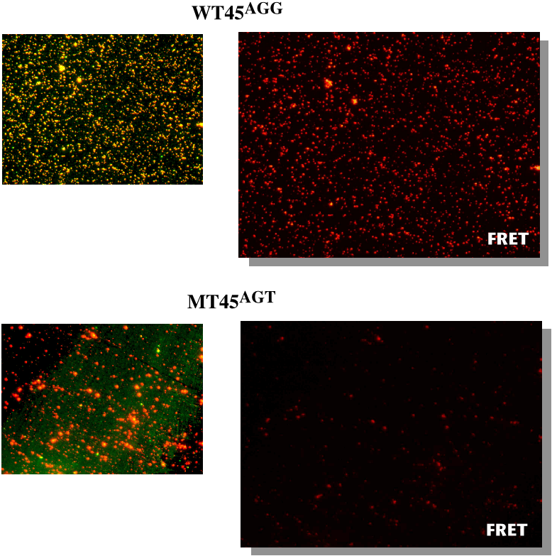
FRET imaging of the sphere aggregates

