Electronic Supplementary Information (ESI) service
B(C6F5)3-CATALYZED FORMATION OF B-P BONDS BY DEHYDROCOUPLING OF PHOSPHINE-BORANES
Jean-Marc Denis,*a Henrietta Forintos,a Helga Szelke,a Loic Toupetc, Pham Thi-Nhàn, Pierre-Jean-Madec, Annie-Claude Gaumont*b

Synthesis of [PhPH-BH₂]n 3
0.3 g (2.4 10⁻³ mol) of phenylphosphine-borane complex and 6.10⁻³ g (1.2 10⁻⁵ mol, 0.5 mol %) of B(C₆F₅)₃ were dissolved into 4 mL of toluene and the resulting solution was heated at 90°C for 3h. After evaporation of the solvent under vacuum, the residue was washed with pentane (2x1 mL). The resulting solution was concentrated under vacuum (0.19g, yield 63%).
Two different fractions of [PhPH-BH2]n were observed by 31P, 11B and size exclusion chromatography. The first one corresponds to the structure previously described by the group of Manners², the second (called “new structure”) corresponds to lower molecular weight oligomeric or cyclic structures.
- “Manners like fraction ” ¹H NMR (300 MHz, D-8 toluene):  7.9-6.7 (aromatic H), 4.25 (br d, J_{PH} 360 Hz; PH), 2.2-0.65 (br, BH₂). ³¹P NMR  -48.9 (br, J_{PH} 348 Hz). ¹¹B  -34.7 (br). Mw = 3900.
-“New structure” ¹H NMR (300 MHz, D-8 toluene): 7.9-6.7 (aromatic H), 4.3 (br d, J_{PH} 360 Hz, PH); 2.2-0.65 (br BH₂). ³¹P NMR, unresolved peaks from -52 to -56 . ¹¹B NMR, -33(shoulder) (br). Mw 830.
Size exclusion chromatography and thermal properties. Molecular weights were determined by size exclusion chromatography. A waters 515 HPLC apparatus, fitted with a refractive index and UV detectors was used. It was equipped with a Styragel HR 0.5 and HR 4E (THF) columns calibrated with standard polystyrene samples using tetrahydrofurane at 30°C as the mobile phase at a flow rate of 0.6 mL min⁻¹. The volume of injected sample solution (1 mg mL⁻¹) was 20μL.
Differential scanning calorimetry. Thermal properties of the polymers were studied by differential scanning calorimetry on a Perkin Elmer DSC-7 calibrated with an indium standard. The values of T_{m} are obtained from the second heating run, at 20°C min⁻¹ under a nitrogen atmosphere At least 10 mg of the sample was used for DSC measurement.

Preparation and characterisation of –[PH₂-BH₂]_{n}- 4
The main problem encountered to extend the dehydrocoupling to the complex H₃B.PH₃ 2 was due the weakness of the P-B bond and its fast dissociation at temperatures as low as - 30°C under atmospheric pressure. We use a special equipment to solve this problem. The following reaction was performed in a well ventilated hood behind a safety shield. Excess of PH₃(g)6 dehydrated in line through two cold traps cooled at - 50°C and ≈1 eq of diborane B₂H₆(g)7 were bubbled through two flex needles into a Schlenk flask containing a CH₂Cl₂ solution of B(C₆F₅)₃ previously cooled at -50°C. Oligomerisation started around +20°C and was complete after heating at 70°C overnight.
H₃P-(BH₂-PH₂)n-PH₃
³¹P NMR : Three broad peaks at -104 (t, J_{PH} 362 Hz),  - 109 (t, J_{PH} 340) (PH₂ groups) and a small peak at  -115 (q, J_{PH} 356) (terminal PH₃ group)] were observed. The ¹¹B NMR showed complex resonance structure (main peaks at  - 32 and  -35 ppm which are characteristic of four-coordinated boron centres attached to two phosphorus atoms). The higher field of the phosphorus in PH₃ allowed to evaluate the value of n (1<n<8).
–[PH₂-BH₂]_{n}- 4 The material obtained by heating the solution at 90°C for one day was assigned to 4 on the basis of the ³¹P NMR (very broad peak from - 95 to - 120) and ¹¹B NMR (very broad peak centred at  - 32). The white solid material thus obtained after evacuation of the solvent was very sensitive to air and water. Very fast oxidation prevented to get correct elemental and HRMS analyses.

Synthesis of the complex PhPH₂-B(C₆F₅)₃ 5
The complex 5 was prepared by addition at 0°C of a toluene solution containing one equivalent of B(C₆F₅)₃ (5 mol%) to a toluene solution of free phenylphosphine (5 mol%). The reaction was completed after one day. Crystallisation in methylene chloride afforded 5. ¹H NMR (300 MHz, CD₂Cl₂):  7.9-6.7 (aromatic H), 6.2 (t J_{PH} = 410 Hz, PH) . ³¹P NMR, 
- 42.9 (t, 1J_{PH} 412 Hz). ¹¹B NMR -15.5 (J_{PB} 34 Hz). HRMS : m/z 110 (80%), ¹⁹F NMR: -130.2, -155.5, -162.7. C₆H₇P (PhPH₂^{+.}) calcd 110.0285, found 110.0283; m/z 512 (100%) C₁₈F₁₅B₁₁ [B(C₆F₅)₃], calcd: 511.9853, found 511.9880. For X-ray structure, see crystallographic data in the CIF format.

Characterisation of complex (C₆F₅)₃B-PH(Ph)- BH₂-SMe₂ 8
Complex 8 was prepared by addition of a toluene solution (1 eq) of 5 (5 mol%) into a toluene solution of the complex PhPH₂-BH₃ cooled at -20°C. Evolution of hydrogen was immediately observed. The reaction was completed after one night to 0°C. Product is thermally unstable and should be kept in solution in the freezer. In the EI mass spectrum, the peak with the highest molecular mass comes from the loss of B(C₆F₅). All attempts to get single crystals for X-ray structure were unsuccessful. Product was only evidenced by multinuclear NMR spectroscopy and by HRMS. The product is not stable and decomposes slowly at room temperature.
¹H NMR (300 MHz, CD₂Cl₂): 7.9-6.7 (aromatic H), 5.6 (d J_{PH} 410 , PH). ³¹P NMR, - 46.8 (d, ¹J_{PH} 372 Hz). ¹¹B NMR -14.5 (J_{PB} 64 Hz); -19.7 (t br). ¹⁹F NMR -128.5, -159.1, -164.5. HRMS m/z 511 (B(C₆F₅)₃), calcd. 511.9853; found 511.9868.

Characterisation of complex (C₆F₅)₃B-PH₂-BH₂-SMe₂ 9
To a toluene solution of 1.3.10⁻¹⁰ mol of the B(C₆F₅)₃. SMe₂ complex, one equivalent of a toluene solution of BH₃/SMe₂ was added at -20°C. The mixture was allowed to warm up to room temperature and the reaction was completed after 24 h. The solvent was evacuated under vacuum. Crystallisation occurred in methylene chloride after two weeks in a freezer. The product decomposed slowly at room temperature. In the EI mass spectrum, the peak with the highest molecular mass comes from the loss of B(C₆F₅)₃. The complex 9 was characterized by multinuclear NMR and single crystal X-ray analysis. For X-ray structure, see crystallographic data in the CIF format.
¹H NMR (300 MHz, CD₂Cl₂): 3.6 (J = 357Hz), 0.9 (broad s). ³¹P NMR: - 104.3 5 (J_{PH} 347 Hz). ¹¹B NMR -17.4 (J_{PB} 42 Hz); - 22.3 [(J_{PB} 33 Hz, J_{BH} 109Hz(t)]. HRMS m/z 511 [B(C₆F₅)₃], calcd. 511.9853; found 511.9868.

Characterisation of complex (C6F5)₃B-SMe₂ 10
Complex 10 was prepared by addition at 20°C of SMe₂ (1.1 eq.) into a toluene solution of B(C₆F₅)₃ (5mol%) previously dried. Reaction was completed after 24h. The product was crystallized (solvent CH₂Cl₂) after evaporation of the toluene under vacuum The structure was evidenced by ¹¹B, ¹⁹F NMR spectroscopy and by X-ray structure. 5 is air- and water sensitive. ¹¹B NMR (toluene): -2.3 (broad s). ¹⁹F NMR: -129.6, -140.8, -160.5. ¹H NMR (300 MHz): 1.58 (s). HRMS: in the EI mass spectrum, the most intense peak comes from the loss of B(C₆F₅)₃. For X-Ray structure, see also crystallographic data in the CIF format.

Molecular structure of(C₆F₅)₃B-SMe₂ 10.

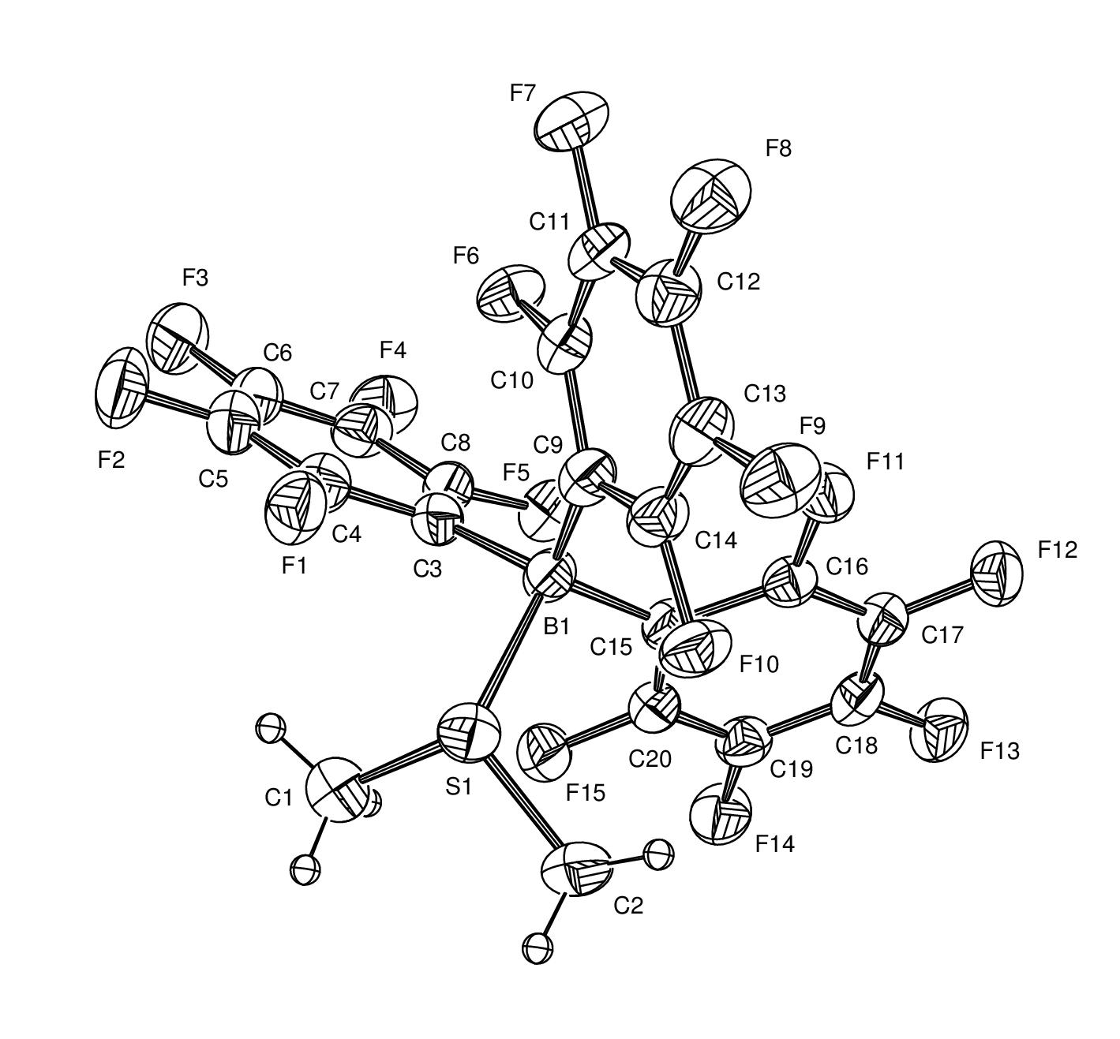
Crystal data and structure refinement for 10
Formula, C₄₀H₁₂B₂F₃₀S₂, Formula weight, 1148.24, Temperature, 293(2) K, Wavelength, 0.71069, Crystal system, monoclinic, Space group, C2/c, Unit cell dimensions, a = .7574(7) α = 90°, b= 11.8948 β = 110.101°, c = 20.2990(9), β = 90°, Volume, 4026.4(3), Z,4, Density (calculated), 1.894, Absorption coefficient, 0.307, F(000), 2256, Crystal 0.12x0.08x0.08mm, Theta range for data collection, 2.10 to 27.48°, Index range, 0<h<23, 0<k<5, -26<l<24, Reflections collected, 4604, Independent reflection, 4604 [R(int) = 0.0000], Reflection, observed (>2sigma), 3119, Refinement method, Full-matrix least-squares on F2, Data/restrains/parameters, 4604.0/335, Goodness-of-fit 1.055, Final R indices [I<2sigma(I)), R~1 = 0.0724 wR~2 = 0.1795, R indices (all data), R~1 = 0.1124, wR~2 = 0.2138.

