Supplementary data

Strong intramolecular chromophore interactions in novel bis([60]fullerene)-oligoporphyrin nanoarrays
Davide Bonifazi and François Diederich*
Laboratorium für Organische Chemie, ETH-Hönggerberg, CH-8093 Zürich, Switzerland, E-mail: diederich@org.chem.ethz.ch
Selected physical and spectral data of the fullerene-porphyrin conjugates 1a-c and 7.
1a: M.p. > 400 °C (PhMe/cyclohexane). δΗ(C6D5CD3, 300 MHz) 1.01 (t, J = 7.2, 6H), 1.38 (s, 18H), 1.40 (s, 18H), 1.50 (s, 18H), 1.51 (s, 18H), 4.09 (q, J = 6.9, 4H), 5.60 (s, 4H), 7.28-7.31 (m, 2H), 7.51 (m, 2H), 7.79 (t, J = 1.8, 2H), 7.90 (t, 2H), 8.18 (m, 2H) 8.28-8.35 (m, 6H), 8.43-8.48 (m, 8H), 8.53 (d, J = 4.5, 2H), 8.92 (d, J = 4.8, 2H), 8.96 (d, J = 4.5 2H), 9.04 (d, J = 4.8, 2H), 9.14 (d, J = 4.5, 2H), 9.19 (d, J = 4.5, 2H). δ_{C}(CDCl₃, 125 MHz) 14.27, 31.69, 31.73, 31.86, 31.87 , 34.94, 34.96, 35.06, 35.09, 52.18, 63.53, 68.21, 70.95, 119.70, 120.70, 120.85, 123.31, 123.54, 125.67, 126.90, 129.48, 129.76, 129.92, 131.82, 131.88, 132.09, 132.24, 132.33, 132.48, 133.25, 133.39, 133.89, 134.69, 137.01, 137.05, 139.06, 139.13, 139.28, 139.30, 139.63, 139.68, 140.03, 140.08, 140.32, 140.59, 140.68, 141.28, 141.30, 141.32, 141.40, 141.42, 141.45, 141.63, 141.67, 141.83, 141.85, 141.92, 142.17, 142.23, 142.25, 142.29, 142.49, 142.54, 142.74, 143.07, 143.11, 143.29, 143.31, 143.44, 143.49, 143.50, 143.56, 143.64, 144.07, 144.10, 144.17, 144.22, 144.37, 144.47, 144.49, 144.53, 144.73, 148.44, 148.48, 148.66, 149.58, 149.61, 150.00, 150.03, 150.88, 154.86, 154.93, 163.36, 163.57 (some peaks overlap). UV-Vis λmax(CHCl3)/nm (ε/M-1 cm-1) 254 (234000), 327 (71200), 428 (115000), 465 (131000), 565 (29700). Fluorescence (λexc = 428 nm) λmax(CHCl3)/nm 621, 661. m/z (HR-MALDI-MS, matrix: trans-2-[3-(4-tert-butylphenyl)-2-methyl-2-propenylidene]malononitrile (DCTB)) 3370.7940 (100, M+), calc. for C240H122N8O8Zn2+: 3370.7963 (M+).
1b: M.p. > 400 °C (PhMe/cyclohexane). δΗ(C6D5CD3, 300 MHz) 1.01 (t, J = 7.2, 6H(s), 6H(a)), 1.26 (s, 18H(s)), 1.38 (s, 36H(a)), 1.41 (s, 36H(s), 36H(a)), 1.43 (s, 36H(s), 36H(a)), 1.49 (s, 18H(s)), 4.18 (q, J = 7.2, 4H(s), 4H(a)), 5.61 (s, 4H(s), 4H(a)), 7.30-7.32 (m, 2H(s), 2H(a)), 7.49-7.54 (m, 2H(s), 2H(a)), 7.69 (m, 1H(s)), 7.80 (m, 2H(a)), 7.82 (m, 4H(s), 4H(a)), 7.91 (m, 1H(s)), 8.20 (s, 4H(s), 4H(a)) 8.25 (d, J = 1.5, 2H(s)), 8.32-8.34 (m, 2H(s), 2H(a)), 8.37 (s, 4H(s), 8H(a)), 8.45 (s, 2H(s), 2H(a)), 8.50-5.52 (m, 6H(s), 4H(a)), 8.58 (d, J = 4.5, 1H(s), 1H(a)), 8.59 (d, J = 4.5, 1H(s), 1H(a)), 8.65 (d, J = 4.8, 1H(s), 1H(a)), 8.90-8.95 (m, 10H(s), 10H(a)), 9.04 (d, J= 4.5, 1H(s), 1H(a)), 9.07 (d, J = 5.1, 4H(s), 4H(a)), 9.27 (d, J = 4.9, 1H(s), 1H(a)), 9.38 (d, J = 4.9, 1H(s), 1H(a)), where s = syn and a = anti. δC(CDCl₃, 125 MHz): 14.26, 31.57(s), 31.71, 31.76, 31.95(s), 34.87(s), 34.97, 34.99, 35.02(a), 35.16(s), 52.18, 52.74, 59.13, 63.52, 68.20, 69.26, 70.60, 70.95, 75.01, 119.78, 120.19, 120.72, 120.80, 123.38, 123.89, 124.26, 124.63, 125.66, 126.87, 127.20, 128.85, 129.35, 129.39, 129.45, 129.98, 130.55, 131.87, 132.00, 132.10, 132.32, 133.32, 133.38, 133.91, 133.98, 134.75, 137.02, 139.09, 139.11, 139.30, 139.63, 139.66, 140.05, 140.28, 140.32, 140.66, 141.29, 141.38, 141.46, 141.52, 141.74, 141.89, 141.90, 142.02, 142.18, 142.21, 142.28, 142.49, 142.55, 143.09, 143.10, 143.31, 143.51, 143.64, 144.10, 144.12, 144.19, 144.22, 144.24, 144.38, 144.46, 144.52, 144.55, 144.57, 144.75, 148.40, 148.45, 148.49, 148.64, 148.86, 149.64, 150.03, 150.54, 150.61, 150.68, 150.93, 154.80, 154.92, 163.36, 163.57 (some peaks overlap). UV-Vis λmax(CHCl3)/nm (ε/M-1 cm-1) 259 (202000), 327 (78400), 423 (167000), 481 (180000), 574 (56800). Fluorescence (λexc = 423 nm) λmax(CHCl3)/nm 634. m/z (HR-MALDI-MS; matrix: DCTB) 4117.1200 (100, M+), calc. for C288H172N12O8Zn3+: 4117.1290 (M+).
1c: M.p. > 400 °C (PhMe/cyclohexane). δΗ(CDCl3, 300 MHz) 1.37-1.40 (m, 72H), 1.48 (bs, 78H), 4.53 (q, J = 7.2, 4H), 6.02 (s, 4H), 7.62 (t, J = 1.8, 2H), 7.69- 7.71 (m, 6H), 7.79-7.82 (m, 6H), 7.91-7.86 (m, 2H), 8.12 (m, 4H) 8.22-8.29 (m, 18H), 8.36-8.40 (m, 4H), 8.45-8.48 (m, 2H), 8.73-8.77 (m, 6H), 8.83 (d, J = 4.8, 2H), 8.92-8.93 (m, 10H), 8.99 (d, J = 4.5, 2H). UV-Vis λmax(CHCl3)/nm (ε/M-1 cm-1) 258 (224000), 327 (86900), 420 (218000), 489 (242000), 576 (93200). Fluorescence (λexc = 420 nm) λmax(CHCl3)/nm 634. m/z (HR-MALDI-MS, matrix: DCTB) 4864.4307 (100, MH+), calc. for C336H223N16O8Zn4+: 4864.4701 (MH+).
7: M.p. > 400 °C (PhMe/cyclohexane). δΗ(CDCl3, 300 MHz) 1.37 (t, J = 7.2, 3H), 1.48 (s, 18H), 1.56 (s, 18H), 4.45 (q, J = 7.2, 2H), 5.90 (s, 2H), 7.77-7.82 (m, 4H), 7.85 (t, J = 1.8, 2H), 8.07 (s, 1H), 8.18 (t, J = 1.8, 2H), 8.38-8.40 (m, 1H) 8.56 (d, J = 4.5, 2H), 8.93 (d, J = 4.5, 2H), 8.19 (d, J = 4.5, 2H), 9.79 (d, J = 4.5, 2H), 10.25 (s, 1H). δC(CDCl3, 125 MHz) 14.17, 31.78, 31.80, 35.01, 35.05, 51.99, 63.42, 68.25, 70.86, 105.98, 120.25, 120.79, 122.05, 125.95, 126.76, 129.53, 129.80, 131.62, 131.72, 132.35, 132.95, 133.13, 134.05, 137.05, 139.10, 139.11, 139.65, 139.97, 140.35, 140.50, 141.19, 141.22, 141.34, 141.39, 141.59, 141.67, 141.77, 142.07, 142.17, 142.25, 142.42, 142.95, 143.18, 143.26, 143.53, 143.66, 143.92, 143.98, 144.09, 144.28, 144.34, 144.38, 144.58. 148.57, 149.37, 149.85, 150.35, 150.43, 163.28, 163.47 (1 peak overlap). UV-Vis λmax(CHCl3)/nm (ε/M-1 cm-1) 259 (227000), 329 (56900), 422 (374000), 549 (18800). Fluorescence (λexc = 422 nm) λmax(CHCl3)/nm 596, 644. m/z (HR-MALDI-MS, matrix: DCTB) 1686.4048 (100, M+), calc. for C120H62N4O4Zn+: 1686.4057 (M+).
______________________________
Figures 1-7(Supplementary Material)
_____________________________

Supplementary Material

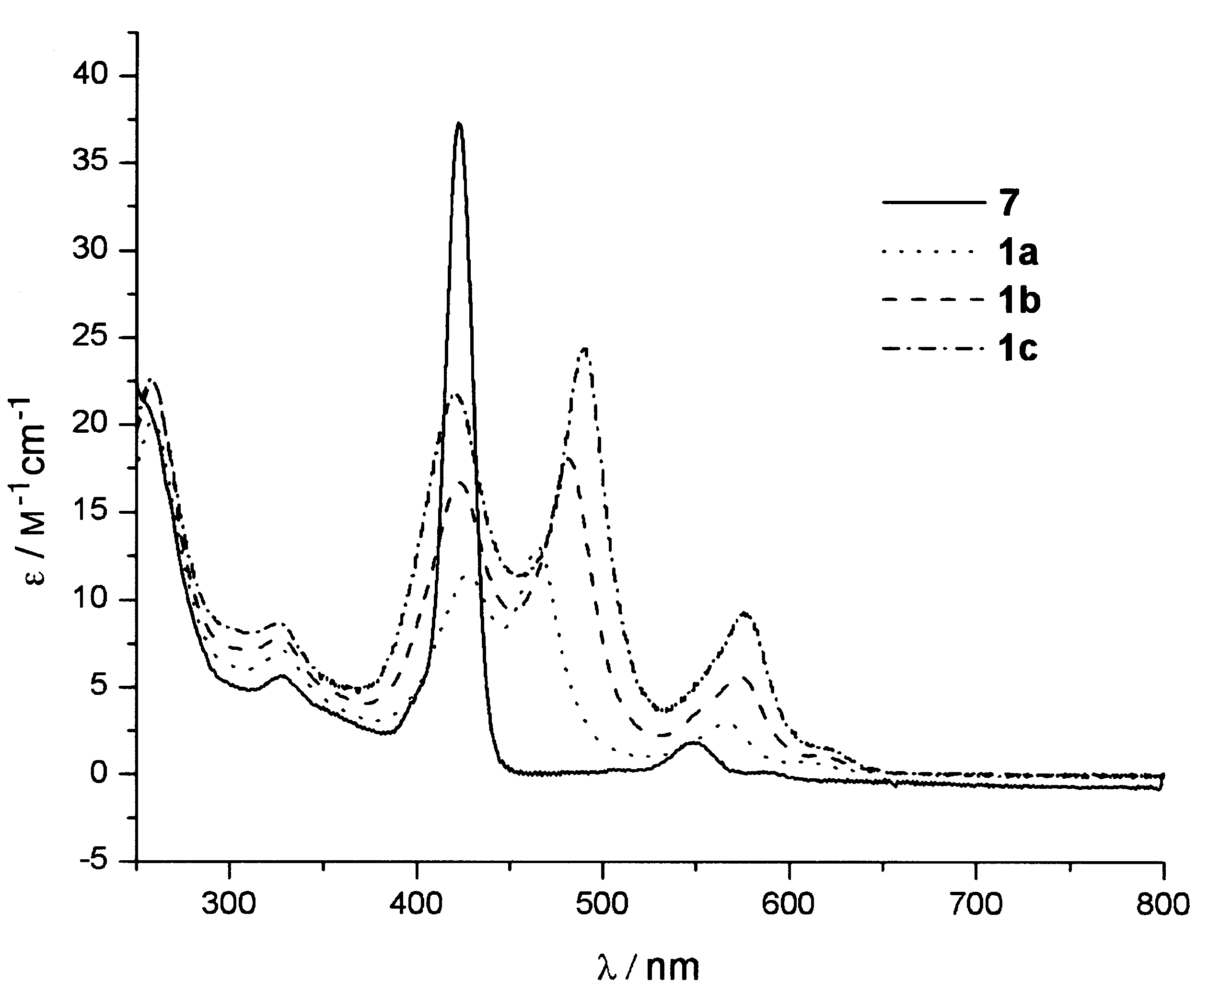

Fig. 1. UV-Vis absorbtion spectra (× 10⁻⁴) of the fullerene-porphyrin conjugates in CHCl₃.

Supplementary Material

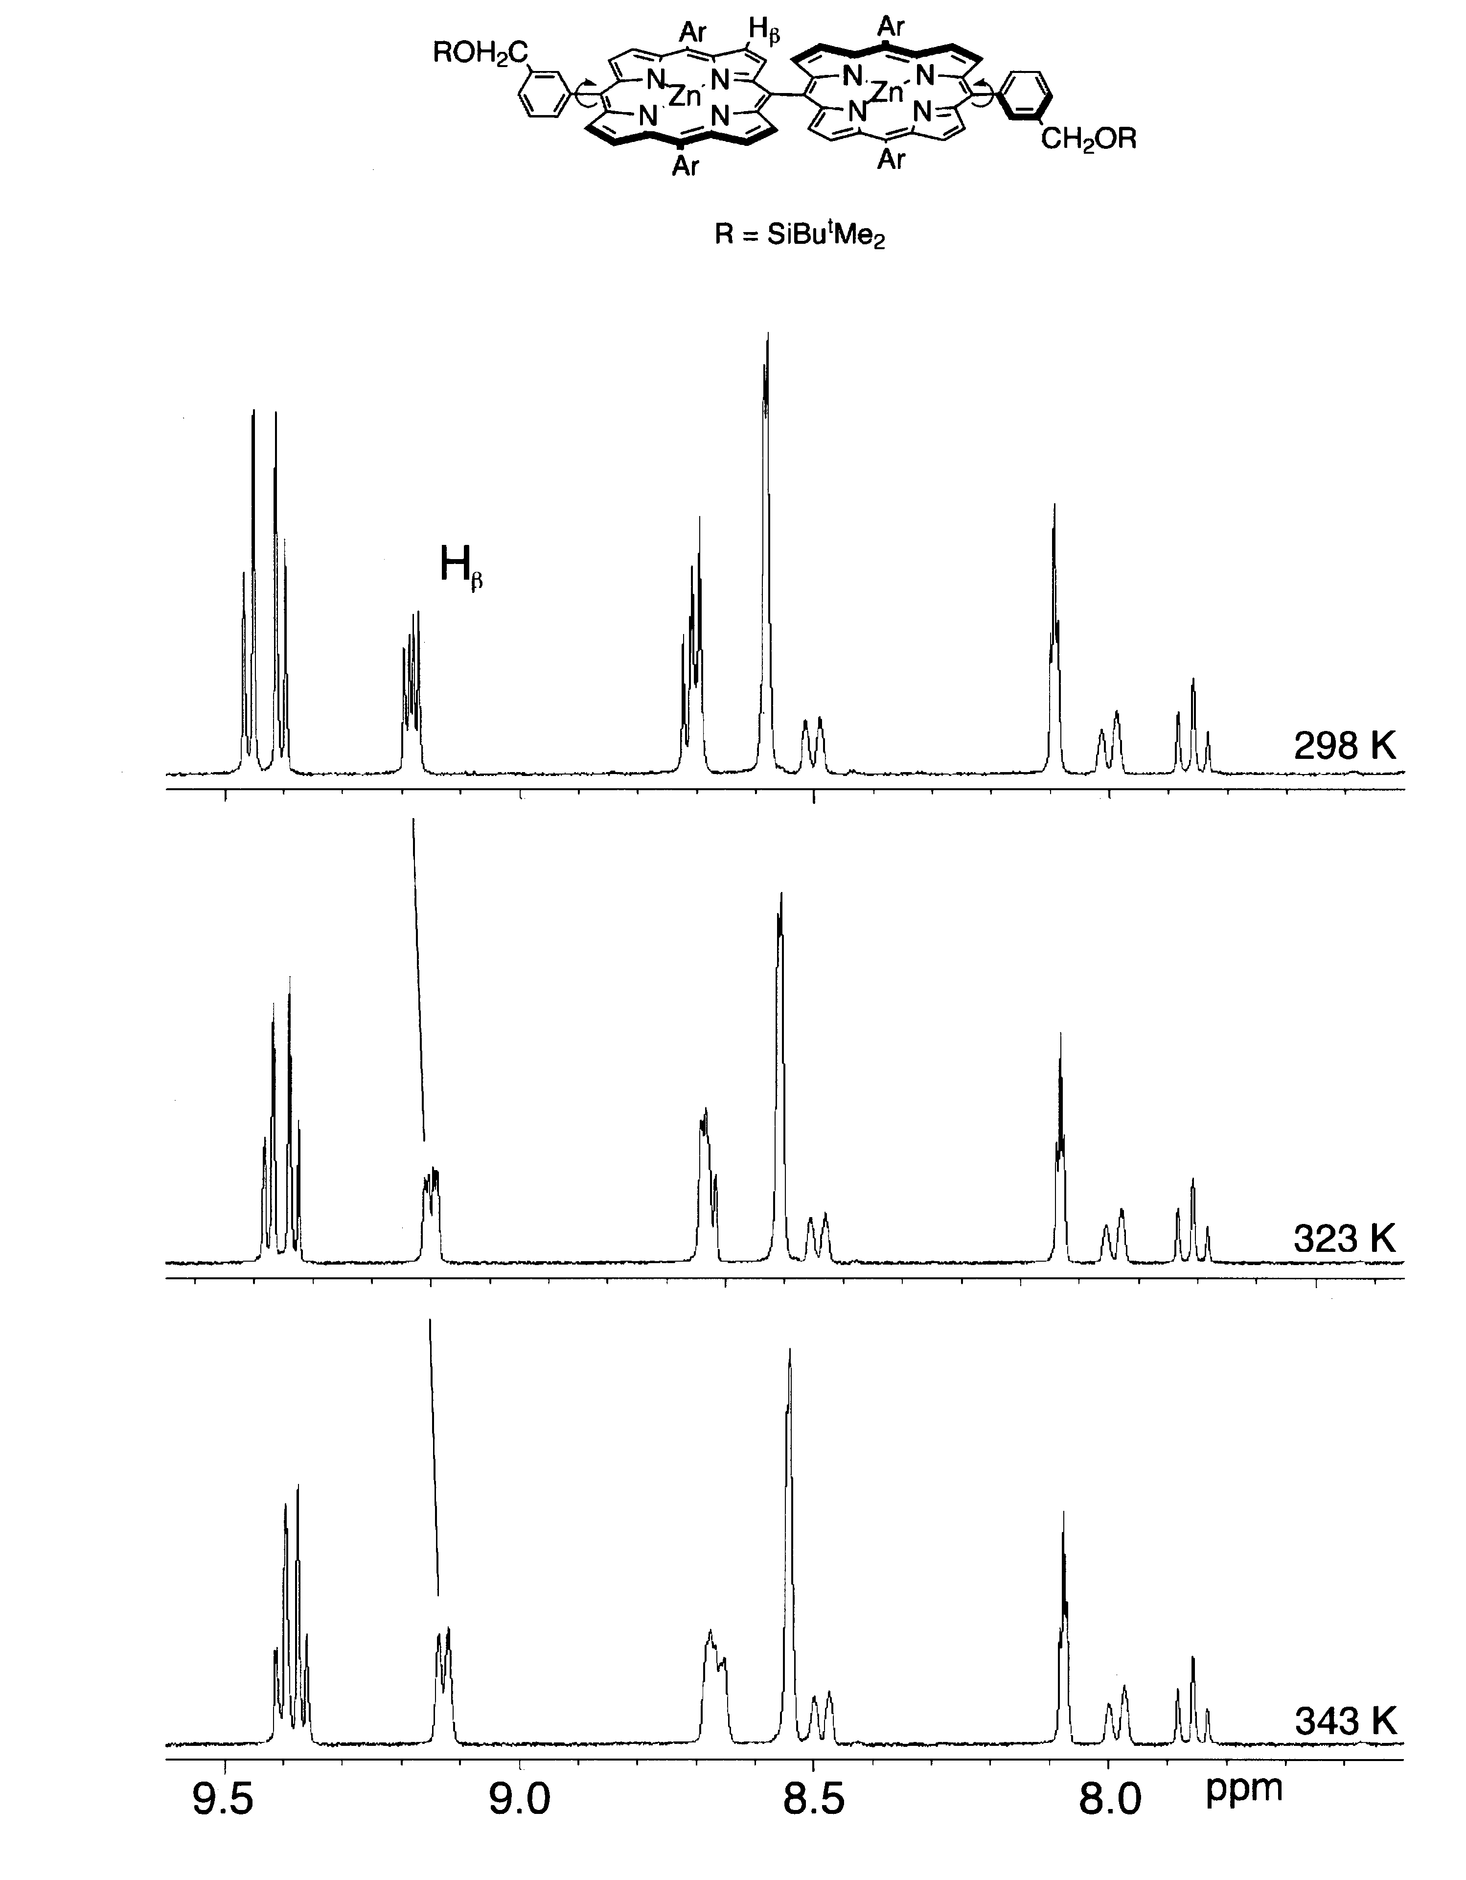

Fig. 2. ¹VT 1H NMR spectra of 5a in C₆D₅CD₃.

Supplementary Material
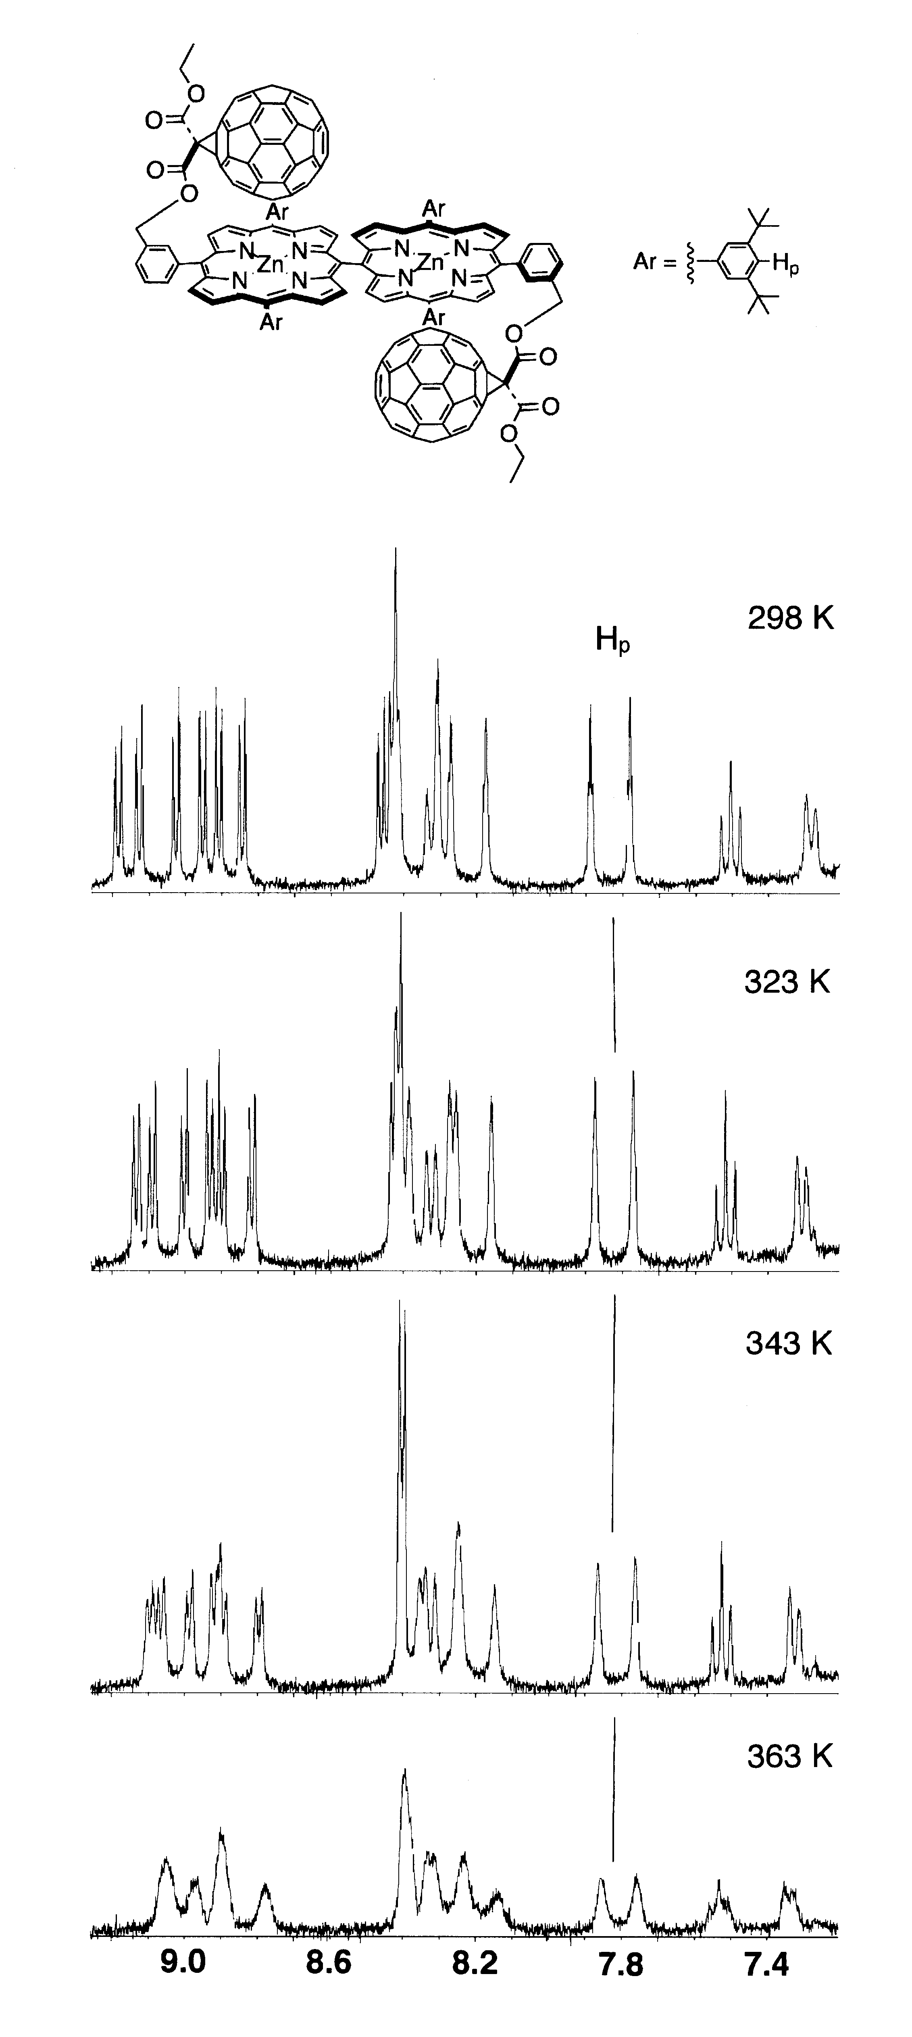

Fig. 3. VT ¹H NMR spectra of 1a in C₆D₅CD₃.
Supplementary Material
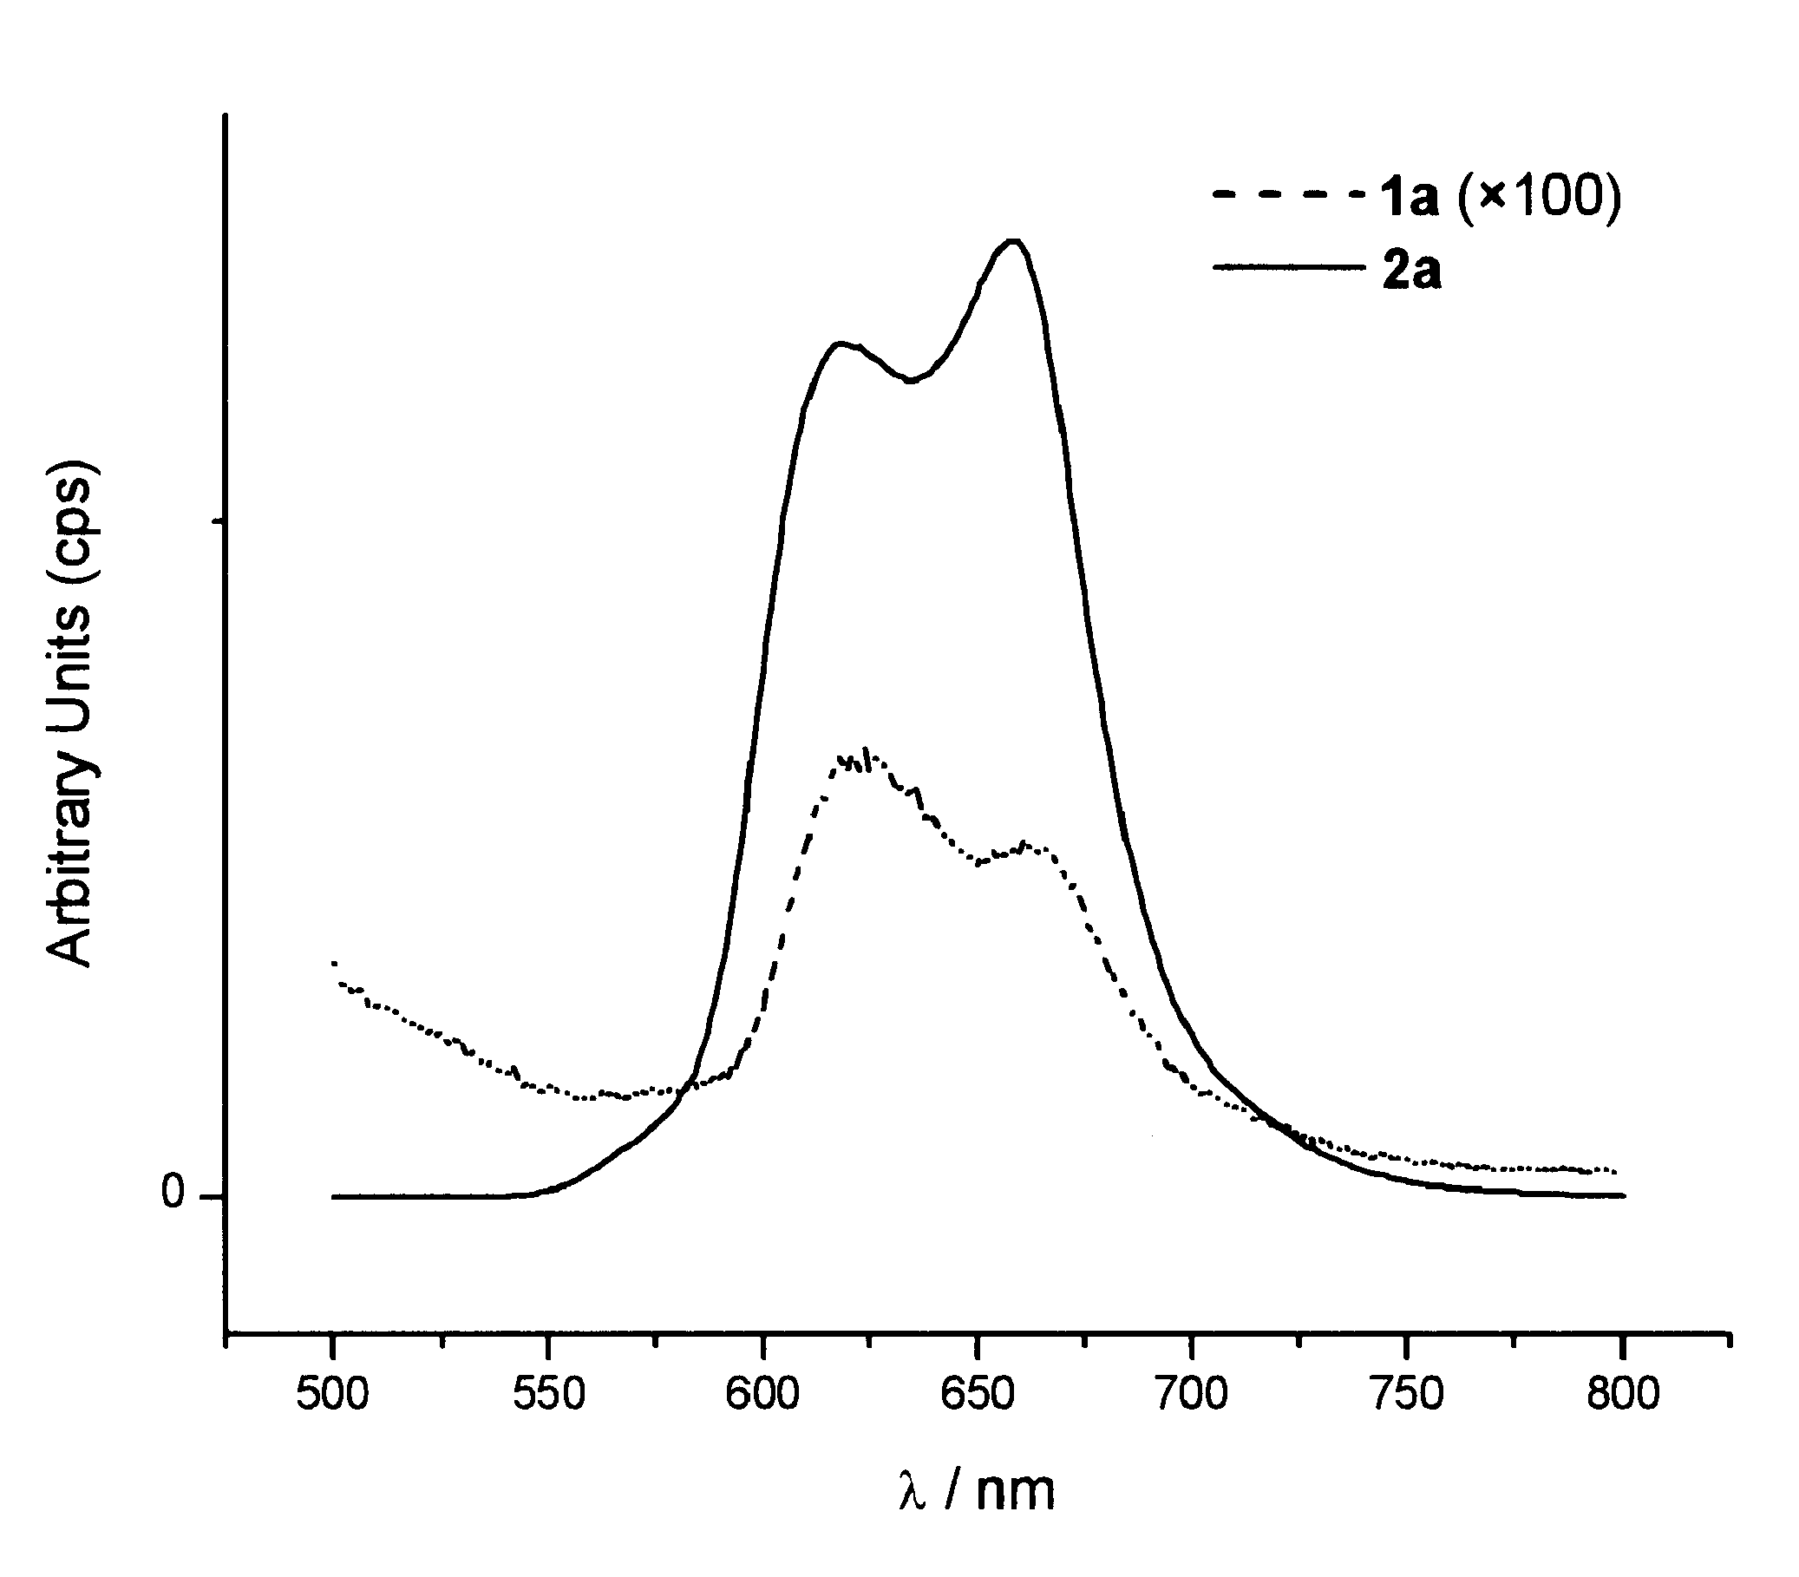
Fig. 4. Fluorescence spectra of 1a and 2a recorded in CHCl₃.

Supplementary Material
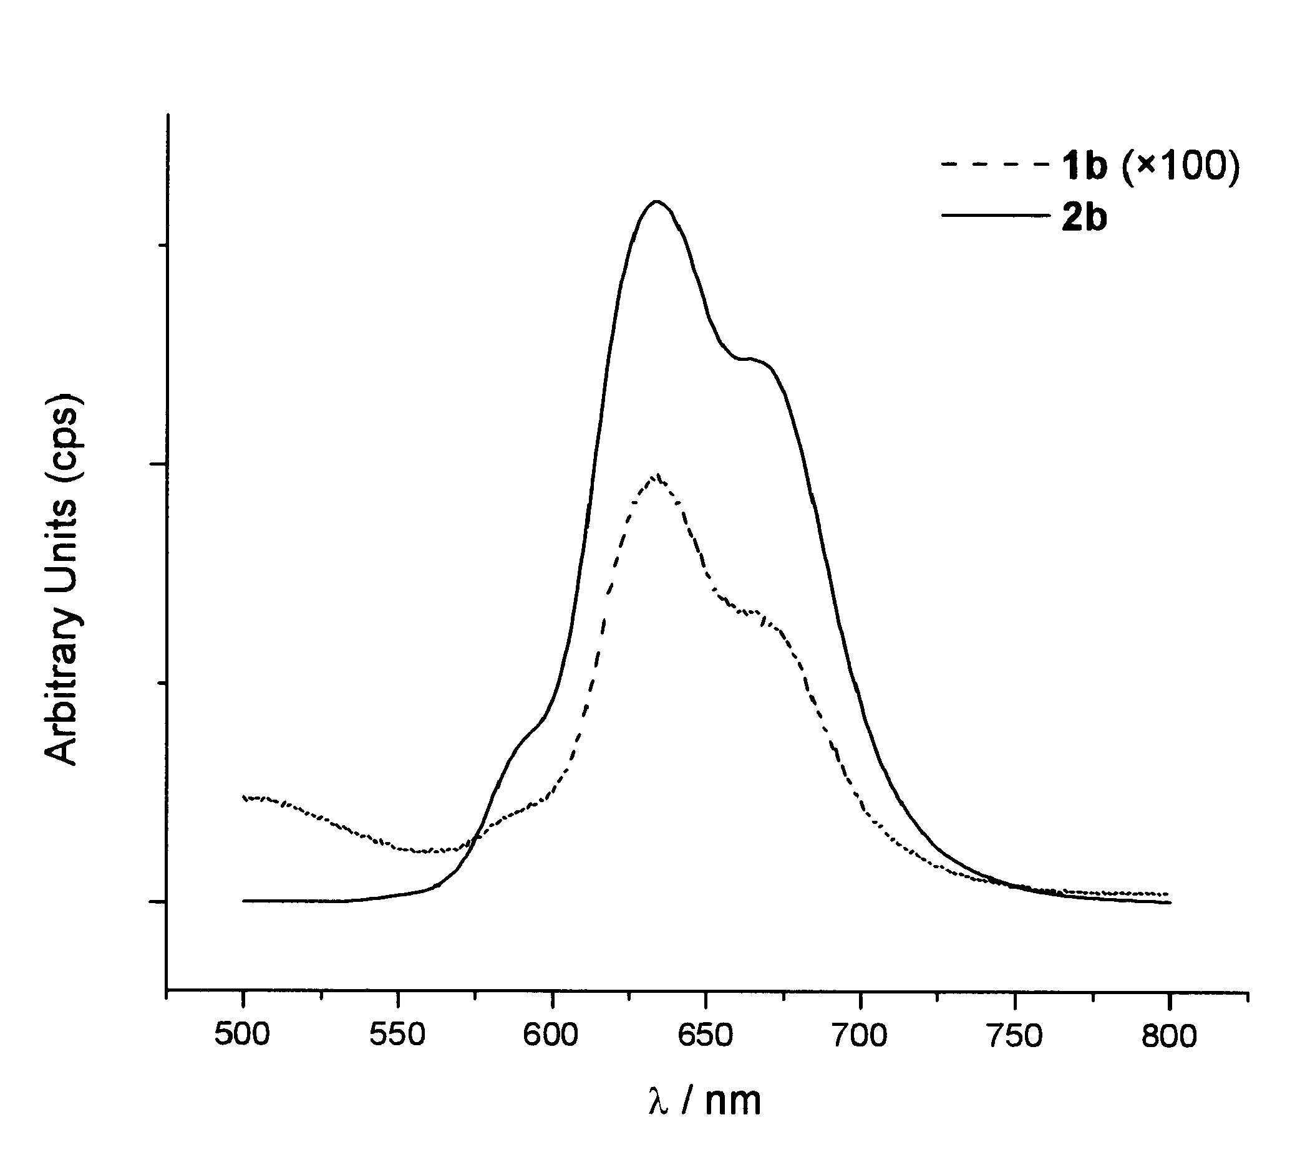
Fig. 5. Fluorescence spectra of 1b and 2b recorded in CHCl₃.

Supplementary Material

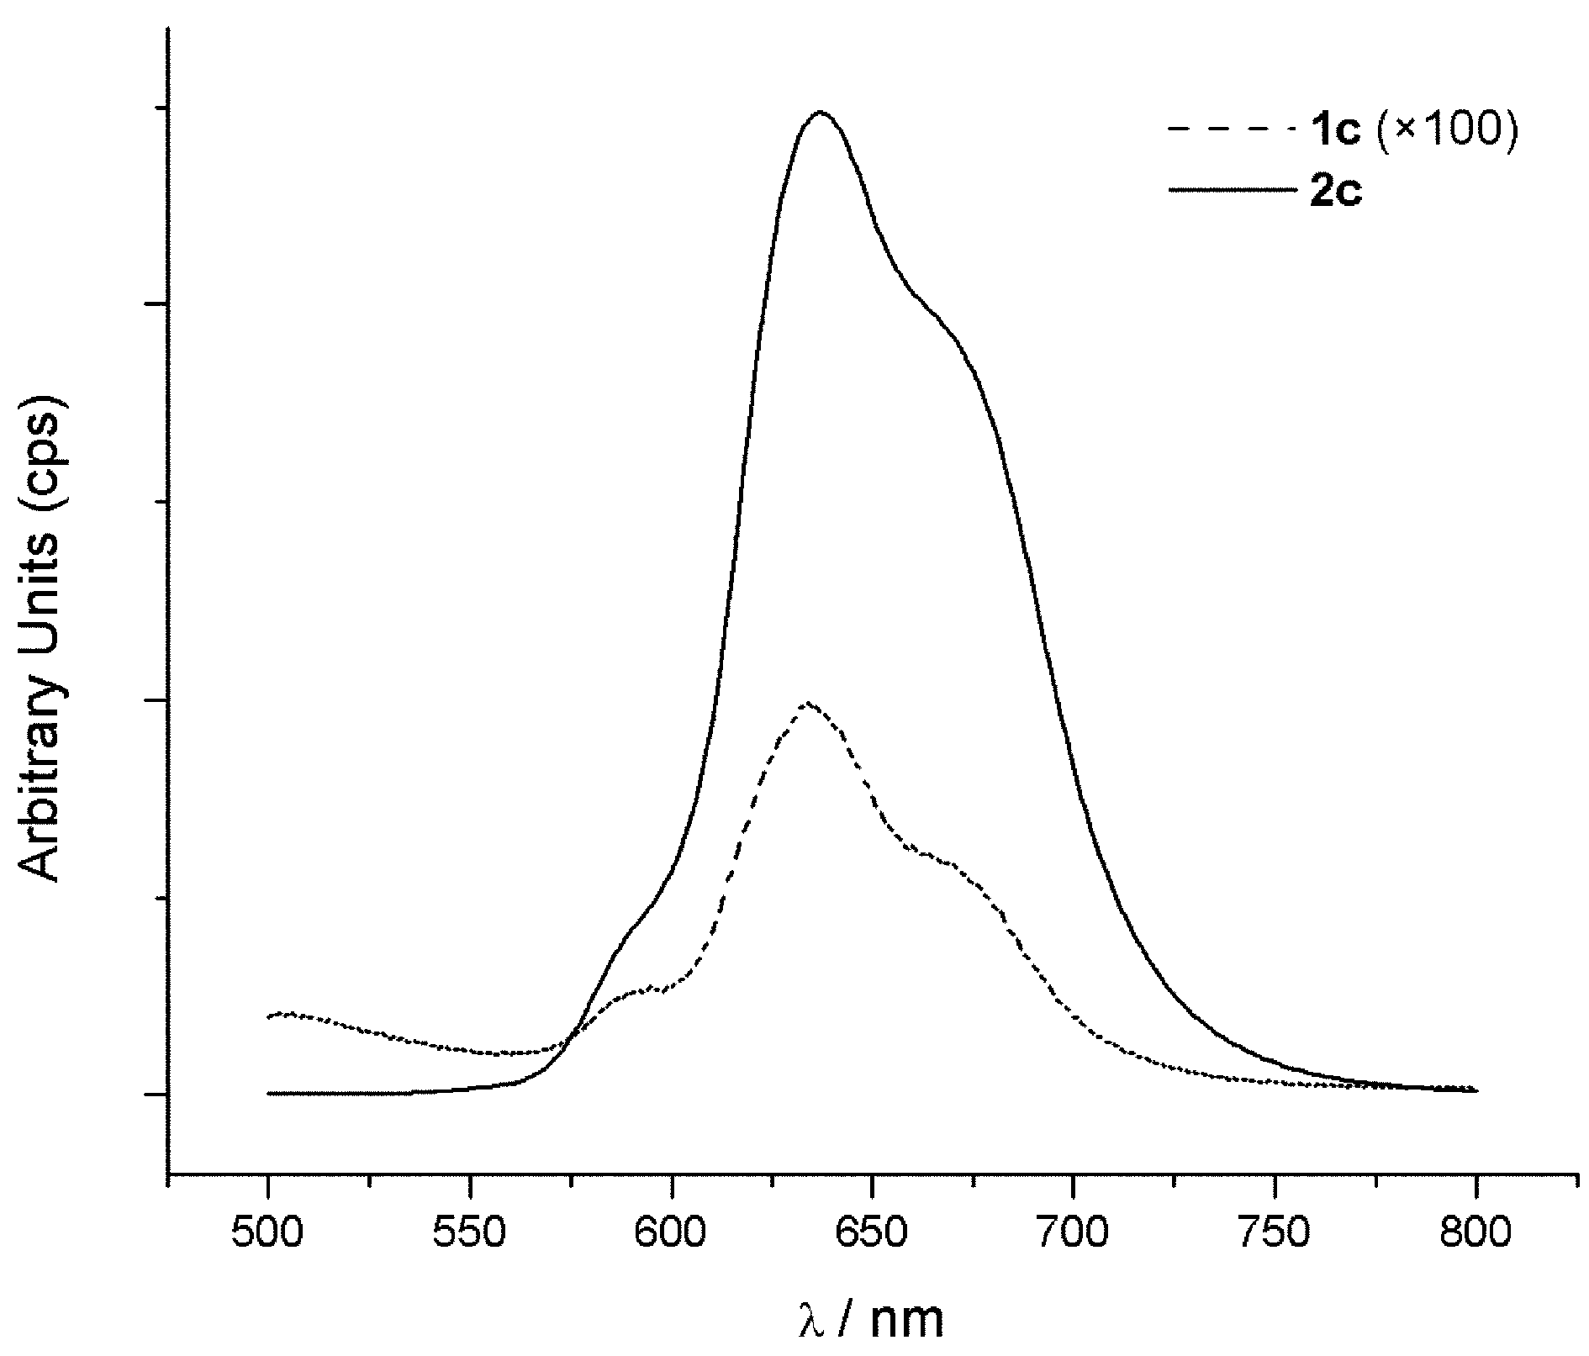

Fig. 6. Fluorescence spectra of 1c and 2c recorded in CHCl₃.

Supplementary Material

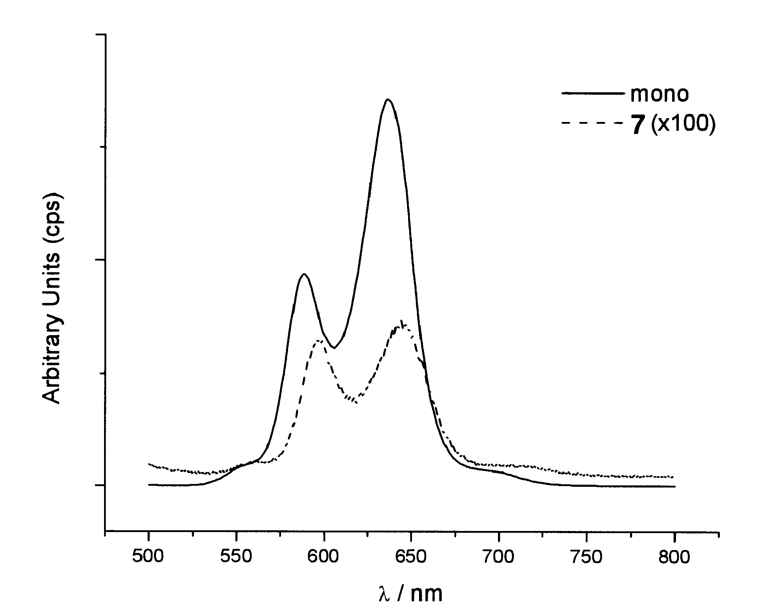

Fig. 7. Fluorescence spectra of 7 and 5,15-bis(3,5-di(tert-butyl)phenyl)porphyrin

recorded in CHCl₃

