Supporting Information

Photophysics of Ir(III) Complexes with Oligo(arylene ethynylene) Ligands
Ksenija D. Glusac, Shujun Jiang and Kirk S. Schanze

Materials and General Methods. The solvents used in the procedures were reagent grade and used without further purification. NMR spectra were acquired on a Gemini 300 MHz NMR spectrometer. OAE ligands 1a and 2a were prepared according to previously published methods.² Dimer [(ppy)₂IrCl]₂ and the parent complex Ir(ppy)₂(bpy)⁺ (3) were prepared as described in the literature.¹
Compound 1. Dimer complex [(ppy)₂IrCl]₂ (30 mg, 0.028 mmol) and ligand 1a² (27 mg, 0.056 mmol) were suspended in 2.8 mL of ethoxyethanol. The reaction mixture was refluxed for 18 hours. Then most of the solvent was removed by vacuum evaporation, and the resulting concentrate was poured into an aqueous solution of NH₄PF₆. An orange precipitate was collected by filtration and it was then washed with ether and hexanes. The product was obtained in 72% yield (45 mg).
Spectral Data: ¹H NMR (acetone-d⁶) δ 3.76 (s, 6H), 3.80 (s, 6H), 6.38 (d, J = 7.5 Hz, 2H), 6.93 (s, 2H), 6.98 (t, J = 7.8 Hz, 2H), 7.02 (s, 4H), 7.09 (t, J = 7.2 Hz, 2H), 7.20 (t, J = 6.6 Hz, 2H), 7.94 (d, J = 8.1 Hz, 2H), 7.99 (t, J = 9.9 Hz, 2H), 8.03 (d, J = 6.0 Hz, 2H), 8.12 (s, 2H), 8.27 (d, J = 8.1 Hz, 2H), 8.31 (t, J = 7.2 Hz, 2H), 8.87 (d, J = 8.4 Hz, 2H). ¹³C NMR (acetone-d⁶) δ 56.2, 56.7, 88.8, 111.6, 113.5, 118.4, 118.6, 121.0, 123.7, 124.7, 125.9, 131.4, 132.6, 139.8, 141.8, 145.0, 150.7, 153.3, 154.2, 155.0, 156.0, 168.4. HRMS (FAB, NBA matrix, positive ion) Calcd for C₅₂H₄₀O₄N₄Ir: 977.268; found: 977.269.
Compound 2. Dimer complex [(ppy)₂IrCl]₂ (30 mg, 0.028 mmol) and ligand 2a² (65 mg, 0.056 mmol) were suspended in 2.8 mL of ethoxyethanol. The reaction mixture was refluxed for 20 hours. Then most of the solvent was removed by vacuum evaporation, and the resulting concentrate was poured into an aqueous solution of NH₄PF₆. A yellow precipitate was collected by filtration and washed with ether and hexanes. The crude product was further purified by column chromatography on silica gel using methylene chloride as an eluent. The product was obtained in 22% yield (36 mg).
Spectral Data: ¹H NMR (CDCl₃) δ 0.86 (s, 12H), 1.29 (s, 16 H), 1.37 (m, 8H), 1.57 (m, 8H), 1.74 (m, 4H), 1.85 (m, 4H), 3.99 (m, 8H), 6.26 (d, J = 7.2 Hz, 2H), 6.91 (t, J = 6.9 Hz, 2H), 6.94 (s, 2H), 6.99 (s, 2H), 7.04 (m, 4H), 7.35 (t, J = 6.9 Hz, 2H), 7.44 (t, J = 7.5 Hz, 4H), 7.58 (s, 12H), 7.68 (d, J = 7.8 Hz, 2H), 7.79 (t, J = 7.5 Hz, 2H), 7.95 (m, 4H), 8.19 (d, J = 7.8 Hz, 2H), 8.72 (d, J = 8.4 Hz, 2H). ¹³C NMR (CDCl₃) δ 14.1, 22.6, 25.8, 26.0, 28.9, 29.1, 29.3, 31.9, 69.5, 69.6, 86.3, 89.2, 94.8, 95.9, 111.3, 116.0, 116.6, 117.0, 120.0, 122.0, 122.7, 123.4, 124.9, 125.1, 125.4, 127.0, 127.7, 128.8, 130.6, 131.6, 132.0, 138.2, 140.2, 141.2, 141.7, 143.3, 148.6, 149.4, 151.8, 153.5, 153.8, 167.7. HRMS (electrospray, FT-MS) Calcd for C₁₀₄H₁₀₄O₄N₄Ir: 1665.794. Found: 1665.756.

Supporting Information References

1. S. Lamansky, P. Djurovich, D. Murphy, F. Abdel-Razzaq, R. C. Kwong, I. Tsyba, M. Bortz, B. Mui, R. Bau and M. E. Thompson. Inorg. Chem. 2001, 40, 1704.
2. K. D. Ley, Y. T. Li, J. V. Johnson, D. H. Powell and K. S. Schanze. Chem. Commun. 1999, 1749.
3. A. A. Vlcek, E. S. Dodsworth, W. J. Pietro and A. B. P. Lever. Inorg. Chem. 1995, 34, 1906.

Table S-1. Electrochemical Potentials and Estimated ³MLCT State Energies for 1 – 3 ª

Complex | E_{1/2} (Ir^{III/IV}) / V ^{b} | E_{1/2} (L/L^{-•}) / V ^{c} | ΔE_{1/2} / V ^{d} | E_{MLCT} / eV
3 | 1.29 | -1.42 (bpy/bpy^{-•}) | 2.71 | 2.25 ± 0.1 ^{e}
1 | 1.39 | -1.04 (1a/1a^{-•}) | 2.43 | 2.0 ± 0.1 ^{f}
2 | ^{g} | -0.92 (2a/2a^{-•}) | -- | 1.9 ± 0.1 ^{h}
ª Electrochemical potentials in CH₃CN solution, relative to SCE electrode. ^{b} Reversible oxidation wave. ^{c} Reversible reduction wave. ^{d} Computed by ΔE_{1/2} = E_{1/2}(Ir^{III/IV}) – E_{1/2}(L/L^{-•}). ^{e} Energy (E_{oo}) estimated by emission spectral fit of room temperature emission spectrum. Note that E_{oo} is a higher energy than would be estimated from emission maximum. ^{f} Estimated from electrochemical potentials by the equation, E_{MLCT} = ΔE_{1/2} - β, where β is estimated from the data for parent complex 3 by the equation, β = ΔE_{1/2} – E_{MLCT}. Ref. 3 provides a detailed justification for this approach to computing MLCT state energies. ^{g} Irreversible wave. ^{h} E_{MLCT} for 2 is estimated to be approximately 0.1 eV lower than E_{MLCT} for 1 based on the 0.12 V difference in the OAE ligand-based reduction potentials (E_{1/2} (L/L^{-•}).
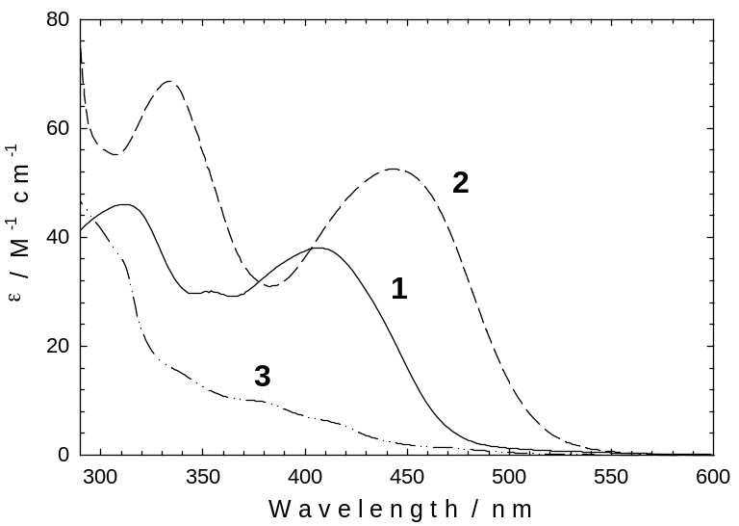
Figure S-1. UV-visible absorption spectra of 1 – 3 in THF solution.
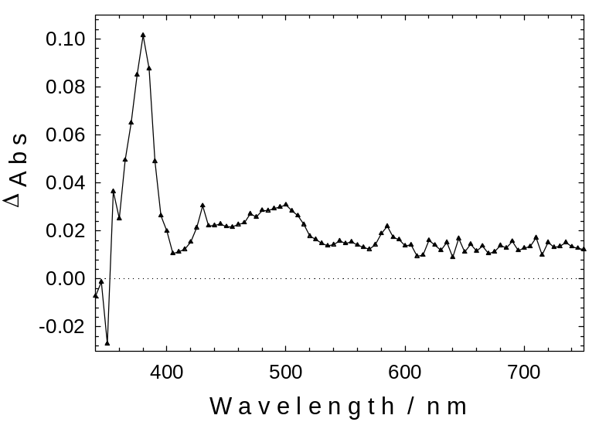
Figure S-2. Transient absorption spectrum of 3 in THF solution 40 ns following 355 nm excitation pulse (5 mj, 10 ns fwhm).

