Electronic Supplementary Information
[60]Fullerene-Linked Gold Nanoparticles: Synthesis and Layer-by-Layer Growth on Solid Surface
Young-Seok Shon* and Hosun Choo
Department of Chemistry, Western Kentucky University, Bowling Green, KY 42101, USA.

Fig. A UV-vis absorption apectra of (a) C₆₀-linked gold nanoparticles, (b) 4-aminothiophenoxide/hexanethiolate-protected gold nanoparticles and (c) C₆₀ in CH₂Cl₂.

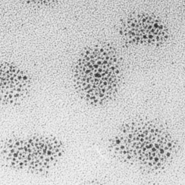
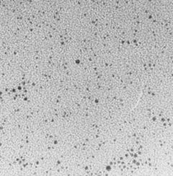
10 nm
10 nm

(a) (b)

Fig. B TEM images of (a) 4-aminothiophenoxide/hexanethiolate-protected gold nanoparticles and (b) C₆₀-induced small aggregates of C₆₀-linked gold nanoparticles.
(a)
(b)

Fig. C UV-vis absorption spectra of the layer-by-layer assemblies (up to five layers) of (a) method 1 and (b) method 2: the dotted lines represent UV-vis spectra obtained after immersion in toluene solution containing C₆₀ and the solid lines represent UV-vis spectra obtained after immersion in toluene solution containing 4-aminothiophenoxide/hexanethiolate-protected gold nanoparticles.

Fig. D The linear regression plots of UV absorbance at 520 nm for both method 1 and method 2.

Fig. E UV-vis absorption spectra of the layer-by-layer assemblies of 4-aminothiophenoxide/hexanethiolate-protected gold nanoparticles and poly(styrene sulfonic acid).

