Supplementary data
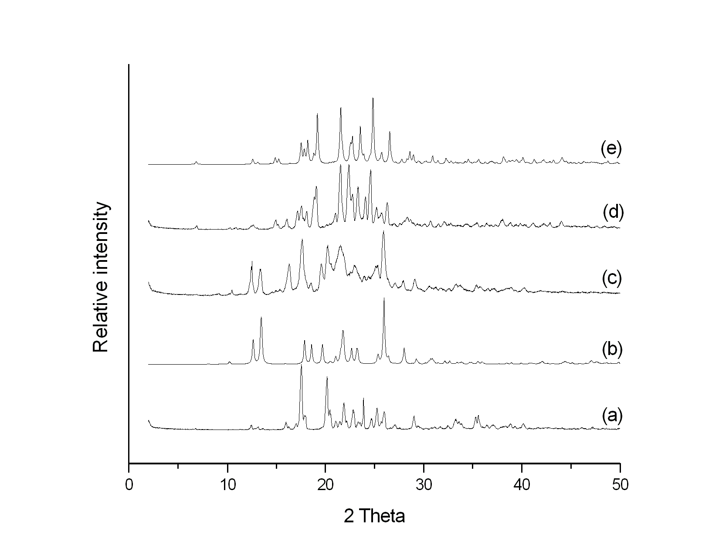
Fig. ESI 1Powder X-ray diffraction pattern of (a) CTA, (b) Bipy, (c) ground dry mixture of CTA+Bipy (1hr), (d) ground mixture of CTA+Bipy with MeOH (20min), (e) simulated pattern from single-crystal structure of CTA.Bipy.

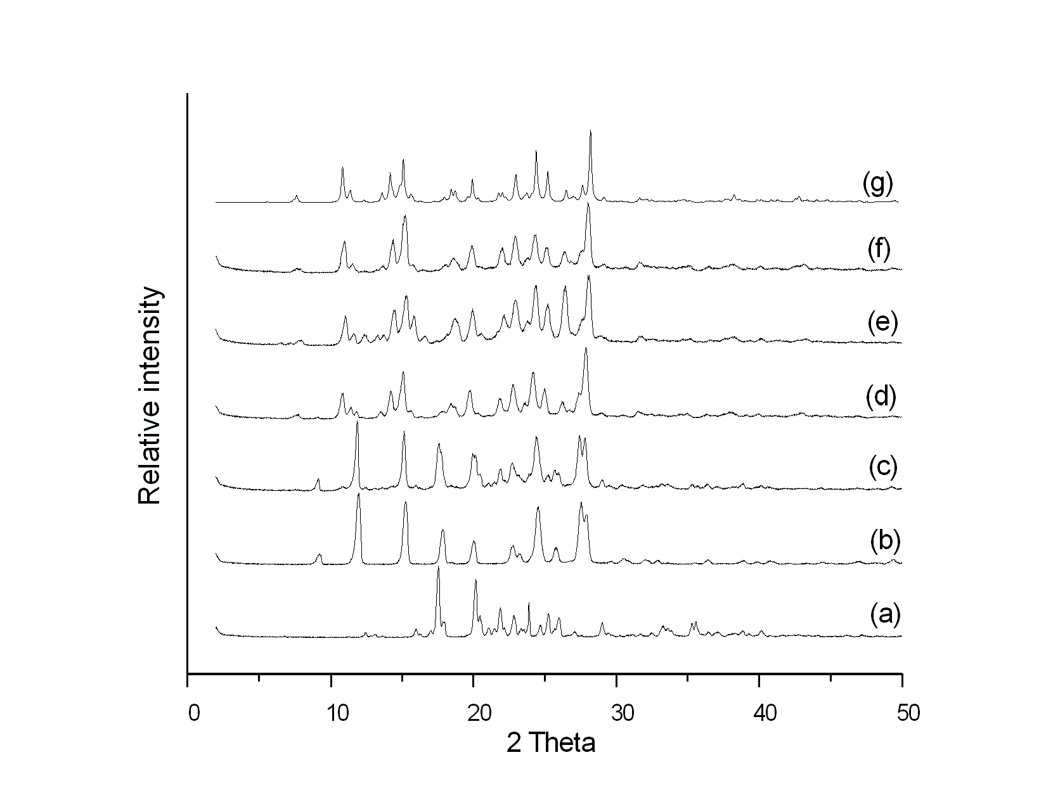
Fig. ESI 2Powder X-ray diffraction pattern of (a) CTA, (b) fPh, (c) ground mixture of CTA+2fPh with cyclohexane (1.5hr), (d) ground mixture of CTA+2fPh with acetonitrile (20min), (e) ground mixture of CTA+2fPh with ethyl acetate (20min), (f) ground mixture of CTA+2fPh with water (20min), (g) simulated pattern from single-crystal structure of CTA.2fPh.

