Electronic supplementary information

Improved synthesis of dithieno[3,2-b:2',3'-d]thiophene (DTT)
and derivatives for cross coupling

Joseph Frey*, Andrew D. Bond and Andrew B. Holmes*
Melville Laboratory for Polymer Synthesis, Department of Chemistry, University of Cambridge, Lensfield Rd, Cambridge CB2 1EW, UK. Fax: 44 1223 334866; Tel: 44 1223 334370;
E-mail: abh1@cam.ac.uk jf245@cam.ac.uk.

Supporting information
2,6-Dibromodithieno[3,2-b:2',3'-d]thiophene (2)
m.p. 162-163 ºC (EtOH); δ_{H} (250 MHz, CDCl₃) 7.26 (2H, s); δ_{C} (62.5 MHz, CDCl₃:CS₂) 112.61, 123.23, 130.93, 139.20; m/z (EI) 351.7677 (M⁺. C₈H₂Br₂S₃ requires 351.7685). (Found: C, 27.1; H, 0.6. C₈H₂Br₂S₃ requires C, 27.1; H, 0.6%).

3,5-Dibromodithieno[3,2-b:2',3'-d]thiophene (3)
m.p. 201 ºC (EtOH); δ_{H} (250 MHz, CDCl₃) 7.29 (2H, s); δ_{C}(125 MHz, CDCl₃:CS₂) 103.95, 123.09, 130.70, 142.68; m/z (EI) 351.7686 (M⁺. C₈H₂Br₂S₃ requires 351.7685). (Found: C, 27.2, H, 0.6. C₈H₂Br₂S₃ requires 27.1; H, 0.6%).

3,5-Dibromo-2,6-bis(trimethylsilyl)dithieno[3,2-b:2',3'-d]thiophene (8)
m.p. 168-169 ºC (EtOH); δ_{H} (250 MHz, CDCl₃) 0.47 (9H, s); δ_{C} (100 MHz, CDCl₃) -0.88, 109.87, 134.16, 136.19, 145.61; m/z (EI) 495.8465 (M⁺. C₁₄H₁₈Br₂S₃Si₂ requires 495.8476).(Found: C, 33.9; H, 3.7. C₁₄H₁₈Br₂S₃Si₂ requires C, 33.7, H, 3.6%).

2,6-Dibromo-3,5-bis(trimethylsilyl)dithieno[3,2-b:2',3'-d]thiophene (9)
m.p. 139 ºC (EtOH); δ_{H} (250 MHz, CDCl₃) 0.51 (9H, s); δ_{C} (100 MHz, CDCl₃) -0.29, 118.40, 130.18, 133.82, 144.71; m/z (CI, NH₃) 496.8553 (M⁺ + H. C₁₄H₁₉Br₂S₃Si₂ requires 496.8554).(Found: C, 33.7; H, 3.5 C₁₄H₁₈Br₂S₃Si₂ requires C, 33.7, H, 3.6%).

2,6-Bis(3-hexyl-2-thienyl)dithieno[3,2-b:2',3'-d]thiophene (12)
m.p. 56 ºC (ex MeOH); δ_{H} (400 MHz, CDCl₃) 0.89 (6H, t, J 7), 1.2-1.5 (12H, m), 1.85 (4H,tt, J 8,8), 2.70-2.82 (4H, m), 6.97 (2H, d, J 5.0), 7.23 (2H, d, J 5.0), 7.30 (2H, s); δ_{C} (100 MHz, CDCl₃) 14.08, 22.62, 29.24, 29.28, 30.74, 31.69, 119.26, 119.28, 124.41, 130.09, 130.55, 130.63, 136.93, 140.38, 140.91; m/z (EI) 528.1103 (M⁺. C₂₈H₃₂S₅ requires 528.1108).

Preparation of dithieno[3,2-b:2',3'-d]thiophene-2,6-dicarboxylic acid diethyl ester (6)

To a mixture of ethyl-2-mercaptoacetate (6.06 cm³, 6.48 g, 53.7 mmol) and potassium carbonate (9.65 g, 70 mmol) in dry DMF (50 cm³) was added a solution of 3,4-dibromo-thiophene-2,5-dicarbaldehyde (8 g, 26.85 mmol) (prepared by formylation of tetrabromothiophene first by transmetallation with n-BuLi followed by addition of N-formylpiperidine) in dry DMF (100 cm³). The resulting mixture was stirred at room temperature for 3 days under a nitrogen atmosphere. The red reaction mixture was then poured into 400 cm³ of water. An off-white precipitate formed and the suspension was extracted with dichloromethane (3 × 100 cm³). The combined organic phases were washed with brine (6 × 100 cm³) to remove the DMF and dried (MgSO₄). Upon concentration in vacuo a white suspension formed which was filtered on a Buchner funnel. The filtrate was further concentrated to yield more precipitate, which was filtered as well. The combined solids were dried in vacuo at room temperature to afford the title compound (6.53 g, 71%) which was recrystallised from ethanol to give colourless crystals, mp 196 ºC: δ_{H} (500 MHz, CDCl₃) 1.41 (6H, t, J 7.0), 4.40 (4H, q, J 7.0), 8.02 (2H, s); δ_{C} (100 MHz, CDCl₃) 14.33, 61.70, 126.69, 135.21, 135.83, 143.25, 162.06; ν_{max} (solid)/ cm⁻¹ 743, 855, 1010, 1068, 1224, 1270, 1356, 1370, 1493, 1689, 1710(sh). m/z (EI) 339.9901 (M⁺. C₁₄H₁₂O₄S₃ requires 339.9898. (Found: C, 49.2, H, 3.5. C₁₄H₁₂O₄S₃ requires C, 49.4; H, 3.55%).

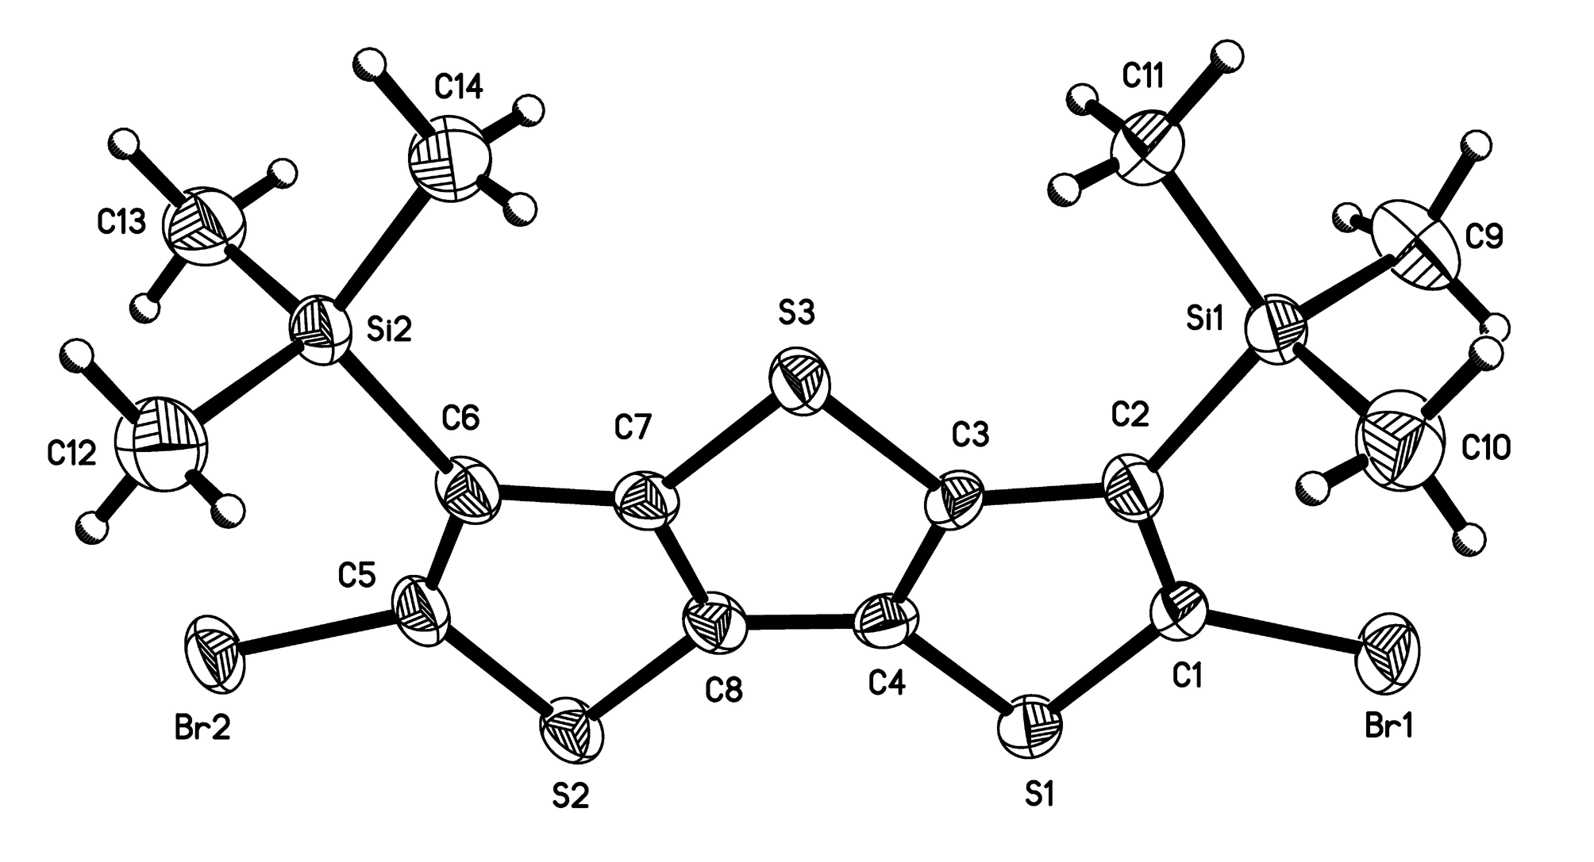
Fig. S1 Molecular structure of 9 showing displacement ellipsoids at 50% probability for non-H atoms. The ellipsoids of the second symmetry independent molecule are comparable

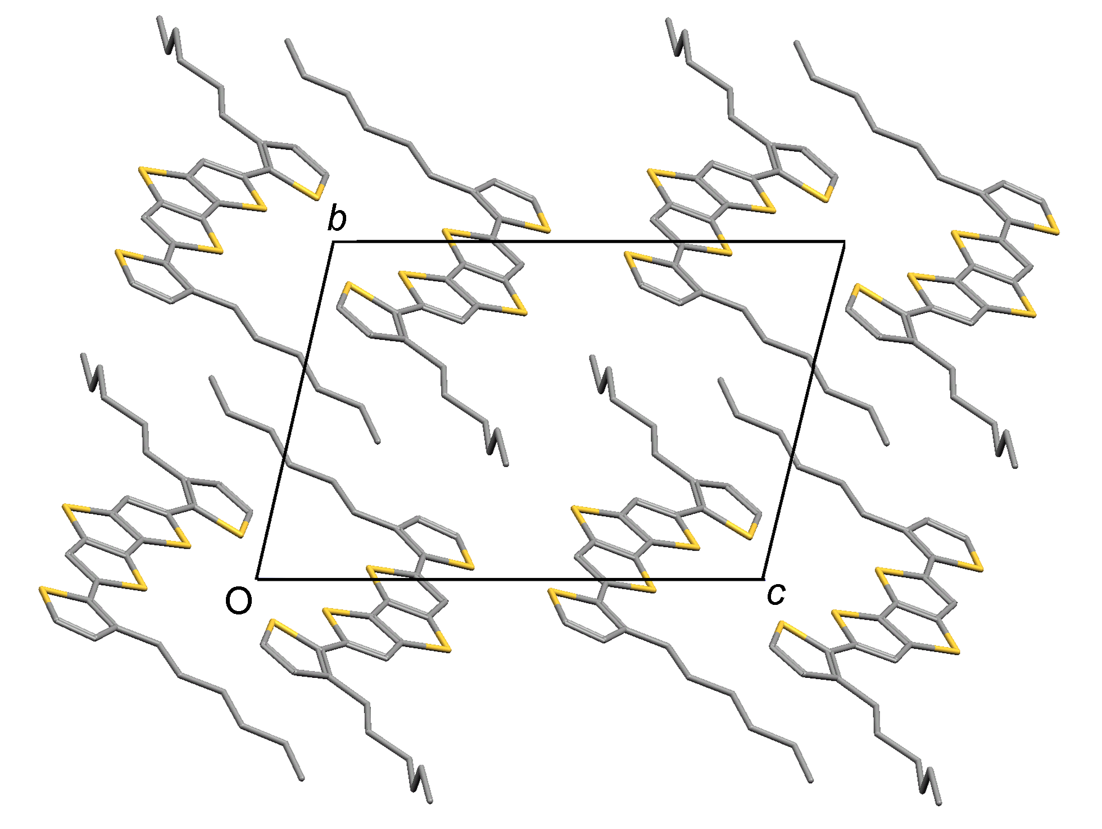

Fig. S2 Projection of the crystal structure of 12 along the stacking direction of the dimeric units.

