SUPPLEMENTARY INFORMATION

A Cyclic Hexacopper(II) Fluoro Complex that Encapsulates Two Fluoride Anions

Xiaoming Liuª, Abbie C. McLaughlin^{b,c}, Marcelo P. de Mirandaª, Eric J. L. McInnes^{d},
Colin A. Kilnerª and Malcolm A. Halcrow^{a,}*

ªDepartment of Chemistry, University of Leeds, Woodhouse Lane, Leeds, UK LS2 9JT.
E-mail: M.A.Halcrow@chem.leeds.ac.uk
^{b}Department of Chemistry, University of Cambridge, Lensfield Road, Cambridge, UK CB2 1EW.
^{c}Interdisciplinary Research Centre in Superconductivity, University of Cambridge, Madingley Road, Cambridge, UK CB3 0HE.

^{d}EPSRC CW EPR Service, Department of Chemistry, University of Manchester, Oxford Road, Manchester, UK M13 9PL.

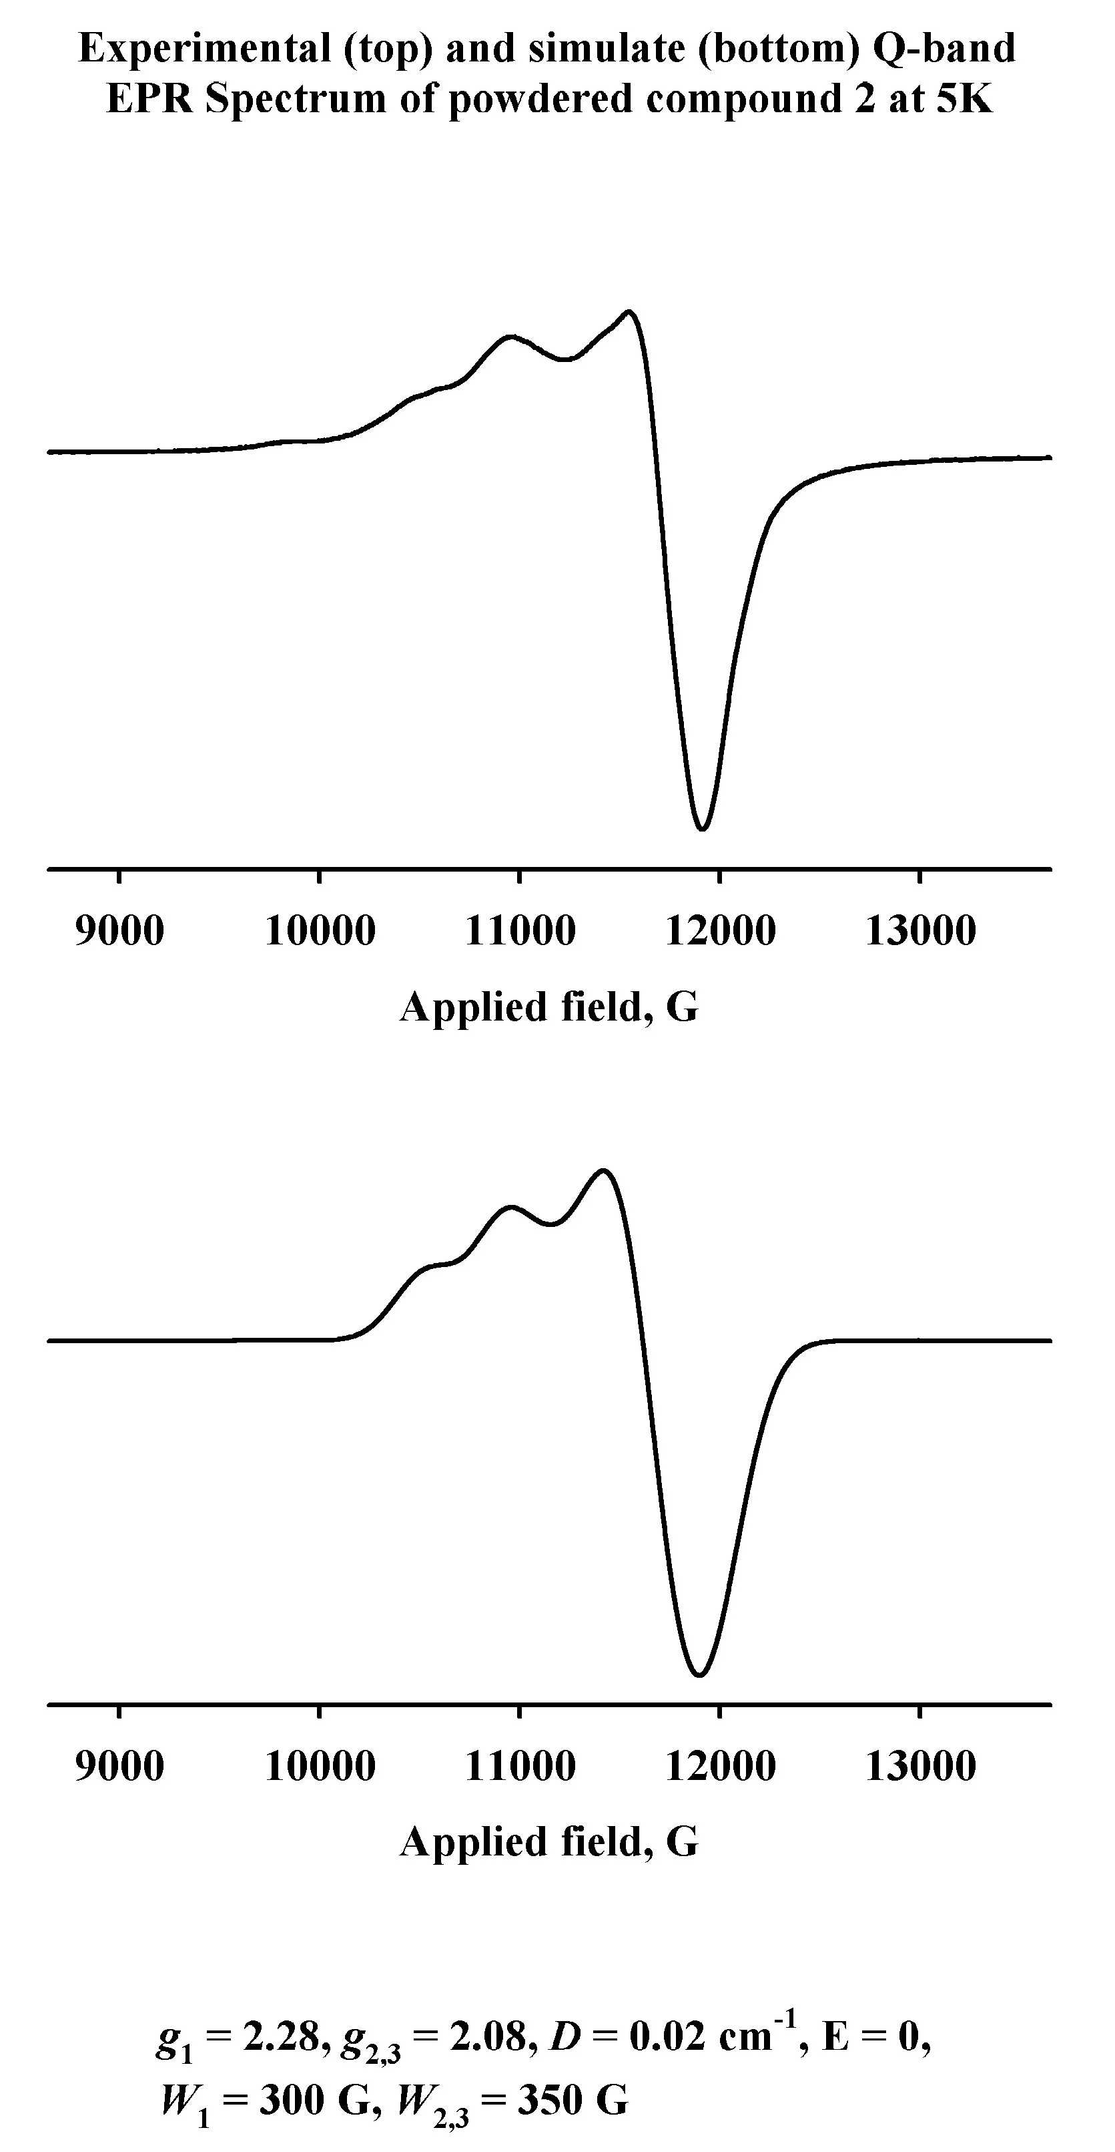

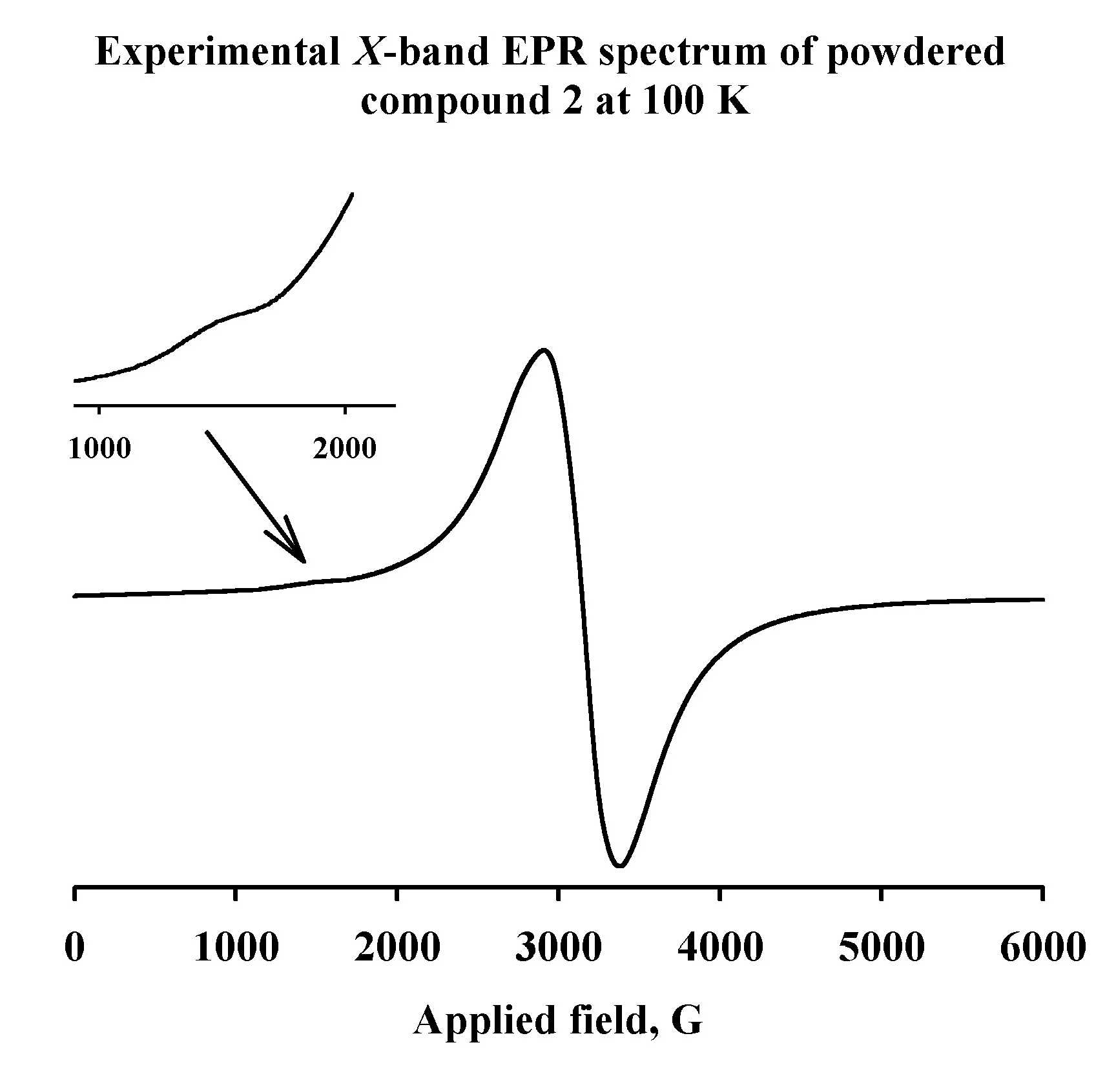

See the main article for more details of the simulation and peak assignments of both these spectra.

