Supplementary information

Synthesis and crystal structure of 2,3,12,13-tetraalkoxy-21, 23-dithiaporphyrins

Neeraj Agarwal,ª Sarada P. Mishra,ª Anil Kumar,ª C-H. Hung,^{b} and M. Ravikanth^{*a}

ª Indian Institute of Technology, Powai, Mumbai,400076 India. Fax:91-22-5723480 Tel: 91-22-5767176; E-mail: ravikanth@chem.iitb.ac.in

^{b} Department of Chemistry, National Changhua University of Education, Changhua, Taiwan 50058, Republic of China.

S 1: ¹H-NMR(300MHz, CDCl₃) spectrum of 10

S 2: ¹H-NMR(300MHz, CDCl₃) spectrum of 10 (expansions)

S 3: ¹H-NMR(300MHz, CDCl₃) spectrum of 12

S 4: ¹H-NMR(300MHz, CDCl₃) spectrum of 12 (expansions)

S 5: ¹H-NMR(300MHz, CDCl₃) spectrum of 2

S 6: ¹H-NMR(300MHz, CDCl₃) spectrum of 4

S 7: LD-MS spectrum of 2

S 8: LD-MS spectrum of 3

Table 1. Crystal data and structure refinement of 2

Table 2. Bond lengths [Å] and angles [°] of 2

Table 3. Torsion Angles (Degrees) of 2

S 9: Packing diagram of 2

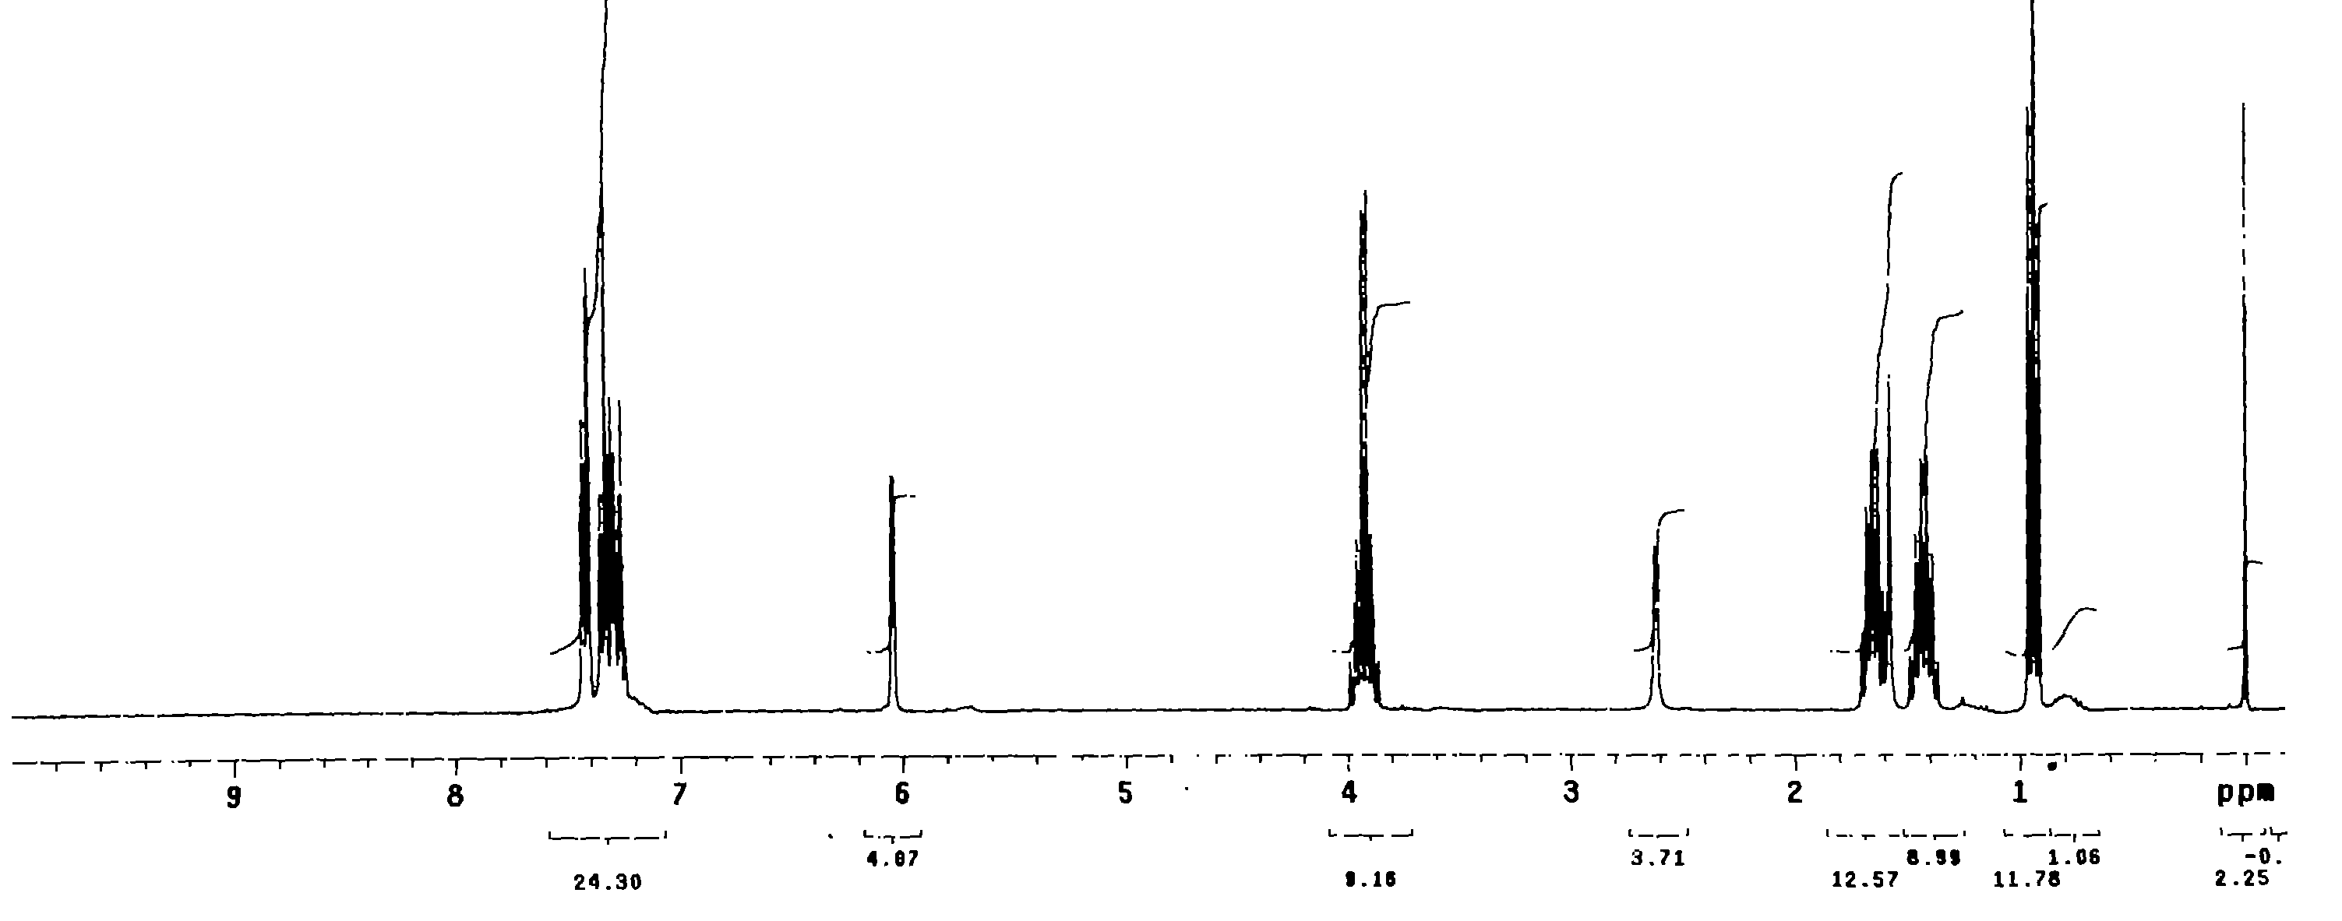

S 1: ¹H-NMR(300MHz, CDCl₃) spectrum of 10

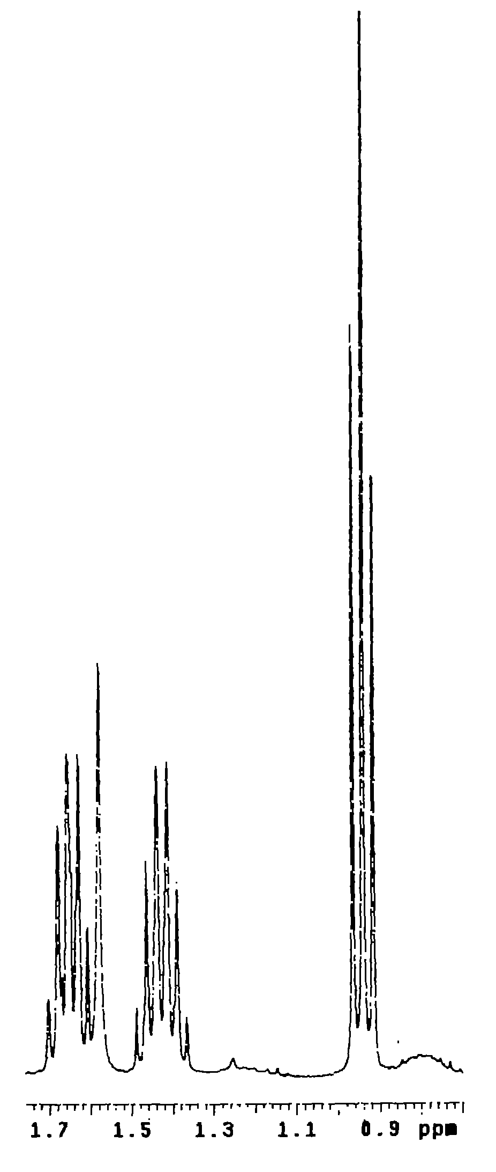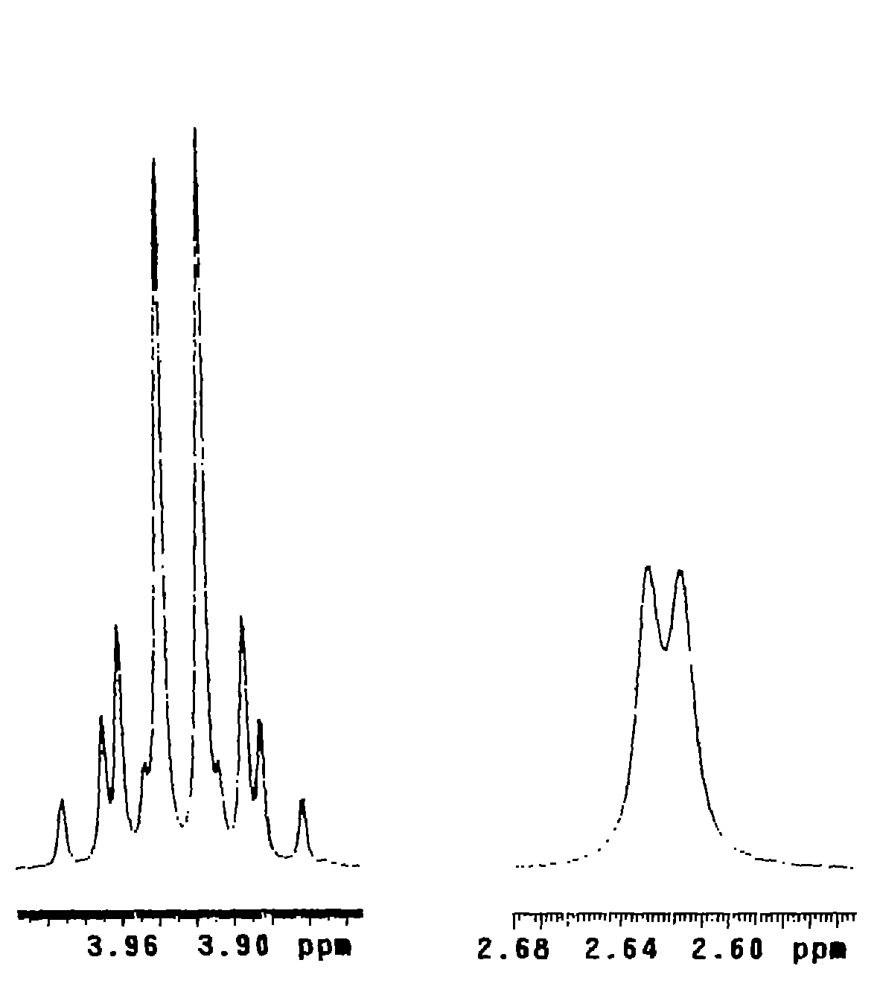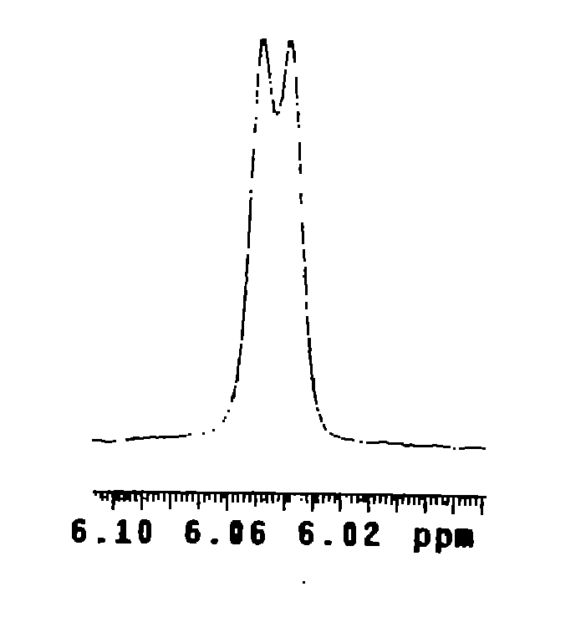

S 2: ¹H-NMR(300MHz, CDCl₃) spectrum of 10 (expansions)

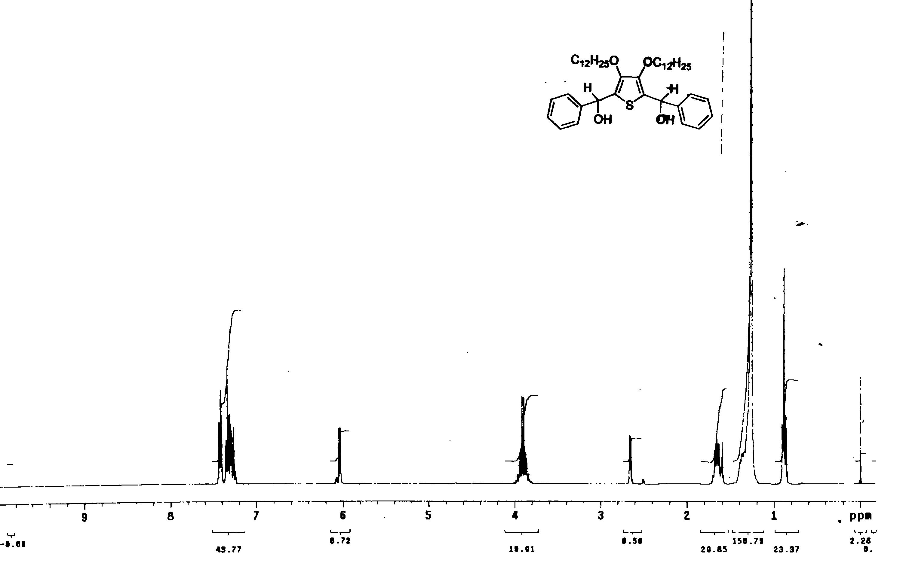

S 3: ¹H-NMR(300MHz, CDCl₃) spectrum of 12

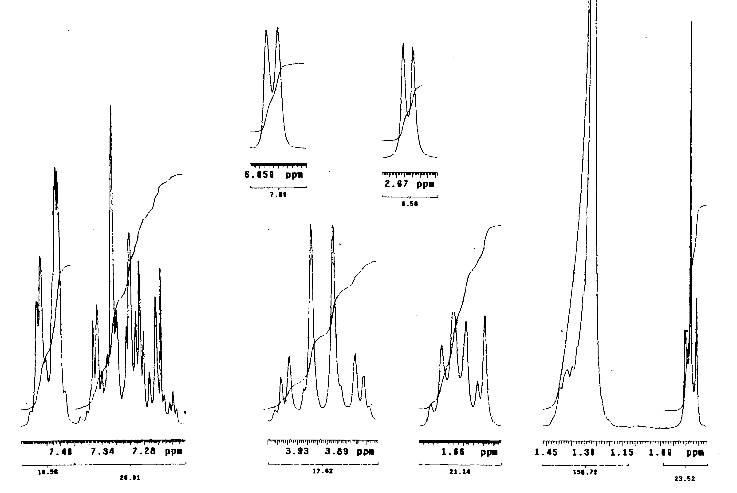

S 4: ¹H-NMR(300MHz, CDCl₃) spectrum of 12 (expansions)

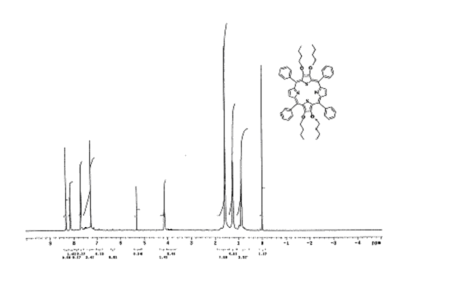

S 5: ¹H-NMR(300MHz, CDCl₃) spectrum of 2

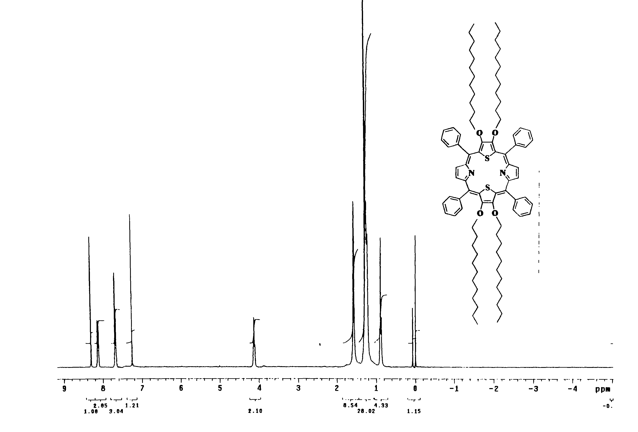

S 6: ¹H-NMR(300MHz, CDCl₃) spectrum of 4

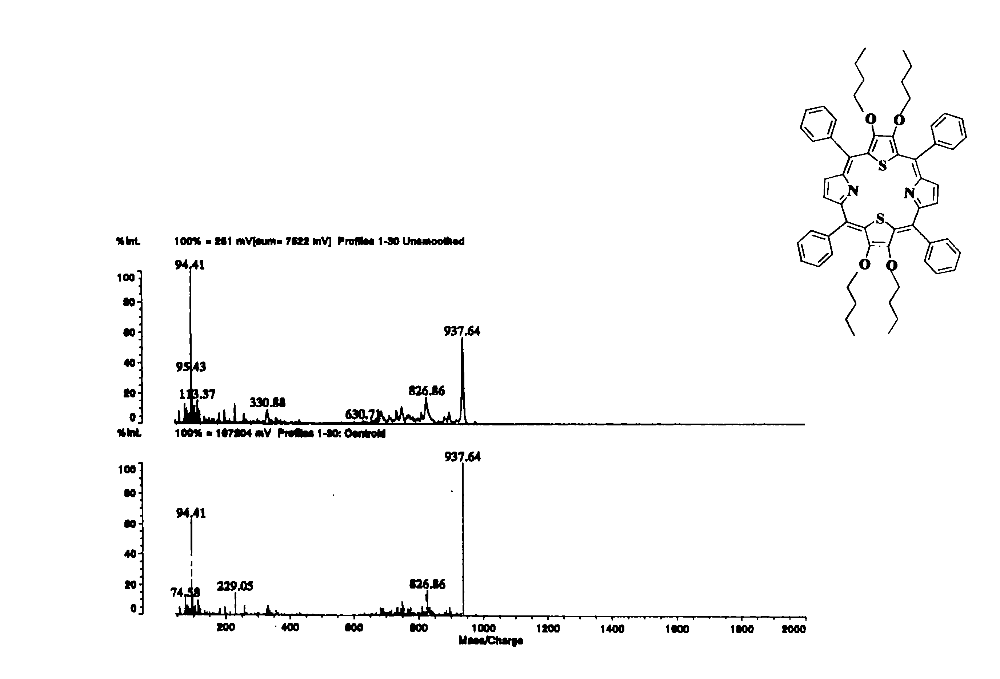

S 7: LD-MS spectrum of 2

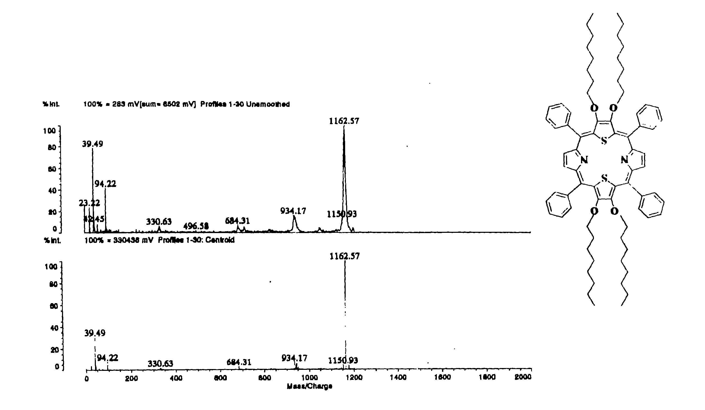

S 8: LD-MS spectrum of 3

Table 1. Crystal data and structure refinement of 2

Empirical formula C30 H03 N O2 S
Formula weight 468.61
Temperature 150(2) K
Wavelength 0.71073 Å
Crystal system Triclinic
Space group P-1
Unit cell dimensions a = 8.6153(9) Å a= 97.985(2)°.
b = 12.0456(13) Å b= 90.840(2)°.
c = 12.2567(14) Å g = 97.106(2)°.
Volume 1249.3(2) Å3
Z 2
Density (calculated) 1.246 Mg/m3
Absorption coefficient 0.157 mm-1
F(000) 498
Crystal size 0.47 x 0.18 x 0.12 mm3
Theta range for data collection 1.68 to 27.53°.
Index ranges -11<=h<=11, -15<=k<=14, -10<=l<=15
Reflections collected 7923
Independent reflections 5514 [R(int) = 0.0394]
Completeness to theta = 27.53° 95.7 %
Absorption correction Empirical used SADABS
Max. and min. transmission 0.9486 and 0.6485
Refinement method Full-matrix least-squares on F2
Data / restraints / parameters 5514 / 0 / 349
Goodness-of-fit on F2 0.918
Final R indices [I>2sigma(I)] R1 = 0.0694, wR2 = 0.1761
R indices (all data) R1 = 0.1264, wR2 = 0.2127
Largest diff. peak and hole 0.763 and -0.498 e.Å-3

Table 2. Bond lengths [Å] and angles [°] of 2
_____________________________________________________

S(1)-C(12) ` 1.741(3)
S(1)-C(9) 1.741(3)
N(1)-C(1)#1 1.355(4)
N(1)-C(20) 1.357(4)
O(1)-C(10) 1.375(4)
O(1)-C(31A) 1.379(15)
O(1)-C(31) 1.454(6)
O(2)-C(11) 1.365(4)
O(2)-C(27) 1.484(5)
O(2)-C(27A) 1.535(16)
C(1)-N(1)#1 1.355(4)
C(1)-C(2) 1.420(4)
C(1)-C(22)#1 1.453(4)
C(2)-C(9) 1.419(4)
C(2)-C(3) 1.498(4)
C(3)-C(8) 1.360(6)
C(3)-C(4) 1.382(6)
C(4)-C(5) 1.369(6)
C(5)-C(6) 1.394(8)
C(6)-C(7) 1.314(8)
C(7)-C(8) 1.399(6)
C(9)-C(10) 1.417(4)
C(10)-C(11) 1.383(4)
C(11)-C(12) 1.438(4)
C(12)-C(13) 1.399(4)
C(13)-C(20) 1.421(4)
C(13)-C(14) 1.501(4)
C(14)-C(19) 1.380(6)
C(14)-C(15) 1.382(6)
C(15)-C(16) 1.388(5)
C(16)-C(17) 1.367(7)
C(17)-C(18) 1.361(6)
C(18)-C(19) 1.388(5)
C(20)-C(21) 1.450(5)
C(21)-C(22) 1.339(5)
C(22)-C(1)#1 1.453(4)
C(27)-C(28) 1.512(6)
C(28)-C(29) 1.507(7)
C(29)-C(28A) 1.414(16)
C(29)-C(30) 1.490(6)
C(31)-C(32) 1.541(8)
C(32)-C(33A) 0.803(11)
C(32)-C(33) 1.460(10)
C(32)-C(32A) 1.818(19)
C(33)-C(34) 1.582(8)
C(34)-C(33A) 1.772(14)
C(27A)-C(28A) 1.511(18)
C(32A)-C(33A) 1.58(2)
C(32A)-C(31A) 1.587(19)

C(12)-S(1)-C(9) 92.89(15)
C(1)#1-N(1)-C(20) 105.9(3)
C(10)-O(1)-C(31A) 118.3(6)
C(10)-O(1)-C(31) 114.7(3)
C(31A)-O(1)-C(31) 105.0(8)
C(11)-O(2)-C(27) 115.2(3)
C(11)-O(2)-C(27A) 112.0(6)
C(27)-O(2)-C(27A) 116.9(6)
N(1)#1-C(1)-C(2) 123.6(3)
N(1)#1-C(1)-C(22)#1 110.2(3)
C(2)-C(1)-C(22)#1 126.2(3)
C(9)-C(2)-C(1) 123.2(3)
C(9)-C(2)-C(3) 120.7(3)
C(1)-C(2)-C(3) 116.1(3)
C(8)-C(3)-C(4) 117.2(4)
C(8)-C(3)-C(2) 122.7(4)
C(4)-C(3)-C(2) 120.0(4)
C(5)-C(4)-C(3) 121.4(5)
C(4)-C(5)-C(6) 119.3(5)
C(7)-C(6)-C(5) 120.3(4)
C(6)-C(7)-C(8) 120.0(6)
C(3)-C(8)-C(7) 121.7(5)
C(10)-C(9)-C(2) 127.3(3)
C(10)-C(9)-S(1) 110.5(2)
C(2)-C(9)-S(1) 122.2(2)
O(1)-C(10)-C(11) 122.7(3)
O(1)-C(10)-C(9) 123.9(3)
C(11)-C(10)-C(9) 113.5(3)
O(2)-C(11)-C(10) 123.8(3)
O(2)-C(11)-C(12) 122.5(3)
C(10)-C(11)-C(12) 113.6(3)
C(13)-C(12)-C(11) 126.7(3)
C(13)-C(12)-S(1) 123.7(2)
C(11)-C(12)-S(1) 109.5(2)
C(12)-C(13)-C(20) 122.5(3)
C(12)-C(13)-C(14) 120.7(3)
C(20)-C(13)-C(14) 116.7(3)
C(19)-C(14)-C(15) 118.1(3)
C(19)-C(14)-C(13) 121.2(4)
C(15)-C(14)-C(13) 120.7(3)
C(14)-C(15)-C(16) 120.3(4)
C(17)-C(16)-C(15) 120.6(5)
C(18)-C(17)-C(16) 119.8(4)
C(17)-C(18)-C(19) 120.0(4)
C(14)-C(19)-C(18) 121.2(4)
N(1)-C(20)-C(13) 123.4(3)
N(1)-C(20)-C(21) 110.9(3)
C(13)-C(20)-C(21) 125.7(3)
C(22)-C(21)-C(20) 106.0(3)
C(21)-C(22)-C(1)#1 107.0(3)
O(2)-C(27)-C(28) 106.7(4)
C(29)-C(28)-C(27) 114.1(4)
C(28A)-C(29)-C(30) 102.5(6)
C(28A)-C(29)-C(28) 103.5(7)
C(30)-C(29)-C(28) 110.3(4)
O(1)-C(31)-C(32) 108.8(4)
C(33A)-C(32)-C(33) 60.6(12)
C(33A)-C(32)-C(31) 157.8(13)
C(33)-C(32)-C(31) 112.0(6)
C(33A)-C(32)-C(32A) 59.9(12)
C(33)-C(32)-C(32A) 59.1(7)
C(31)-C(32)-C(32A) 98.1(6)
C(32)-C(33)-C(34) 104.8(6)
C(33)-C(34)-C(33A) 44.2(5)
C(28A)-C(27A)-O(2) 107.8(12)
C(29)-C(28A)-C(27A) 114.4(12)
C(33A)-C(32A)-C(31A) 110.0(13)
C(33A)-C(32A)-C(32) 26.1(5)
C(31A)-C(32A)-C(32) 89.9(10)
C(32)-C(33A)-C(32A) 94.0(14)
C(32)-C(33A)-C(34) 135.5(17)
C(32A)-C(33A)-C(34) 99.3(10)
O(1)-C(31A)-C(32A) 102.6(12)

_____________________________________________________________
Symmetry transformations used to generate equivalent atoms:
#1 -x,-y+2,-z

Table 3 - Torsion Angles (Degrees) of 2

C(12)-S(1)-C(9)-C(2) -179.1(3)
C(12)-S(1)-C(9)-C(10) 0.9(3)
C(9)-S(1)-C(12)-C(11) -1.1(3)
C(9)-S(1)-C12-C(13) -177.9(3)
C(31)-O(1)-C(10)-C(9) -108.7(4)
C(31)-O(1)-C(10)-C(11) 69.5(5)
C(10)-O(1)-C(31)-C(32) -159.6(4)
C(27)-O(2) –C(11)-C(10) 61.3(5)
C(27)-O(2) –C(11)-C(12) -119.3(4)
C(11)-O(2) –C(27)-C(28) 178.8(3)
C(1_a) -N(1) -C(20)-C(13_ 178.7(3)
C(20)-N(1) –C(1_a) -C(2_a) 179.9(5)
C(20)-N(1) –C(1_a) -C(22) 0.3(4)
C(1_a) -N(1) –C(20)-C(21) -0.3(4)
C(22_a) -C(1) –C(2) –C(3) 1.3(5)
C(22_a) -C(1 )-C(2) –C(9) 179.6(4)
N(1_a) -C(1) –C(2) –C(9) -0.8(6)
N(1_a) -C(1) –C(2) –C(3) 179.1(3)
C(2) –C(1) –C(22_a) -C(21_a) 179.7(4)
C(1) –C(2) –C(3) –C(8) -78.8(5)
C(1) –C(2) –C(3) –C(4) 97.8(4)
C(1) –C(2) –C(9) –S(1) -1.3(5)
C(1) –C(2) –C(9)-C(10) 178.7(4)
C(3) –C(2) –C(9) –S(1) 176.9(3)
C(3) –C(2) –C(9) –C(10) -3.1(6)
C(9) –C(2) –C(3) –C(4) -80.5(5)
C(9) –C(2) –C(3) –C(8) 102.9(5)
C(2) –C(3) –C(4) –C(5) -176.0(4)
C(4) –C(3) –C(8) –C(7) -2.3(7)
C(2) –C(3) –C(8) –C(7) 174.4(5)
C(8) –C(3) –C(4) –C(5) 0.8(7)
C(3) –C(4) –C(5) –C(6) 0.3(7)
C(4) –C(5) –C(6) –C(7) 0.1(8)
C(5) –C(6) –C(7) –C(8) -1.6(9)
C(6) –C(7) –C(8) –C(3) 2.8(9)
S(1) –C(9) –C(10)-O(1) 177.8(3)
C(2) –C(9 )-C(10)-C(11) 179.5(4)
S(1) –C(9) –C(10)-C(11) -0.5(4)
C(2 )-C(9) –C(10)-O(1) -2.2(6)
O(1) –C(10)-C(11)-O(2) 0.7(6)
C(9) –C(10)-C(11)-C(12) -0.3(5)
O(1) –C(10)-C(11)-C(12) -178.7(3)
C(9) –C(10)-C(11)-O(2) 179.1(3)
C(10)-C(11)-C(12)-S(1) 1.0(4)
C(10)-C(11)-C(12)-C(13) 177.7(4)
O(2) –C(11)-C(12)-C(13) -1.7(6)
O(2) –C(11)-C(12)-S(1) -178.4(3)
S(1) –C(12)-C(13)-C(20) -1.9(5)
S(1) –C(12)-C(13)-C(14) 179.8(3)
C(11)-C(12)-C(13)-C(14) 3.5(6)
C(11)-C(12)-C(13)-C(20) -178.2(4)
C(12)-C(13)-C(14)-C(15) -93.3(5)
C(20)-C(13)-C(14)-C(19) -90.8(4)
C(12)-C(13)-C(20)-N(1) 1.4(6)
C(12)-C(13)-C(20)-C(21) -179.7(4)
C(14)-C(13)-C(20)-N(1) 179.8(3)
C(14)-C(13)-C(20)-C(21) -1.4(5)
C(12)-C(13)-C(14)-C(19) 87.6(5)
C(20)-C(13)-C(14)-C(15) 88.3(5)
C(13)-C(14)-C(19)-C(18) -179.5(4)
C(15)-C(14)-C(19)-C(18) 1.4(6)
C(13)-C(14)-C(15)-C(16) -179.9(4)
C(19)-C(14)-C(15)-C(16) -0.8(7)
C(14)-C(15)-C(16)-C(17) 0.6(8)
C(15)-C(16)-C(17)-C(18) -1.0(8)
C(16)-C(17)-C(18)-C(19) 1.6(7)
C(17)-C(18)-C(19)-C(14) -1.8(7)
C(13)-C(20)-C(21)-C(22) -178.7(4)
N(1) –C(20)-C(21)-C22 0.3(4)
C(20)-C(21)-C(22)-C(1_a) -0.1(4)
O(2) –C(27)-C(28)-C(29) 57.1(5)
C(27)-C(28)-C(29)-C(30) -175.2(4)
O(1) –C(31)-C(32)-C(33) -68.5(7)
C(31)-C(32)-C(33)-C(34) -173.0(5

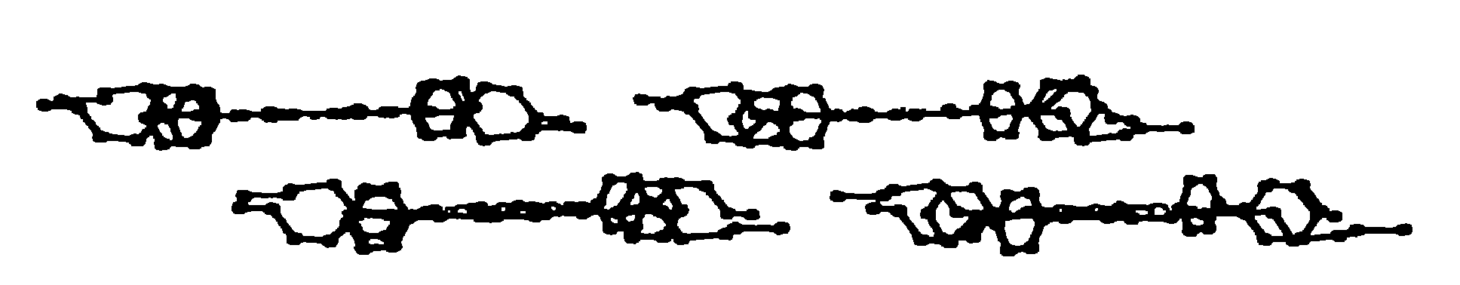

S 9: Packing diagram of 2

