
Supplementary Information:
A new entry to N-heterocyclic carbene chemistry: synthesis and characterisation of a triscarbene complex of thallium(I)
Hidetaka Nakai, Yongjun Tang, Peter Gantzel and Karsten Meyer*
University of California, San Diego, Department of Chemistry and Biochemistry, La Jolla, CA 92093, USA. E-mail: kmeyer@ucsd.edu

Fig. S1 Three views of the solid-state molecular structure of [1a]₂ · 5H₂O
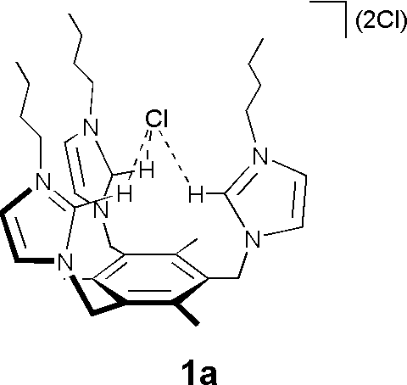

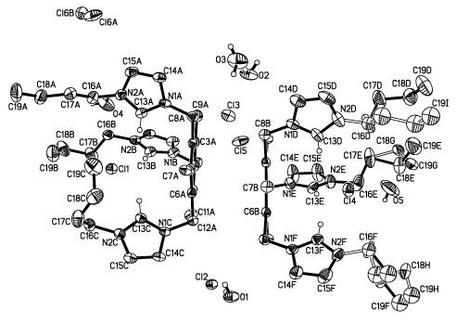
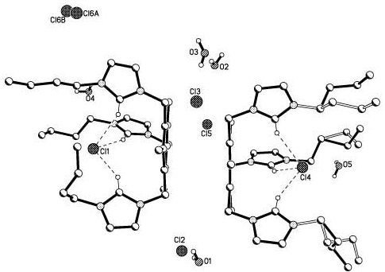

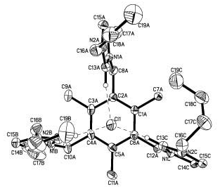

Table S1. Selected bond lengths (Å) for 1a.
atom atom distance atom atom distance
C13A N1A 1.329(5) C13D N1D 1.333(5)
C13A N2A 1.327(4) C13D N2D 1.342(5)
C13B N1B 1.324(5) C13E N1E 1.325(5)
C13B N2B 1.335(5) C13E N2E 1.325(5)
C13C N1C 1.327(5) C13F N1F 1.326(5)
C13C N2C 1.328(4) C13F N2F 1.328(5)

Table S2. Selected bond angles (°) for 1a.
atom atom atom angle atom atom atom angle
N1A C13A N2A 108.7(3) N1D C13D N2D 107.5(3)
N1B C13B N2B 108.8(3) N1E C13E N2E 109.2(3)
N1C C13C N2C 108.5(3) N1F C13F N2F 109.1(3)

Fig. S2 Orbital interactions in [(timtmb^{tBu})Tl^{I}]⁺ (2) showing purely electrostatic, σ-donating interactions between the Tl-s and the percarbene filled s-orbitals (HOMO, left). The LUMO (middle) and LUMO+1 (right, almost degenerate with LUMO) clearly show that there is no Tl (central atom, yellow) arene interaction present in 2.
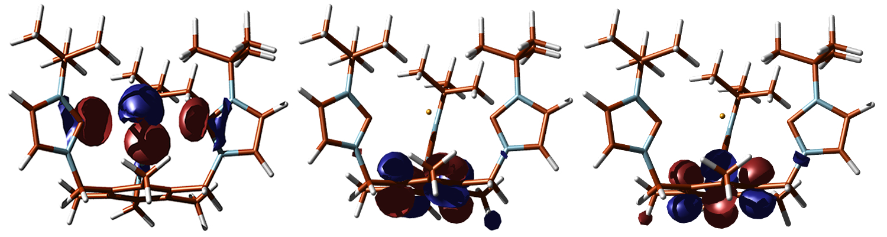

Computational Details
Density Functional Theory calculations on 2 were performed using the ADF2002.01 program suite[1-3] starting from the X-ray crystallographically refined coordinates of the cationic core structures. The Vosko, Wilk and Nusair (VWN) local density approximation, Becke’s exchange correlation (1988) and Perdew correlation (1986) were used. The calculation also included scalar relativistic effects (ZORA) for all atoms. Tl: triple-ζ basis set with polarization and frozen core 4d. N: triple-ζ basis set with polarization and frozen core 1s. C: triple ζ-basis set with polarization and frozen core 1s. H: triple-ζ basis set with polarization including H-polarization.

[1] ADF2002.01, SCM, Theoretical Chemistry, Vrijie Universiteit Amsterdam, The Netherlands.
[2] C. F. Guerra, J. G. Snijders, G. te Velde, E. J. Baerends, Theor. Chem. Acc. 1998, 99, 391-403.
[3] G. T. Velde, F. M. Bickelhaupt, E. J. Baerends, C. F. Guerra, S. J. A. Van Gisbergen, J. G. Snijders, T. Ziegler, J. Comput. Chem. 2001, 22, 931-967.

Input file

#! /bin/sh
$ADFBIN/adf <<eor
BASIS
TYPE TZP
CORE SMALL
END
XC
GGA BECKE PERDEW
END

relativistic ZORA
charge 1 0
atoms cartesian
H -1.26169 1.50894 -5.81930
H -1.48693 -0.84784 -5.70538
H -2.76602 1.12629 -5.43246
H -2.23396 2.61702 -5.19552
C -1.98777 1.66778 -5.18252
H -0.80072 -3.04729 -4.83810
C -1.21334 -1.04604 -4.81712
C -0.84410 -2.23479 -4.34928
H 0.40279 1.98099 -4.06400
C -1.52960 1.28104 -3.77932
N -1.12266 -0.15343 -3.76035
H -0.56958 3.08863 -3.44226
C -0.31586 2.14266 -3.41734
H -3.40919 0.92030 -3.01298
N -0.53663 -2.06312 -3.02015
H -2.91197 2.41834 -2.75667
C -2.64177 1.47607 -2.76794
C -0.70596 -0.77121 -2.62158
H 0.61484 -3.64499 -2.51048
H -0.00736 1.90997 -2.51722
H -0.93117 -3.84288 -2.14521
H 2.27609 -2.39287 -2.14634
C -0.18594 -3.19117 -2.14581
H -2.32215 1.21823 -1.87660
H 2.85219 -3.63330 -1.31236
H 4.07710 2.43691 -1.28066
H -2.44750 -2.65084 -1.29643
C 2.56536 -2.69768 -1.26050
H 3.08659 3.66605 -1.02510
H 3.31204 -2.14454 -0.95220
H 2.53328 2.16634 -0.95948
C 3.30135 2.74558 -0.76825
C 0.09298 -2.76514 -0.73053
C -2.41939 -2.76304 -0.32301
H -3.91914 2.74692 -0.22339
C 1.40891 -2.57863 -0.28501
H -2.73250 -3.66166 -0.08801
Tl 0.18368 0.46302 -0.05262
H -2.99726 -2.09492 0.09938
C -0.98904 -2.57956 0.16631
H 5.58553 3.28891 0.49769
H -4.07477 4.19155 0.44732
H -1.46410 2.78257 0.28796
C -4.09378 3.22566 0.61256
H 4.59746 4.51346 0.79297
C 3.61826 2.69462 0.71913
H -4.97713 2.97271 0.95587
C 4.81430 3.58614 1.02538
H -1.62338 4.22413 0.96112
H 3.61287 -2.78762 1.06903
C 2.96277 0.29652 1.00370
N 3.91057 1.27990 1.10448
C 1.62906 -2.24175 1.05236
C -1.64420 3.25797 1.12438
H 2.20582 4.10323 1.30798
H 1.64940 2.60431 1.38196
N 3.62868 -0.80031 1.44832
C 5.11028 0.80024 1.59888
C -0.74341 -2.16132 1.46716
C 2.42336 3.17897 1.55465
C 3.04665 -2.14777 1.57007
H 5.90271 1.30265 1.75384
C -3.01697 2.86122 1.64871
C 4.94063 -0.50538 1.81969
H 5.02749 3.52934 1.97928
H -0.96125 3.02404 1.78663
C -2.02159 0.51060 1.81913
N -3.06729 1.39269 1.89044
C 0.57323 -1.97174 1.92694
H 5.58595 -1.11282 2.16027
N -2.59590 -0.65626 2.21246
C -4.23454 0.78271 2.31240
H -2.56728 -2.67654 2.28536
H -5.07993 1.20206 2.43647
C -1.91386 -1.94427 2.41248
H 2.65203 3.14129 2.50645
C -3.94828 -0.51261 2.51775
H 3.05756 -2.41773 2.52146
H -3.28623 4.52422 2.84593
H -4.54349 -1.19378 2.80797
C -3.28778 3.55340 2.97770
H -4.16198 3.27039 3.31894
H 1.67818 -0.89104 3.27406
C 0.84967 -1.41161 3.29628
H -1.58534 -1.99235 3.34483
H -2.59089 3.30898 3.62160
H 0.10605 -0.83356 3.57000
H 0.94353 -2.14693 3.93723
end

FILE XYZ molden.xyz

geometry
end

scf
iterations 200
end

endinput
eor

